1.Navigate to url to create Spring boot project  
 <https://start.spring.io/>

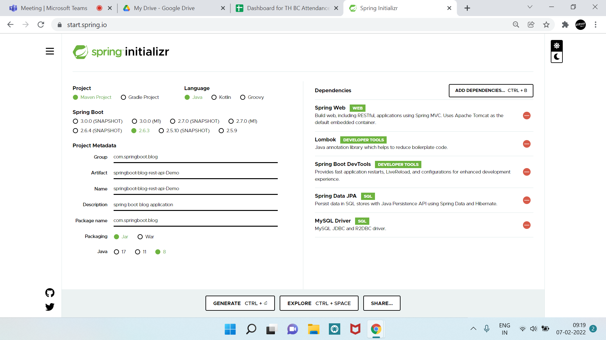

GET  
POST

PUT

DELETE

Persistence Logic

Business Logic

API LAYER

DB

DAO

SERVICES

COONTROLLERS

POSTMAN CLIENT

Post(Entity)

🡪JDBC Driver

{

“title”:” My New Post”,

“description :”Post Description”,

“content”: “This is My New Post”

}

🡪JDBC URL

🡪USERNAME

🡪PASSWORD

2 – Creating Packages

