Bizcom Engine - Media Section: All Changes (Rivoli)
TBL to tech team · 3 November 2026 · covers the CEO media page, the competition block with the new thumbnail gallery, and the data coverage map
How to read this: Part 1 is the standard the media page follows. Parts 2-3 are exact changes, marked as numbered orange markers on screenshots of the current build. Part 4 is what data the CEO report actually runs on. Part 5 lists the import files and open data asks. Same conventions as the creative document (2 Nov).
Part 1 - The contract: the CEO media page
The page runs on exactly THREE feeds plus the human Highlights: (1) the GA4 import (Rivoli-Consumer-GA4-Import v4 - net revenue, first-time purchasers, channels, refunds), (2) the platform-spend import (Meta + Google monthly exports), (3) the Ad Library capture (EDIT-AdLibrary-Capture2). Nothing else enters the page. The engine computes context; it never writes analysis text and never scores before baselines are signed.
Slot | Block | What it holds
1 | What went in, what came out | Monthly spend beside net site revenue and first-time purchasers (separate sources, printed as such). Support lines: 'coverage, not ROAS' and the one-line attribution note.
2 | What a customer costs | Blended CAC vs AOV (AED 267 vs 1,614 - 17% of first order), per-platform CAC row with CTR labels kept separate per platform.
3 | Where traffic and money come from | Channel strip from GA4: paid vs organic share of sessions AND revenue, top channels, the Unassigned refund line, the AI Assistant line.
4 | What worked, what to stop | Engine-computed top 3 + bottom 3 campaigns, 'CTR as reported' per row; TBL verdict line via Highlights import. Full tables behind 'See all'.
5 | The competition | EDIT block: delta cards, the thumbnail gallery (the competitor's wall), theme mix with campaign-platform tag.
- Banned on this page: any blended cross-platform metric (one blended CTR number mixing Google interactions with Meta link clicks), any platform ROAS, any competitor performance claim.
- Fixtures: 'Highlights this month' (human-written, pending state when absent), depth badge, 'Unscored - baselines pending'.
Part 2 - The media page: 10 changes
# | Change | Done when
1 | Rename 'TBL reads this period' to 'Highlights this month'; add the depth badge beside the section title. | No 'TBL reads' string; badge renders
2 | Remove the 'Biggest mover: Blended CTR' line. | No blended metric anywhere
3 | Delete the Blended CTR headline card. Per-platform CTRs live in Slot 2 with their own labels (Google 'interaction rate', Meta 'link CTR'). | Card gone
4 | Demote Platform Conversions to the one-line attribution note under Slot 1. | Not a headline card
5 | Revenue coverage becomes a support line inside Slot 1; the Blended CAC card is promoted to the Slot 2 headline. | Page leads with money in/out, then CAC
6 | The 'Aligned' spend-vs-FTP card becomes Slot 1 at the top of the page: extended to Sept-Oct, month tiles replaced by a two-panel line chart (spend above, FTP below, no dual axis). | Chart renders Jan-Oct from imports
7 | Fill the 'Data not available' channel card: the Channel Revenue sheet in GA4 import v4 supplies 17 channels, Sept and Oct, reconciled 100% to the dirham. Show Unassigned as its own line labelled 'includes unattributed refunds'. | Slot 3 renders; refund line visible
8 | Compress the attribution caveat paragraph to one printed line under Slot 1: 'Platform-reported conversions 811 vs 1,262 site purchases - overlapping credit; coverage is not ROAS.' | One line, not a panel
9 | Keep the per-platform table as the Slot 2 support row. It needs the Sept + Oct platform exports - Meta from BOTH ad accounts (Rivoli Group + Hour Choice; the 431K vs ~2.02M reconciliation is still the open blocker). | Sept-Oct rows render; both Meta accounts
10 | Slot 4: engine computes top 3 + bottom 3 campaigns by spend vs conversions, 'CTR as reported' label per row, TBL verdict via Highlights import. Both full campaign tables move behind 'See all campaigns'. | Default view is 6 campaigns, not 40
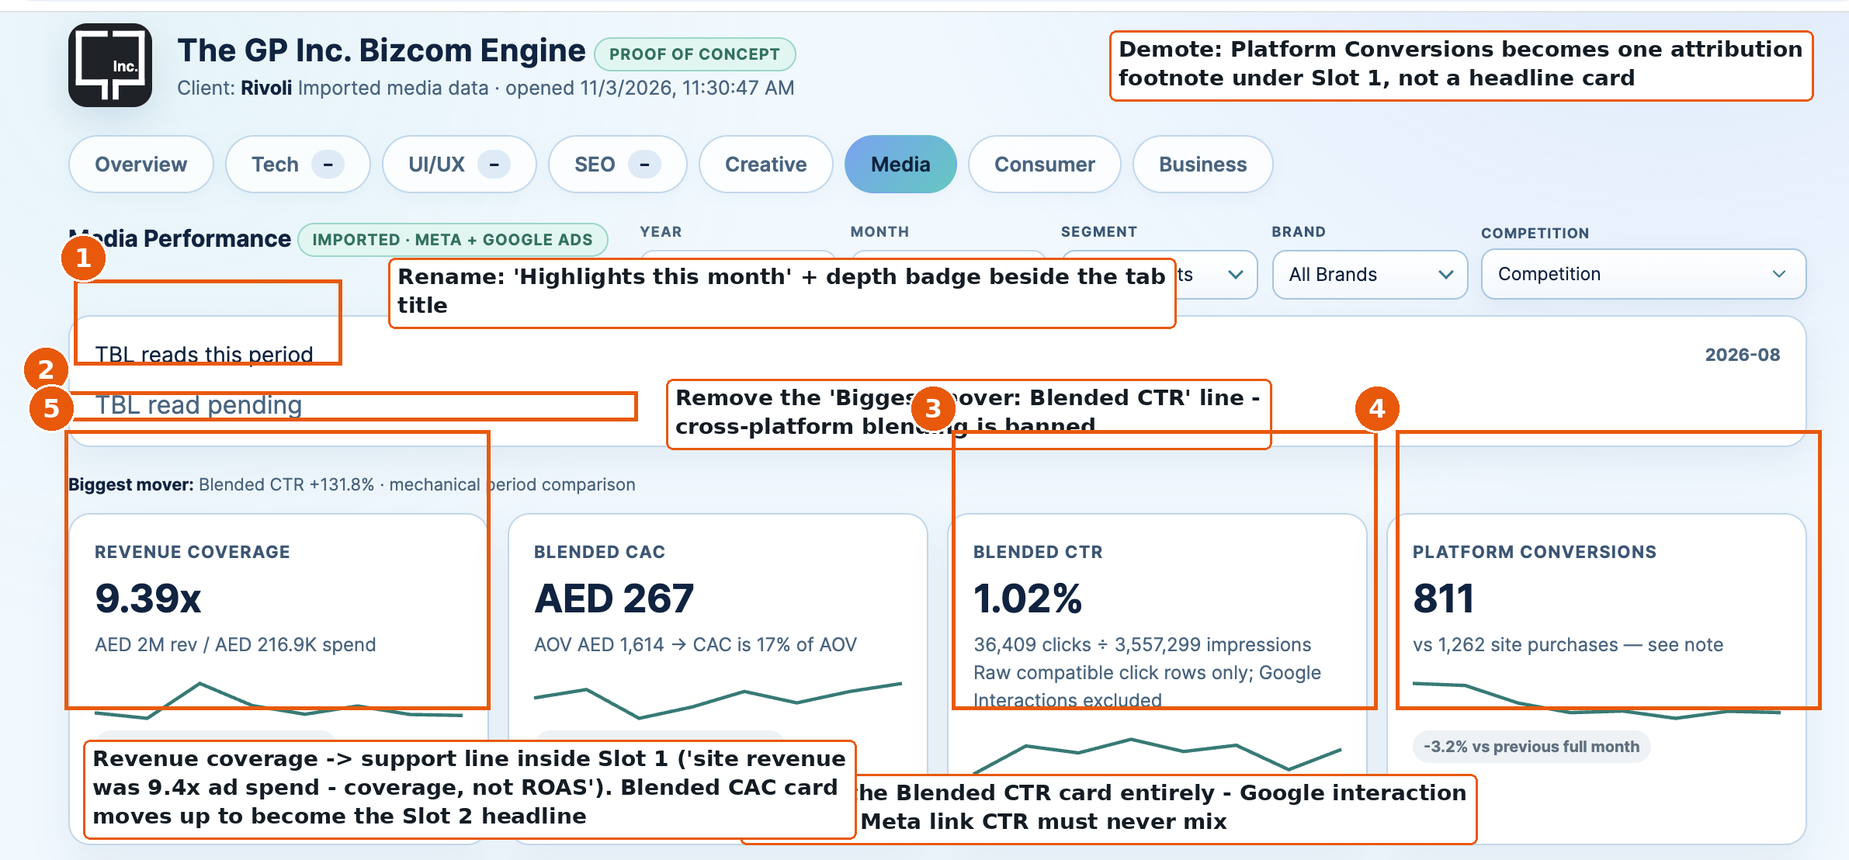
Media page header: markers 1-5
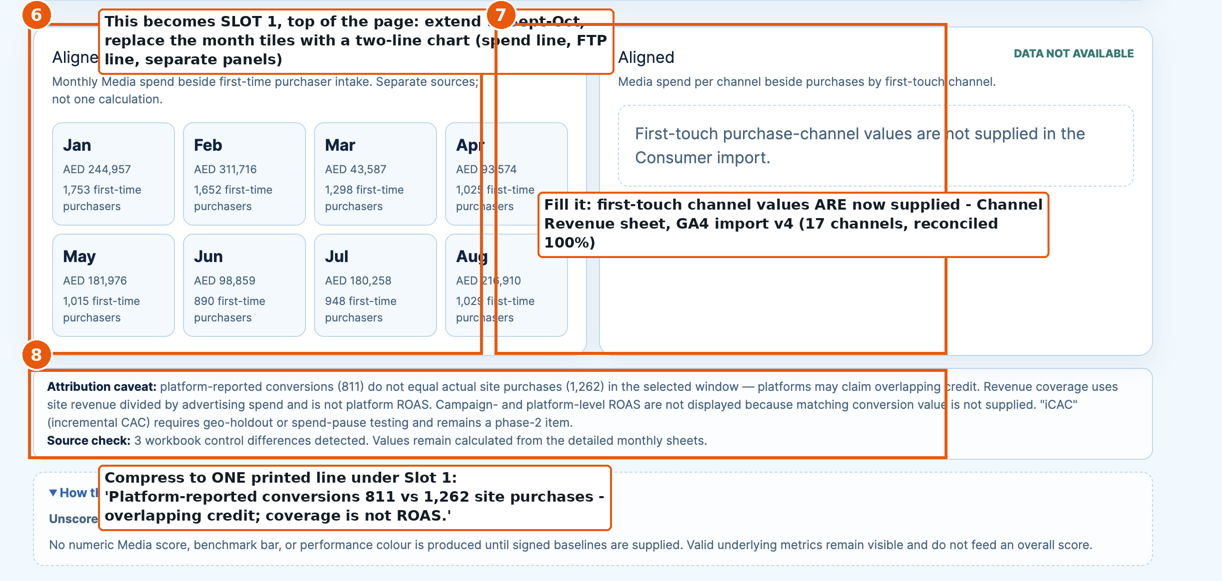
Aligned pair: markers 6-8
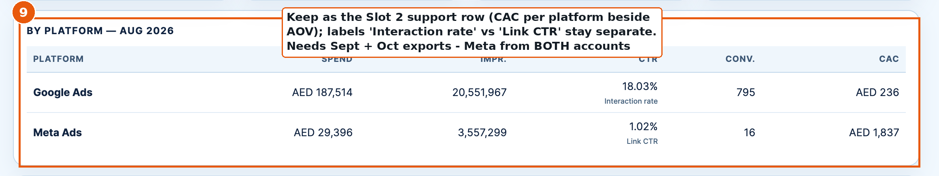
By platform: marker 9
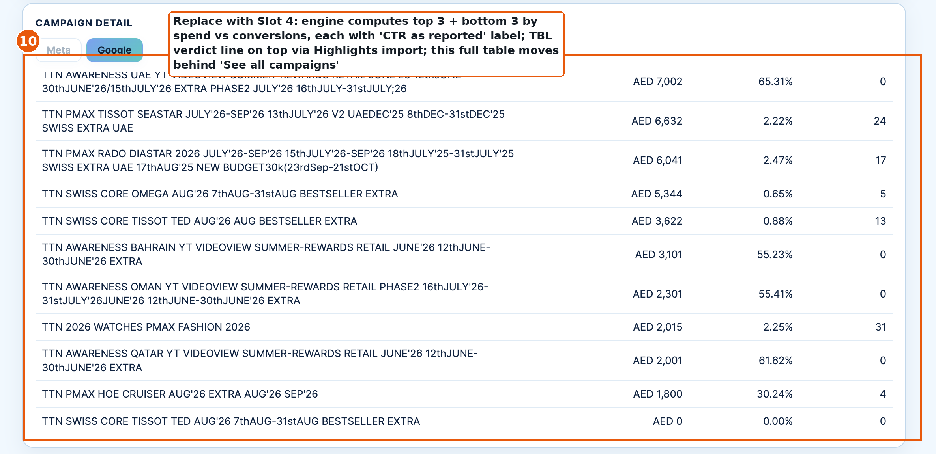
Campaign detail: marker 10
Part 3 - Competition: capture #2 and the competitor's wall
Fed by EDIT-AdLibrary-Capture2-03Nov2026.xlsx (68 ads, register by Library ID) plus the thumbnail pack (15 images). Markers 11-17.
# | Change | Done when
11 | Rename the block strip to 'Highlights this month', keyed to the CAPTURE month (Nov 2026). Three bullets arrive via the Highlights import - the brand-platform read first. | Strip shows Nov capture bullets
12 | History card switches ON: 37 (1 Oct) to 68 (3 Nov). Remove all first-capture caveats. | History renders with both captures
13 | 'Started since last capture' becomes real: 36 launches. Age profile updates (36 / 20 / 12). | Cards show capture-to-capture deltas
14 | Longest-running stays as built - now 168 days. It feeds gallery row 2. | Values from capture #2
15 | REPLACE the theme laundry-list tables with the thumbnail gallery - 'The competitor's wall': 4 rows, 15 analyst-picked ads, exactly per the layout mock below and the Gallery sheet in the capture file. Full register behind 'See all 68 ads'. | Gallery renders; tables gone from default view
16 | Launch timeline now moves month to month (Oct-Nov waves). | Timeline shows the three waves
17 | Theme mix gains the CAMPAIGN PLATFORM line above the bars: 'Own Your Moment - moments language on 15 of 68 ads'. Platforms cut across theme buckets; the tag comes from the new Campaign platform column in the register. | Tag renders from the import column
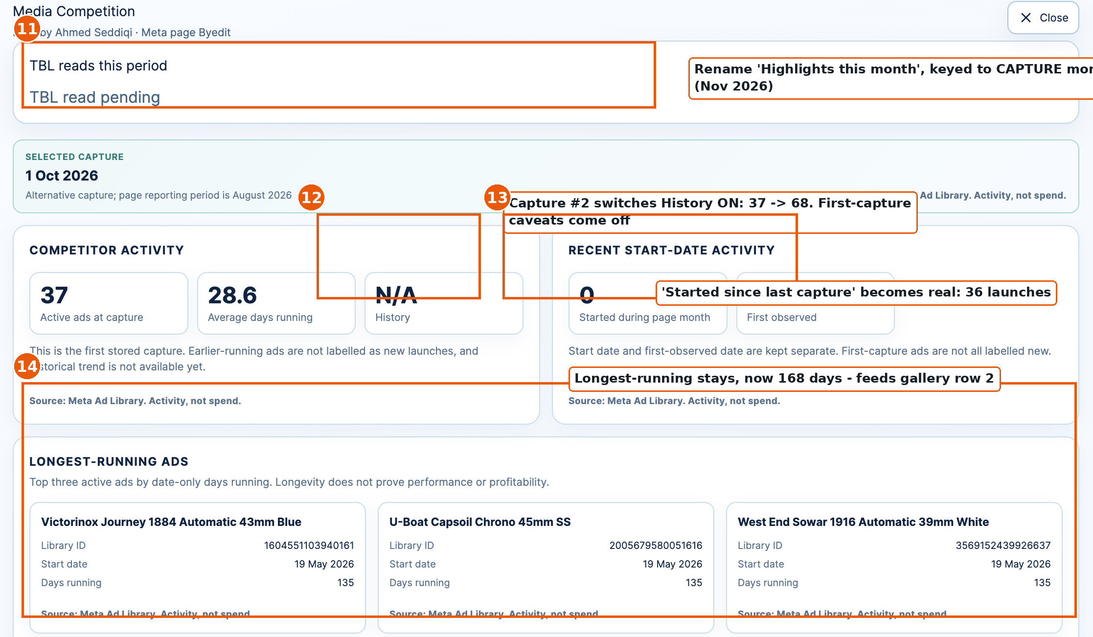
Competition block: markers 11-14
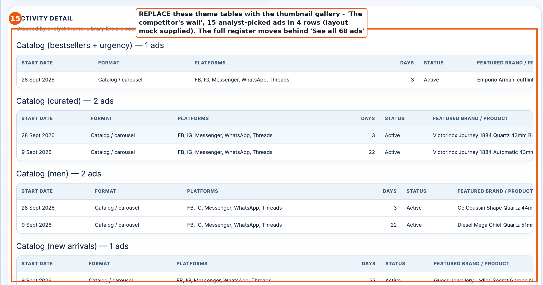
Theme tables to be replaced: marker 15
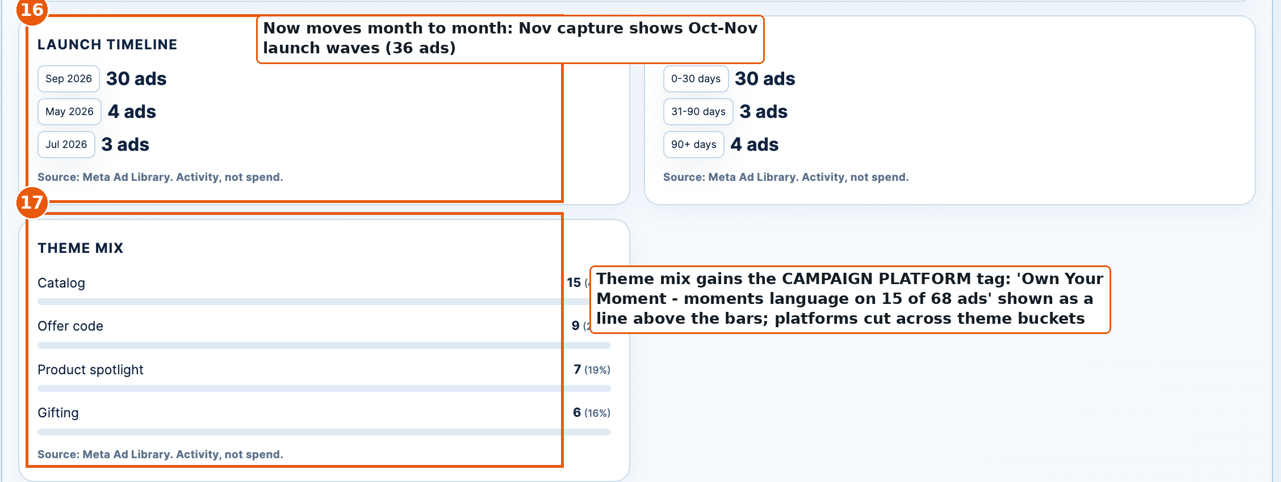
Launch timeline and theme mix: markers 16-17
The competitor's wall - build exactly this layout
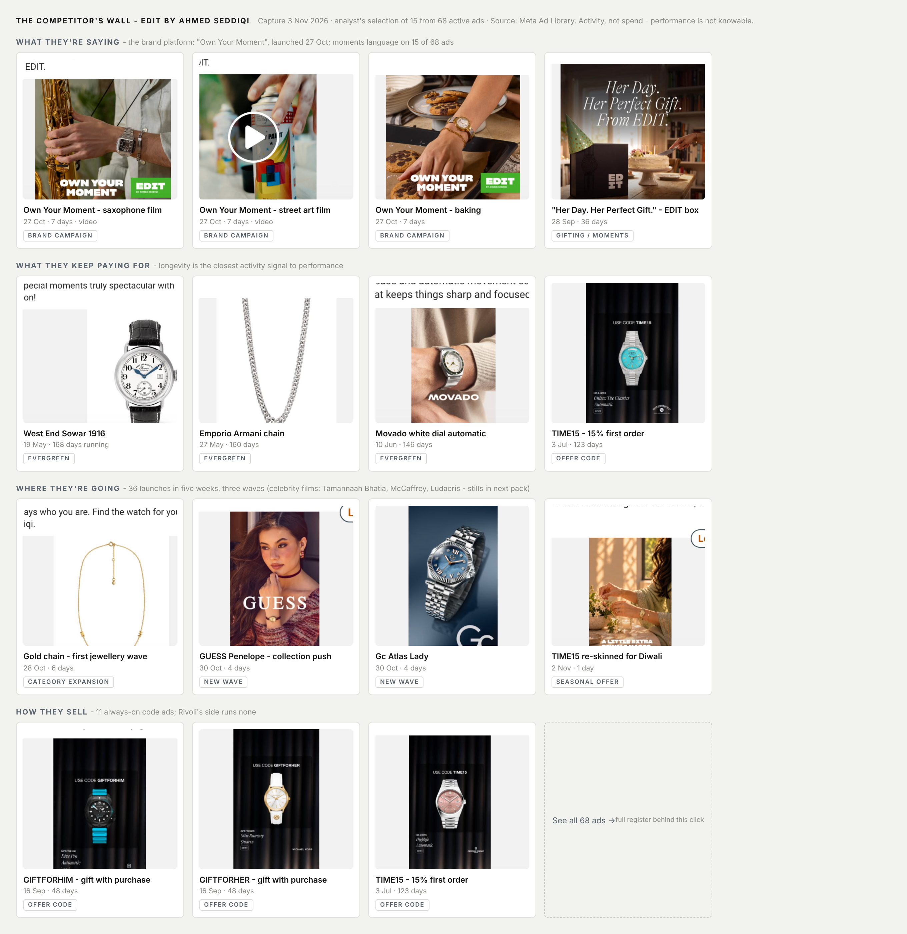
Layout mock built with the real capture #2 thumbnails (supplied in the thumbnail pack). Celebrity film stills join row 3 next capture.
- Honesty line printed on the wall: "Analyst's selection of 15 from 68 active ads. Source: Meta Ad Library. Activity, not spend - performance is not knowable."
- Every thumbnail: caption, start date + days running, theme chip. Thumbnail files and the row/slot/caption mapping are in the Gallery sheet of the capture workbook; TBL supplies a fresh pack each capture.
- Never on this block: spend, reach, performance, 'impactful' labels, auto-guessed themes.
Part 4 - The CEO report, worked backwards: data coverage
Slot | Numbers shown | Source | Status
1 In/out | Monthly spend; net revenue; first-time purchasers; coverage support line; attribution line | Platform exports + GA4 import v4 | GA4 side verified Jan-Oct; spend verified Jan-Aug; Sept-Oct exports OPEN
2 Customer cost | Blended CAC vs AOV; CAC per platform; CTRs as reported | Platform exports + GA4 | Working through Aug; Sept-Oct OPEN incl. Meta both accounts (blocker)
3 Channels | Sessions + revenue share per channel; paid share; Unassigned refunds; AI Assistant | GA4 import v4 | VERIFIED - reconciles 100% both months
4 Campaigns | Top 3 / bottom 3 by spend vs conversions; verdict line | Platform exports + Highlights import | Google verified through Aug; Meta partial
5 Competition | Delta cards; the wall; theme mix + platform tag | Ad Library capture #2 + thumbnails | VERIFIED - 68 ads registered 3 Nov
- Never covered, printed as such: platform ROAS (no matched conversion value), blended cross-platform metrics, competitor performance, scores before signed baselines.
- Pending for consumer-side repeat %: monthly-level Total purchasers export (daily values are not summable).
Part 5 - Import files and open asks
- Rivoli-Consumer-GA4-Import-v4.xlsx (3 Nov) - slots 1-3 GA4 side; also updates the Consumer tab (Sept-partial flags come off; October added).
- EDIT-AdLibrary-Capture2-03Nov2026.xlsx + EDIT-Capture2-Thumbnails.zip (3 Nov) - slot 5.
- TBL Highlights import - all 'Highlights this month' strips, media page and competition block.
- OPEN ASK 1 (owner: media team): September + October exports - Google Ads, and Meta from BOTH ad accounts (Rivoli Group + Hour Choice).
- OPEN ASK 2 (owner: GA4): monthly-level Total purchasers for Sept and Oct.
- OPEN ASK 3 (owner: TBL): celebrity film stills for gallery row 3, next capture.

