Bizcom Engine - Creative Section: All Changes
TBL to tech team · 2 November 2026 · covers Union Coop, Pocari Sweat, Souq Al Haraj, Souq Al Jubail, competition display, and the CLEO market block
How to read this document: Part 1 is the standard every creative page follows. Parts 2-6 are the exact changes, marked as numbered orange markers on screenshots of the current build; each marker number matches a row in the table before it. Part 7 is display rules that apply everywhere. Part 8 is the visual refresh, which is a SEPARATE second sprint - do not hold up Parts 2-6 for it.
Part 1 - The contract: how creative reaches the CEOs every month
Each month TBL verifies the raw platform exports, computes every number, and sends import files. The engine imports and displays. It never computes analysis text, never estimates a missing value, and never generates a score before baselines are signed.
- Every brand's creative page is the SAME page, in the same order, at whatever depth that brand's data allows:
Slot | Block | What it holds
1 | Output & Effort | Posts / Reels / Stories published this month + effort-vs-return line
2 | Attention | Reach and views trend, frequency; follows as one support line only
3 | Engagement, honestly | Typical (median) vs best post; Earned vs rented engagement; action mix
4 | What worked and why | Top 3 with thumbnails and why-it-worked factors; Top/Core/Low bands; cuts
- Three fixtures on every page: the data-depth badge (Level 1-3), the 'Highlights this month' strip (human-written, arrives via the Highlights import, shows 'pending' when absent), and the competition strip (Meta Ad Library, activity not spend).
- Brands are compared only to their own history. Platforms are never compared on the same card. Facebook and Instagram numbers never mix.
- Missing data shows 'n/a' with a printed reason, never zero. Every rate shows its raw counts beside it.
Part 2 - Union Coop: 11 changes
Markers 1-11 below. All are display work on data already imported (Why-It-Worked import v4).
# | Change | Done when
1 | Rename 'TBL reads this period' to 'Highlights this month'. Applies to every tab of every brand, including competition blocks. | No 'TBL reads' string anywhere in the product
2 | Add the data-depth badge next to the section title: 'Data depth: Level 3 of 3' for Union Coop. | Badge renders from config per brand
3 | Insert Slot 1 card row (Output & Effort): Posts / Reels / Stories published + the line 'Stories: 79% of output, near-zero measured return'. Values come from Monthly Benchmarks sheet of import v4. | Row shows above the bucket cards; values match import
4 | Reorder existing cards into the four slots. Frequency and reach/views cards form Slot 2; Typical vs Best and action mix sit in Slot 3. | Page reads in slot order 1-4
5 | New headline card in Slot 3: 'Earned vs rented engagement' - 78.4% of 2026 actions from giveaway posts; non-giveaway median 0.35%. Values from Creative Cuts sheet (ALL 2026 row). | Card live with both numbers and giveaway post count (72)
6 | Monthly trends: remove the Dec point. The axis starts January 2026. | First x-axis label is Jan
7 | Monthly trends: replace the dual-axis chart with two stacked panels (active engagement above, frequency below), straight lines. | No secondary y-axis in the product
8 | Ranked posts: real thumbnails. TBL sends a top-3 thumbnail file monthly; 'Image not available' disappears for ranked posts. | Top band shows images
9 | CEO view shows Top 3 only, each with its why-it-worked line; the full Top/Core/Low grid moves behind 'See all posts'. | Default view is Top 3 + bands summary
10 | Giveaway cut stays in the cuts grid AND feeds the new Slot 3 headline card (marker 5). | Same numbers in both places
11 | Follows panel: demote. One support line inside the Attention card: '428 follows attributed to posts'. Remove follows as a standalone panel. | No follows headline anywhere
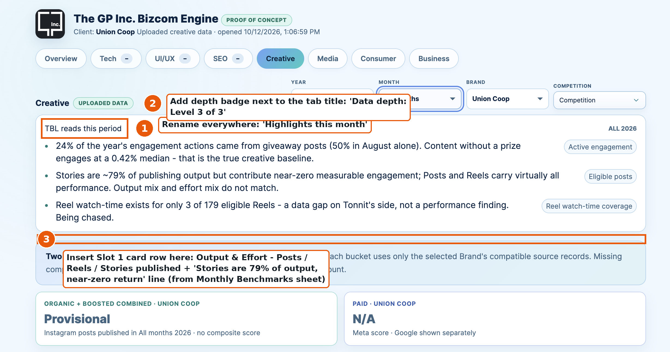
Union Coop creative header: markers 1, 2, 3
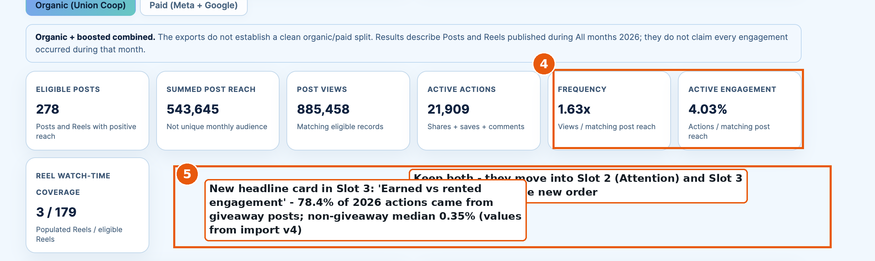
Union Coop score cards: markers 4, 5
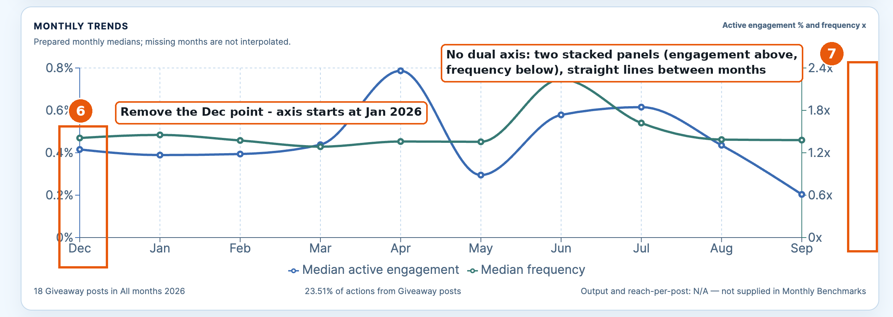
Union Coop monthly trends: markers 6, 7
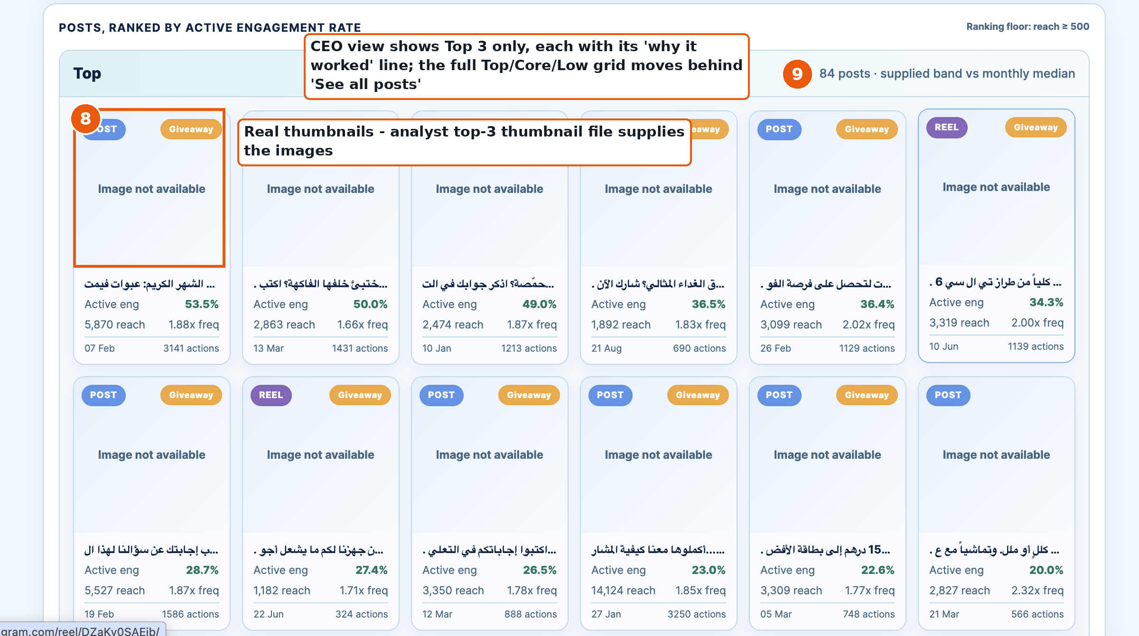
Union Coop ranked posts: markers 8, 9
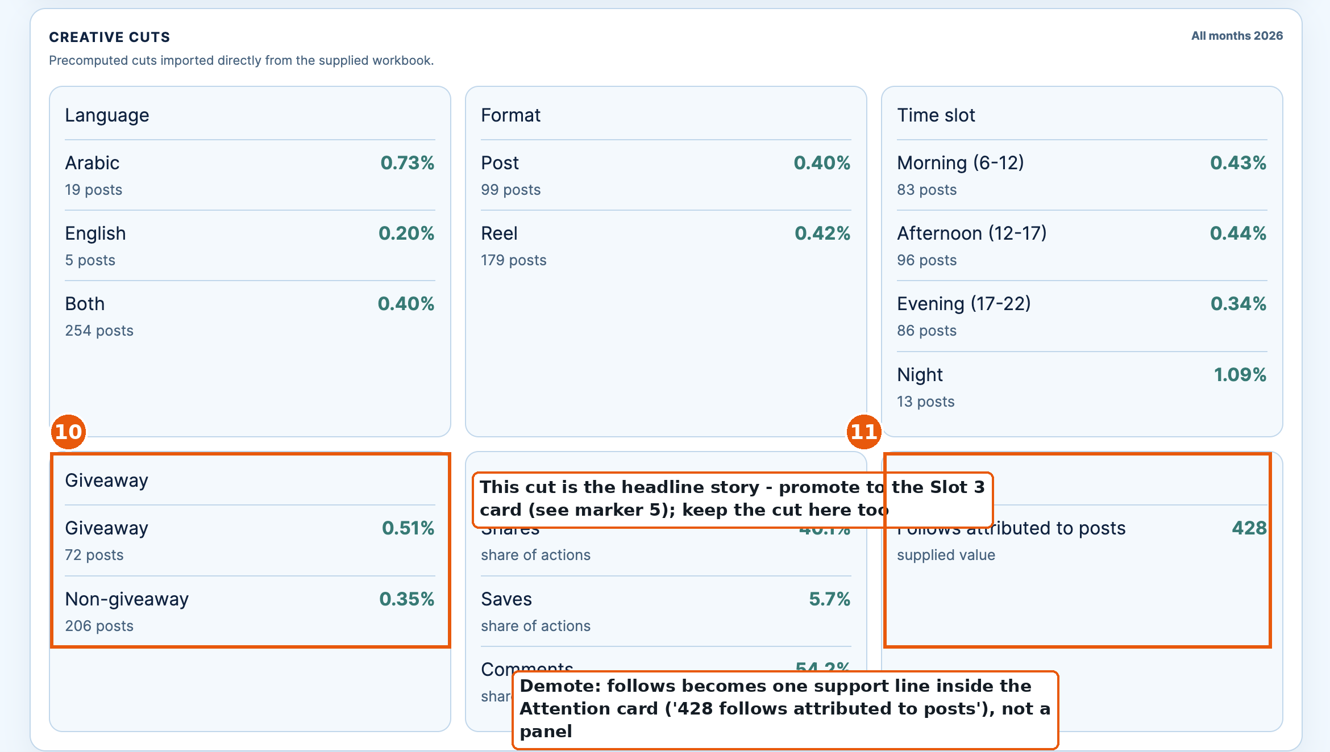
Union Coop creative cuts: markers 10, 11
Part 3 - Competition on the creative page: the standard block
One competition block design serves every brand. Source is the Meta Ad Library only. It reports activity, never spend - the 'Source: Meta Ad Library. Activity, not spend.' label stays on every card. Markers 12-14 on the current block below.
# | Change | Done when
12 | Wire the competition selector. It lists the brand's agreed competitor set and switches the whole block. Union Coop: Carrefour, LuLu (Nesto and Spinneys when captured). Rivoli: EDIT by Ahmed Seddiqi. Souqs and Pocari: sets to be named by TBL - the block stays hidden for them until then. | Selecting a competitor swaps every card below
13 | Rename the block's strip to 'Highlights this month' and key its bullets to the CAPTURE month, never the page month. Bullets arrive via the Highlights import with the capture date. | Strip shows capture month; no mismatch with page month
14 | Add the creative-lens cards beside the activity cards: Theme mix (analyst-tagged, from capture workbook - never auto-guessed), Ad language (text and artwork counted separately), Prize mechanics count (their giveaways vs ours), Launch tempo (their new ads per month vs our posts per month). | Four cards render from the capture workbook columns
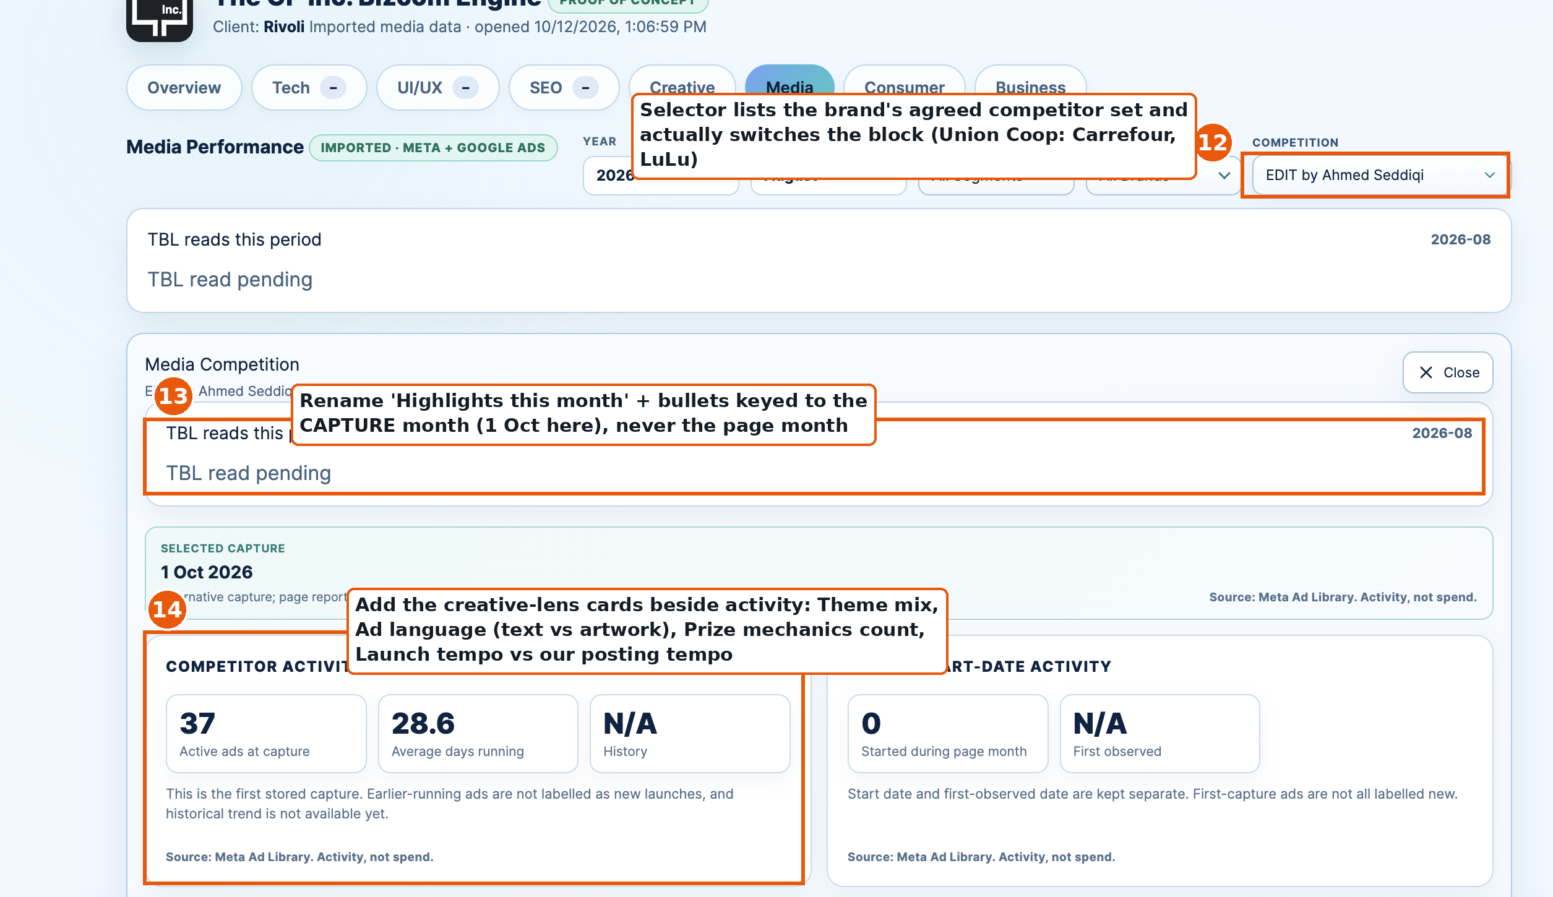
Competition block (Rivoli/EDIT shown - same layout for all brands): markers 12, 13, 14
What the block never shows: spend, reach, or performance for competitors (the Ad Library does not provide them); themes the analyst has not tagged; any competitor engagement rate. Longevity (days running) is the closest activity signal to performance and is already displayed correctly.
Part 4 - Union Coop only: new block 'What the market is asking' (CLEO)
WHAT CLEO IS: a tool TBL subscribes to for Union Coop. It tracks the questions people ask AI engines (ChatGPT, Google AI Overviews, Perplexity, Claude) about groceries in the UAE, and records which brands the engines answer with. TBL exports from it monthly and sends one import file. The engine displays; it never connects to CLEO directly, and no Bizcom data flows back to CLEO.
WHERE IT GOES: the LAST block of the Union Coop page, after the band grid and the competition strip. Union Coop only - no other brand gets this block.
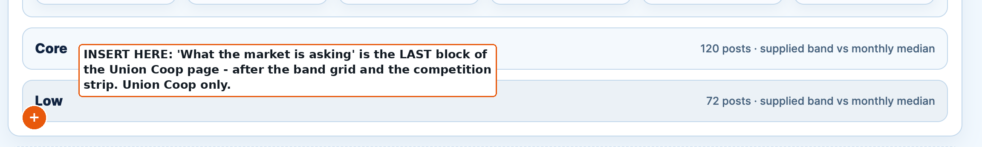
Placement: insert after the end of the current Union Coop creative page

WHAT IT LOOKS LIKE AND WHAT GOES IN: build this layout. Every element is numbered; the table below gives the exact data points and the import sheet each number is filled from. Dashed borders mark the unscored context band - nothing in this block is ever scored.
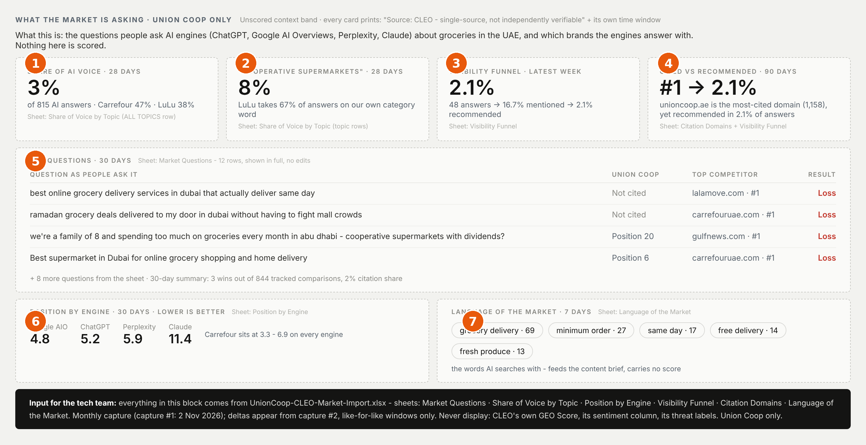
The block to build - numbers 1-7 match the data-point table below
# | Element | Data points to input | Import sheet | Window
1 | Share of AI voice card | Union Coop %, Carrefour %, LuLu %, total answers (3% / 47% / 38% / 815) | Share of Voice by Topic - ALL TOPICS row | 28 days
2 | Category card | Topic rows: each topic's answers + every brand's % + leader ('Cooperative supermarkets': UC 8%, LuLu 67%) | Share of Voice by Topic - topic rows | 28 days
3 | Visibility funnel card | Answers analysed, mentioned, cited, recommended - counts and % (48 / 16.7% / 16.7% / 2.1%) | Visibility Funnel | Latest week
4 | Cited vs recommended card | unioncoop.ae rank, citations, share, trend (1 / 1,158 / 4.32% / -6.21%) + recommended % from the funnel; Earned vs Owned and avg link position as support lines | Citation Domains + Visibility Funnel | 90 days
5 | Questions table | All 12 rows: question text, Union Coop position, top competitor + their position, Union Coop citations, result; summary line: 3 wins / 844, 2% citation share | Market Questions | 30 days
6 | Position by engine panel | All 6 brands x 4 engines, average citation position; plus Union Coop % of answers cited per engine | Position by Engine | 30 days
7 | Language of the market strip | Phrase + count of AI searches containing it ('grocery delivery' 69, 'minimum order' 27, 'same day' 17...) | Language of the Market | 7 days

WHERE EACH NUMBER COMES FROM IN CLEO (reference - TBL does this part; the tech team only loads the import file):
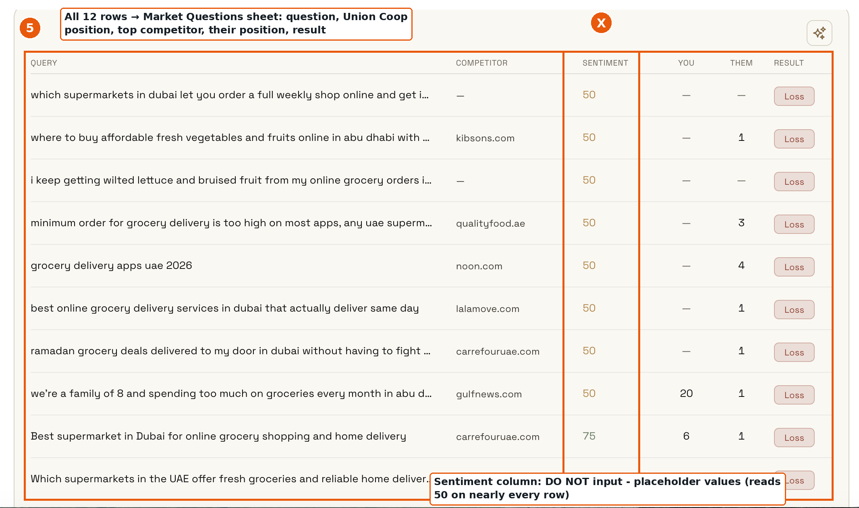
CLEO query table: all rows go into the Market Questions sheet; the Sentiment column is never input
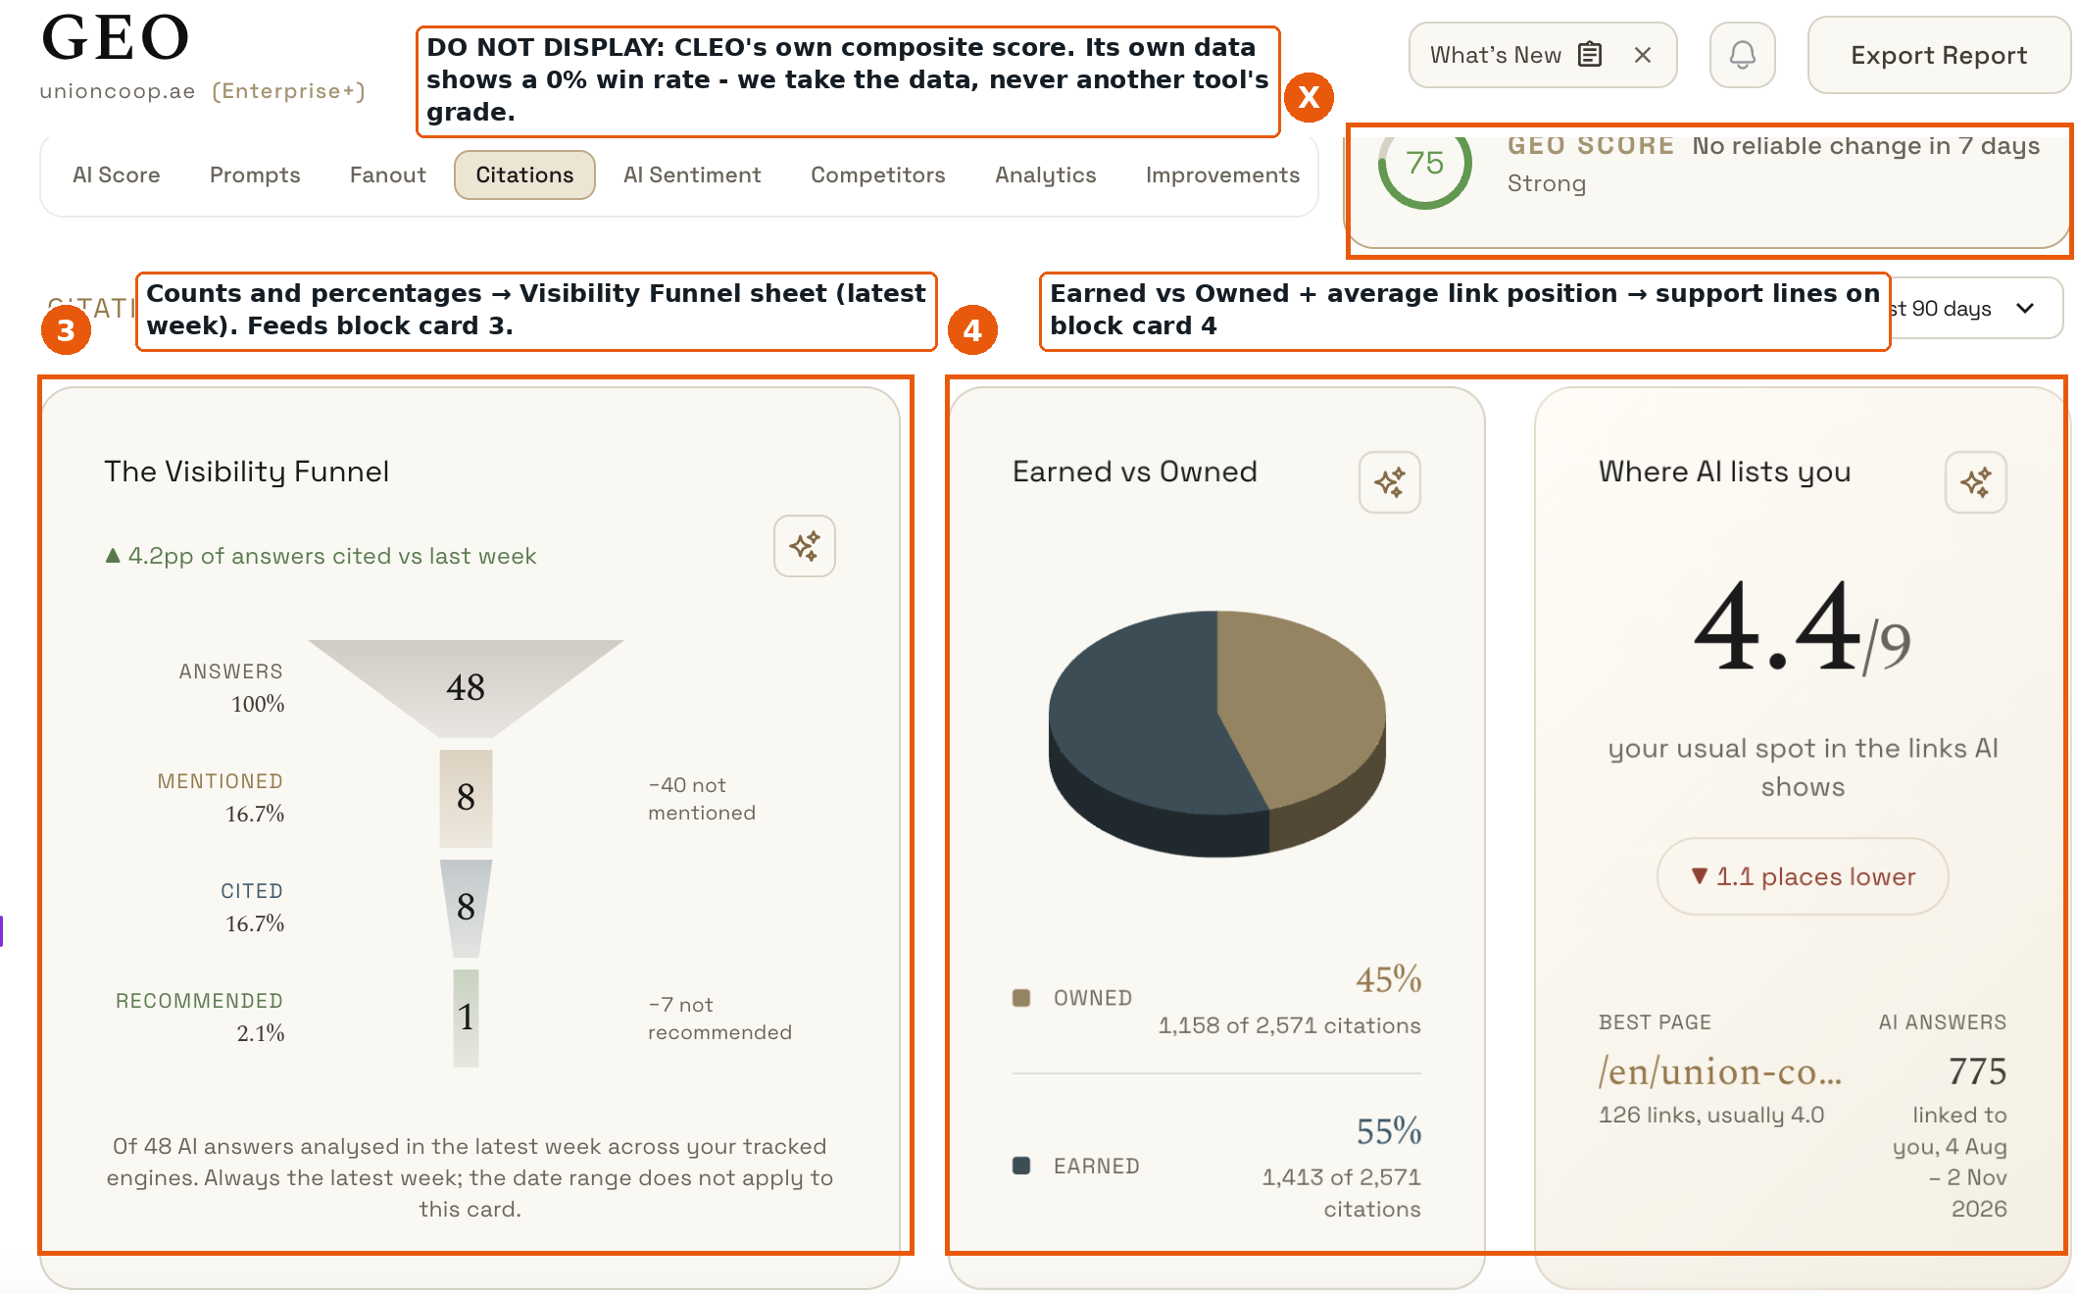
CLEO overview: funnel feeds card 3; CLEO's own GEO Score is never displayed
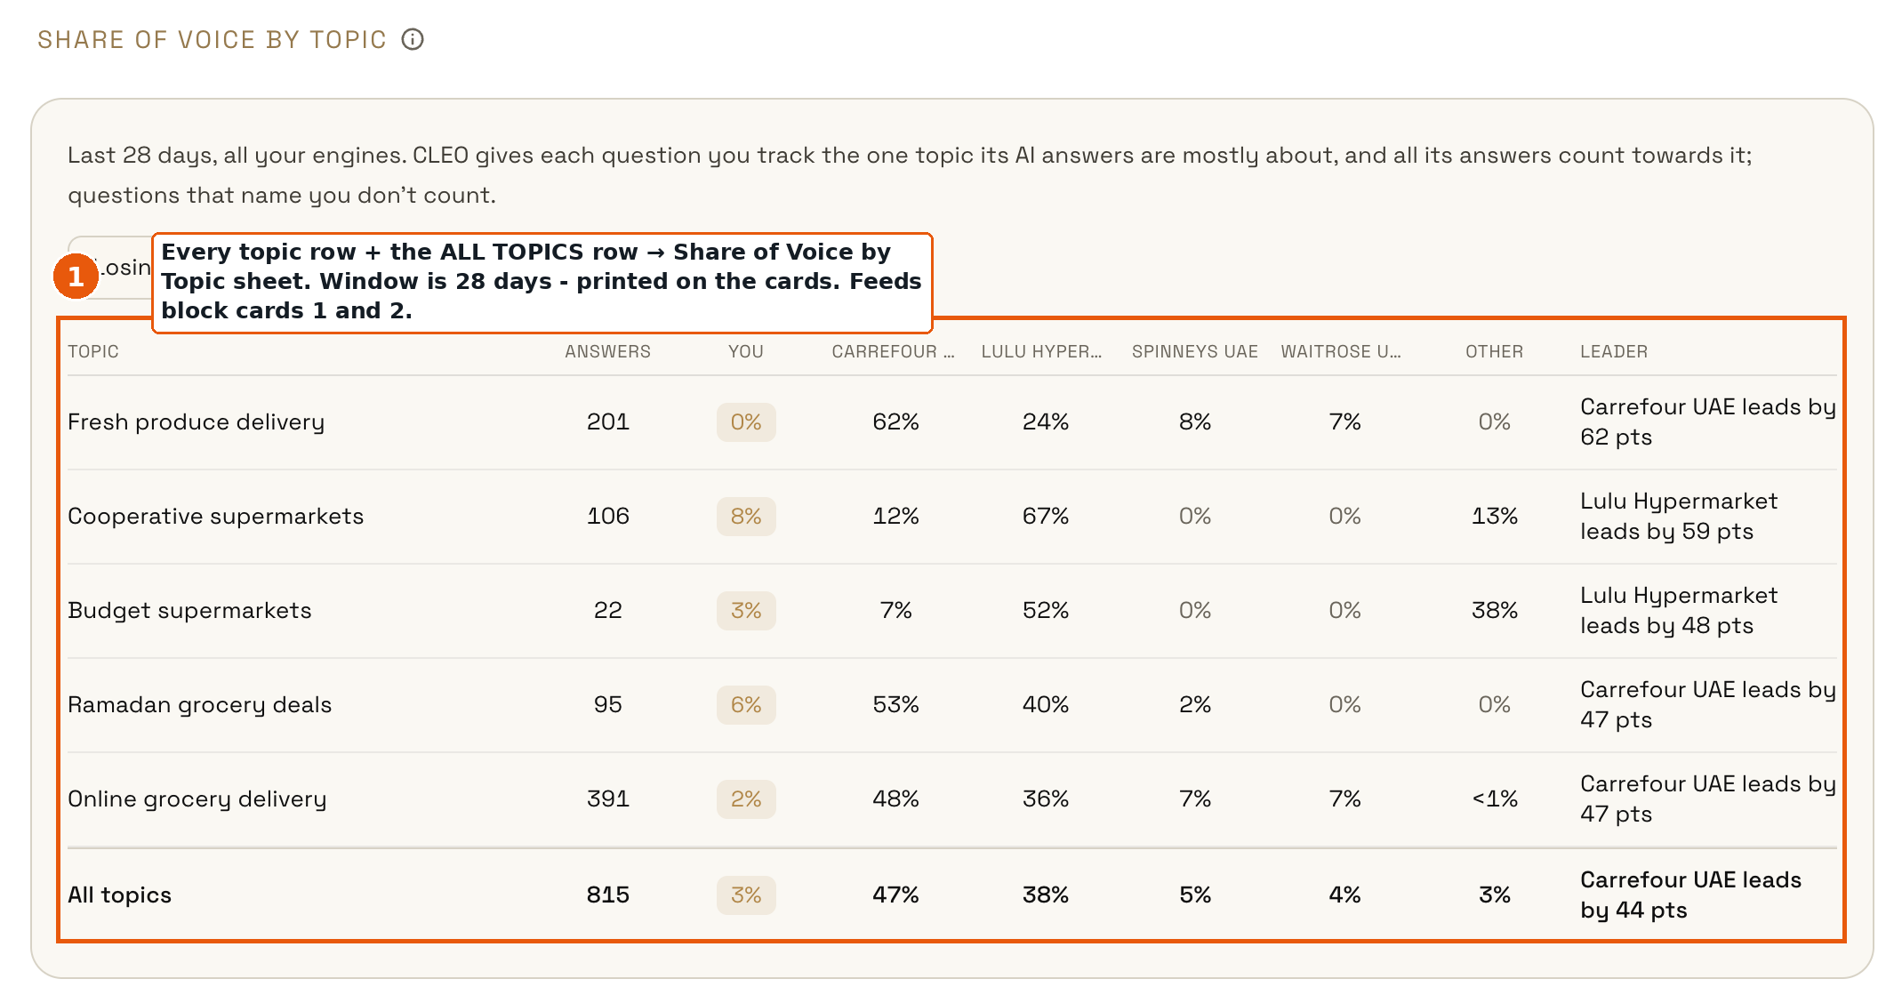
CLEO share of voice: topic rows feed cards 1 and 2
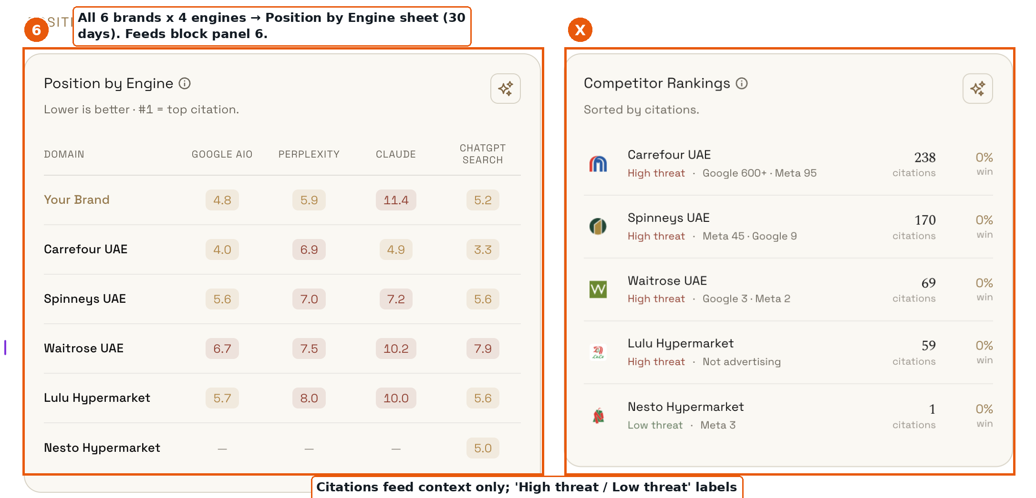
CLEO rankings: positions feed panel 6; threat labels are never displayed
Rules for this block
- Mandatory label printed on every card and table: "Source: CLEO - single-source, not independently verifiable."
- Each card prints its own time window (7 / 28 / 30 / 90 days). Never compare numbers across different windows.
- NEVER display: CLEO's own GEO Score (its composite grade contradicts its own underlying data), the Sentiment column (placeholder values), the 'High threat / Low threat' labels (editorial). These are deliberately absent from the import file.
- Monthly capture (capture #1: 2 Nov 2026). Deltas appear from capture #2 onward, like-for-like windows only.
- Unscored context band styling: dashed borders, paper-grey cards (see the block mock and the design prototype). No 0-100 score is ever computed from this data.
Part 5 - Pocari Sweat: 3 changes
# | Change | Done when
15 | Replace 'incomplete score' wording with the depth badge: 'Data depth: Level 2 of 3', plus the named owner of the missing full ad-level export. | No 'incomplete score' string; badge + owner shown
16 | Rename the strip to 'Highlights this month'. The pending state is correct and stays until TBL bullets arrive via import. | Renamed; pending state intact
17 | Apply the same four-slot frame at Pocari's depth: Slots 1-2 from available data, Slot 3 partial with its printed caveats (paid shares/saves unavailable), Slot 4 grey AWAITING card with named owner. Empty slots are never hidden. | Page shows all four slots, each either filled or grey with owner
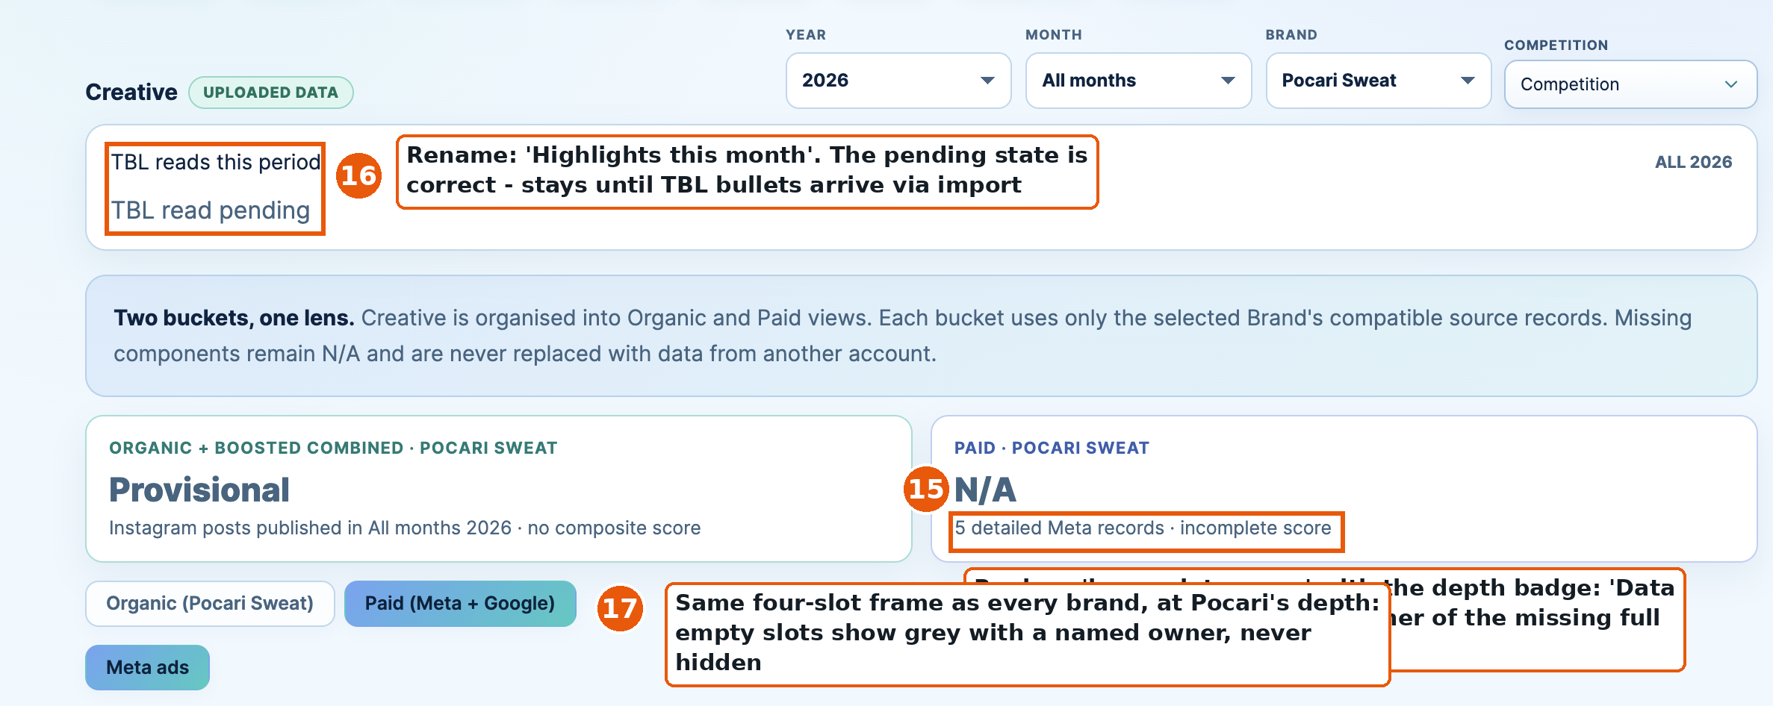
Pocari creative header: markers 15, 16, 17
The existing honesty work on Pocari (paid reach source check, excluded passive likes, N/A earned actions) is correct - keep all of it unchanged.
Part 6 - Souq Al Haraj and Souq Al Jubail: new build
Both pages are built fresh in the four-slot format from Souqs-Creative-Import.xlsx v2 (supplied 2 Nov: Facebook + Instagram, 52 post records, bands and Top 3 precomputed). Markers 18-19 on the current account-level screen below.
# | Change | Done when
18 | Fix the brand labels. The verified exports are 'Souq Al Haraj' and 'Souq Al Jubail'. The build currently shows 'Souq Al Bahar'. Confirm the brand list with TBL and correct every label. | Brand names match the import file
19 | Build the four-slot per-post page from the import; keep the existing account-level daily cards as the Slot 2 trend source underneath. | Both brands render the standard page
20 | Platform toggle: Facebook / Instagram. Definitions per platform from the import README: FB actions = reactions+comments+shares (saves and follows n/a); IG actions = likes+comments+shares+saves (clicks n/a). 'n/a' with reason, never zero. Never compare the two platforms on one card. | Toggle works; n/a labels correct
21 | Bands and Top 3 come straight from the import (computed per brand, per platform, per month). Why-it-worked lines are in the import, pending Kavita's sign-off. | Values match the import exactly
22 | Souq Al Jubail September: display 'No posts published' on both platforms - a dark month is a finding, not missing data. | Sept shows the finding, not zeros
23 | Context line on both pages: identical cross-posted content earns about 4x the engagement rate on Instagram vs Facebook. Both pages fully organic - no boosted reach in the window. | Line renders from import README values
24 | Depth badge: 'Data depth: Level 2 of 3' for both Souqs (stories and paid not exported). | Badge shows on both brands
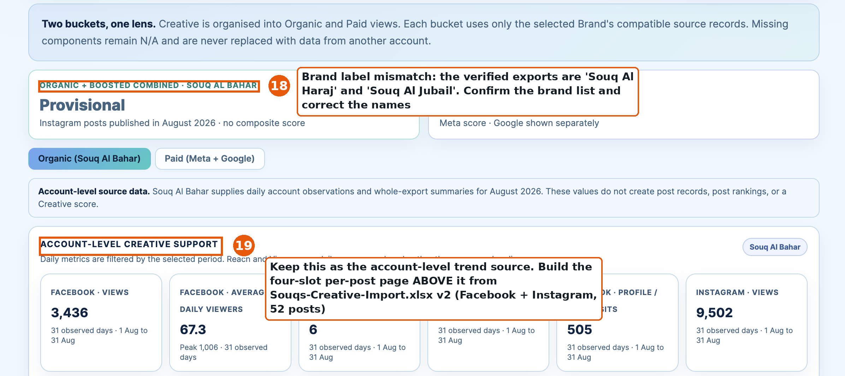
Souqs current account-level screen: markers 18, 19
Part 7 - Display rules that apply everywhere (recap)
- 'Highlights this month' is the only name for the analysis strip. It is human-written and arrives only via the Highlights import. 'Highlights pending' when absent. The engine never writes a bullet itself.
- Depth badge on every brand: Level 1 (account-level only), Level 2 (per-post), Level 3 (per-post + cuts + competitive). It replaces every 'incomplete / provisional score' phrasing.
- No score until baselines are signed: 'Unscored - baselines pending' stays as is.
- Nothing estimated; every number traceable to an import file; n/a with reason, never zero; raw counts beside every rate.
- Brands vs own history only. Platforms never mixed. Sources never mixed on one card. Source label printed on every externally sourced card (Ad Library, CLEO).
Import files referenced by this document
- UnionCoop-Creative-WhyItWorked-Import.xlsx (v4) - Union Coop slots 1-4
- Souqs-Creative-Import.xlsx (v2, 2 Nov) - both Souq pages
- UnionCoop-CLEO-Market-Import.xlsx (2 Nov) - the CLEO block
- Competition capture workbooks: EDIT (37 ads), Carrefour (30), LuLu (24) - competition blocks
- TBL Highlights import - all 'Highlights this month' strips
Part 8 - Visual refresh (sprint two, after Parts 2-6 ship)
The dashboard reads as dated because of default chart styling, decorative color, uniform text sizes and dense grids. The refresh is subtraction, not rebuild. A clickable reference prototype accompanies this document - match it, do not reinterpret it.
Principle | Rule
Color | GP Inc. black and greys are the chrome (headers, structure, text). Color only when it carries meaning: one green/red pair for deltas, amber for AWAITING, one neutral accent. Remove all decorative color, including the rainbow band bars and blue-gradient background.
Type | One sans family (IBM Plex Sans or Inter). Three sizes only: big number, small caps label, body. Headline numbers readable at arm's length.
Cards | One job per card: headline number + delta chip + one support line. White cards on a near-white grey page, hairline borders, no drop shadows.
Charts | Flat. No gradients, no 3D, no dual axes, no curve smoothing that invents values. Thin lines, direct labels on the line, months Jan to current.
Honesty states | Depth badge, AWAITING cards, source labels and 'pending' strips share one designed style - they are the product's signature, not an apology.
Density | CEO view: the four slots on one screen. Analyst detail behind 'See all'.

