**1. What are some of the problems that the company has?**

There are many challenges and difficulties faced by Prodigy Finance on proceeding loan applications and to approve them and few of them are assessment of eligibility criteria such as including age, citizenship status, and residency, to make sure whether the applicant fulfills the eligibility for securing a loan. Applicants financial background, which influences their credit score, repayment behavior, and previous financial needs/ loan history, to assess their creditworthiness. To assess the applicant's loan eligibility, the employment status of the applicant is one of the major documents required for especially working professional or working profession who prefer to pursue higher studies in abroad, this includes proof of income, job history, and future career prospects, through which they can predict applicant can make the repayments and job security level is also high for them.

Future more, it is difficult to predict the marital status of the applicant. Joint applications may involve combined income and assets, while marital disputes or legal issues could impact financial stability. In the current era, identity theft is becoming more common, and to avoid identity theft, prodigy authenticate their identity by means of legal documentation and verifying their identity documents, which typically takes a week or two. An applicant's academic background may not have a direct relation with loan approval, but it can have an indirect influence on their employment prospects and earning capacity, consequently, can affect their ability to repay loans.

**2.What are the company’s overall goals?**

Prodigy Finance helps students from around the world who want to study abroad but can't find easy loan options. They use smart tech and data analysis to pick out who can get loans, focusing on helping talented people reach their education dreams. Their big goals are to make more education opportunities, encourage worldwide connections, and help local areas and economies grow. Prodigy Finance is also really focused on keeping their customers and the finance world safe from online dangers and scams. They use the latest tech and smart methods to spot and stop any sketchy online actions, like unsafe online banking or payments. By doing this, they aim to cut down on money loss and make the online banking world safer and stronger for everyone. Their objective is to achieve this by utilizing modern facilities technology and analytics to detect and stop illegal activities that take place via digital channels including online banking, mobile banking, and electronic payments. Through thorough analysis, Prodigy Finance aims to prevent financial losses and enhance the overall security posture of the banking industry, fostering a safer and more resilient digital banking environment for all stakeholders involved.

1. **How could Business Intelligence help the company to solve the problems?**

Business Intelligence (BI) can play a significant role in helping Prodigy Finance address the challenges and difficulties it faces in processing and approving loan applications. BI tools can be used to analyze applicant data against basic eligibility criteria such as age, citizenship status, residency, and other relevant factors. By automating this assessment process, BI can ensure that only eligible applicants move forward in the loan application process, reducing manual effort and improving efficiency. BI also can analyze applicant's financial histories, including credit scores, repayment behaviors, previous loan histories, and financial needs. This analysis helps in evaluating applicants' creditworthiness and their ability to repay loans, providing insights into risk assessment and decision-making. BI can integrate employment databases and analyze applicants' job histories, income levels, and future career prospects. This analysis helps in assessing applicants' loan eligibility based on their ability to make repayments, job stability, and overall financial capacity. BI can help in analyzing joint applications, assessing combined income and assets for loan approvals. Additionally, BI can flag potential risks related to marital disputes or legal issues that may impact applicants' financial stability and loan repayments. BI tools can streamline identity verification processes by automating document verification, authentication, and fraud detection. This ensures that loan applications are processed securely and efficiently while mitigating the risk of identity theft and fraud. Although academic history may not directly influence loan approvals, BI can analyze applicants' educational backgrounds to understand their employment prospects, earning potential, and overall financial stability. This holistic analysis provides a more comprehensive view of applicants' creditworthiness.

By leveraging Business Intelligence in these ways, Prodigy Finance can enhance its loan application processing, improve risk assessment accuracy, reduce manual errors, and make informed decisions regarding loan approvals. This not only streamlines operations but also ensures responsible lending practices and enhances customer satisfaction.

1. **What software does the company utilize?**

Prodigy Finance uses a range of software tools and technologies for various purposes. JavaScript is used in the development of websites and the creation of interactive features for online platforms. Google Tag Manager is used to maintain and deploy marketing and analytics tags on a website, making it simpler to track and analyze user activity. Google Font API is used to incorporate Google Fonts into websites, improving the platform's typography and aesthetic appeal. Apache is very likely used as their web server software, which guarantees reliable and safe web hosting services for their online platform. Google Analytics is used for website analytics, which helps Prodigy Finance keep tabs on traffic trends, analyze user engagement, and learn about user behavior. HTTP/2 is a protocol used that allows web servers and clients to communicate securely and effectively, enabling quicker and more secure data transfer on their platform. Prodigy Finance most certainly also makes use of mobile app development tools and technologies as proven by the fact that their app is available on Google Play and iTunes Connect. Given the financial nature of Prodigy Finance's activities, SQL can be utilized for database management and querying as it facilitates effective management and analysis of big datasets.

1. **What are the logical components of the star schema of prodigy finance? Or if they don't have a business intelligence system in place, what would the components be to analyze data useful in solving the problem?**

Considering the datasets of a banking sector, the logical components of star schema of Prodigy Finance could include Fact Tables. This includes Loan Transaction Fact contains information on loan transactions, such as amounts disbursed, interest rates, repayment schedules, and statuses. Financial Performance Fact contains important financial data, including revenue, profit, expenses, and other performance indicators, which are stored here.

Dimension Tables can also be included which contains Customer Dimension contains data about customers, such as contact information, employment status, educational background, and demographics. Loan Dimension offers information on loans, including loan numbers, categories, amounts, interest rates, and conditions of repayment. Date Dimension holds information about dates, such as calendar dates, months, quarters, years, holidays, etc., for use in time-based analysis. Geographic Dimension contains data regarding nations, currencies, exchange rates, and geographical areas are included in this. Financial Product Dimension contains data about the financial products that Prodigy Finance offers, including product kinds, IDs, and eligibility requirements. Product Dimension helps gathering information about various financial goods, like identities (Single/not, Married, House/ap, etc.) and loan kinds (Cash loans, Revolving loans).

The star schema for the Prodigy Finance dataset could also include the following additional

components, such as

Bridge Tables can be used to model relationships between dimensions that are many-to-many (such as, when a consumer has numerous accounts). Mini-dimension tables can be made to decrease redundancy in the main dimension tables and increase query efficiency for dimensions having attributes that have a restricted range of values, such as account types and product categories. Audit Dimensions can help add audit dimensions to trace data changes, including who updated what, when, and how they were applied. Data lineage and auditing requirements are supported by this.

1. **What are the sources of data?**

Prodigy Finance's credit assessment procedure makes use of many kinds of data sources. The applicant's credit report, which offers an in-depth examination of their financial life, including debt management and payment history, is one important source. Prodigy Finance also considers future earning potential with its own model, which accounts for the applicant's expected postgraduation income. Prodigy Finance is different from usual financial institutions in that it looks toward the future rather than depending on just historical financial data. Prodigy Finance looks to give international students looking for school loans a thorough and specific credit assessment by considering credit records and future earnings potential.

To acquire information for their credit evaluation procedure, Prodigy Finance may also use other data sources like credit reporting agencies, colleges and universities, and other third-party suppliers. Prodigy Finance uses these sources to gather information on an individual's financial standing and loan-repayment abilities.

1. **What is the frequency of the data?**

Prodigy Finance uses a special model that accounts for income growth after graduation in addition to past and current financial standing. Prodigy Finance is different from usual lenders in that it takes a forward-looking approach rather than depending entirely on past and present financial data.

Since Prodigy Finance's evaluation of credit is based on a thorough examination of numerous factors to calculate loan cost-effectiveness, the data frequency for this process can be thought of as dynamic and continuous. The analysis considers several factors, including the borrower's expected future earnings pattern, present payment, current debts, projected post-graduation employment offers, and educational requirements. This in-depth evaluation guarantees that the loan offer matches the borrower's after-graduation financial capacity.

1. **What else can you do to help the company achieve their goals? (E.g. Increase sales?**

**Lower costs? Increase organizational efficiency? Provide better decision-making capacity?)**

Prodigy Finance could consider several important methods to get further to its overall objectives. To increase revenue per customer, the organization can first improve cross-selling opportunities by finding more financial goods or services that go well with their current offers. Second, implementing agile approaches in software development and project management can promote innovation, reduce time-to-market, and improve organizational adaptability. Thirdly, costs can be reduced, and timely resource delivery can be guaranteed by streamlining supply chain management procedures, such as inventory control and procurement. Fourth, putting priority on staff development and training programs will improve abilities, output, and job satisfaction. Fifth, data-driven decision-making and continuous improvement will be made possible by developing key performance indicators (KPIs) and using data analytics to track performance. Sixth, regulatory risks can be reduced by investing in compliance management systems and keeping abreast of regulatory regulations. Seventh, spending money on in-depth market research will provide information that can be used to improve marketing plans and product offerings. Eighth, corporate social responsibility will be improved, and environmental effects will be reduced by integrating sustainability programs into business operations. Nineth, strengthening partnerships with regulators, academic institutions, and fintech firms will encourage innovation and market growth. Lastly, establishing a customer-centric culture across the entire company will put the needs and loyalty of the client first, which will eventually propel Prodigy Finance's long-term success and expansion.

1. **Who is/are the consumer(s) of Business Intelligence insights?**

Within a company, a wide range of stakeholders use business intelligence (BI) insights, each with specific needs and purposes. BI insights are an essential tool for strategic decision-making at the executive and senior management level. They offer a thorough understanding of organizational performance and identify areas that require development and improvement. Sales and marketing teams use BI data to track sales performance, understand consumer behavior, and improve marketing tactics. Operations managers use BI insights to optimize workflows, streamline procedures, and increase operational efficiency. Departments of finance and accounting use BI insights to estimate financial performance, manage budgets, and make sure regulations are followed. HR specialists use BI data to improve workforce planning, boost employee engagement, and support talent management programs. Logistics and supply chain teams use BI insights to cut costs, enhance supply chain visibility, and optimize inventory management.

Overall, business intelligence (BI) insights are used by almost all the departments in an organization which will enable companies to make data-driven choices, enhance operations, and accomplish strategic goals in all functional areas.

1. **What might you recommend the company do to improve their Business Intelligence systems?**

Prodigy Finance could take a few calculated risks to enhance their Business Intelligence (BI) systems. Firstly, investing resources into sophisticated analytics technologies like machine learning and predictive modeling could improve their ability to anticipate student behavior, precisely evaluate credit risks, and identify market patterns ahead of time. Also, combining information from many sources such as external databases and internal systems may provide a more thorough knowledge of financial performance and student characteristics. By adding interactive dashboards and customizable reports to data visualization capabilities, end users may find it easier to obtain and use BI insights, which could speed up decision-making. In addition, through implementing real-time analytics capabilities into practice, Prodigy Finance may be able to quickly adapt to shifting market conditions and track important data in realtime. To guarantee the precision and reliability of BI insights, strong data quality standards, governance guidelines, and data stewardship procedures must be established. Lastly, democratizing data access and analysis within the company could promote a data-driven culture and accelerate decision-making processes by providing employees with self-service analytics tools and extensive training programs. By giving these initiatives the highest priority, Prodigy Finance will be able to improve their BI systems, gain valuable insight, and encourage strategic decision-making to meet their objectives.

**Data Analysis Tools and Methods:**

The correct software tools must be chosen in the finance sector, where data analysis is essential for evaluating risks and well-informed decision-making. To evaluate financial data efficiently, finance professionals need strong data handling abilities, advanced statistical methods, and visualization applications.

One of the most used programs for financial data analysis is Excel. Because of its range of uses, users may rapidly develop models, generate reports, and carry out a variety of financial calculations. For many financial analysts, Excel is their first option due to its familiarity and flexibility. Using Tableau, finance professionals can use their datasets to generate attractive reports and interactive dashboards. Tableau is a strong data visualization application. It is easy to look at and present complex financial data in a clear and clear manner thanks to its userfriendly interface and drag-and-drop feature.

A huge amount of data set in finance can also be viewed and analyzed with the help of SQL (Structured Query Language), a standard language for scheduling and querying relational databases. SQL is used by finance professionals to calculate, extract specific data from databases, and produce information for decision-making. To do in-depth analysis, make wise judgments, and manage risks. Experts in the finance business need a combination of processing skills, complex analytics features, and visualization options, which these solutions for software deliver.

**DATA ANALYSIS:**

**1. Payment difficulty chart based on loan type:**

: 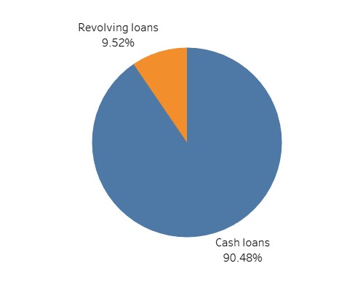

(i)

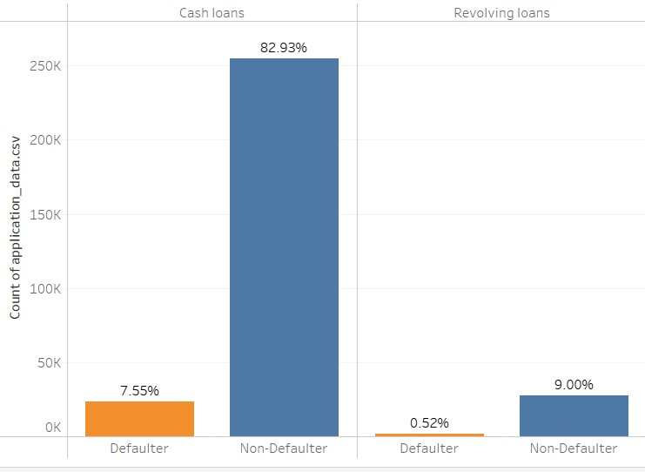

(ii)

Cash loans and Revolving loans

* + Most preferred type of loan is Cash loans which is overall 90% which is applicable for students whereas revolving loans are not very much welcomed.
  + We could see that clients are facing high payment difficulties for cash loans whereas for revolving loans its low.

**2. Payment difficulty chart based on gender:**

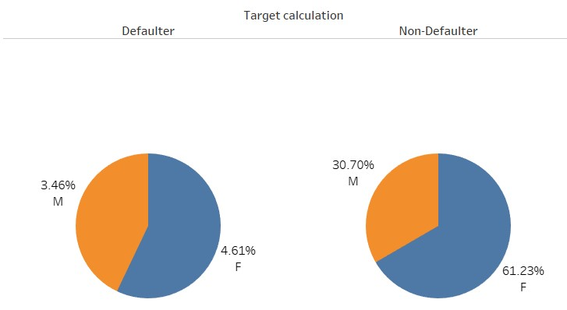

* Mostly prodigy can prefer loans to Female clients followed by Male clients considering the repayment and other factors.
* In the "Defaulter" category, males constitute 3.46% while females make up a slightly larger proportion at 4.61%.
* Conversely, in the "Non-Defaulter" category, females have a significantly larger share at 61.23%, compared to 30.70% for males, suggesting that a higher percentage of females are non-defaulters compared to males.

**3. Analysis on Applicant’s profession:**

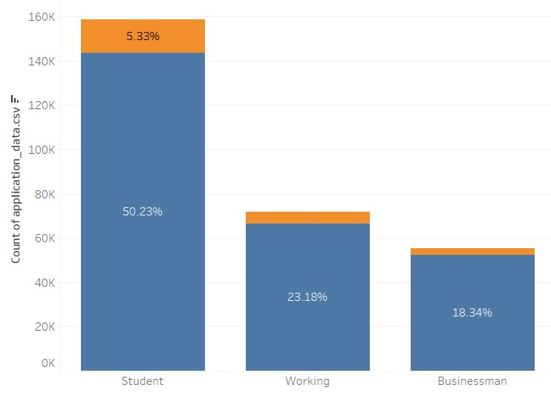

* It represents the count of applications or data by previous occupation, with students, working individuals, and businessmen categories.
* Students comprise the largest group with over 150,000 applications or data entries, making up over half at 50.23%. Working individuals follow with approximately 70,000 entries (23.18%), and businessmen account for the smallest segment at around 18.34%.
* The orange portions atop each bar indicate a smaller percentage, with the student category having an additional 5.33% atop the base count, working individuals with 1.88

% and Businessman with 1.04 %.

**4. Credit Amount based on applicant’s occupation:**

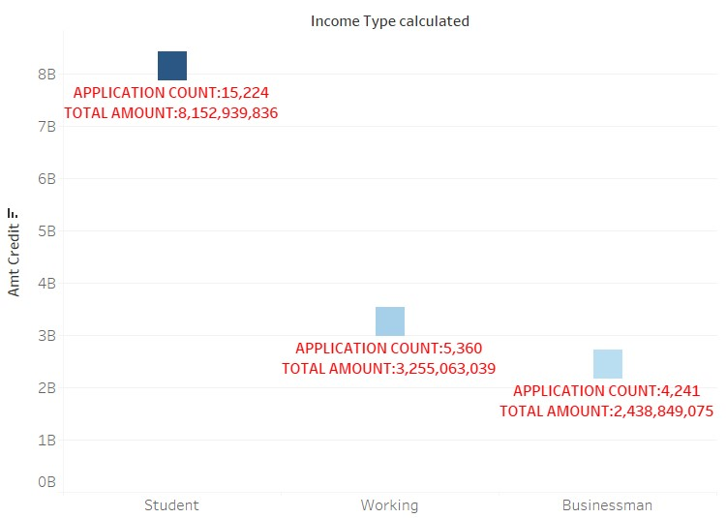

Based on the analysis we observe that

* Around 15K application were from the applicants who are recently graduated/no or min. experience/students and the credit amount is nearly 8.1Billion. The applicants belongs to this category requires the loan mostly.
* Around 5k applications were from the working professionals and they hold the second position with the credit amount of 3.2 Billion.
* Around 4k applications were from the businessman/ and they hold the third position with the credit amount of 2.4 Billion.

1. **Analysis based on marital status:**

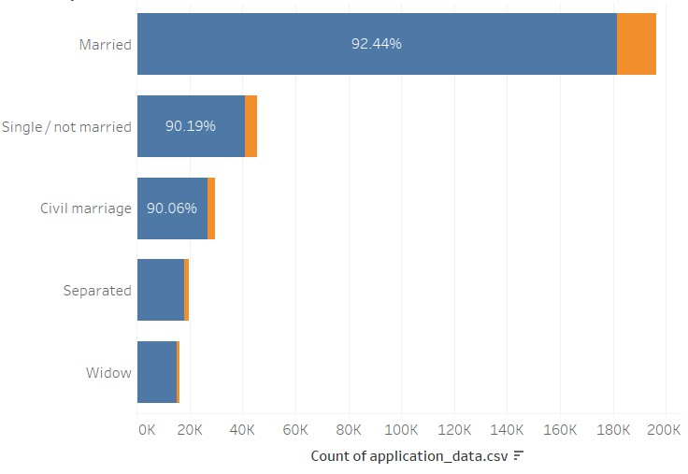

Based on the above chart, we also observe that the applicant whose marital status is widowed holds 1st position with 94 % on repaying their loans with less default rate and it followed by Married applicants 92 % , Separated – 91 % and unmarried/civil marriage with 90 %.

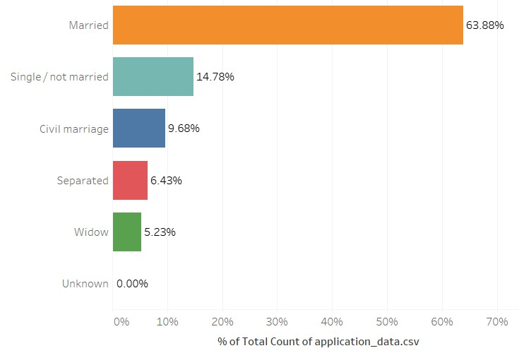

From the data 63 % of the applicants were married, 14 % of the applicants single and remaining 23 % falls under civil marriage/ Separated/ Widow.

1. **Analysis based income, credit amount, annuity:**

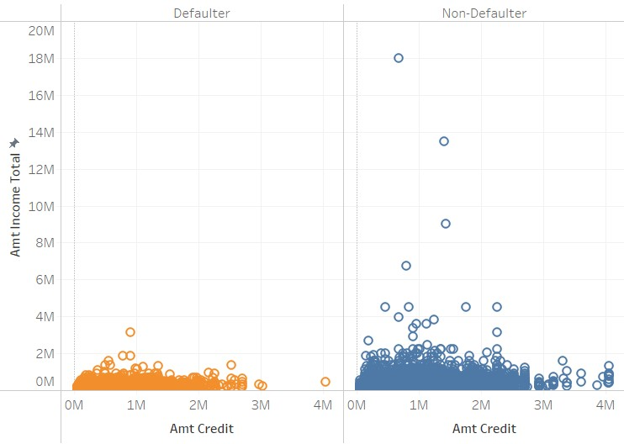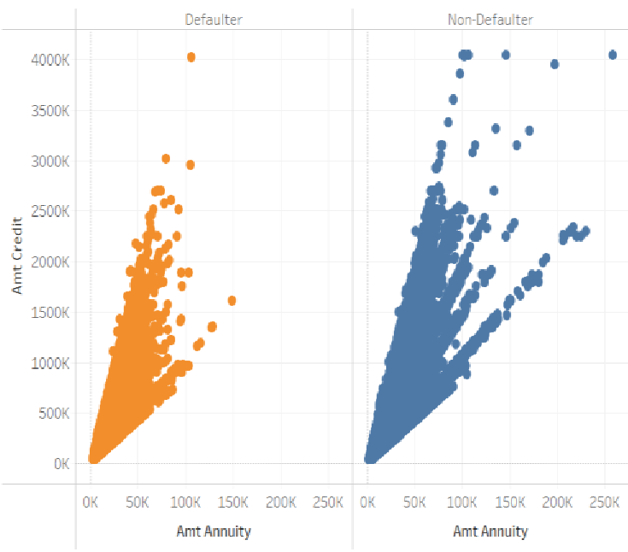

Based on the analysis we observe that

* Around 15K application were from the applicants who are recently graduated/no or min. experience/students and the credit amount is nearly 8.1Billion. The applicants belongs to this category requires the loan mostly.
* Around 5k applications were from the working professionals and they hold the second position with the credit amount of 3.2 Billion.
* Around 4k applications were from the businessman/ and they hold the third position with the credit amount of 2.4 Billion.

1. **Analysis based on Contract Status**

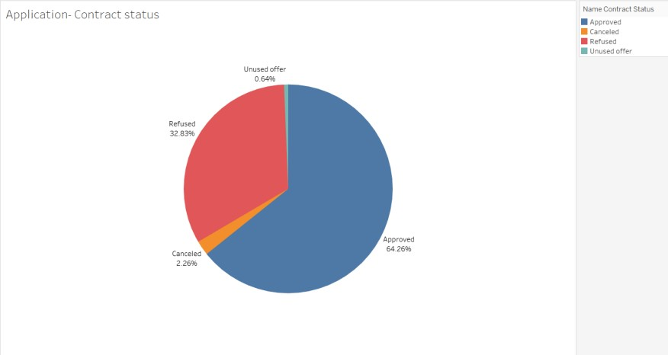

This is a pie chart showing the application contract status where largest slice is in blue representing 64.26% of applications that were approved. And then we see, the second largest slice is red in color indicating amount of rejected applications having 32.83percent and also there are not much considerable number of applications are under cancelled and unused sections with 2.26% and 0.64%. Overall, we can say, approved loan status is highest among all loan applications.

1. **Analysis based on Channel type and credit amount.**

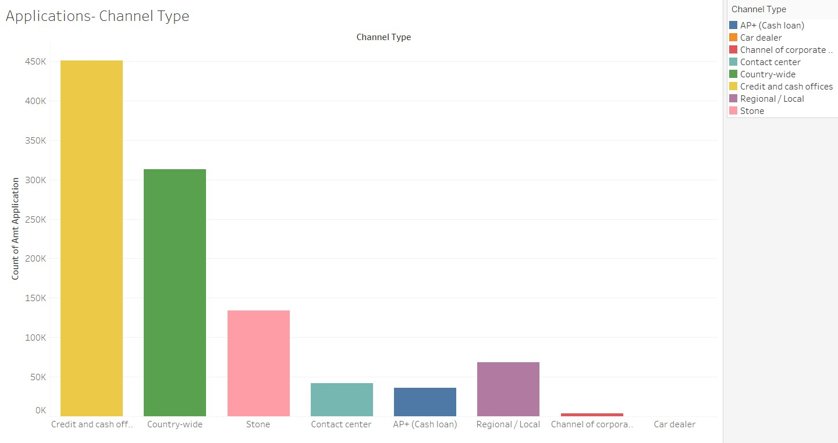

This is a bar chart showing the number of applications received through different channel types for loans. The channels with the highest application volumes are "Credit and cash offices" and "Country-wide," suggesting these are major distribution channels.

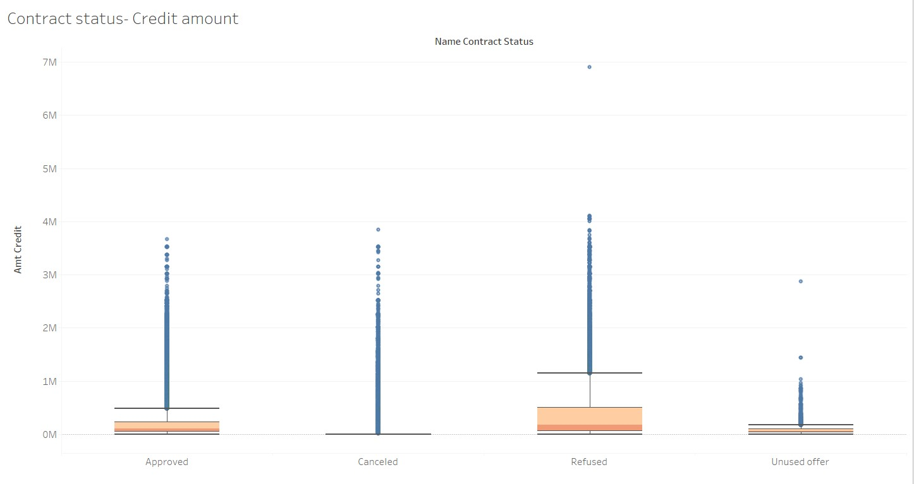

The distribution of the credit amount throughout the contract statuses of "approved,"

"canceled," "refused," and "unused offer" is shown in this box plot. For each status category,

the graph displays the median credit amount, the spread, and any outliers. This makes it possible to compare the average credit amounts and their variations according to the status of the contracts. We can see clients who are Refused apply for higher median credit amount.

1. **Analysis based on client type.**

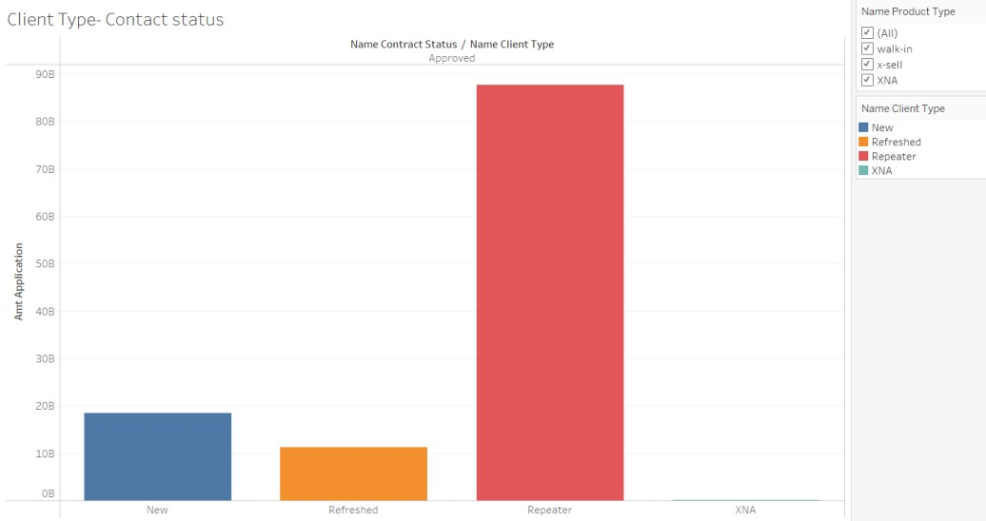

The relationship between client types and contract approval status is shown in this stacked bar chart. The "Approved" contract status is broken down in the chart by client category, which includes "New," "Refreshed," "Repeater," and "XNA." Each bar segment's height represents the total number of contracts that have been approved for that specific clientele. The conclusion that can be made from this analysis is that clients who are 'Repeaters' received the most approvals followed by 'New' than ‘Refused’.

**References:**

* 1. *Prodigy Finance Adds New Countries to its Student Loan Program. (2024, April 9).*  *Www.businesswire.com.* [https://www.businesswire.com/news/home/20240405385164/en/ProdigyFinanceAddsNewCo untries-to-its-Student-Loan-Program](https://www.businesswire.com/news/home/20240405385164/en/Prodigy-Finance-Adds-New-Countries-to-its-Student-Loan-Program)

* 1. *Prodigy Student Loans Review 2024 – Forbes Advisor*. (n.d.). [Www.forbes.com.](http://www.forbes.com/)

RetrievedApril

12, 2024, from <https://www.forbes.com/advisor/student-loans/prodigy-student-loan-review/>

* 1. *Prodigy Finance Private Student Loans: 2024 Review*. (n.d.). [Www.sparrowfi.com.](http://www.sparrowfi.com/)

Retrieved

April 13, 2024, from <https://www.sparrowfi.com/blog/prodigy-finance-review>

* 1. *Disrupting student loans: Meet Prodigy Finance*. (n.d.). [Www.linkedin.com.](http://www.linkedin.com/) Retrieved April 13, 2024, from [https://www.linkedin.com/pulse/disrupting-studentloans-meetprodigy-finance-paige-robertson](https://www.linkedin.com/pulse/disrupting-student-loans-meet-prodigy-finance-paige-robertson)

* 1. monday.com, A. of us at. (2022, September 14). *How organizational efficiency can transform your business*. Monday.com Blog.

<https://monday.com/blog/project-management/organizational-efficiency/>

* 1. Kohtamäki, M. (2017). Real-time Strategy and Business Intelligence:

Digitizing Practices and Systems. In *Google Books*. Springer.

[https://www.google.com/books/edition/Real_time_Strategy_and_Business_I ntellig/BDwrDwAAQBAJ?hl=en&gbpv=1&dq=how+to+improve+business +intelligence+systems&printsec=frontcover](https://www.google.com/books/edition/Real_time_Strategy_and_Business_Intellig/BDwrDwAAQBAJ?hl=en&gbpv=1&dq=how+to+improve+business+intelligence+systems&printsec=frontcover)