Chapter 1 :

Summary :

- The paper emphasizes the critical importance of forecasting the Air Quality Index (AQI) to empower individuals in protecting their health, particularly in regions plagued by heightened pollution levels.

- It systematically examines a range of computational models, spanning both machine learning and deep learning methodologies, to evaluate their efficacy in AQI prediction.

- Following rigorous analysis, the study discerns that the proposed hybrid Long Short-Term Memory (LSTM) and Gated Recurrent Unit (GRU) model outperforms its standalone counterparts.

- This hybrid model demonstrates commendable performance metrics, including a Mean Absolute Error (MAE) of 36.11 and an impressive R-squared (R^2) coefficient of 0.84.

- Notably, the hybrid model's capability in AQI prediction is underscored by its significantly reduced error rates.

- These findings underscore the potential of advanced computational techniques to enhance the accuracy and reliability of AQI forecasts.

- Consequently, proactive interventions can be facilitated to mitigate the health risks posed by ambient air pollution, based on more precise AQI predictions.

Research Addressed :

- The research addresses the urgent necessity for precise Air Quality Index (AQI) forecasts in densely polluted urban areas, highlighting its profound implications for managing public health.

- By developing and evaluating a hybrid deep learning model (LSTM-GRU), the study seeks to refine existing predictive methods, comparing the hybrid model's performance with other commonly used machine learning and deep learning models for AQI prediction.

- Emphasis is placed on key metrics like Mean Absolute Error (MAE) and R-squared (R2) values, underscoring the significance of accuracy in AQI predictions to inform individuals about potential health hazards linked to air pollution.

- Additionally, the research underscores the vital role of predictive models in facilitating proactive measures to mitigate the adverse health consequences of poor air quality.

- Through demonstrating the hybrid model's superior accuracy and performance metrics, the study not only advances the realm of air quality prediction but also furnishes practical insights for policymakers, environmental agencies, and healthcare professionals to effectively manage and alleviate the impacts of air pollution on public health.

Proposed Solution :

1. The proposed solution integrates LSTM and GRU, combining their respective strengths in capturing long-term dependencies and managing computational efficiency.

2. LSTM networks excel in retaining information over extended sequences, crucial for capturing long-term patterns in AQI data.

3. GRU networks offer computational efficiency compared to LSTM, while still effectively capturing short-term dependencies.

4. By combining LSTM and GRU, the hybrid model leverages their complementary strengths, enhancing both short-term fluctuations and long-term patterns in AQI data.

5. The model undergoes training using historical AQI data, optimizing its parameters to minimize prediction errors through iterative adjustments.

6. During evaluation, the hybrid model demonstrates superior performance compared to standalone LSTM or GRU models, as well as traditional ML methods such as linear regression, support vector machines (SVM), and k-nearest neighbors (KNN).

7. The hybrid model outperforms other ML and DL models commonly used in AQI prediction, including linear regression, SVM, KNN, LSTM, and GRU.

8. Providing accurate and timely forecasts, the hybrid model empowers decision-makers with valuable insights for air quality management and public health initiatives in Delhi.

Proposed Architecture:

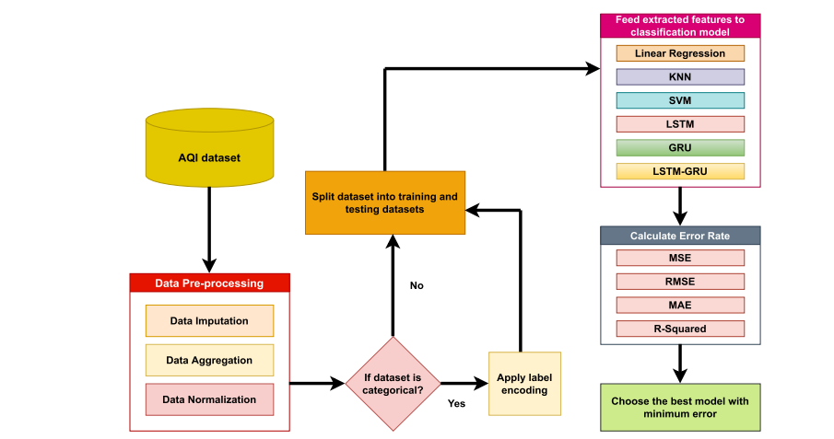

Classification models used :

- \*\*Linear Regression (LR)\*\*:

- Utilized for its simplicity and interpretability in modeling linear relationships between input features and AQI values.

- Predicts AQI levels based on a weighted sum of input variables, assuming a linear relationship between predictors and AQI.

- \*\*Support Vector Machines (SVM)\*\*:

- Employed to find the optimal hyperplane that separates different AQI classes.

- Classifies AQI levels based on their proximity to the decision boundary defined by the hyperplane.

- \*\*k-Nearest Neighbors (KNN)\*\*:

- Predicts the AQI of a given location based on the majority class of its k nearest neighbors.

- Utilizes the proximity of data points in the feature space to determine AQI levels.

- \*\*Long Short-Term Memory (LSTM) Network\*\*:

- A type of recurrent neural network (RNN) known for its ability to capture long-term dependencies in sequential data.

- Effective in learning and remembering patterns over extended periods, making it suitable for modeling the complex dynamics of air quality changes.

- \*\*Gated Recurrent Unit (GRU) Network\*\*:

- Another type of recurrent neural network designed to address the vanishing gradient problem and improve training efficiency.

- Simplifies the architecture by merging the memory and input gates, leading to faster training and inference times compared to LSTM.

- \*\*Hybrid LSTM-GRU Model\*\*:

- Integrates the strengths of both LSTM and GRU architectures for enhanced AQI forecasting.

- Combines LSTM's proficiency in capturing long-term dependencies with GRU's computational efficiency and effective management of short-term information.

- Offers a robust solution capable of discerning both short-term fluctuations and long-term patterns in AQI data.

- Outperforms standalone models and traditional machine learning algorithms, providing accurate forecasts for air quality management and public health initiatives in Delhi.