# ****Phase 1: Problem Understanding & Industry Analysis****

## ****Problem Statement: Internal Helpdesk CRM****

**Prepared by:** **MACHAPATHRI VAMSHI**

### ****Requirement Gathering****

**Core Functionality:**  
Employees should be able to raise IT support tickets for issues such as password resets, software installation, or hardware problems. Tickets should automatically get assigned to the right IT support staff based on category, and the status should be tracked until resolution.

**Reporting & KPIs:**  
The system should measure average resolution time, ticket volume per category per month, and percentage of tickets resolved within SLA timelines.

**Automation:**  
Notifications should be sent to employees when tickets are created, updated, or resolved. Escalations should occur automatically if SLA timelines are breached.

### ****Stakeholder Analysis****

* **Employees:** Need a simple way to raise tickets and get updates quickly.
* **IT Support Team:** Need an organized queue of tickets to work on and update status easily.
* **IT Manager:** Needs dashboards and reports to monitor SLA performance and team workload.
* **Management:** Wants visibility into major recurring issues to take preventive actions.

### ****Business Process Mapping****

**Step 1:** Employee logs in and submits a ticket.  
**Step 2:** System auto-assigns ticket to appropriate support staff based on category.  
**Step 3:** Support staff works on the issue and updates ticket status.  
**Step 4:** Ticket is marked closed once resolved, and notification is sent to employee.  
**Step 5:** Resolution time and ticket data are captured for reports.

**Simple Process Flow Diagram (describe or draw):**

[Submit Ticket] → [Auto Assign] → [Work on Ticket] → [Close Ticket] → [Report Metrics]

### ****Industry-Specific Use Case Analysis****

An internal helpdesk CRM is critical for any corporate environment to ensure smooth IT operations. It helps reduce downtime, ensures SLA compliance, and improves employee satisfaction. For cybersecurity, it tracks security-related tickets like MFA issues or phishing reports, enabling faster incident response.

### ****AppExchange Exploration****

Explore ITSM and helpdesk apps on AppExchange such as **Service Cloud**, **Spoke Desk**, or **Milestones PM** to understand best practices in case management, escalation rules, and SLA tracking. These apps can provide inspiration for dashboards, reports, and automation flows.

# Internal Helpdesk CRM – Phase 2: Org Setup & Configuration

# 1. Project Goal

Prepare Salesforce org with users, roles, profiles, permission sets, sharing settings, and email templates in preparation for building the Helpdesk Ticket object.

### Step 1: Log in to Salesforce Org

* Go to [https://login.salesforce.com](https://login.salesforce.com" \t "_new)
* Enter username and password
* Click **Log In**

## Step 2: Set Company Information

1. Setup → Quick Find → **Company Information** → Click
2. Verify/update:

* Company Name
* Primary Contact
* Default Locale: English (India)
* Default Time Zone: Asia/Kolkata

1. Click **Edit** → update → **Save**

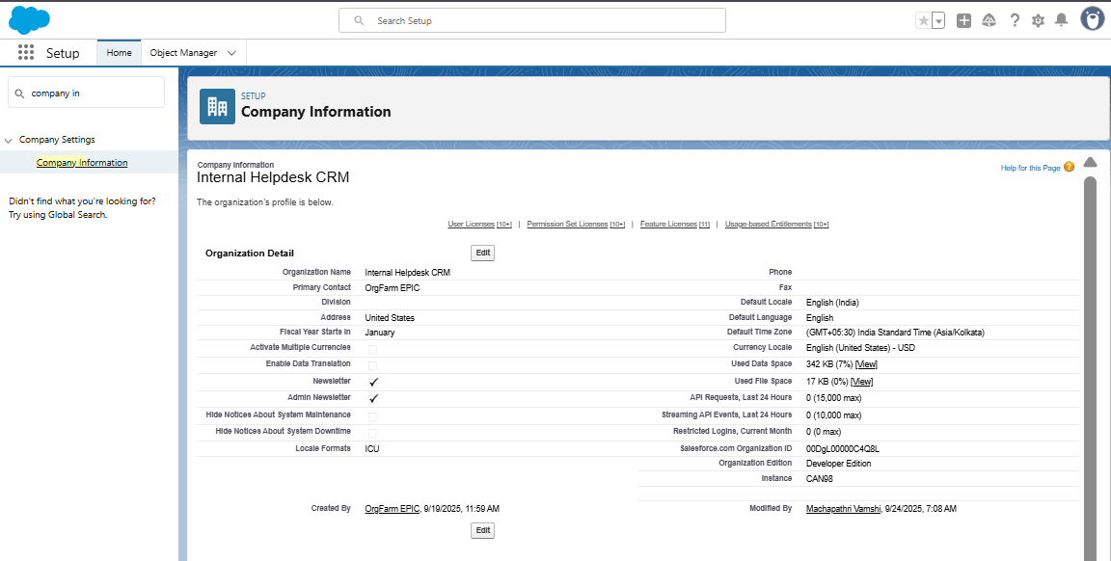

## Step 3: Define Business Hours

1. Setup → Quick Find → **Business Hours** → Click
2. Click **New Business Hours**:

Name: IT Support Hours

Default: yes

Time Zone: Asia/Kolkata

Open: 09:00 → Close: 06:00 (Mon-Fri)

1. Click Save

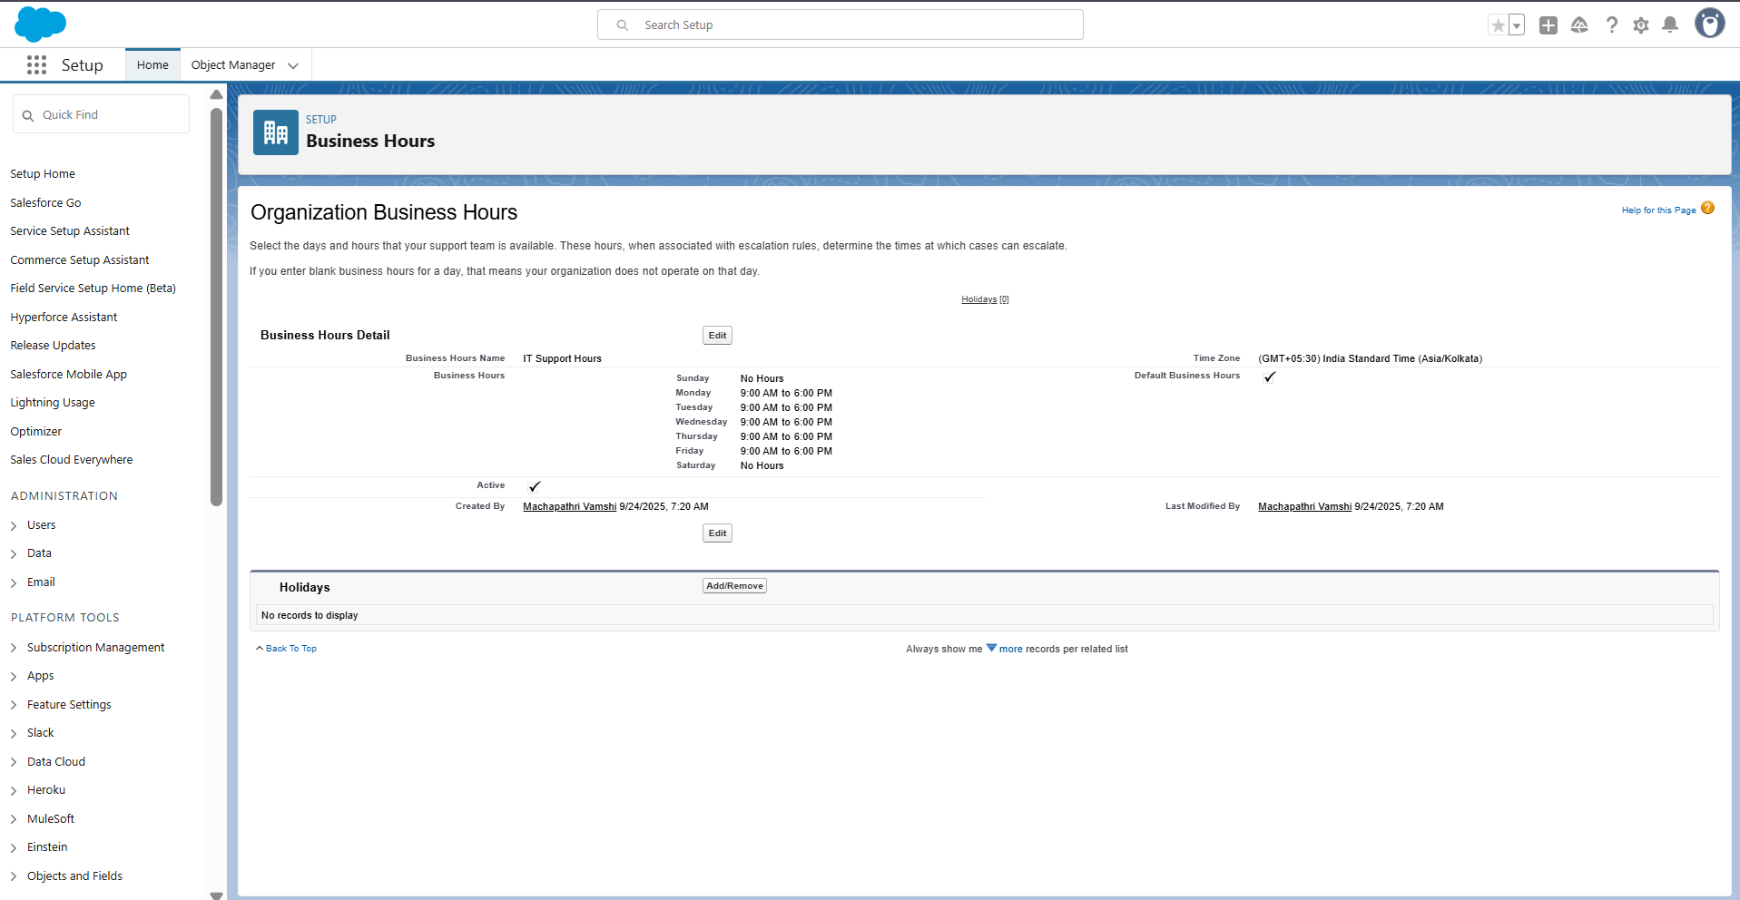

## Step 4: Add Holidays

1. Setup → Quick Find → **Holidays** → Click
2. Click **New Holiday**:

* Holiday Name: Republic Day
* Date: 26-Jan

1. Click Save
2. Click **Add Business Hours** → add IT Support Hours

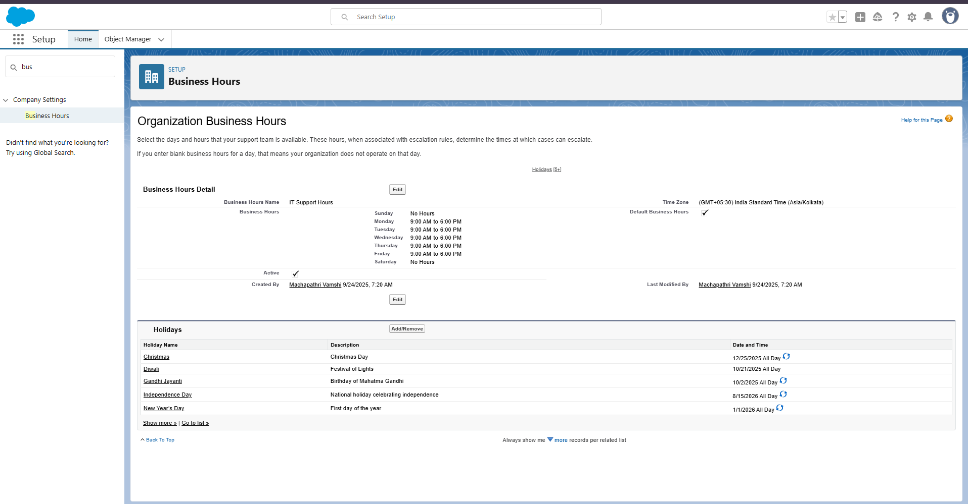

## Step 5: Create Role Hierarchy

1. Setup → Quick Find → Roles → Click Set Up Roles
2. Click Expand All
3. Add roles:

* CEO
* IT Manager
* IT Support
* Employee

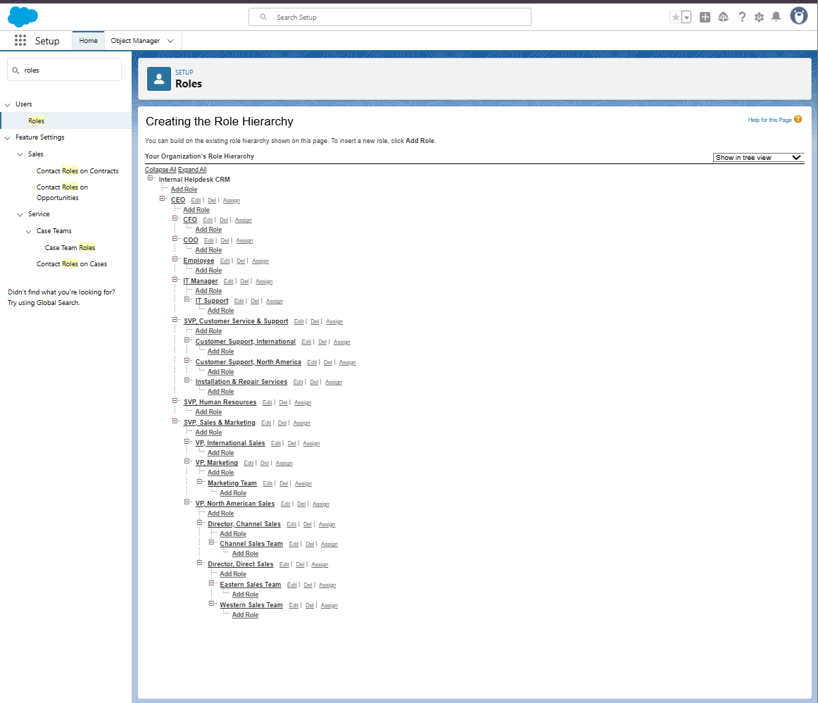

## Step 6: Create Users

1. Setup → Quick Find → Users → Click New User
2. Employee User:

* First Name: Employee | Last Name: Test
* Alias: EMP
* Email: working email
* Username: unique (employee.test@internalhelpdesk.com)
* Profile: Standard User
* Role: Employee → Save

1. IT Support User:

* Profile: System Administrator
* Role: IT Support → Save

1. (Optional) IT Manager user with role IT Manager

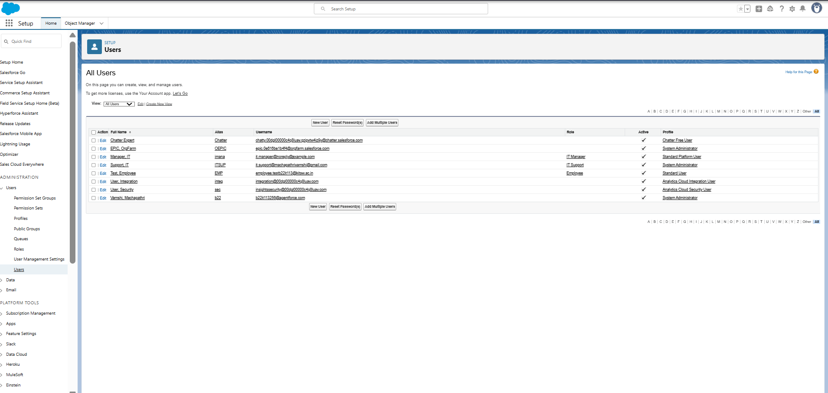

## Step 7: Create Permission Set

1. Setup → Quick Find → Permission Sets → Click New
2. Label: Helpdesk Access
3. API Name: auto-fills
4. Click Save
5. Assign object permissions after Phase 3

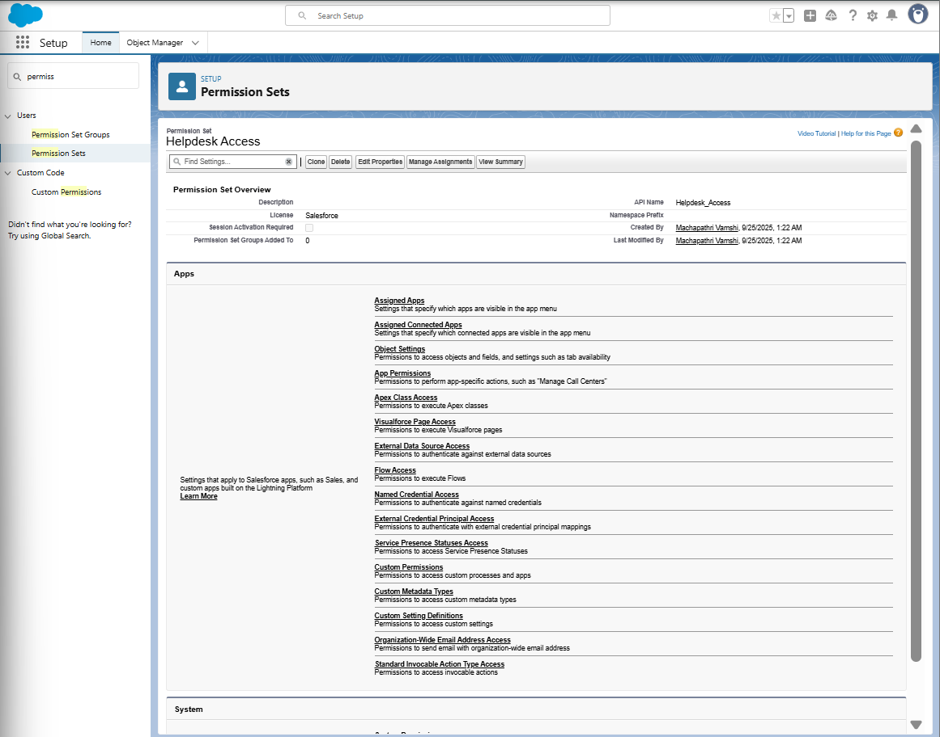

## Step 8: Prepare Org-Wide Defaults (OWD)

1. Setup → Quick Find → Sharing Settings → Click
2. Click Edit
3. Note: Helpdesk Ticket object will be Private after Phase 3
4. Click Save

## Step 9: Create Public Group

1. Setup → Quick Find → Public Groups → Click New
2. Label: IT Support Group
3. Add IT Support User → Save

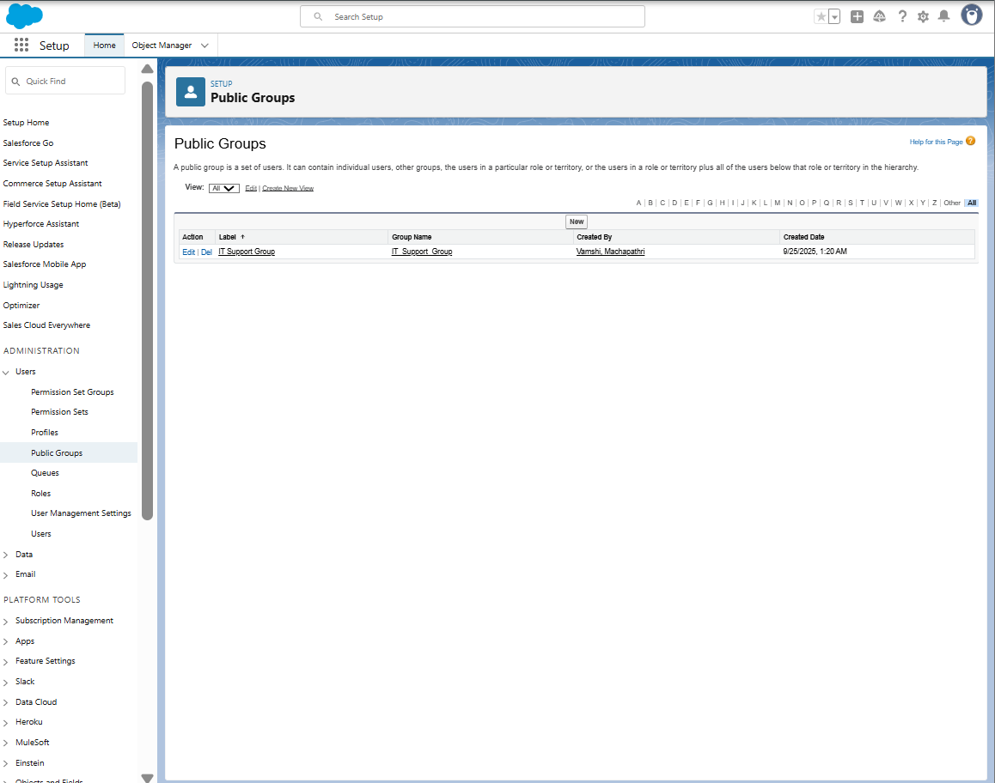

## Step 10: Enable Admin Login Access

1. Setup → Quick Find → Login Access Policies → Click
2. Check Administrators Can Log in as Any User → Save

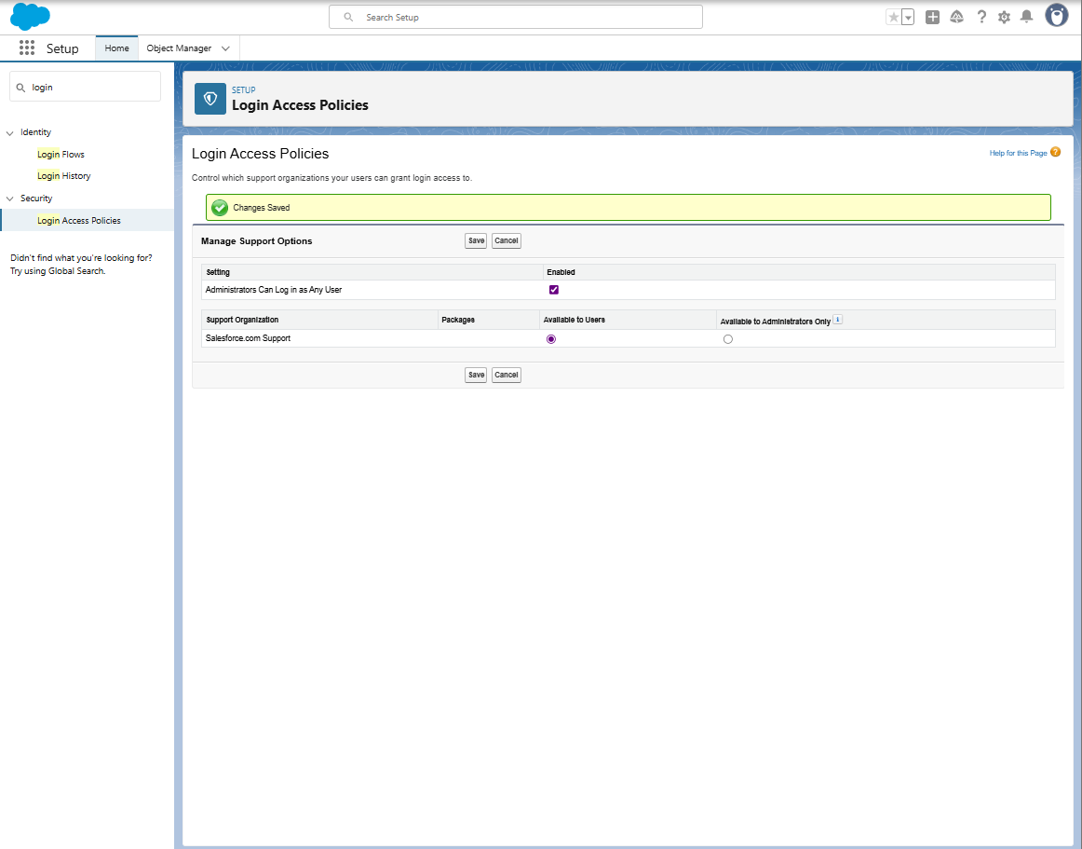

## Step 11: Create Email Templates

1. Setup → Quick Find → Email Templates → Click
2. New Email Template (Classic):

* Folder: Unfiled Public Email Templates
* Available For Use: ✔️
* Template Name: Ticket Submitted
* Subject: Your Helpdesk Ticket {!Helpdesk\_Ticket\_\_c.Name} has been submitted
* Text/HTML Body Example:

Hello {!Helpdesk\_Ticket\_\_c.Requester\_\_c},

Your ticket "{!Helpdesk\_Ticket\_\_c.Description\_\_c}" has been created successfully.

Ticket Number: {!Helpdesk\_Ticket\_\_c.Name}

Status: {!Helpdesk\_Ticket\_\_c.Status\_\_c}

Our IT Support team will review and get back to you soon.

Thanks,

IT Helpdesk Team

1. Save ✅
2. Repeat for Ticket Updated and Ticket Resolved
3. 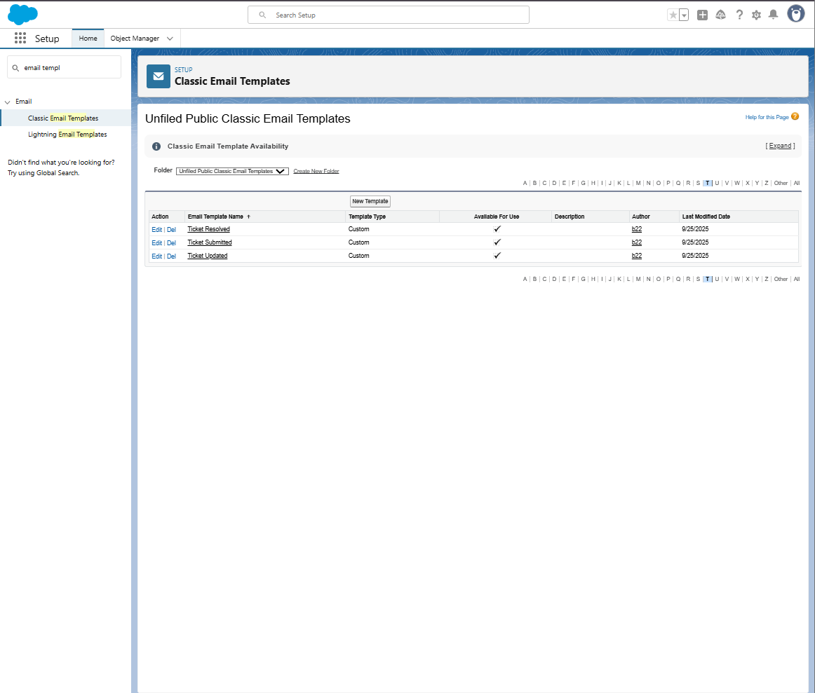

## 3. Final Confirmation Checklist

* Log in to Salesforce Org
* Set Company Information
* Define Business Hours
* Add Holidays
* Create Role Hierarchy
* Create Users
* Create Permission Set
* Prepare Org-Wide Defaults
* Create Public Group
* Enable Admin Login Access
* Create Email Templates (Ticket Submitted, Updated, Resolved)
* Assign object permissions after Phase 3