FLIPKART

Flipkart is an Indian e-commerce company founded in 2007 by Sachin Bansal and Binny Bansal . It started as an online bookstore and later expanded into various categories such as electronics, fashion, and more. Flipkart operates a marketplace model, where it connects sellers with consumers through its platform



STAGES OF CUSTOMER JOURNEY WHILE USING THE APPLICATION

1. **Discovery and Browsing:**
   * *The customer opens the Flipkart app, which usually displays personalized recommendations, deals of the day, or popular categories based on previous interactions.*
2. **Product Search:**
   * ***Search:*** *Customers use the search bar to find specific products or browse through category listings.*
   * ***Filters and Sorting:*** *They apply filters (price range, brand, ratings, etc.) and sorting options (price low to high, relevance, etc.) to refine their search results.*
3. **Checkout Process:**
   * *Customers review items in their cart and proceed to checkout.*
   * ***Payment Options:*** *They choose a payment method (credit/debit card, net banking, UPI, COD, etc.) and enter relevant details.*
4. **Order Confirmation:**
   * *After completing the checkout process, customers receive an order confirmation with details such as estimated delivery date, order number, and summary*

*.*

1. **Post-Purchase Experience:**
   * ***Order Tracking:*** *Customers can track their order status within the app, including shipment updates and delivery notifications.*
   * ***Customer Support:*** *They can contact Flipkart's customer support through the app for any queries or issues related to their order.*

Difficulties of customer while using the application

1.**Technical Issues:**

* ***App Crashes:*** *Occasionally, the app may crash or freeze, disrupting the browsing or checkout process.*
* ***Slow Loading:*** *Slow loading times for product pages or search results can frustrate users, especially during peak traffic periods.*

2.**User Interface (UI) Challenges:**

* ***Complex Navigation:*** *Users might find it challenging to navigate through various sections or find specific categories/products due to complex menu structures or lack of intuitive design.*
* ***Cluttered Layout:*** *A cluttered interface can overwhelm users, making it difficult to focus on essential information or find relevant options.*

3. **Payment and Checkout Issues:**

* ***Payment Failures:*** *Instances of payment failures or issues with payment gateways can disrupt the checkout process.*
* ***Limited Payment Options:*** *Users may face limitations in payment options available, which might not cater to their preferences or convenience.*

**4. Product Availability and Pricing:**

* ***Out of Stock Items:*** *Products shown as available may turn out to be out of stock after adding to the cart, causing disappointment.*
* ***Price Fluctuations:*** *Prices may fluctuate unexpectedly, affecting user expectations and decisions.*

**5. Customer Service and Support:**

* ***Delayed Responses:*** *Users may experience delays in customer service responses for queries or issues related to orders, refunds, or returns.*
* ***Resolution of Complaints:*** *Resolving disputes or complaints related to orders, refunds, or damaged products may sometimes require multiple follow-ups.*

**6.Security and Privacy Concerns:**

* ***Data Security:*** *Concerns about data security and privacy, especially related to payment information or personal details stored in the app.*
* ***Fraudulent Sellers:*** *Instances of fraudulent sellers or counterfeit products can impact trust and reliability.*

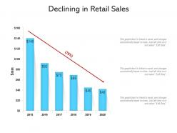

Flipkart have reported losses in recent years. For Instance, despite being one of the early pioneers in the Indian e-commerce space, Flipkart has consistently reported losses since its inception. In the fiscal year 2021, Flipkart's losses widened to Rs 4,362 crore ($588.9 million), primarily due to its technical issues and its decreased in customers reviews and satisfaction The loss is continuously growing as even in FY23, the company reported loss and struggled to manage to break even irrespective of high turnover and Flipkart recorded a loss of Rs 4,890.6 crore ($621.1 million) in FY 2022-23.

Pain points of flipkart why its losing its customers ?

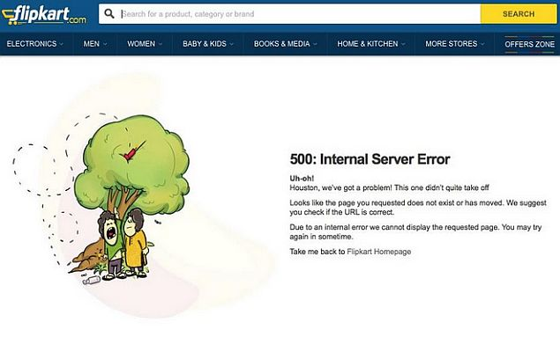

1. **Customer Service Issues:**

*Slow or ineffective customer support responses can frustrate users, especially when dealing with order problems or refunds.*

1. **Technical Glitches:**

*App crashes, slow loading times, or navigation difficulties can deter users from completing purchases.*

1. **Security Concerns:**

*Issues related to data security or privacy breaches may erode trust and prompt customers to seek more secure alternatives*

**HERE IS MY VIEW ON HOW TO IMPROVE APP USUABILITY AND FUNCTIONALITY**

To improve customer satisfaction while using the Flipkart online shopping application, consider implementing the following strategies:

1. **Enhance User Experience (UX):**
   * **I*ntuitive Interface:*** *Simplify navigation and ensure a user-friendly interface with clear categories, filters, and search functionalities.*
   * ***Fast Loading Times:*** *Optimize the app for speed to reduce loading times for product pages and search results.*
   * ***Smooth Checkout Process:*** *Streamline the checkout process with fewer steps and clear guidance, minimizing errors and drop-offs.*
2. **Improve Customer Support:**
   * ***Responsive Service:*** *Ensure prompt and helpful responses to customer queries and issues through multiple support channels (chat, phone, email).*
   * ***Empowerment Tools:*** *Provide self-service options such as order tracking, easy returns initiation, and FAQs to empower customers.*
3. **Secure and Transparent Transactions:**
   * ***Safe Payment Options:*** *Ensure a variety of secure payment methods and encryption protocols to protect customer data.*

***Transparent Policies:*** *Clearly communicate shipping costs, return policies, and warranty information to build trust and manage expectations*

1. **Personalization and Recommendations:**
   * ***Customized Experience:*** *Use data analytics to personalize product recommendations based on browsing history and purchase behavior.*
   * ***Tailored Offers:*** *Send personalized offers and notifications to engage customers effectively without overwhelming them.*
2. **Feedback and Continuous Improvement:**
   * ***Customer Feedback:*** *Encourage customers to leave reviews and ratings, and use this feedback to identify areas for improvement.*
   * ***Iterative Development:*** *Continuously update and enhance the app based on user feedback and technological advancements.*

**By focusing on these aspects, Flipkart can enhance overall customer satisfaction, loyalty, and retention, thereby strengthening its position in the competitive e-commerce market.**

Top of Form

Bottom of Form