  - Machine Learning Operations (AIMLCZG523)
Assignment 01

Heart Disease Risk Prediction: An End-to-End MLOps Pipeline
VAMSHI VARMA NAMPALLY- (BITS ID 2025AE05667)
20 October 2026
Code repository: https://github.com/Vamshi1210/heart-disease-mlops
Video walkthrough: https://drive.google.com/file/d/1CX58kkPcAZWP1O3Ga5LB4KXOGknN1Kq1/view?usp=sharing



1. Introduction
Heart disease screening is a setting where the two kinds of error do not cost the same. A sick patient who is told they are healthy may go untreated, while a false alarm usually leads only to a follow-up test. This project builds a classifier that predicts the risk of heart disease from 13 routine clinical measurements, and runs it the way a production service would be run: reproducible training, tracked experiments, automated testing, a containerised API, deployment on Kubernetes, and live monitoring.
Item | Result
Final model | Logistic Regression in a scikit-learn pipeline, decision threshold 0.2285
Cross-validation (training data) | F2 0.834, ROC-AUC 0.908, accuracy 0.859
Held-out test set (61 patients) | Recall 1.000, ROC-AUC 0.958, accuracy 0.787, precision 0.683
Testing | 24 pytest unit tests, all passing
CI/CD | GitHub Actions: lint → test → train (quality gate) → build and smoke-test container, about 4 minutes
Deployment | FastAPI in Docker, 2 replicas on Minikube behind a LoadBalancer
Monitoring | Prometheus scraping each pod every 5 s, Grafana dashboard

2. Architecture
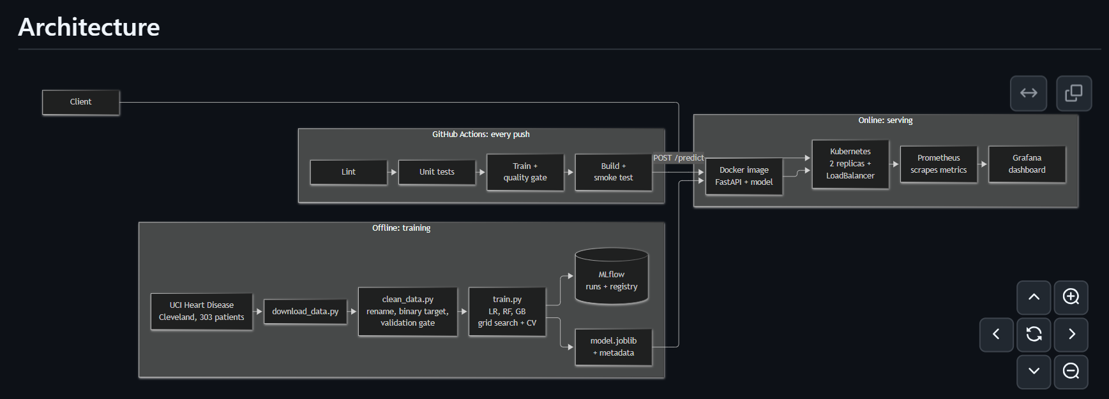
Figure 1: End-to-end architecture (rendered from the README)
The system has an offline half and an online half. Offline, raw data is downloaded, cleaned and validated, then three models are tuned and compared; every run is recorded in MLflow and the winning pipeline is saved with its metadata. Online, the saved pipeline is served by a FastAPI application, packaged as a Docker image, deployed on Kubernetes and watched by Prometheus and Grafana. GitHub Actions connects the two: every push re-runs linting, tests, training and a container smoke test, so nothing broken reaches the image.
Layer | Tool | Location in repository
Data | UCI download and validation | src/download_data.py, src/clean_data.py
Features and model | scikit-learn Pipeline | src/features.py, src/train.py
Experiment tracking | MLflow 3.17.1 (SQLite backend) | mlflow.db, mlruns/
Serving | FastAPI + Uvicorn | api/main.py
Container | Docker (python:3.14-slim, non-root user) | Dockerfile
Orchestration | Kubernetes on Minikube | k8s/
Monitoring | Prometheus + Grafana | monitoring/
CI/CD | GitHub Actions | .github/workflows/ci.yml
Tests | pytest | test/

3. Setup and Access Instructions
Development and deployment run in GitHub Codespaces (Ubuntu 24.04, Python 3.14), so the only local requirement is a browser. The README contains the complete step-by-step commands; the essentials are:
Train and test
git clone https://github.com/Vamshi1210/heart-disease-mlops.git
cd heart-disease-mlops
python -m venv .venv && source .venv/bin/activate
pip install -r requirements.txt
python src/download_data.py
python src/clean_data.py
python src/train.py
pytest -v
Run the API in Docker
docker build -t heart-disease-api:1.1 .
docker run -d -p 8000:8000 heart-disease-api:1.1
curl -X POST localhost:8000/predict -H "Content-Type: application/json" \
-d @api/sample_request.json
Deploy on Kubernetes and monitor
minikube start
minikube image load heart-disease-api:1.1
kubectl apply -f k8s/
minikube tunnel # separate terminal; gives the LoadBalancer an IP
kubectl get svc heart-api -n mlops # EXTERNAL-IP is the API address
kubectl apply -k monitoring/
kubectl port-forward svc/prometheus 9090:9090 -n mlops
kubectl port-forward svc/grafana 3000:3000 -n mlops
Access. Deployment is local (Minikube), so there is no public URL. The API is reached at the LoadBalancer IP shown by kubectl get svc while minikube tunnel runs, or through kubectl port-forward. Interactive API documentation is served at /docs.

4. Data Acquisition and Exploratory Data Analysis

4.1 Dataset choice
The project uses the UCI Heart Disease dataset (Cleveland subset): 303 patients, 13 clinical features and a diagnosis from 0 to 4. I deliberately avoided the widely shared 1,025-row heart.csv found on Kaggle. It mostly repeats the same ~300 patients, so identical rows land in both the training and the test set and inflate accuracy, which is a form of data leakage.

4.2 Download, cleaning and validation
- src/download_data.py fetches the data from the UCI repository and saves data/raw/heart_disease_raw.csv (303 rows × 14 columns).
- src/clean_data.py renames the cryptic UCI codes to readable names (for example cp → chest_pain_type, ca → num_major_vessels, thal → thalassemia), converts the diagnosis into a binary target (0 = no disease, 1–4 = disease) and drops the original column, and removes duplicate rows (none were found).
- A validation gate rejects physically impossible values, such as an age of 500, a cholesterol of 5 or an unknown category code. Bad data stops the pipeline before training instead of silently producing a bad model.
- Missing values (4 in num_major_vessels, 2 in thalassemia) are kept rather than dropped. They are imputed inside the model pipeline, so exactly the same rule applies at prediction time, and the API can still score a patient whose results for these tests are unknown.
- The cleaned file is saved as data/processed/heart_disease_clean.csv, and an MD5 fingerprint of it is recorded with every model as its data version.

4.3 Exploratory analysis
The analysis lives in notebooks/01_eda.ipynb. The classes are roughly balanced (164 without disease, 54%; 139 with disease, 46%), so no resampling was needed, although class weighting was still tried during tuning.
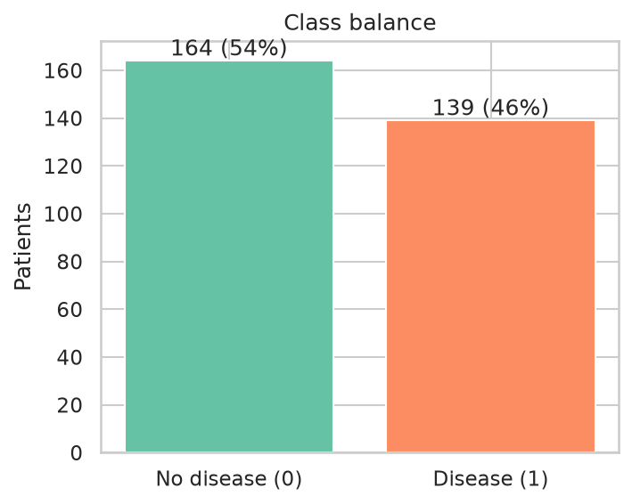
Figure 2: Class balance of the binary target
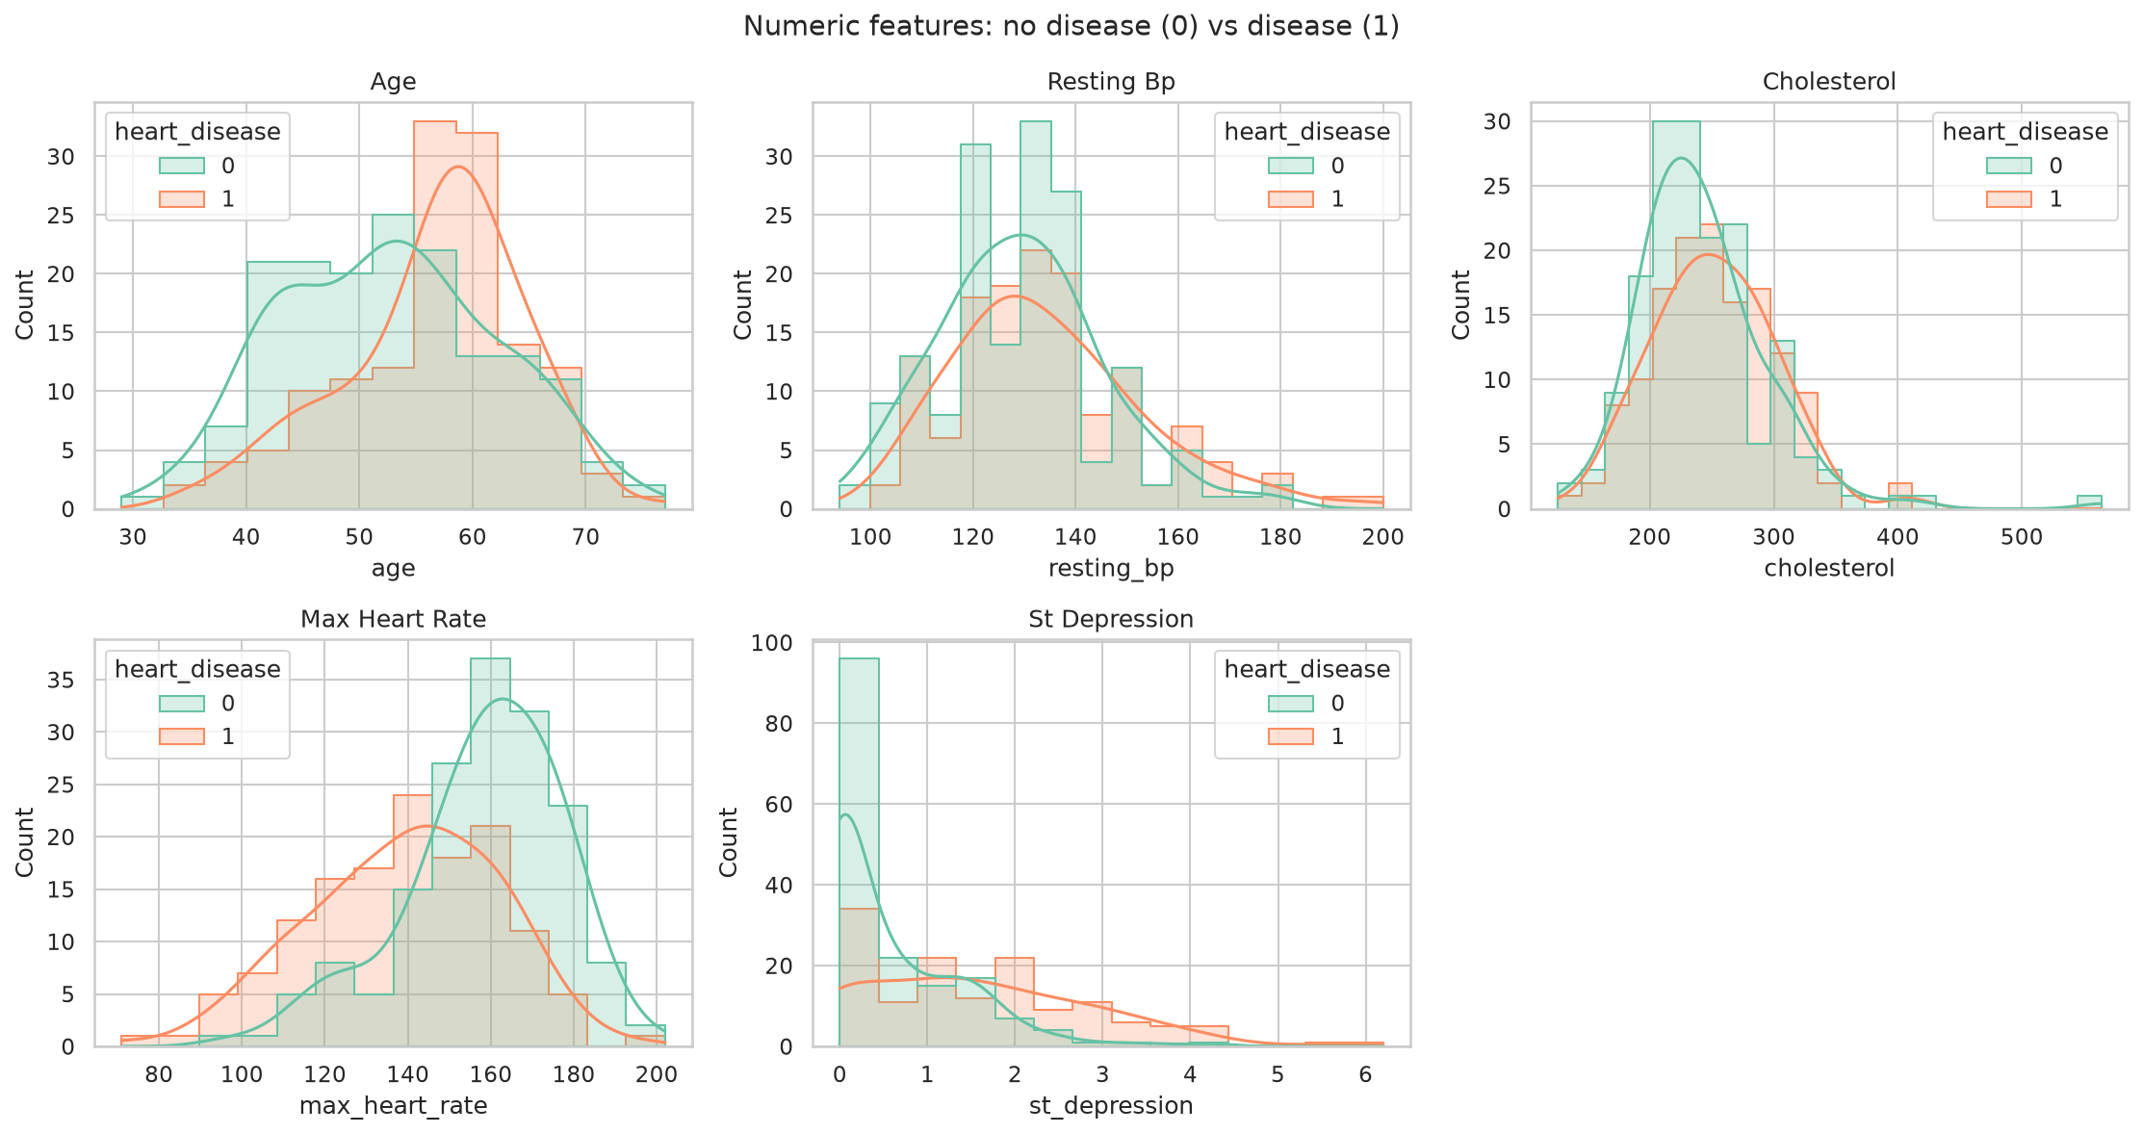
Figure 3: Distributions of the numeric features
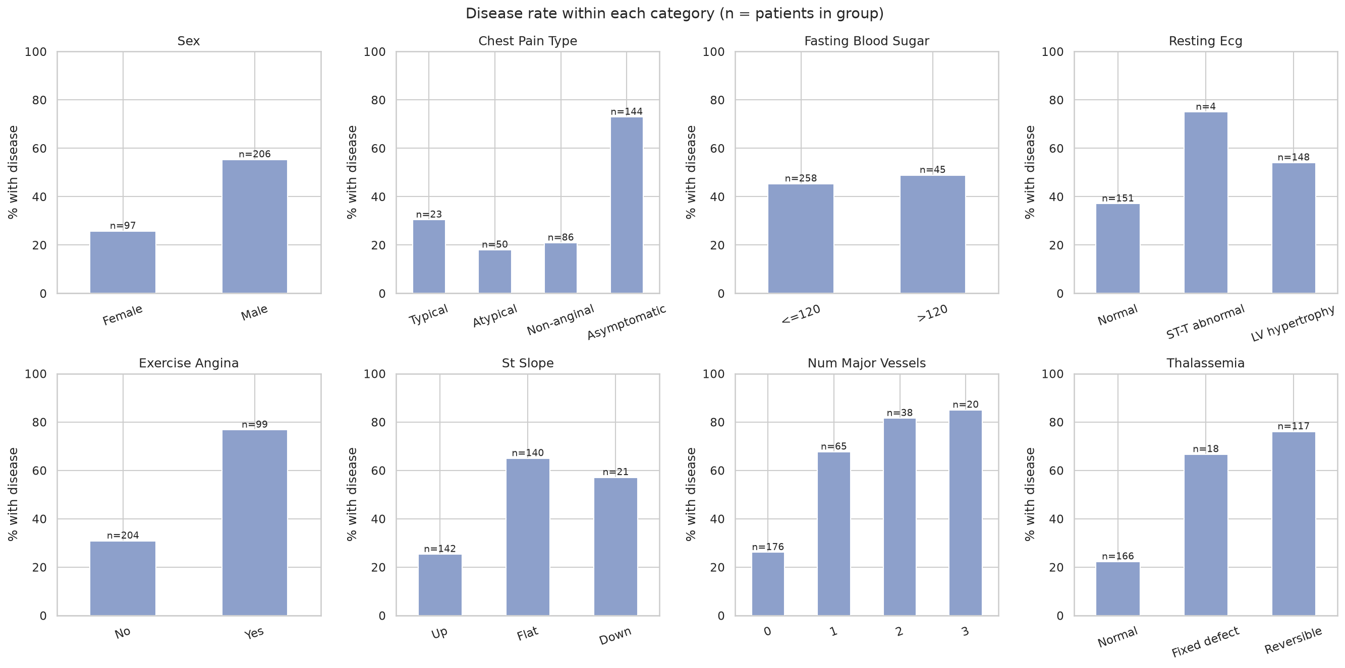
Figure 4: Disease rate by category for the categorical features
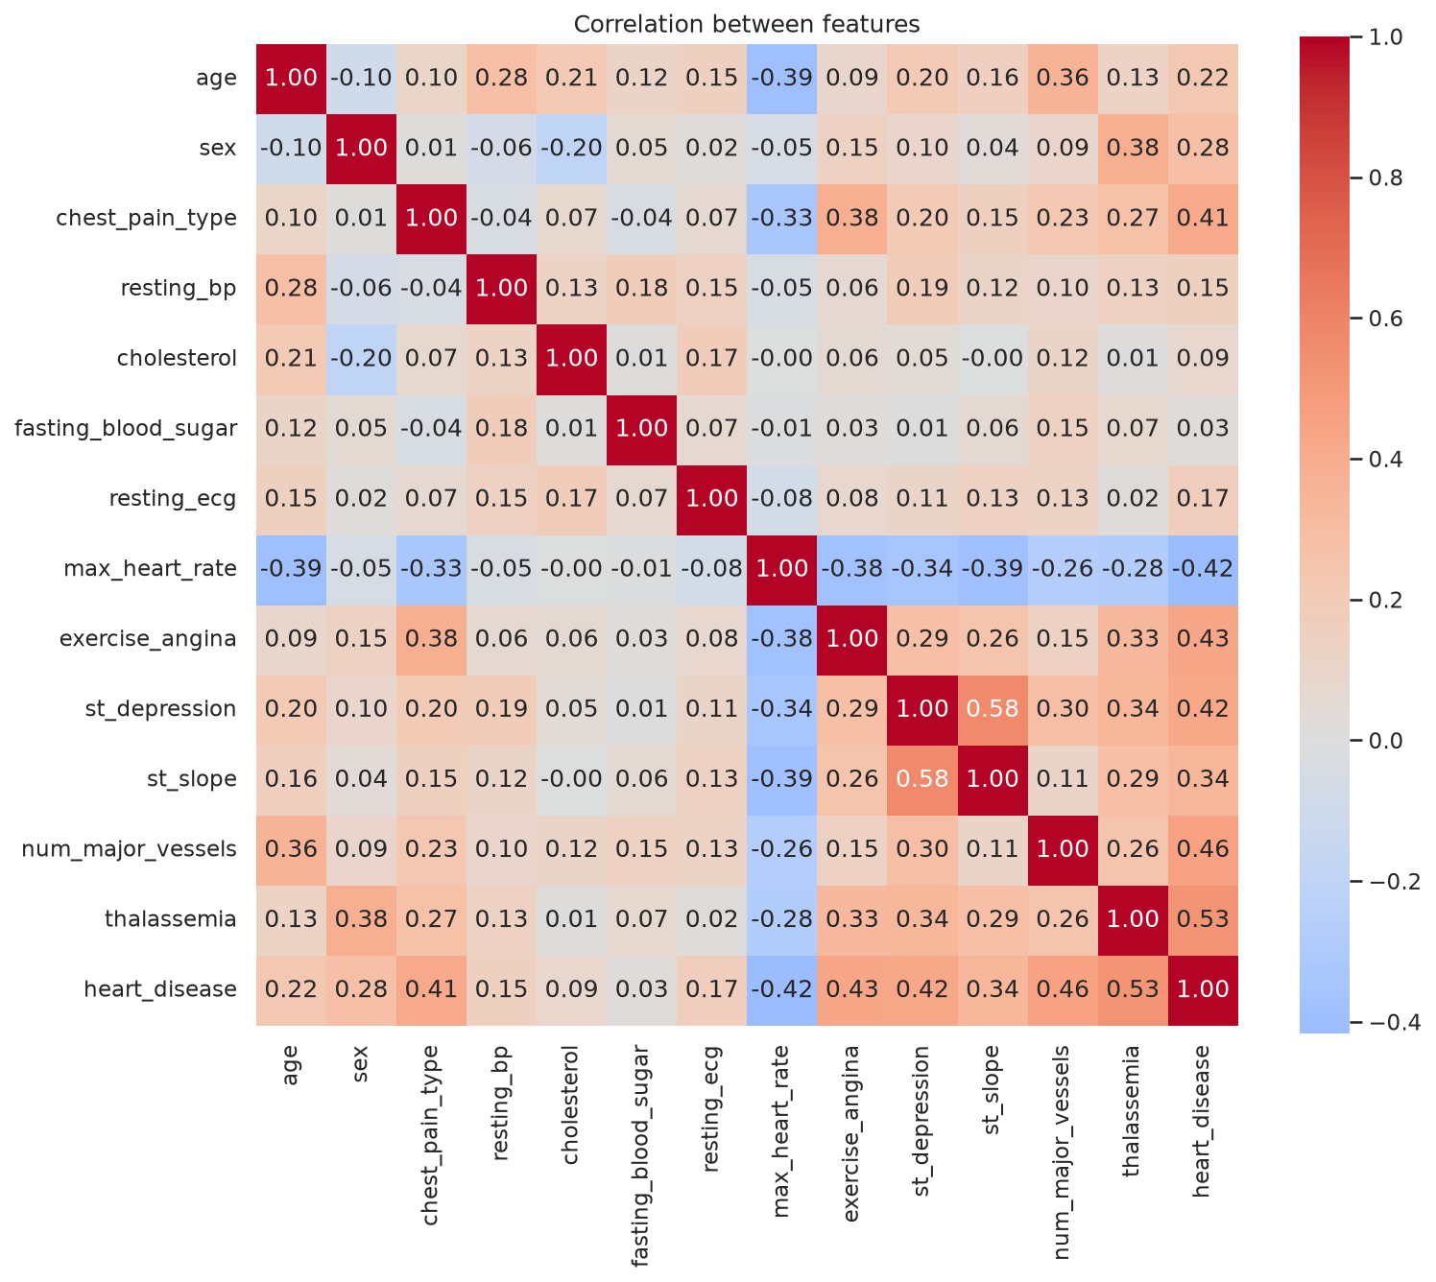
Figure 5: Correlation heatmap
Key findings. The features most strongly related to the target are thalassemia, number of major vessels and exercise-induced angina.
- Chest pain type gave the most surprising result. Patients with asymptomatic chest pain (type 4) had the highest disease rate, higher even than patients with typical angina. So “more pain means more risk” does not hold here. This is also why I one-hot encoded chest pain type instead of treating it as a number.
- How the heart reacts to exercise is one of the strongest signals. Patients with disease had a clearly lower maximum heart rate and higher ST depression, and exercise-induced angina was much more common among them. Cholesterol, which I expected to matter a lot, showed only a weak link to the target.

5. Feature Engineering and Model Development

5.1 Features and preprocessing
The 13 inputs are grouped into numeric, binary and nominal features (src/features.py). Preprocessing is part of the model pipeline itself: missing values are imputed, numeric features are scaled, and nominal codes such as chest pain type and thalassemia are one-hot encoded, because their values are labels rather than quantities. Codes never seen during training are ignored instead of crashing the service. Each of these behaviours is covered by a unit test.

5.2 Models, tuning and selection
Three models were trained on a stratified 80/20 split (242 training, 61 test patients): Logistic Regression, Random Forest and Gradient Boosting. Each was tuned with a grid search using stratified 5-fold cross-validation on the training data, and every hyperparameter combination was logged as a nested MLflow run.
The selection metric is F2, which weights recall twice as heavily as precision, because a missed diagnosis is costlier than a false alarm. Cross-validated results for the best configuration of each model:
Model | Accuracy | Precision | Recall | F2 (± std) | ROC-AUC
Logistic Regression | 0.859 | 0.870 | 0.828 | 0.834 ± 0.037 | 0.908
Random Forest | 0.826 | 0.833 | 0.783 | 0.790 ± 0.071 | 0.898
Gradient Boosting | 0.802 | 0.779 | 0.793 | 0.789 ± 0.049 | 0.853
Logistic Regression won on every metric and was also the most stable across folds (lowest standard deviation). On a dataset of this size, a simple, interpretable model generalising better than tree ensembles is a reasonable outcome. Its best parameters were C = 1 and class_weight = balanced.

5.3 Decision threshold
A classifier normally predicts “disease” when the probability exceeds 0.5. For screening that is too conservative, so the threshold was tuned to maximise F2, giving 0.2285. The threshold was tuned with 5-fold stratified cross-validation on the training set only (scikit-learn’s TunedThresholdClassifierCV); the test set was never used for tuning or model selection.

5.4 Test-set results
Metric | Test set (61 patients)
Recall | 1.000
ROC-AUC | 0.958
F2 | 0.915
Accuracy | 0.787
Precision | 0.683
The model caught all 28 patients with heart disease in the test set, at the cost of 13 false alarms among the 33 healthy patients. Test precision is lower than in cross-validation precisely because the threshold was lowered on purpose: this is the trade-off chosen for screening.
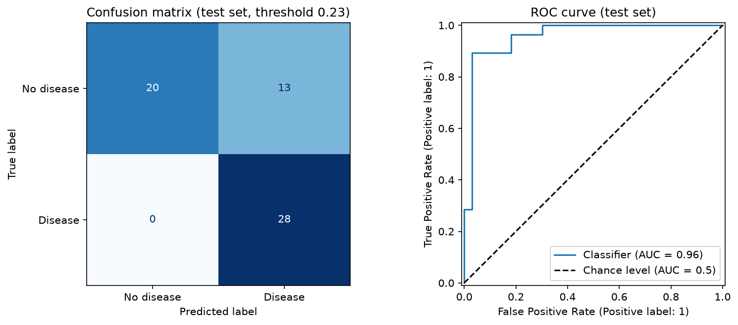
Figure 6: Final model on the test set (confusion matrix and ROC curve)

6. Experiment Tracking (MLflow)
MLflow 3.17.1 uses a SQLite backend (mlflow.db) with artifacts stored in mlruns/, all under the experiment heart-disease-classifier. Runs are organised as one parent run per model family, nested child runs for each hyperparameter combination, and a final run for the selected model; across all training sessions the experiment holds 28 runs. Parameters, metrics (cross-validation means and standard deviations, and test metrics) and artifacts (evaluation plots and the model itself) are logged.
The final model is registered in the Model Registry as “mlops model” version 1, and MLflow records its lineage: the script (train.py), the branch (main) and the exact git commit (acf680f). One failed Gradient Boosting run is still visible; it is the attempt made before the serialisation fix described in Section 12, kept as part of the history.
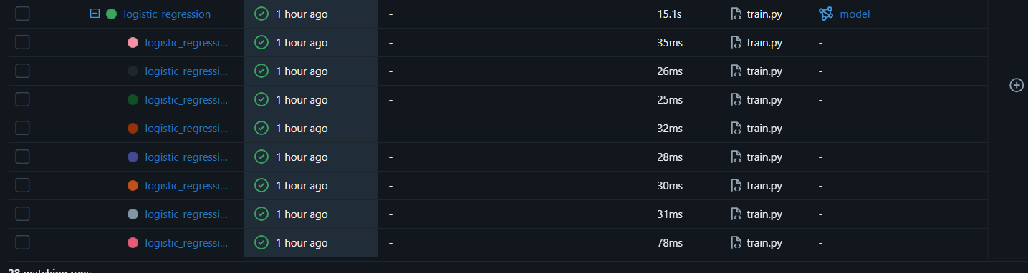
Figure 7: MLflow runs, with nested tuning runs under each model
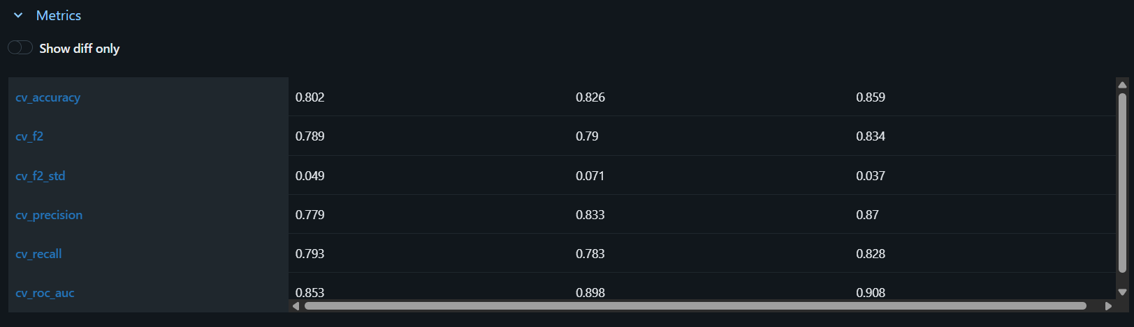
Figure 8: MLflow comparison of the three models
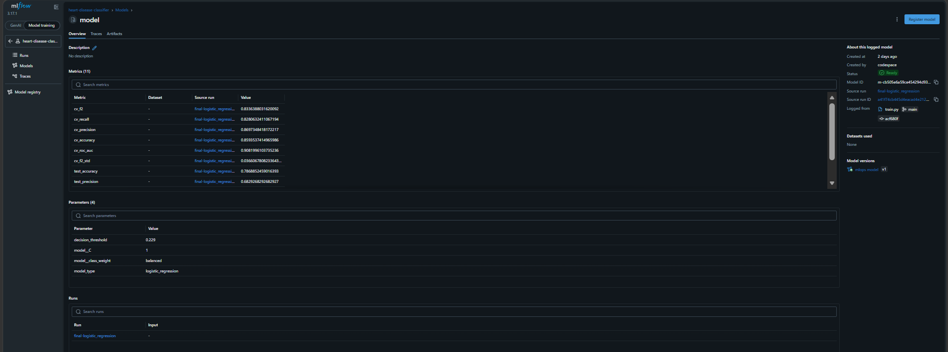
Figure 9: Final logged model with metrics, parameters and git lineage

7. Model Packaging and Reproducibility
- One pipeline, one file. Preprocessing, classifier and threshold are saved together as models/model.joblib, so serving can never drift from the preprocessing used in training.
- Metadata. models/model_metadata.json records the model version, model type, decision threshold, feature list, best parameters, cross-validation and test metrics, data version, MLflow run ID and scikit-learn version.
- MLflow model package. The logged model contains MLmodel, model.pkl, conda.yaml, python_env.yaml and requirements.txt, and loads either as a plain scikit-learn model or through MLflow’s generic python_function interface.
- Dependencies. requirements.txt covers training and development and pins exact versions (MLflow 3.17.1, scikit-learn 1.9.1, pandas 3.0.6, NumPy 2.5.4); api/requirements.txt holds only the slim serving dependencies used by the Docker image.
- Proof of reproducibility. CI retrains the model from a clean environment on every push and reproduces the same decision threshold (0.2285) and the same test metrics. Model version labels differ between runs only because they are training timestamps.
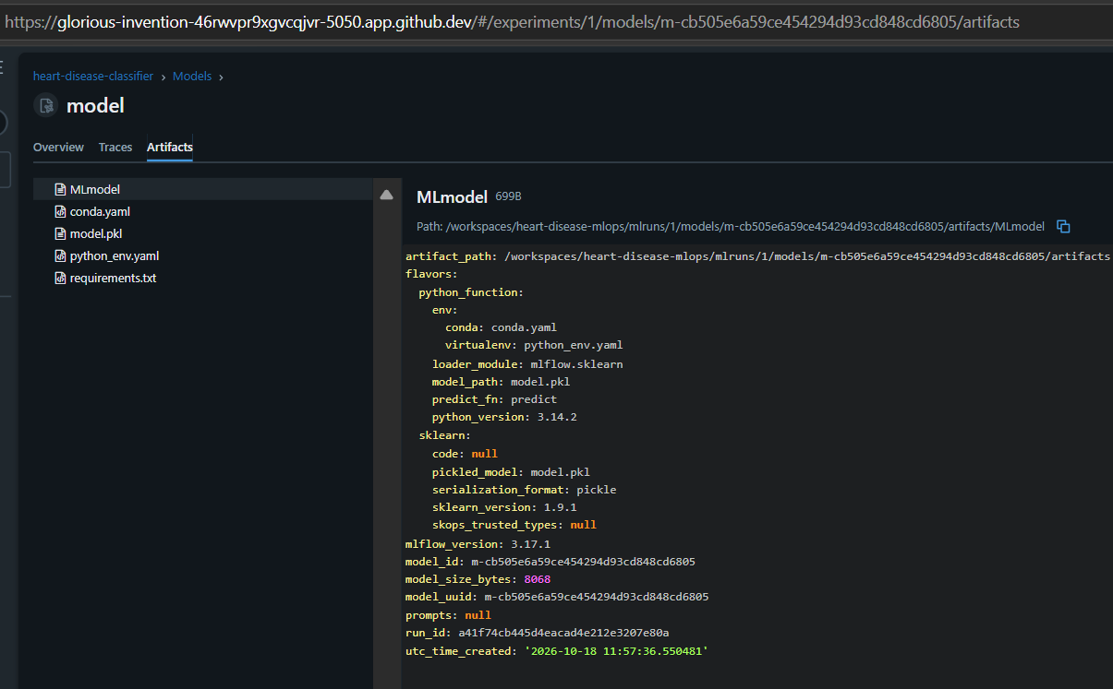
Figure 10: MLflow model artifacts and environment files

8. CI/CD Pipeline and Automated Testing

8.1 Unit tests
Test file | Tests | What is checked
test_clean_data.py | 8 | Column renaming, duplicate removal, binary target, validation accepts missing values and rejects impossible ones
test_model.py | 6 | Complete feature list without the target, imputation, one-hot encoding, unseen codes, metric calculation, a lower threshold raising recall
test_api.py | 10 | /health, prediction with confidence, missing optional fields, five kinds of invalid input, a missing required field, /metrics counters
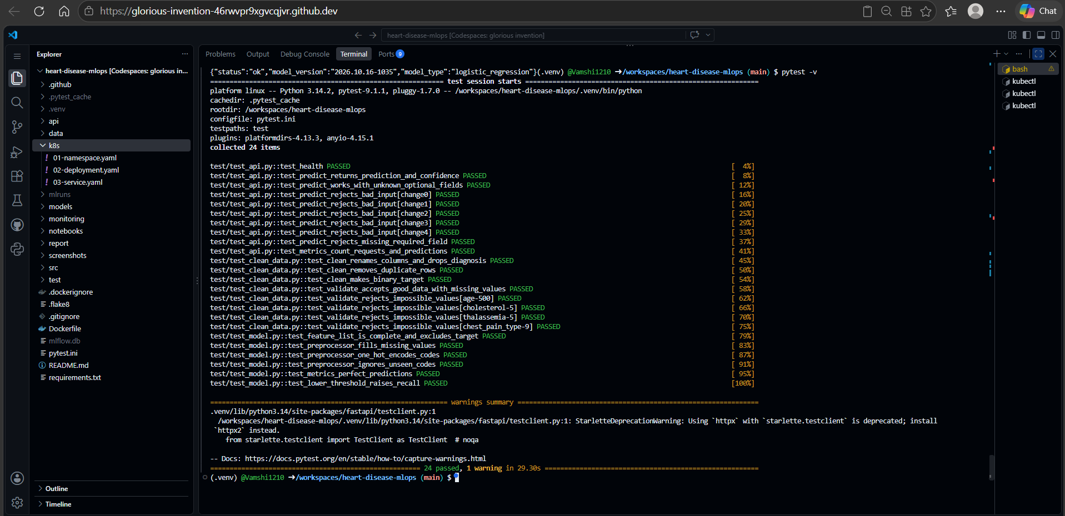
Figure 11: All 24 unit tests passing

8.2 Workflow
Every push runs .github/workflows/ci.yml on a pinned ubuntu-24.04 runner. Each job starts only if the previous one succeeded:
Job | What it does | Duration
1. Lint | flake8 code-style check | 8 s
2. Unit tests | pytest, JUnit report saved as an artifact | 1 m 9 s
3. Train | Data validation, training with MLflow, quality gate (fails if the model’s metrics drop below a set minimum), metrics table in the run summary | 1 m 49 s
4. Build and smoke-test | Builds the Docker image with the newly trained model and calls /health and /predict | 41 s
Each run publishes three artifacts: test-report, mlflow-run and trained-model.
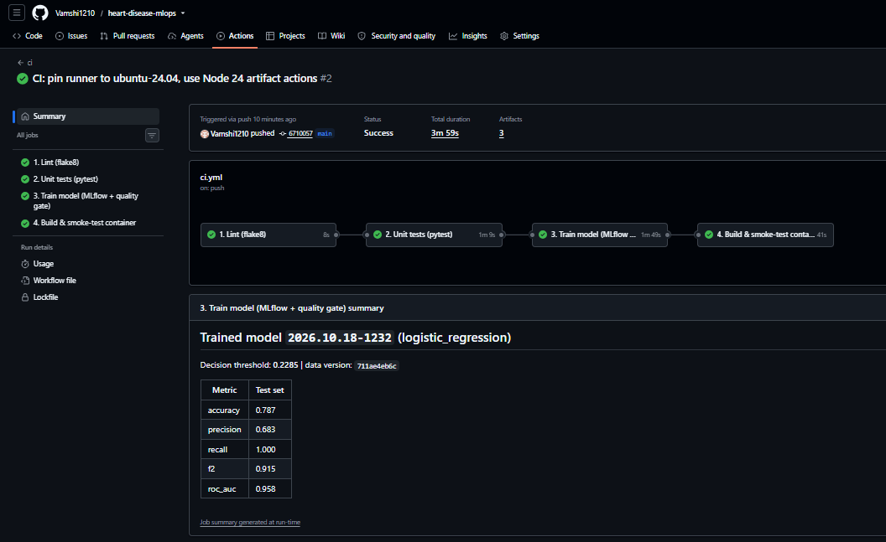
Figure 12: Green pipeline run with the model summary
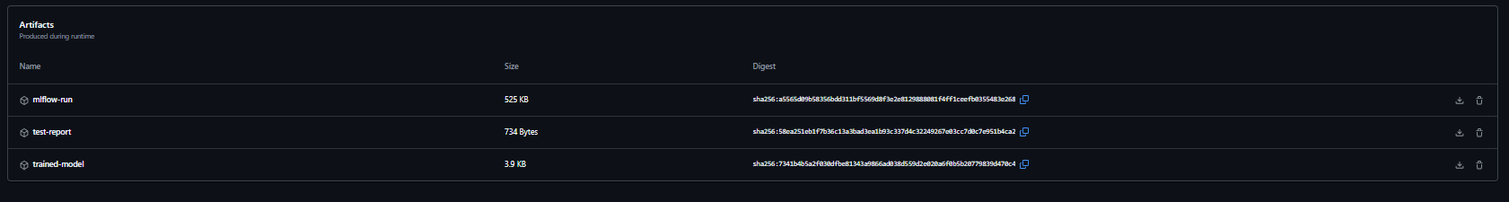
Figure 13: Artifacts published by the pipeline

8.3 Failure demonstration
To prove that the pipeline stops on bad code, a deliberate style error was pushed on a separate branch (ci-failure-demo). The lint job failed with a clear message naming the file, line and rule, and all later jobs were skipped, so the broken code never reached the container image.
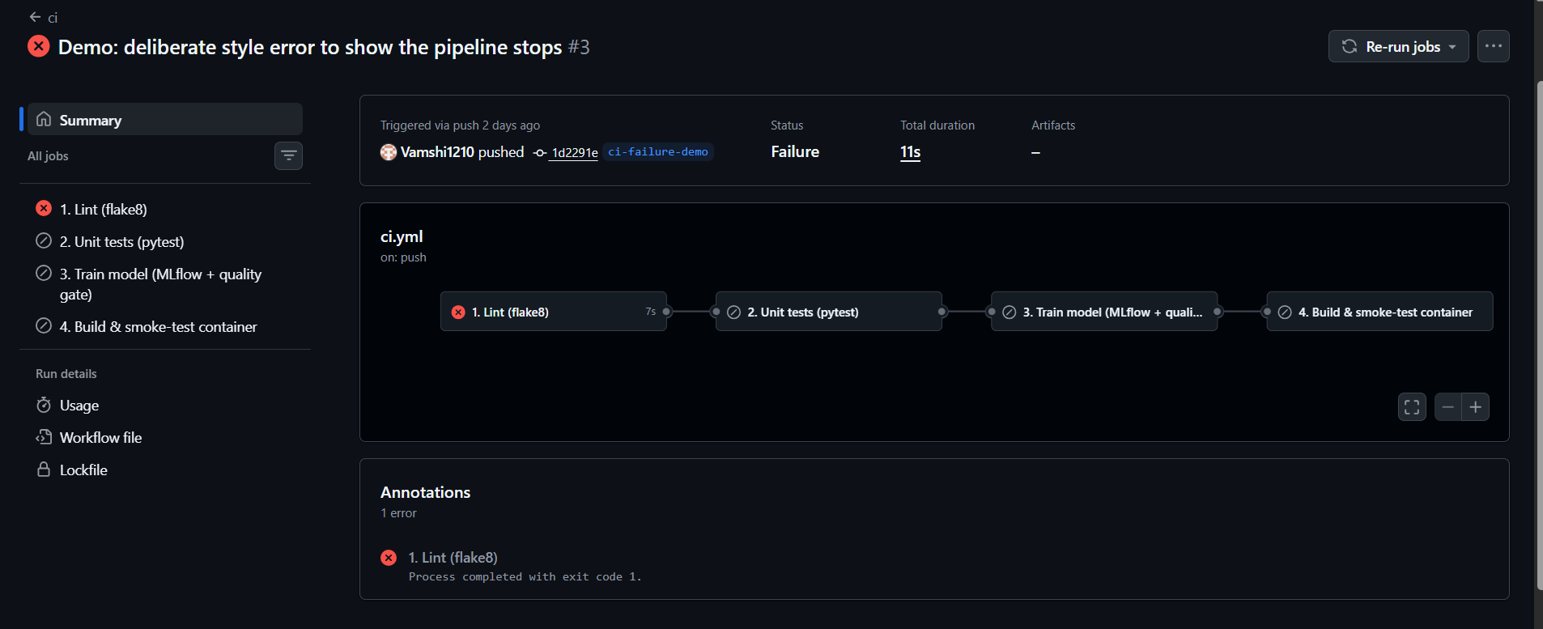
Figure 14: Pipeline stopping at the lint job

9. Model Containerisation
The Dockerfile starts from python:3.14-slim, installs only the serving dependencies, copies in the API code and the model, runs as a non-root user and defines a health check, so Docker itself reports whether the service is ready.
Endpoint | Purpose
GET /health | Service status, model version and model type
POST /predict | Accepts patient data as JSON and returns prediction, label, disease probability, confidence, threshold and model version
GET /metrics | Prometheus metrics
GET /docs | Interactive Swagger documentation
Example response for the sample patient in api/sample_request.json:
{
"prediction": 0,
"label": "heart disease unlikely",
"disease_probability": 0.2001,
"confidence": 0.7999,
"decision_threshold": 0.2285,
"model_version": "2026.10.16-1035"
}
Inputs are validated: an impossible value such as age: -5 is rejected with HTTP 422 and a clear message before it reaches the model.
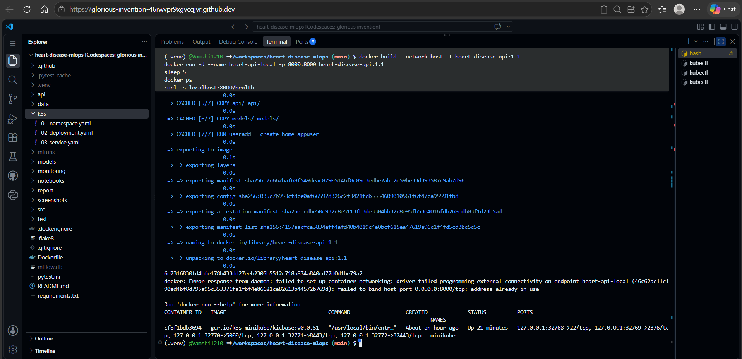
Figure 15: Docker image build
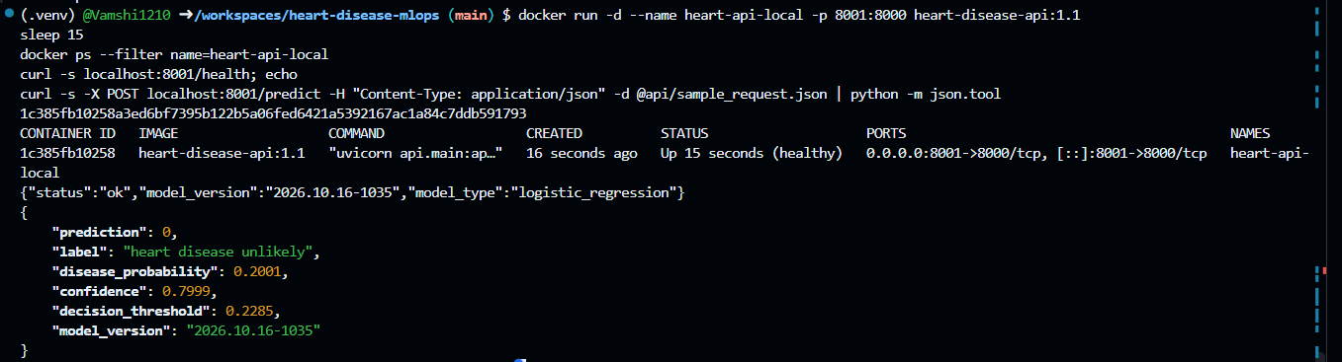
Figure 16: Container running healthy and serving a prediction for the sample input
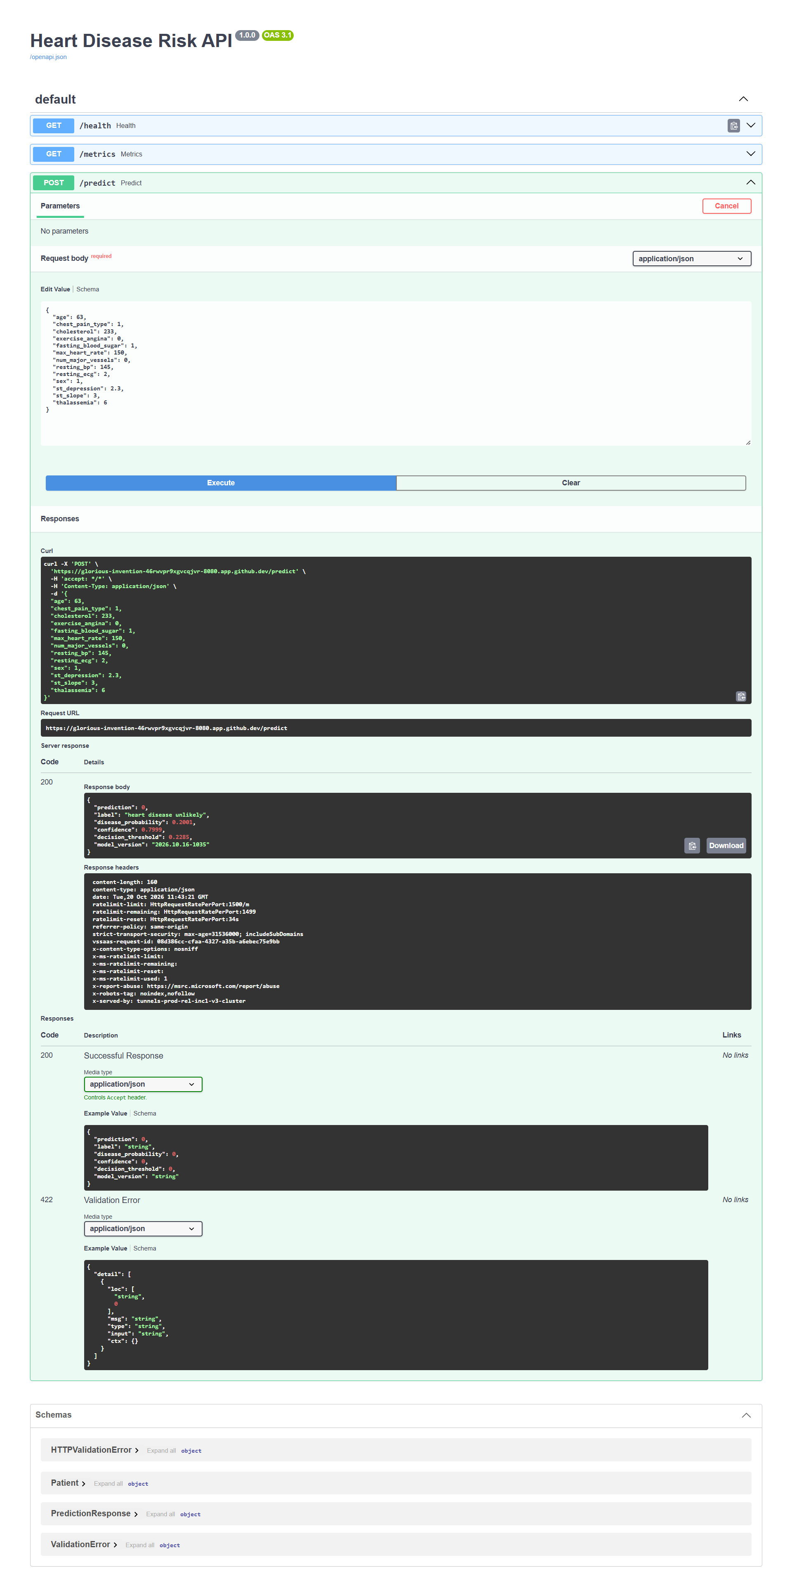
Figure 17: Successful prediction (HTTP 200) through Swagger
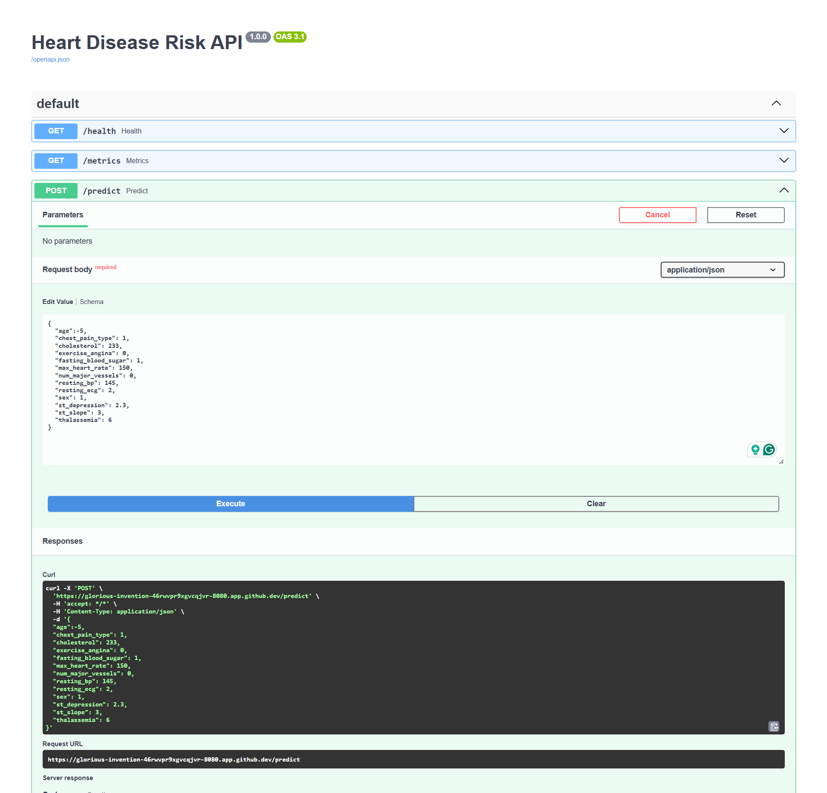
Figure 18: Invalid input rejected with HTTP 422

10. Production Deployment (Kubernetes)
The API runs on Minikube inside the Codespace. The manifests in k8s/ create:
- a namespace, mlops
- a Deployment with 2 replicas, readiness and liveness probes, and resource limits
- a LoadBalancer Service mapping port 80 to the container’s port 8000, plus a headless service that lets Prometheus reach each pod individually
Because the Codespace cannot pull images from inside the cluster, images are loaded with minikube image load. With minikube tunnel running, the LoadBalancer received the external IP 10.110.85.139, and /health and /predict were verified through it, returning the same prediction as the local container.
Self-healing. When a pod was deleted, the Deployment immediately created a replacement. It received traffic only after passing its readiness probe (0/1 → 1/1), while the second replica kept serving.
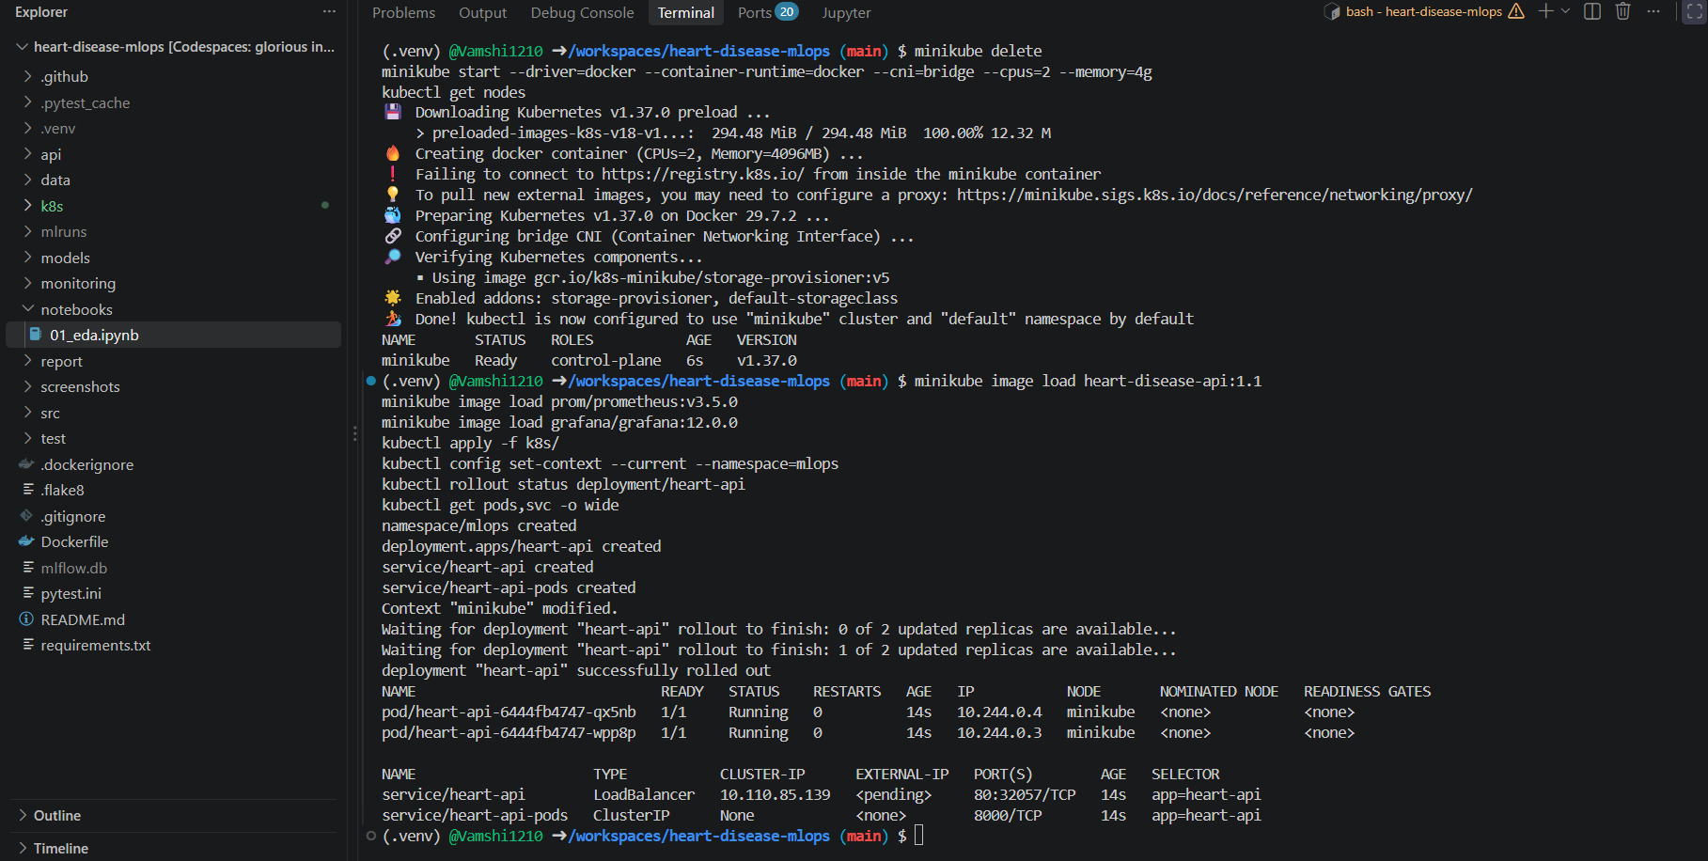
Figure 19: Pods and services in the mlops namespace
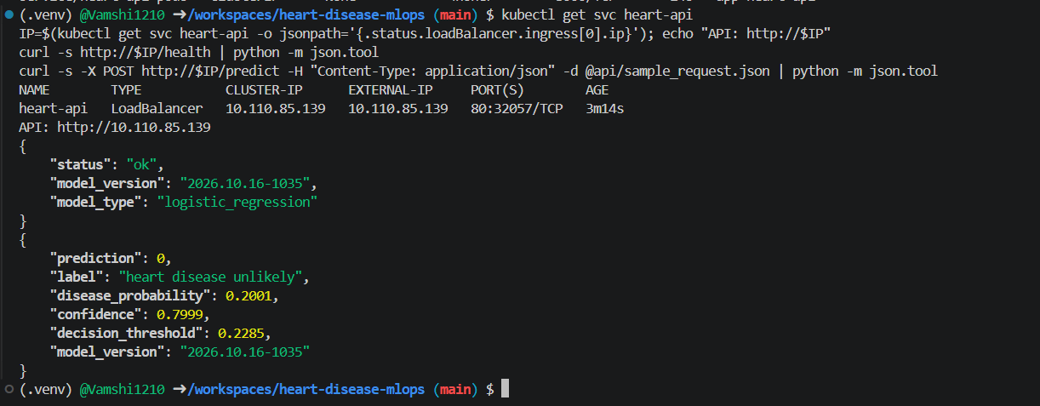
Figure 20: Prediction through the LoadBalancer
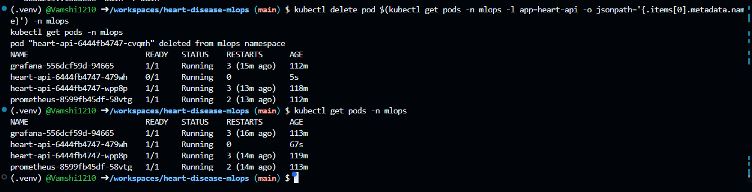
Figure 21: Self-healing after a pod is deleted

11. Monitoring and Logging
- Logging. Every API request is logged with its outcome. Patient measurements are never written to the logs.
- Metrics. /metrics exposes request counts, latency histograms, predictions by result and the distribution of predicted risk.
- Prometheus scrapes each pod every 5 seconds.
- Grafana opens an automatically provisioned dashboard with 8 panels: pods up, request rate, p50/p95 latency, predictions per result, invalid requests, and average predicted risk as a simple drift signal.
- Load test. monitoring/send_traffic.py generates realistic traffic. In the Prometheus graph below, the two load tests peak at about 4.8 requests per second, over a baseline of background traffic from health checks and monitoring.
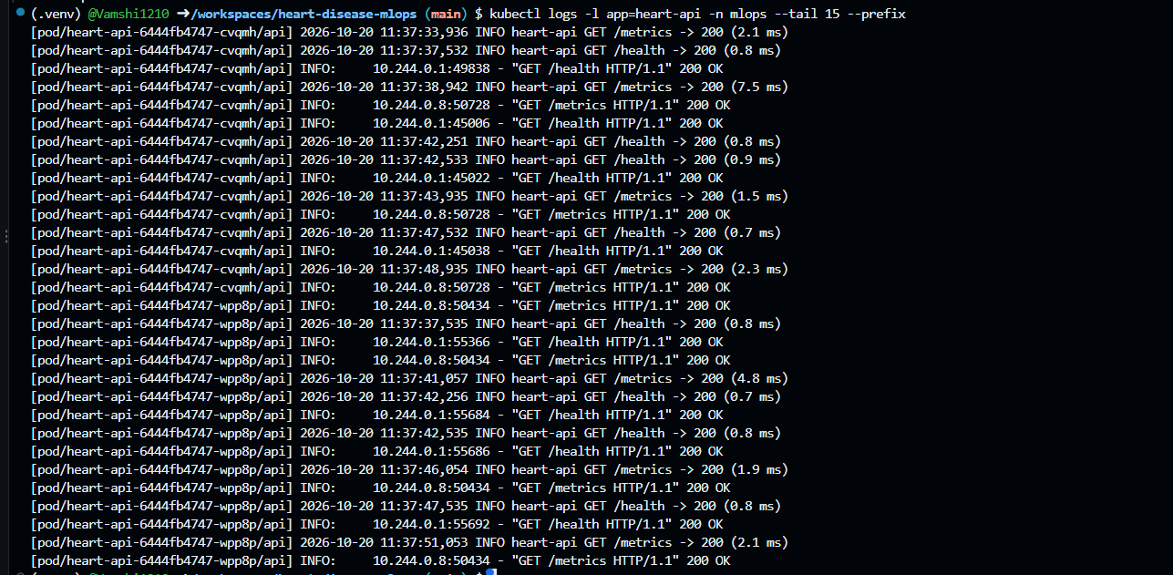
Figure 22: API request logs from both pods
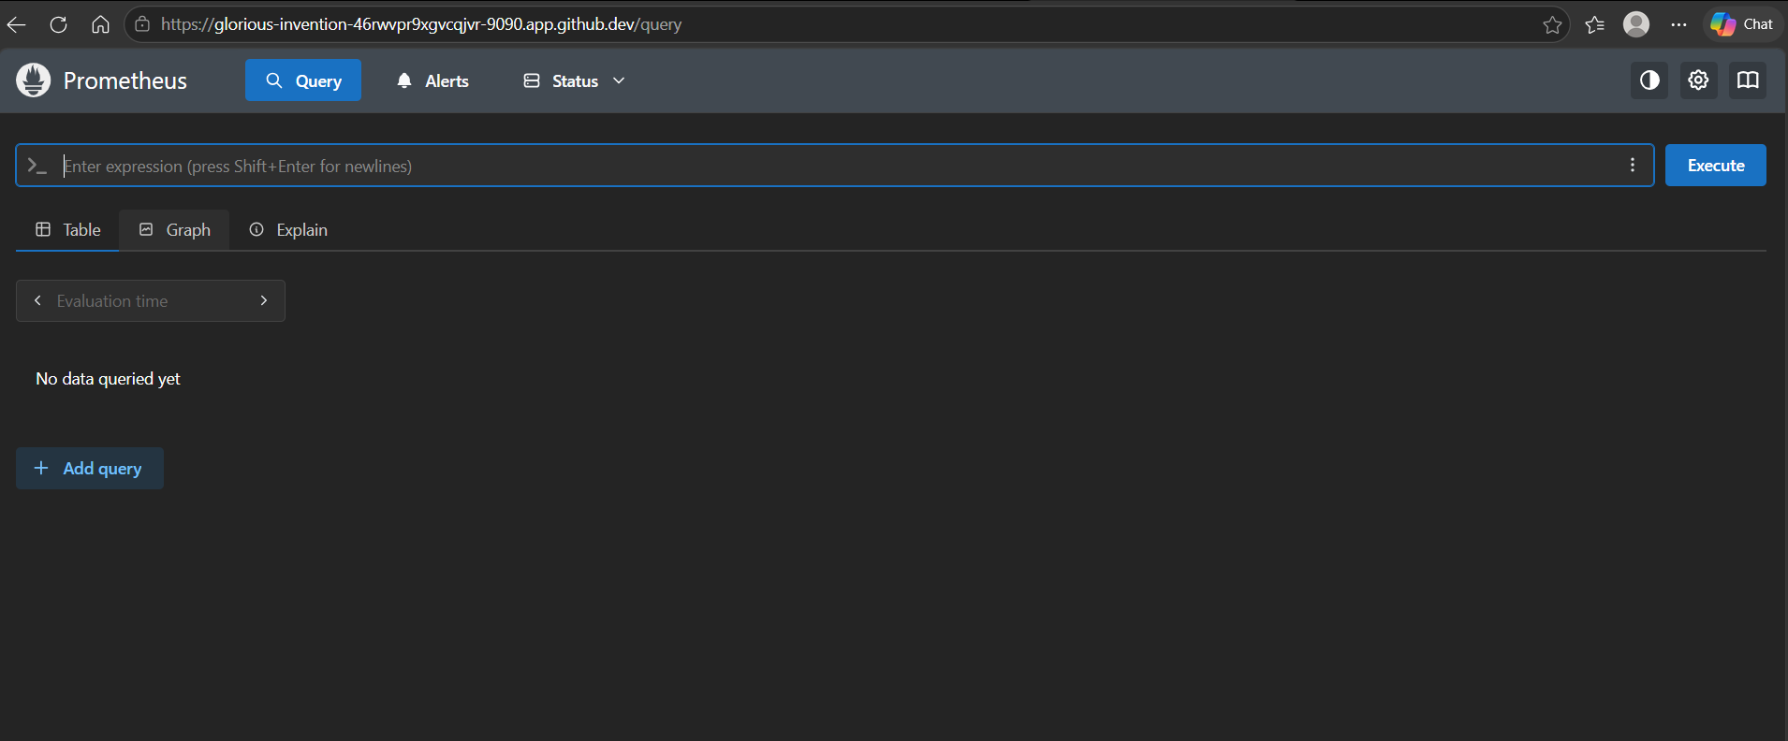
Figure 23: Prometheus targets (both pods UP)
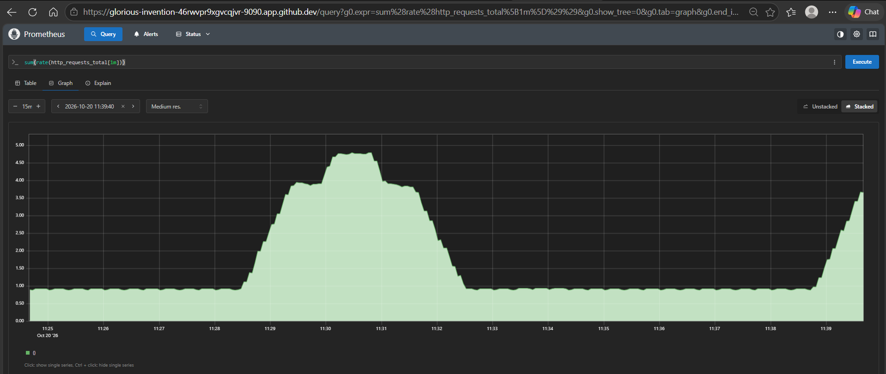
Figure 24: Request rate in Prometheus, sum(rate(http_requests_total[1m]))
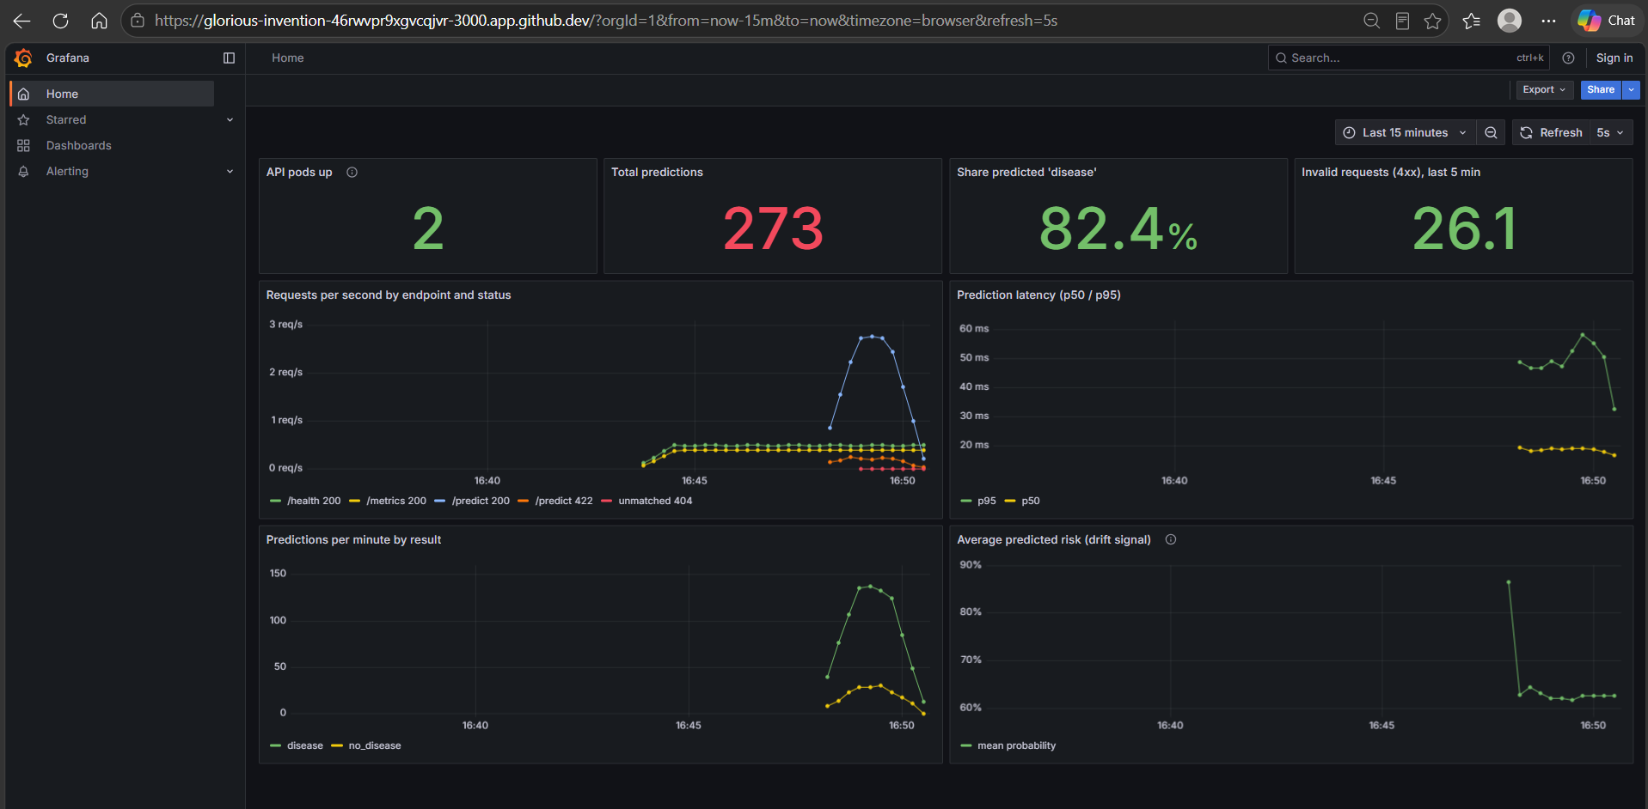
Figure 25: Grafana monitoring dashboard with live data

12. Challenges and Solutions
Problem | Cause | Solution
MLflow failed to save the model | Incompatibility with MLflow’s default skops serialisation | Switched to the pickle format
Docker builds timed out | Network restrictions inside Codespaces | Built with --network host
Kubernetes node stayed NotReady | Minikube’s default network add-on could not be downloaded | Diagnosed with kubectl get nodes and events, switched to the built-in bridge network
Pods could not pull images | No registry access from inside the cluster | Loaded images directly with minikube image load
EDA notebook became empty | File lost between editor sessions | Rebuilt and committed it; adopted the habit of pushing at the end of every session
Port 8000 already in use | An earlier process still held the port | Ran the container on port 8001

13. Conclusion and Future Work
The project delivers a complete, reproducible path from raw data to a monitored service: validated data, three tuned models compared in MLflow, a recall-focused Logistic Regression pipeline, 24 automated tests, a four-stage CI pipeline with a quality gate, a hardened Docker image, a self-healing Kubernetes deployment and a live monitoring dashboard.
Future work: push the image to a container registry and deploy automatically to a managed cluster (GKE or EKS); add Prometheus alerting on error rate and latency; replace the simple drift signal with statistical drift tests on input distributions; promote models through registry stages; and extend training to the other UCI sites (Hungary, Switzerland, VA) to test how well the model generalises.
What I learned: Training the model was the smallest part of this project. Most of the effort went into making it repeatable and safe: validating the data, tracking every run, writing tests, and making the pipeline stop on bad code. I also learned that the “best” model depends on the cost of mistakes. I chose a threshold that catches every sick patient, even though it adds some false alarms.

Appendix A: Repository Structure
heart-disease-mlops/
├── .github/workflows/ci.yml CI pipeline
├── api/ FastAPI service, serving requirements, sample request
├── data/raw/, data/processed/ Raw and cleaned dataset
├── k8s/ Namespace, Deployment, Service manifests
├── models/ Final model and metadata
├── monitoring/ Prometheus, Grafana, traffic generator
├── notebooks/01_eda.ipynb Exploratory data analysis
├── report/ This report and its figures
├── screenshots/ Evidence screenshots
├── src/ Download, cleaning, features, training
├── test/ 24 unit tests
├── Dockerfile
├── requirements.txt
└── README.md Setup and access instructions

