**Minishift Setup on Windows**

To download the latest Minishift release and view any release notes, visit the

**Minishift releases page.**

<https://github.com/minishift/minishift/releases>

Before using Minishift, ensure you check out the installation instructions for any prerequisites your system must satisfy.

**Refer Link:**

<https://docs.okd.io/3.11/minishift/getting-started/setting-up-virtualization-environment.html#for-windows>

Run Power-shell as administrator

Note** After unzipping minishift make sure to set environment path pointing to minishift folder.

If any error with power shell, make sure environment path pointing to power-shell.

After all basic setup, we can start minishift from power-shell

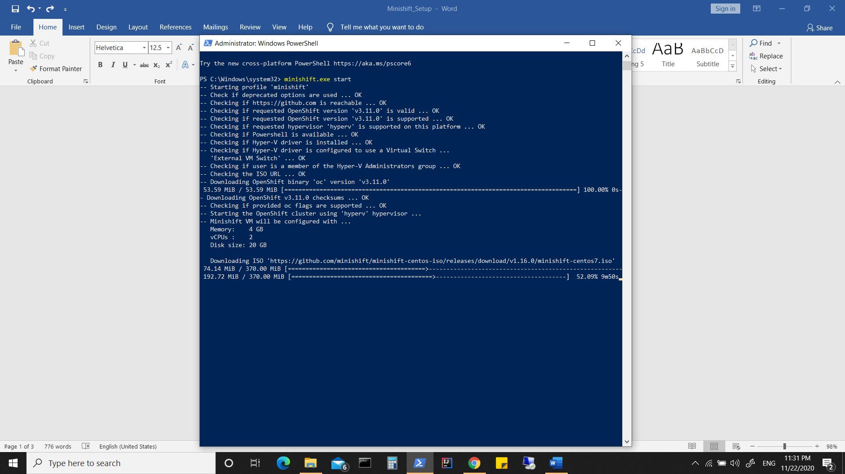

This will start minishift and openshift cluster.

OR disable Hyper-V &

If Using Virtualbox (provided Virtualbox already installed)

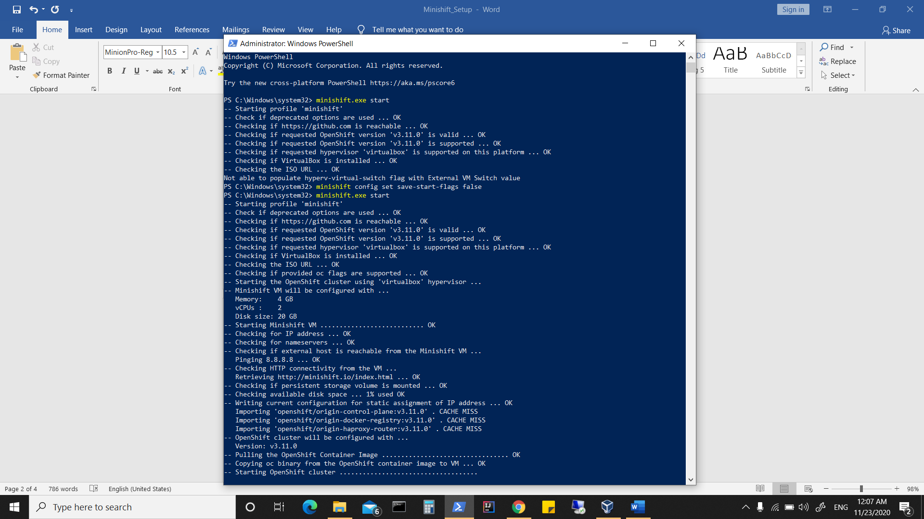

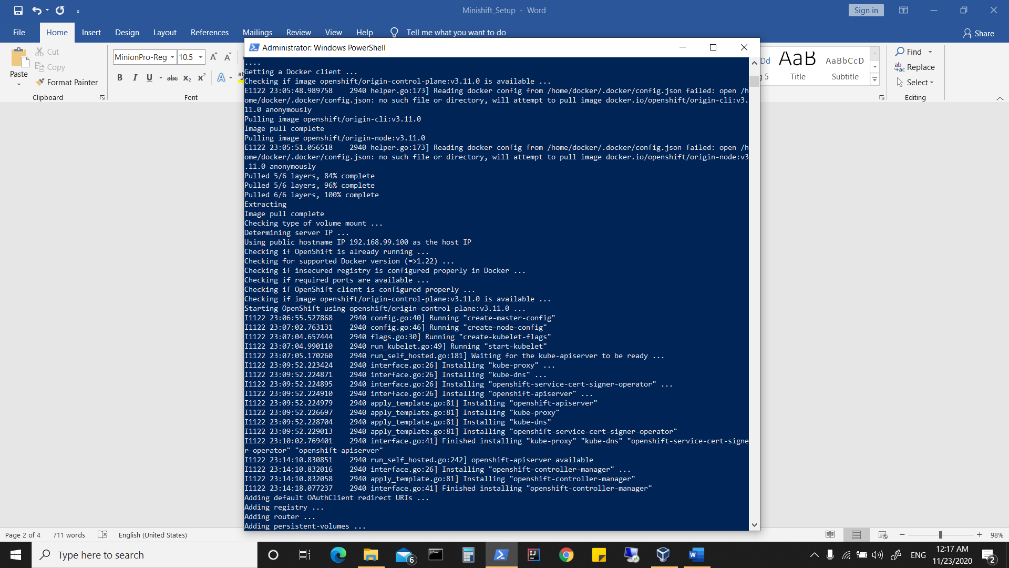

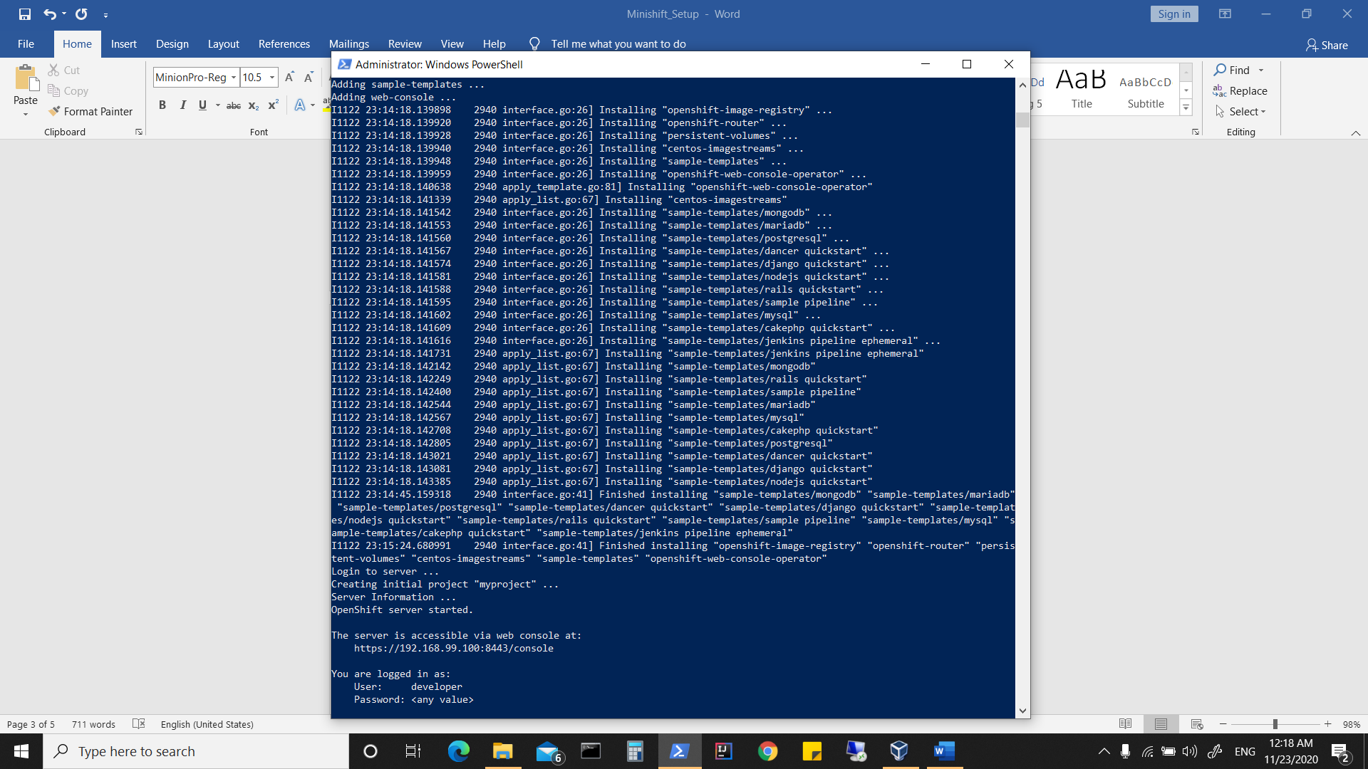

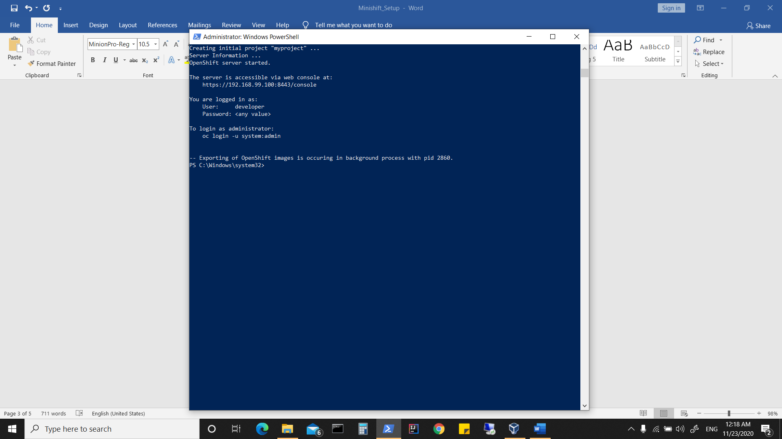

Run the command minishift oc-env to output instructions on how to set up your shell

environment so it can find the oc program:

**PS C:\Windows\system32> minishift oc-env**

**$Env:PATH = "C:\Users\Win10\.minishift\cache\oc\v3.11.0\windows;$Env:PATH"**

**# Run this command to configure your shell:**

**# & minishift oc-env | Invoke-Expression**

**PS C:\Windows\system32> & minishift oc-env | Invoke-Expression**

**PS C:\Windows\system32> oc**

To access the web console for OpenShift, run the command minishift console.

This will open up a browser client for you in the web console.

To determine the URL for the OpenShift cluster, for use when logging in from the

command line or accessing the web console from a browser, run the command

minishift console --url.

The login credentials you should use with the OpenShift

cluster created by Minishift are:

• Username: developer

• Password: developer

To shut down the OpenShift cluster, run the command minishift stop. You can

restart it again using minishift start. All your work will be restored on a restart. To

delete the OpenShift cluster, run the command minishift delete.

When Minishift creates a cluster, it will use default settings for the number of CPUs,

memory available, and the size of the VM disk. It is recommended you override these

with values that better match what resources you have available, or need. This can be

done using options to minishift start the first time it is used to create the OpenShift cluster. You can override the default values for these resources, as well as the VM driver used, using the minishift config command.

**Minishift uses OpenShift Origin.**

**If connecting to VM**

the default login and password is just the same as it is on minikube...  
login: docker  
pass: tcuser