**Cluster Setup: Road Blocks**

While Deploying (1st block): Control plane pods to come up and become ready

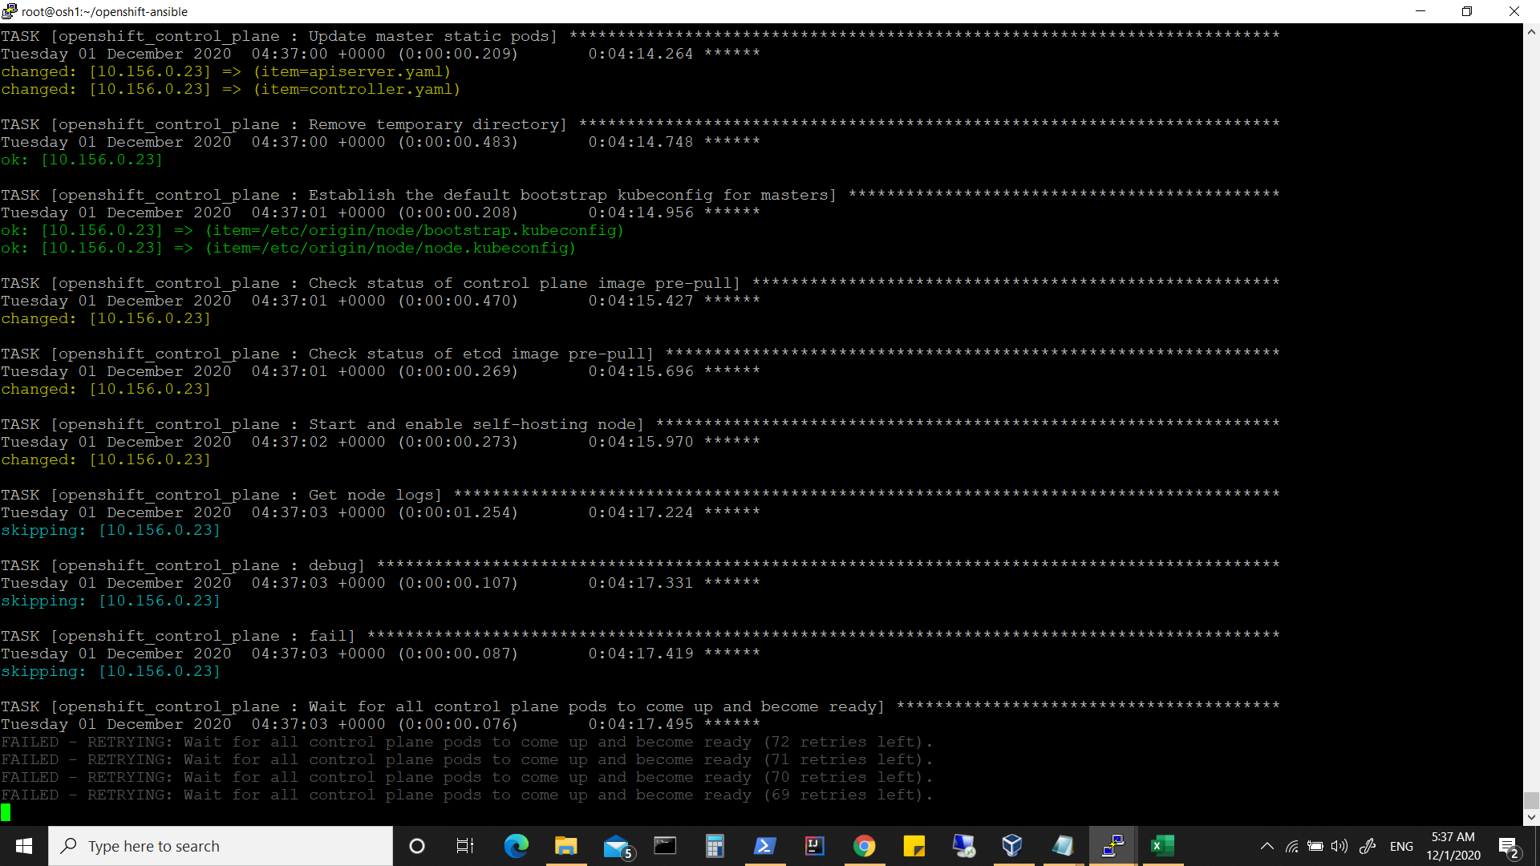

2nd block : sync daemonset to become ready and available

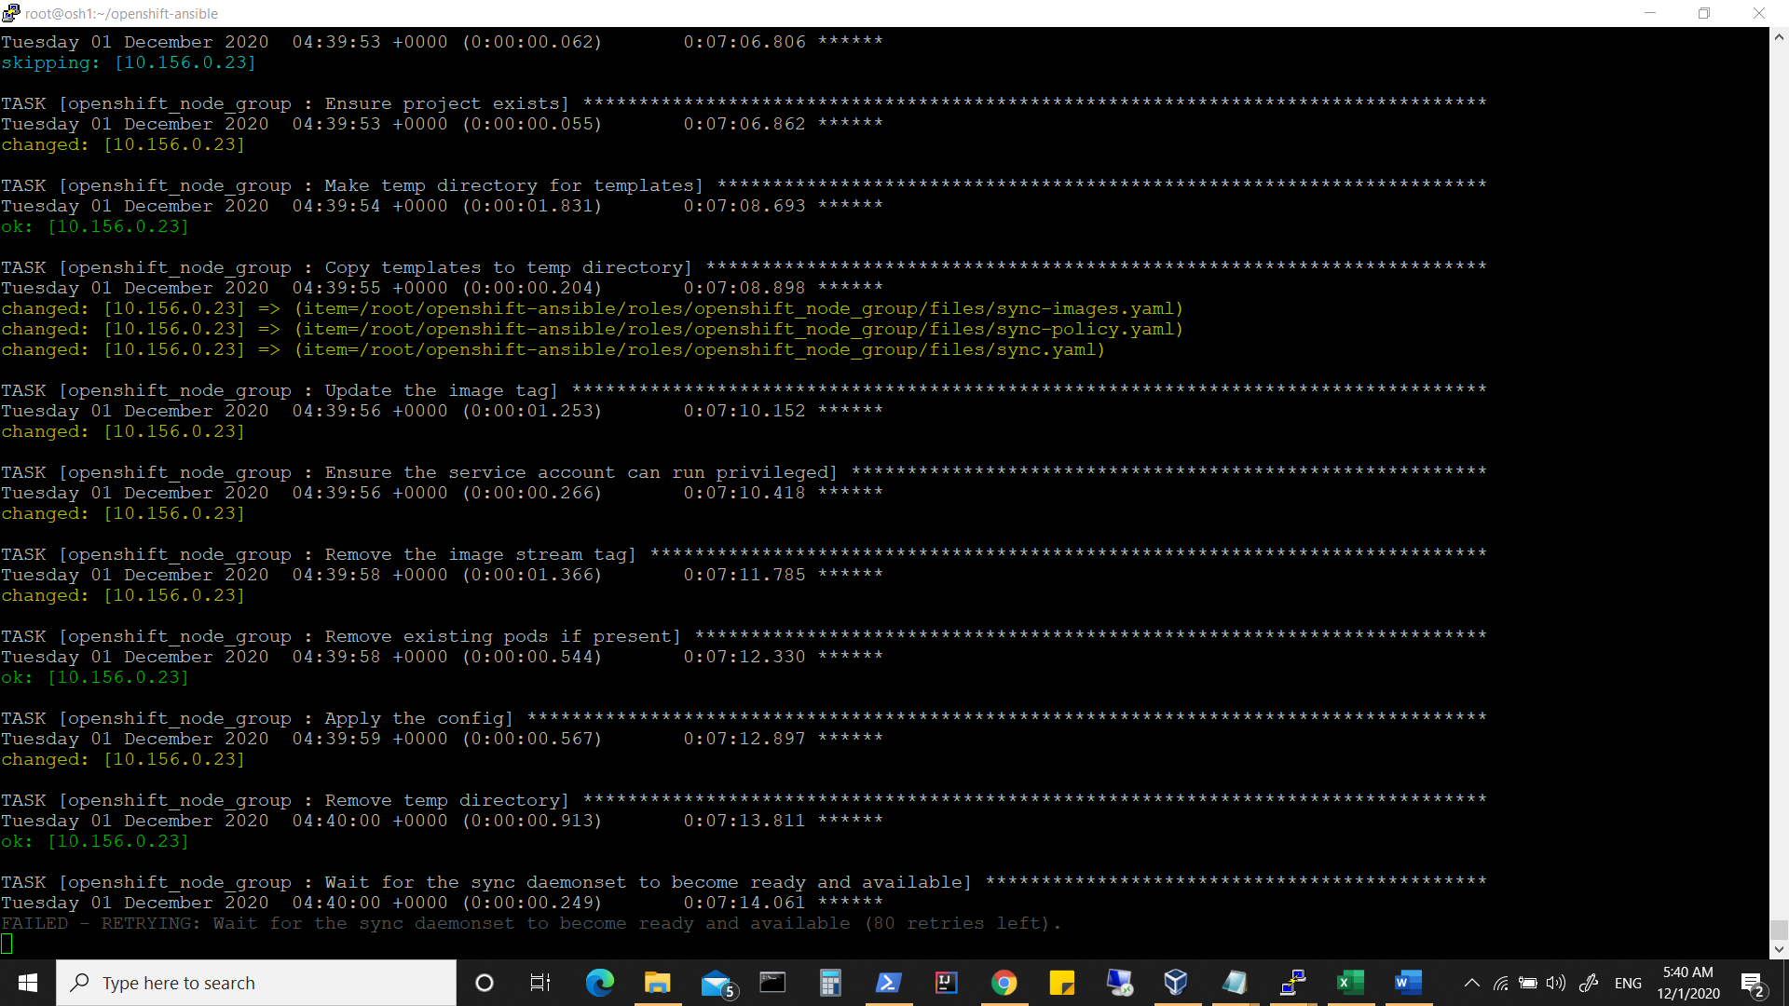

3rd Block (waiting for node to be ready)

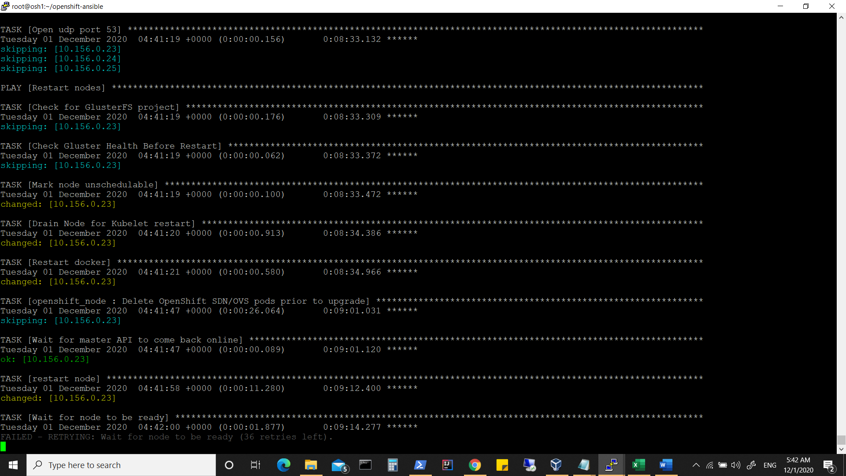

4th Block (waiting for console to be up)

