* Create registrationform.html
* Create one folder on desktop(ex: cse)
* Go to command prompt
* Change directory (to cse)

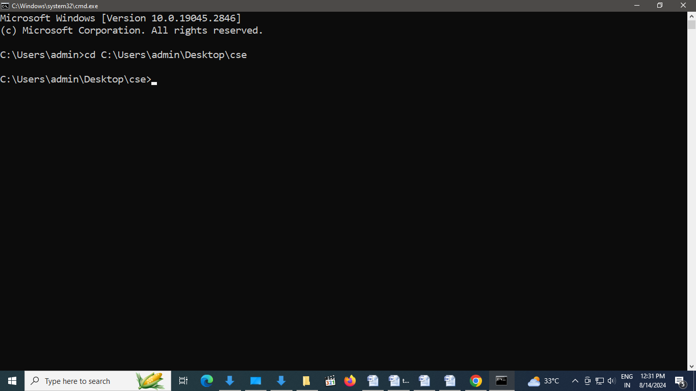

* Open your github account

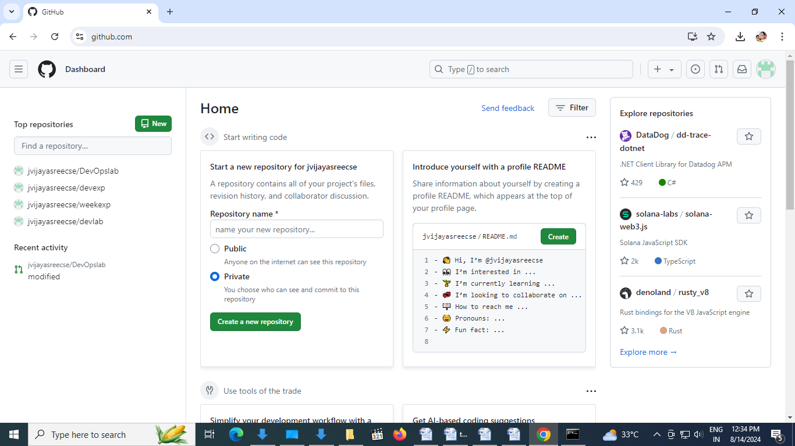

* Create new repository(ex: devopslabexp)

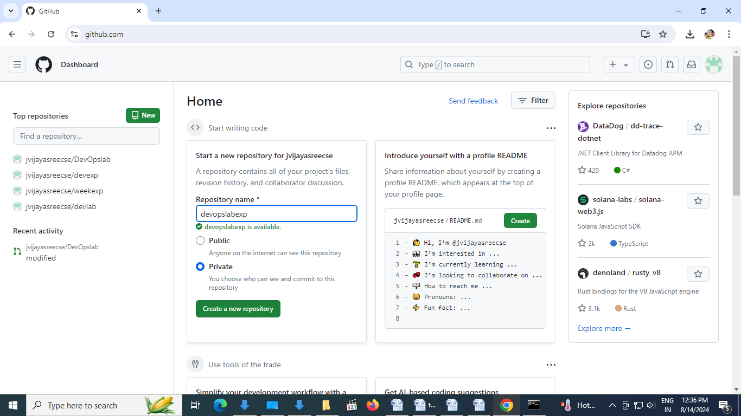

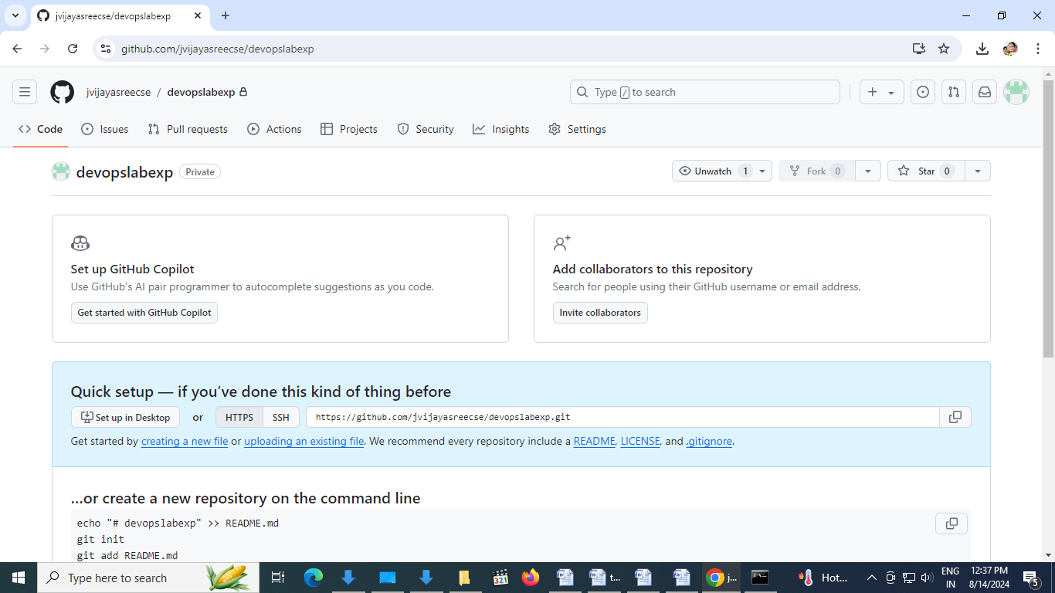

* Upload your registrationform.html to devopslabexp repository



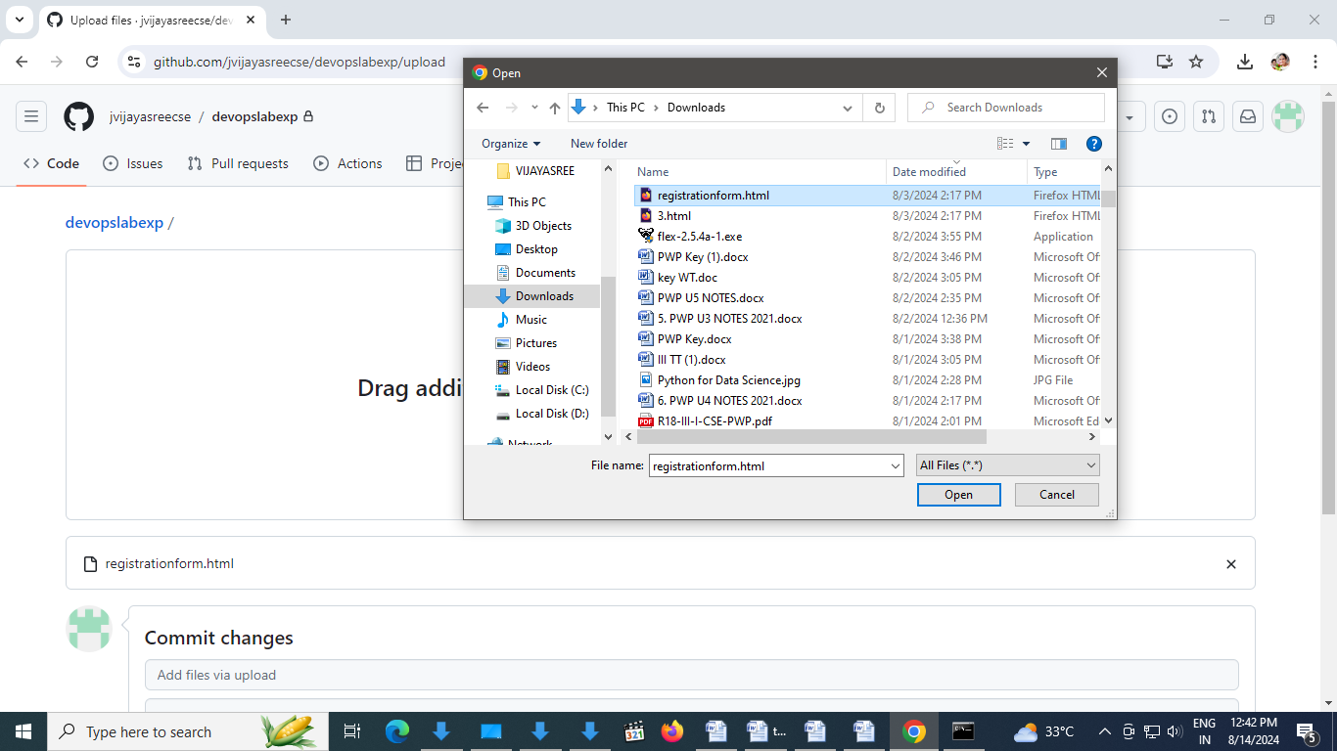

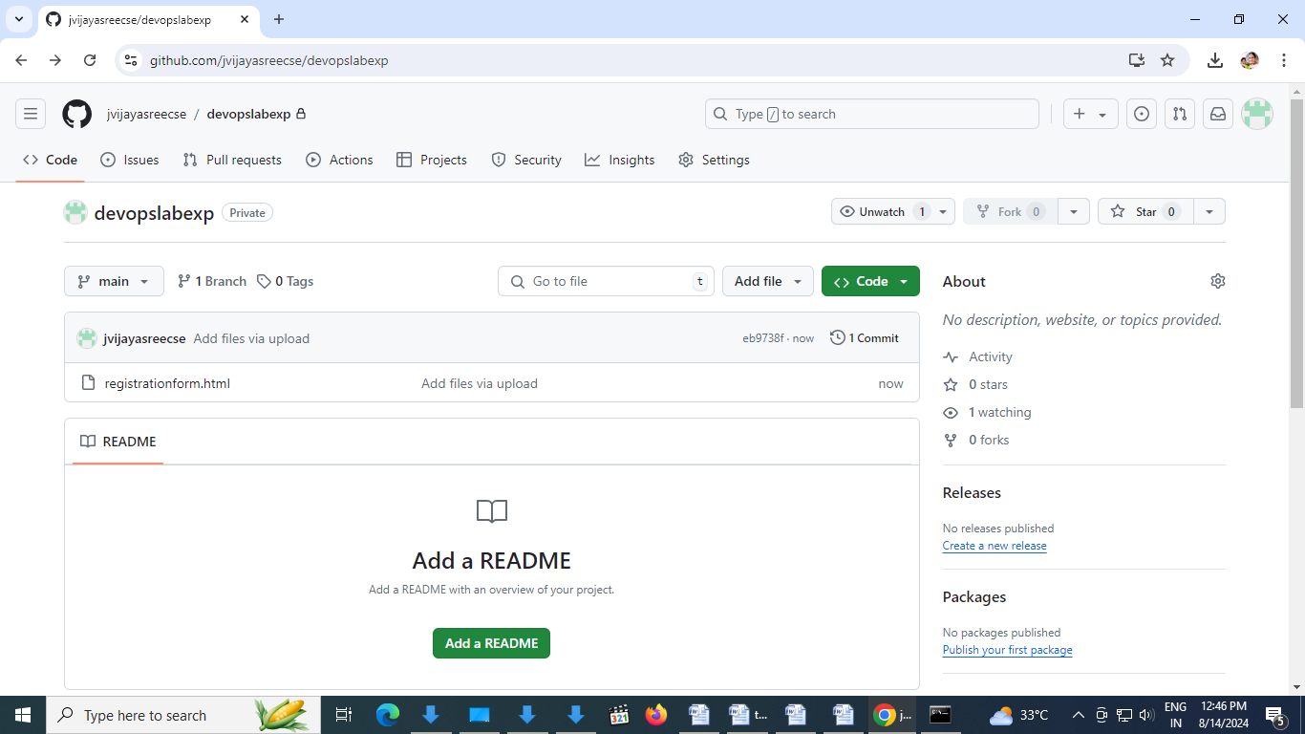

* Go to command prompt give command **git init**

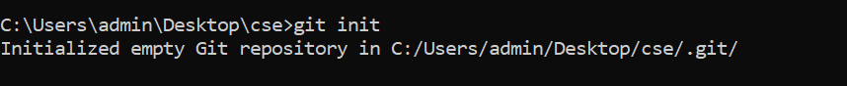

* Go to command prompt give command **git status**

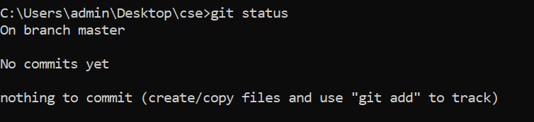

* Copy repository URL

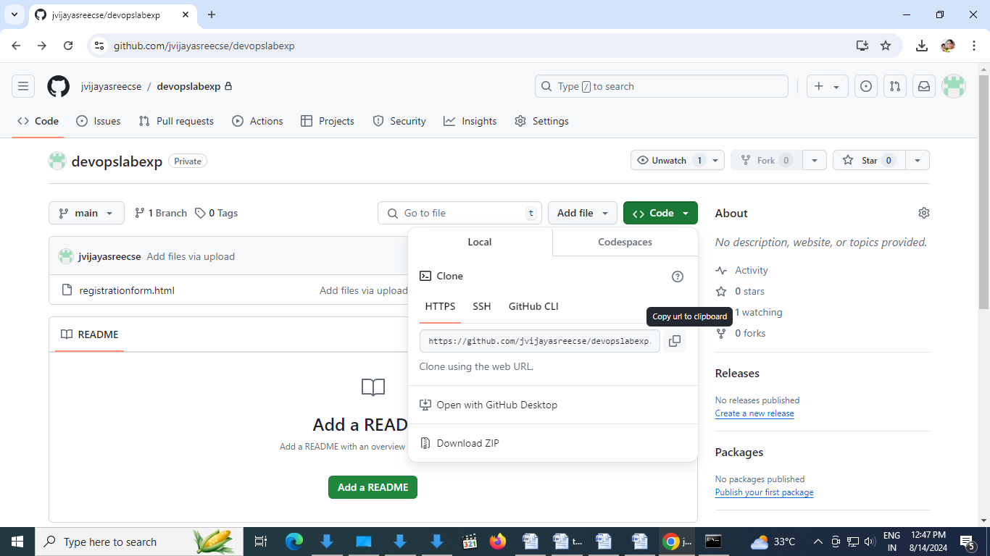

Go to command prompt give command **git clone** [**https://github.com/jvijayasreecse/devopslabexp.git**](https://github.com/jvijayasreecse/devopslabexp.git)

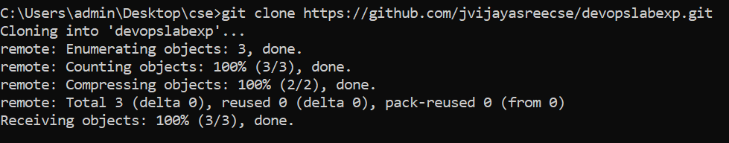

* devopslabexp cloned to cse folder

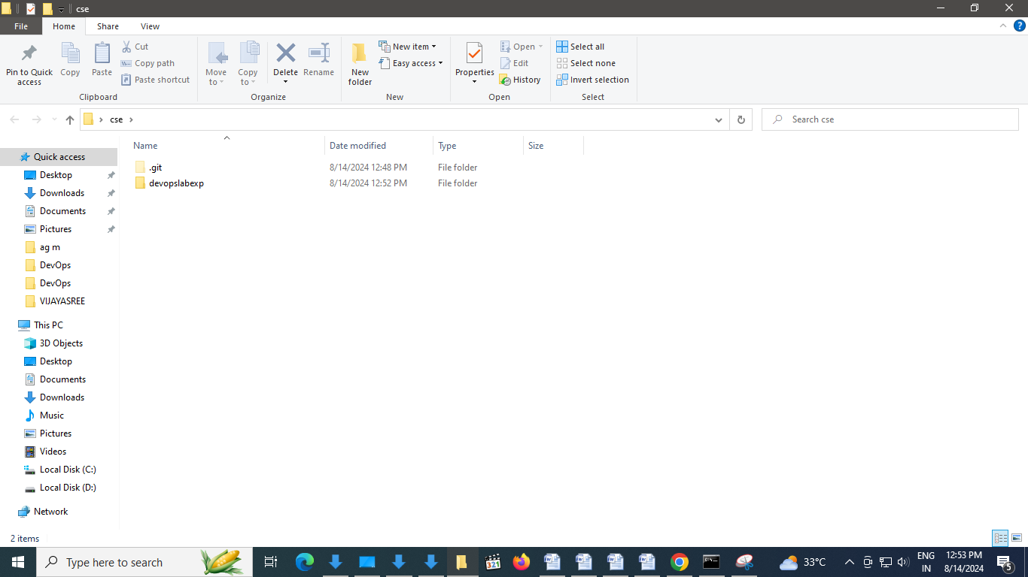

* go to command prompt change to devopslabexp directory



* Go to command prompt give command **git branch -a**

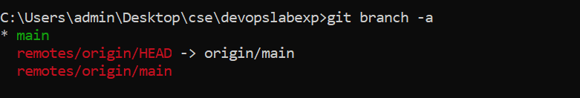

* Go to command prompt give command **git branch weekexp3** to create branch weekexp3

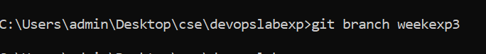

* Go to command prompt give command **git branch -a**

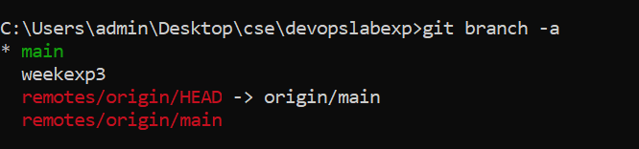

* Go to command prompt give command **git checkout weekexp3** to switch branch weekexp3

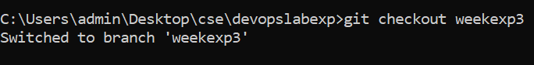

* Go to command prompt give command **git puh origin weekexp3** to push origin branch to weekexp3

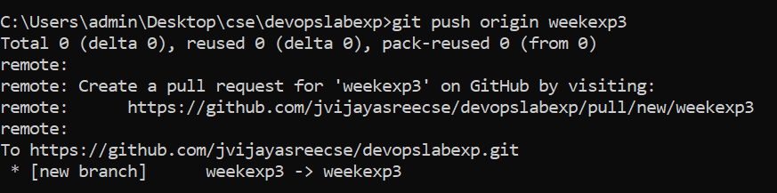

* **Modify code in registrationform.html and save (in cse folder)**

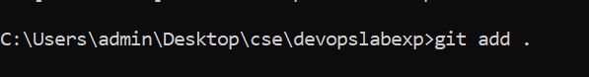

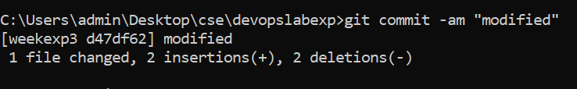

* Go to command prompt give command **git puh origin weekexp3** to push origin branch to weekexp3

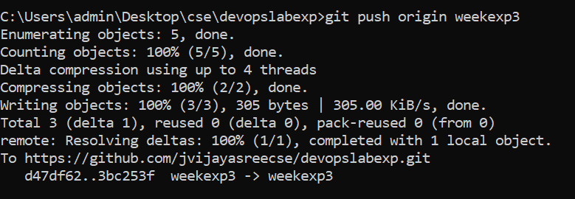

Check code in github under weeekexp3 modified code reflected in github

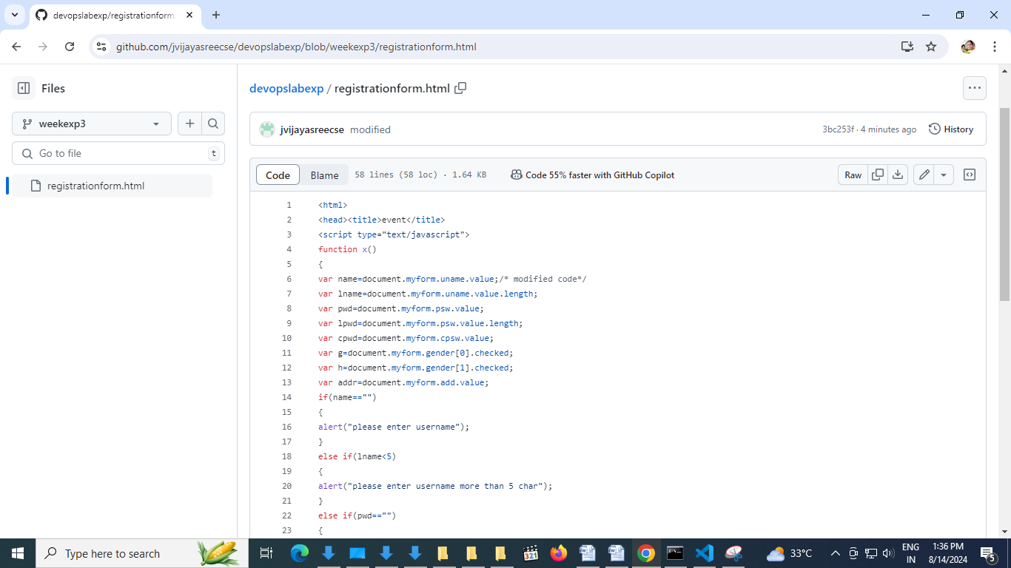

Go to github devopslabexp repository

