A Novel Hybrid Deep Learning Method for Early Detection of Lung Cancer using Neural Networks

In the past many automation algorithms and bio-markers based algorithms are introduced to detect cancerous cells from Lung CT-scan images but all those techniques or algorithms detection accuracy is not accurate. To overcome from this issue author of this paper employing Hybrid (combination of CNN and LSTM) algorithm is utilized to detect cancer cells. 3DCNN algorithm is best known for features extraction and classification and then RNN (LSTM long short term memory) algorithm is used to detect changes in images over different time, so by combining both this algorithms application can detect changes of cancer cell over time.

In propose paper before classifying cancer cell author employing UNET algorithm to segment cancel cell and then applying propose CCDC-HNN (Cancer Cell Detection using Hybrid Neural Network) algorithm to classify cancer cell. Based on detected cancel cell size physician can easily understand stage of cancer.

To train propose algorithm author has utilized LIDC-IDRI (Lung Image Database Consortium and Image Database Resource Initiative) which can be downloaded from below KAGGLE URL.

<https://www.kaggle.com/datasets/rangan2510/lidc-idri-pngs-with-masks>

Above dataset contains CT-SCAN lung images along with mask images for UNET segmentation. Above dataset contains more than 14000 images and the mask image with 0 white colour pixels will be consider as Benign and mask with white colour images will be consider as ‘Malignant’ cancer cell.

To implement this project we have designed following modules

1. Upload LIDC-IDRI Dataset: using this module will upload dataset to application
2. Process Dataset: using this module application will read all images and then resize and normalize and all images pixel values
3. Train & Test Split: this module will split dataset into train and test where application will be using 80% images for training and 20% for testing
4. Run Hybrid CCDC-HNN Algorithm: 80% training images will be input to propose algorithm to train a model and this model will be applied on 20% test images to calculate prediction accuracy
5. Cancer Cell Detection & Classification: using this module will upload test image and then UNET will segment cancer cell if exists and then CCDC-HNN will classify detected cancel cell as Benign or Malignant
6. CCDC-HNN Training Graph: using this module will plot propose algorithm training accuracy and loss graph

SCREEN SHOTS

To run project double click on run.bat file to get below screen

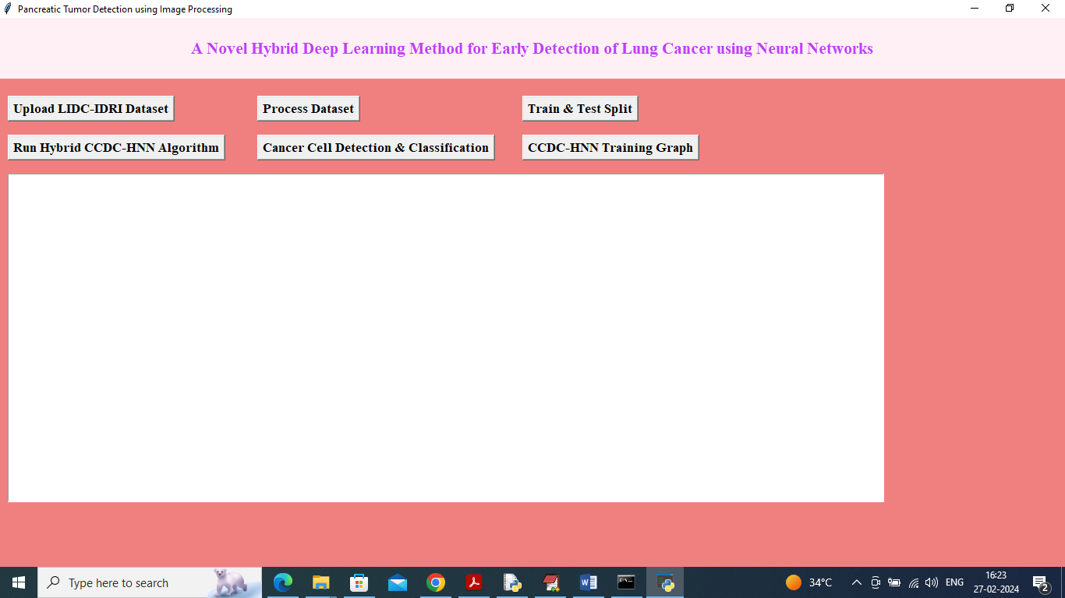

In above screen click on ‘Upload LIDC-IDRI Dataset’ button to upload dataset and get below page

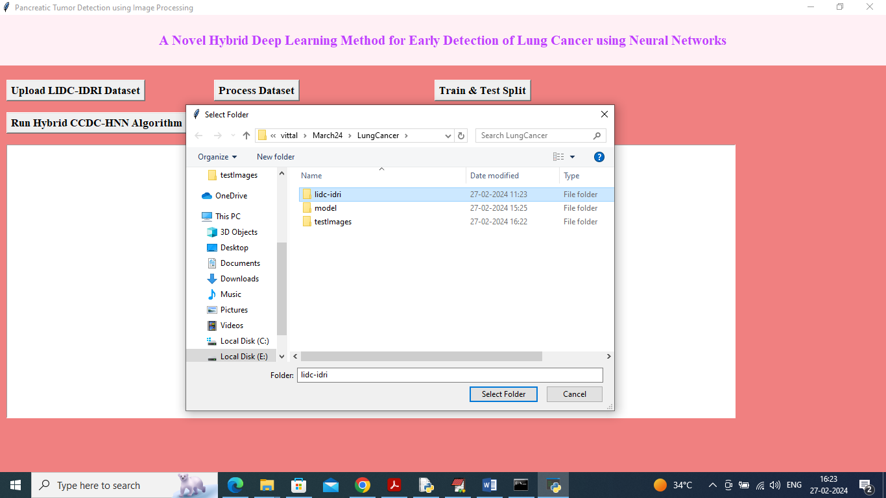

In above screen selecting and uploading ‘LIDC-IDRI’ dataset and then click on ‘select folder’ button to load dataset and get below page

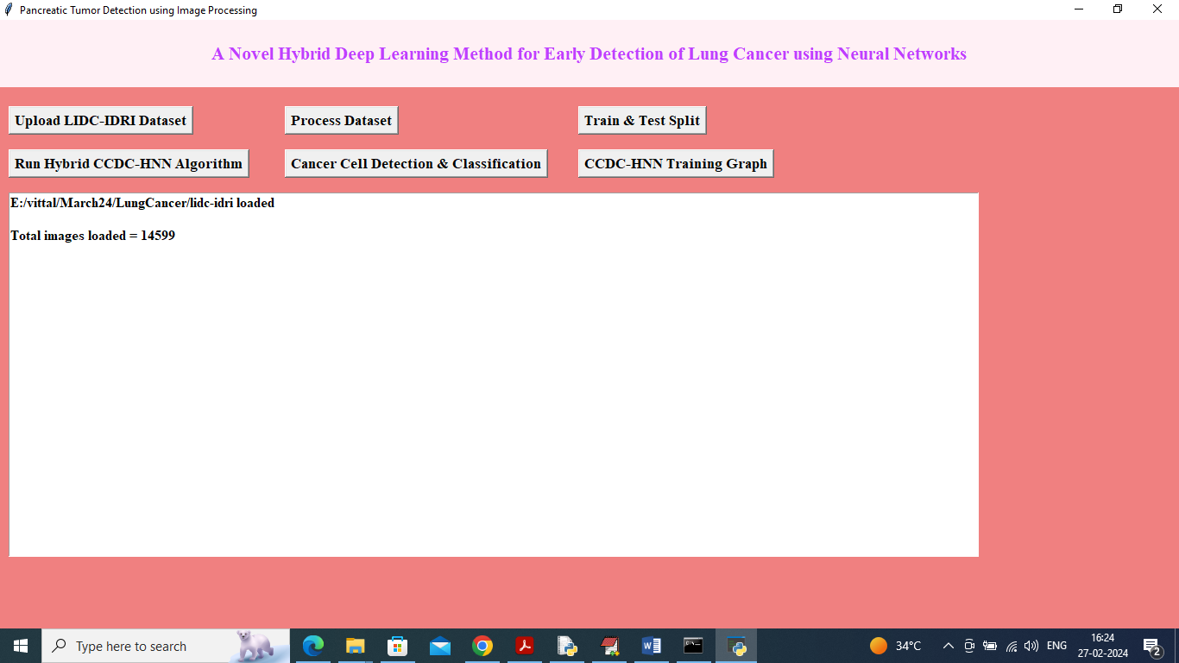

In above screen total 14599 images loaded from dataset and now click on ‘Process Images’ to clean and normalize images and then get below output

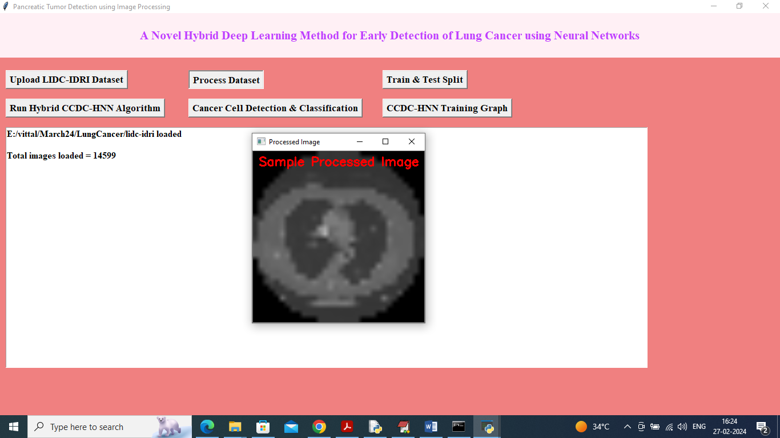

In above screen all images pixels are normalized and then displaying sample processed image and now close above image and then click on ‘Train & Test Split’ button to split dataset into train and test and then will get below output

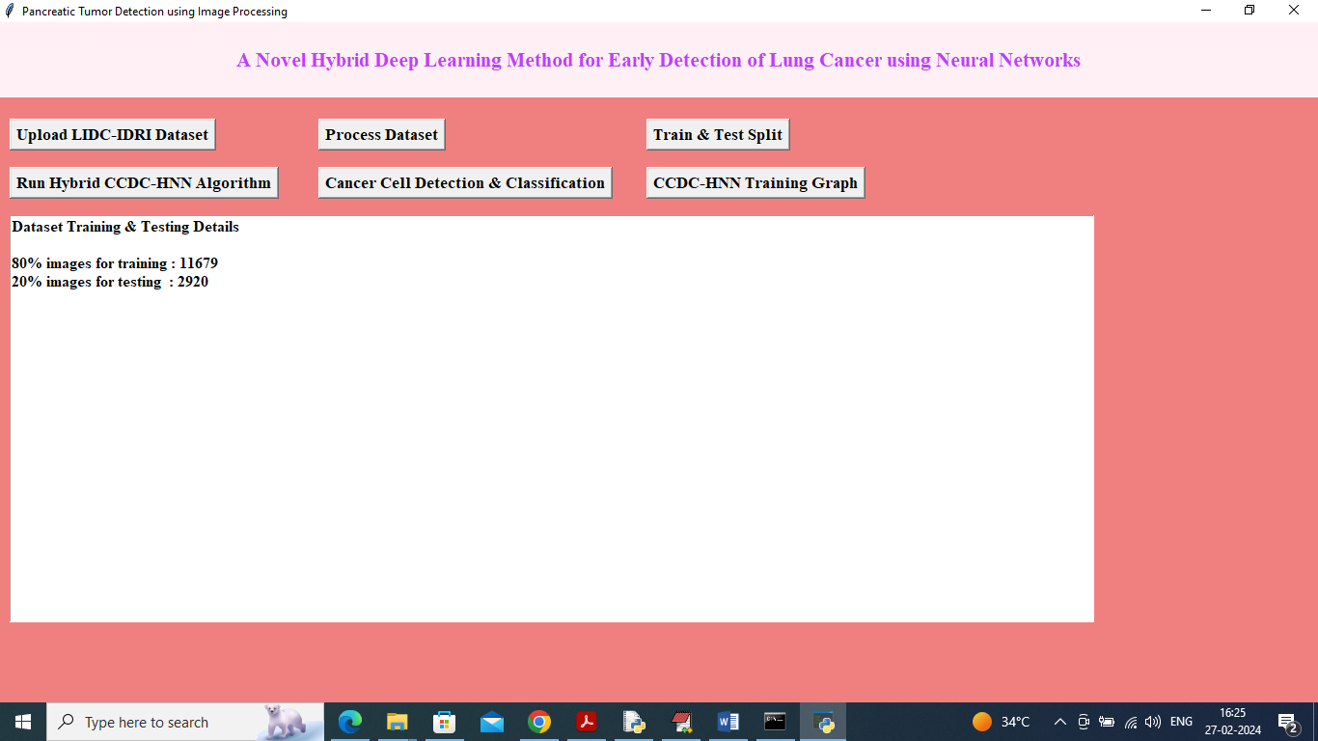

In above screen can see train and test size of dataset out of 14599 total images and now click on ‘Run Hybrid CCDC-HNN Algorithm’ button to train model on training images and tested on testing images

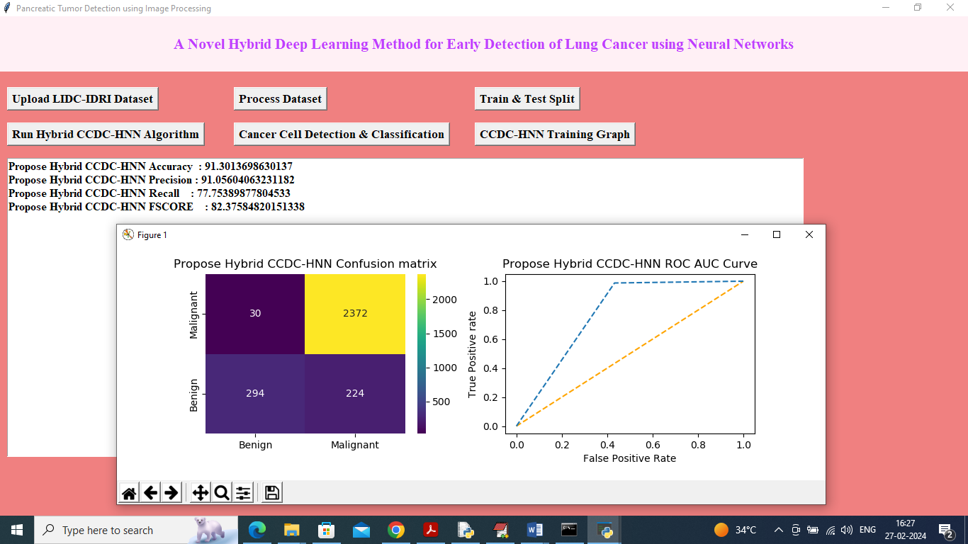

In above screen propose algorithm got 91% accuracy and can see other metrics like precision, recall and etc. in confusion matrix graph x-axis represents Predicted Labels and y-axis represents True labels and then yellow and light blue color boxes in diagnol represents correct prediction count and all blue boxes in diagnol represents incorrect prediction count which are very few. In ROC graph x-axis represents False Positive Rate and y-axis represents True Positive Rate and if blue lines comes below orange line then all predictions are incorrect or false and if goes above orange line then all predictions are correct or true. Now close above graph and then click on ‘Cancer Cell Detection & Classification’ button to upload test image and get below output

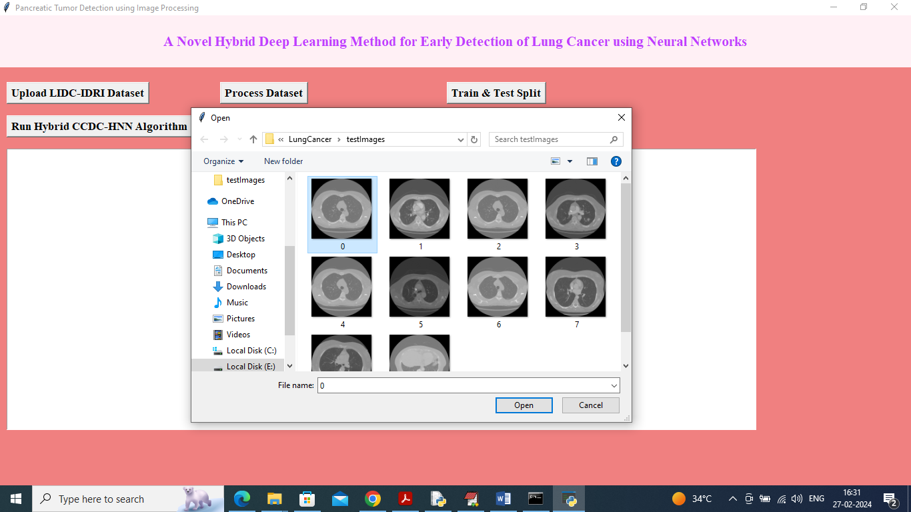

In above screen selecting and uploading ‘0.png’ image and then click on ‘Open’ button to get below output

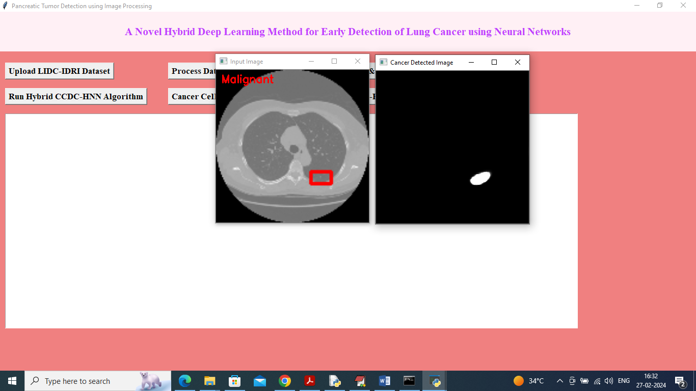

In above screen first image is the original image and second image is UNET segmented image of cancer cell detection and then propose ‘CCDC-HNN’ algorithm classify cell as Malignant. Similarly you can upload and test other images

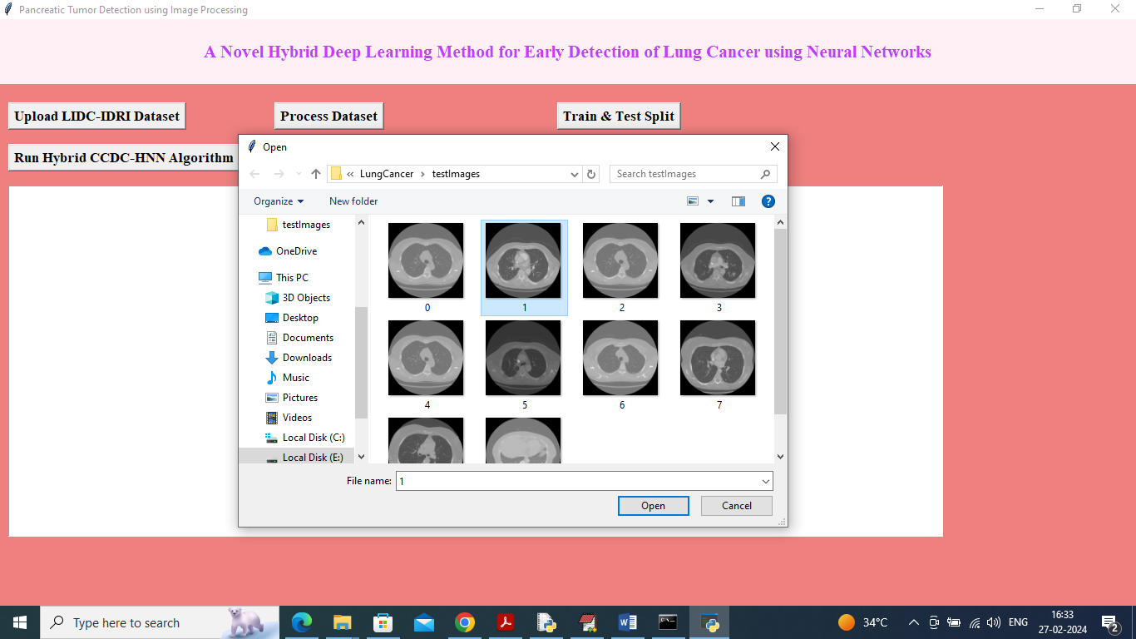

In above screen selecting and uploading another image and below is the output

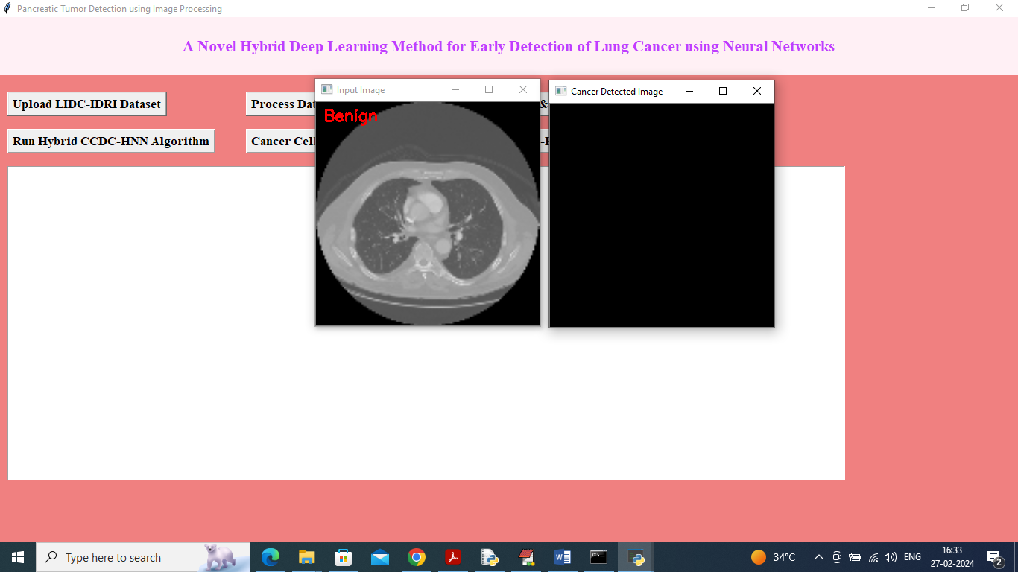

In above screen image classify as Benign as there is no cancer cell detected and below is another example

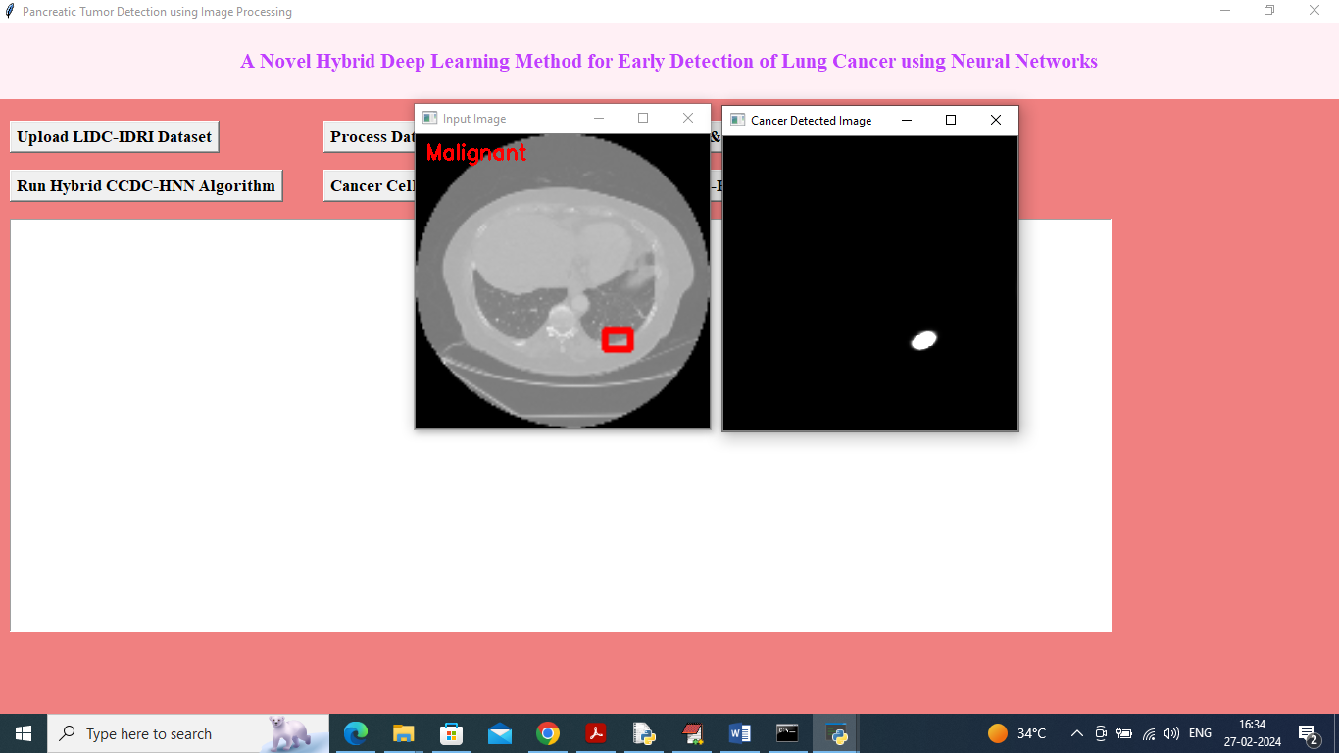

In above screen displaying another detected output as ‘Malignant’.