238W1A12C2
Week-11
1. Using h2 database
Project name: h2db
Author.java
package com.example.mysqldemo;

public class Author {
private String firstName;
private String lastName;
public String getFirstName() {
return firstName;
}
public void setFirstName(String firstName) {
this.firstName = firstName;
}
public String getLastName() {
return lastName;
}
public void setLastName(String lastName) {
this.lastName = lastName;
}
public Author(String firstName, String lastName) {
super();
this.firstName = firstName;
this.lastName = lastName;
}
}

AuthorService
package com.example.mysqldemo;
import java.util.ArrayList;
import java.util.*;
import org.slf4j.*;
import org.springframework.beans.factory.annotation.Autowired;
import org.springframework.jdbc.core.JdbcTemplate;
import org.springframework.stereotype.Service;
import jakarta.annotation.PostConstruct;

@Service
public class AuthorService {
private static final Logger log =LoggerFactory.getLogger(AuthorService.class);
@Autowired
JdbcTemplate jdbcTemplate;
@PostConstruct
public void postConstruct() {
Author author1=new Author("Manogna","IT");
Author author2=new Author("Varshini","CSE");
List <Author> authors = new ArrayList<>();
authors.add(author1);
authors.add(author2);
log.info("Creating tables");
jdbcTemplate.execute("DROP TABLE IF EXISTS author");
jdbcTemplate.execute("CREATE TABLE author(" + " first_name varchar(255), last_name varchar(255))");
authors.forEach(i->jdbcTemplate.update("INSERT INTO author(first_name, last_name) VALUES (?,?)",i.getFirstName(),i.getLastName()));
log.info("Records Saved");
//retrieve saved records.
log.info("Retrieving records");
authors = jdbcTemplate.query("select * from author", (rs, rowNum)-> new Author(rs.getString("first_name"),rs.getString("last_name")));
authors.forEach(i -> log.info(i.getFirstName() + " " +i.getLastName()));
}
}

Application.properties:
server.port=83
spring.application.name=h2db

# H2 console
spring.h2.console.enabled=true
spring.h2.console.path=/h2-console

# Datasource Settings
spring.datasource.url=jdbc:h2:mem:testdb
spring.datasource.driverClassName=org.h2.Driver
spring.datasource.username=sa
spring.datasource.password=

spring.jpa.hibernate.ddl-auto=none
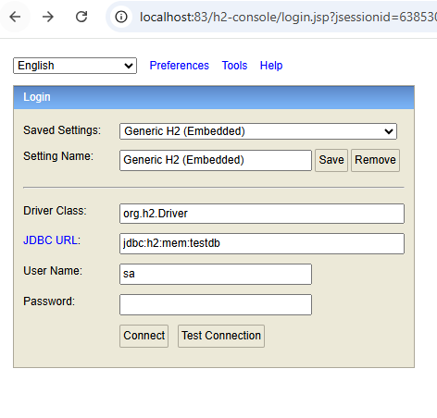

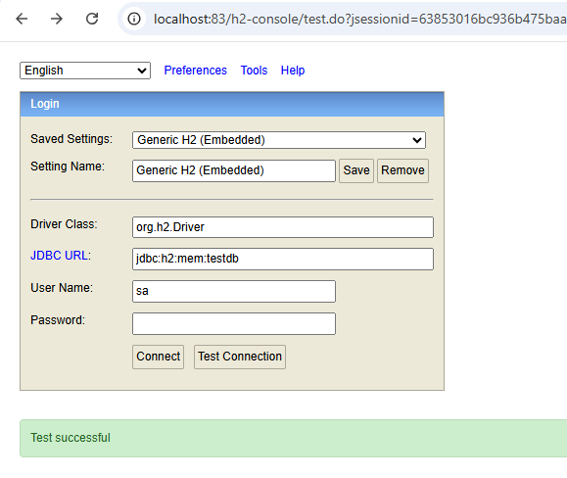

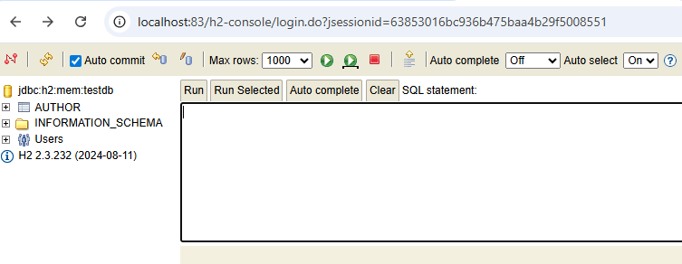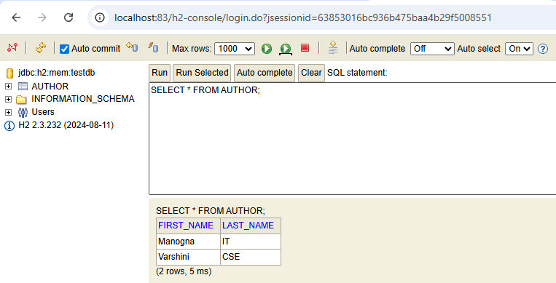

JDBC with MySQL:

Employee.java
package com.example.demo;

import jakarta.persistence.Entity;
import jakarta.persistence.Id;

@Entity
public class Employee {

@Id
private int id;
private String name;
private String department;

public Employee() {}

public Employee(int id, String name, String department) {
this.id = id;
this.name = name;
this.department = department;
}

public int getId() { return id; }
public void setId(int id) { this.id = id; }

public String getName() { return name; }
public void setName(String name) { this.name = name; }

public String getDepartment() { return department; }
public void setDepartment(String department) { this.department = department; }
}

EmployeeRepository.java
package com.example.demo;

import org.springframework.data.jpa.repository.JpaRepository;

public interface EmployeeRepository extends JpaRepository<Employee, Integer> { }

MysqlJdbcDemoApplication.java
package com.example.demo;

import org.springframework.boot.SpringApplication;
import org.springframework.boot.autoconfigure.SpringBootApplication;

@SpringBootApplication
public class MysqlJdbcDemoApplication {
public static void main(String[] args) {
SpringApplication.run(MysqlJdbcDemoApplication.class, args);
System.out.println("welcome");
}
}

Applications.properties
spring.application.name=MysqlJdbcDemo
server.port=85

spring.datasource.url=jdbc:mysql://localhost:3306/employee_db?useSSL=false&serverTimezone=UTC
spring.datasource.username=root
spring.datasource.password=

spring.datasource.driver-class-name=com.mysql.cj.jdbc.Driver

spring.jpa.hibernate.ddl-auto=none
spring.jpa.show-sql=true

spring.sql.init.mode=always
spring.jpa.defer-datasource-initialization=true

DATABASE

Create database employee_db;
Use employee_db;
CREATE TABLE IF NOT EXISTS employee (
id INT PRIMARY KEY,
name VARCHAR(255),
department VARCHAR(255)

);

data.sql
INSERT INTO employee (id, name, department) VALUES
(1, 'Manogna', 'IT'),
(2, 'Keerthi’, 'CSE'),
(3, 'Sai', 'ECE');
Pom.xml
<?xml version="1.0" encoding="UTF-8"?>
<project xmlns="http://maven.apache.org/POM/4.0.0" xmlns:xsi="http://www.w3.org/2001/XMLSchema-instance"
xsi:schemaLocation="http://maven.apache.org/POM/4.0.0 https://maven.apache.org/xsd/maven-4.0.0.xsd">
<modelVersion>4.0.0</modelVersion>
<parent>
<groupId>org.springframework.boot</groupId>
<artifactId>spring-boot-starter-parent</artifactId>
<version>3.5.7</version>
<relativePath/> <!-- lookup parent from repository -->
</parent>
<groupId>com.example</groupId>
<artifactId>MysqlJdbcDemo</artifactId>
<version>0.0.1-SNAPSHOT</version>
<name>MysqlJdbcDemo</name>
<description>Servlet + HttpSession + JPA + H2 demo</description>
<url/>
<licenses>
<license/>
</licenses>
<developers>
<developer/>
</developers>
<scm>
<connection/>
<developerConnection/>
<tag/>
<url/>
</scm>
<properties>
<java.version>17</java.version>
</properties>
<dependencies>
<dependency>
<groupId>org.springframework.boot</groupId>
<artifactId>spring-boot-starter-data-jdbc</artifactId>
</dependency>
<dependency>
<groupId>org.springframework.boot</groupId>
<artifactId>spring-boot-starter-web</artifactId>
</dependency>

<dependency>
<groupId>mysql</groupId>
<artifactId>mysql-connector-java</artifactId>
<version>5.1.49</version>
</dependency>

<dependency>
<groupId>com.mysql</groupId>
<artifactId>mysql-connector-j</artifactId>
<scope>runtime</scope>
</dependency>
<dependency>
<groupId>org.springframework.boot</groupId>
<artifactId>spring-boot-starter-test</artifactId>
<scope>test</scope>
</dependency>
</dependencies>

<build>
<plugins>
<plugin>
<groupId>org.springframework.boot</groupId>
<artifactId>spring-boot-maven-plugin</artifactId>
</plugin>
</plugins>
</build>

</project>

http://localhost:85/employees

Output:
