238W1A12C2
Date: 04-08-25
Week-3
AIM: JDBC-MYSQL CONNECTION
Procedure:
- Click the category as java and in projects java application and click on next.

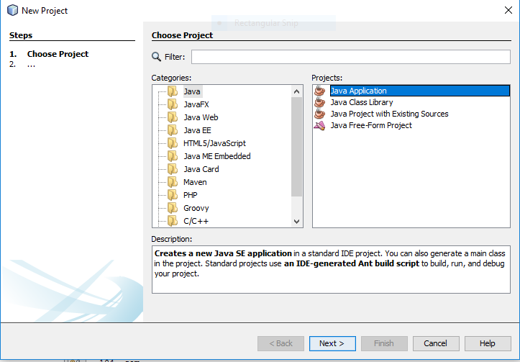

- Enter file name and click finish now your file is setup is completed.

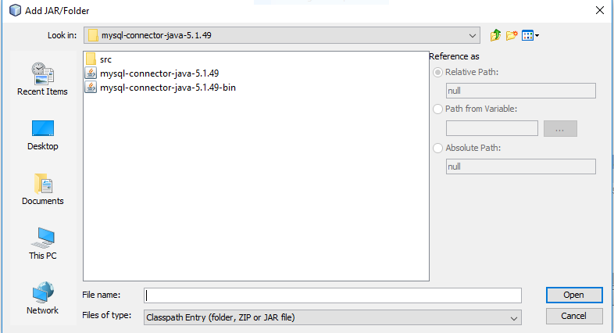

- Open mysql server and create a database welcome. After creation of database, change the database into welcome database. Insert the table with data of some students and run the server.

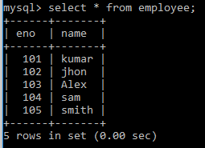

- After running of the mysql server and return to the project mysql1 ,run the program and the output is displayed which are added in the table.

Source code:
package mysql;
import java.sql.*;
import java.util.*;

public class MySql {
public static void main(String[] args) {
try{
Class.forName("com.mysql.jdbc.Driver");
Connection con=DriverManager.getConnection("jdbc:mysql://localhost:3306/it","root","");
Statement st=con.createStatement();
//int insert = st.executeUpdate("insert into employee values(105,'Manoj')");
ResultSet rs=st.executeQuery("select * from employee");
while(rs.next())
System.out.println(rs.getInt(1)+" "+rs.getString(2));
con.close();
}
catch(Exception e){
System.out.println(e);
}
}
}
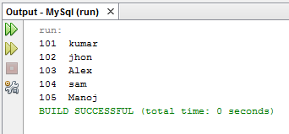

Source code:

package mysql;

import java.sql.*;
import java.util.*;

public class MySql {

public static void main(String[] args) {

try{
Class.forName("com.mysql.jdbc.Driver");
Connection con=DriverManager.getConnection("jdbc:mysql://10.0.9.22:3306/mysqldbcon","root","");
Statement st=con.createStatement();
//int insert = st.executeUpdate("insert into employee values(105,'Manoj')");
ResultSet rs=st.executeQuery("select * from stu");
while(rs.next())
System.out.println(rs.getInt(1)+" "+rs.getString(2));
con.close();
catch(Exception e){
System.out.println(e);
}}}

