Install Tomcat, should be 8.5 or greater
Check executable path, see if you have it:
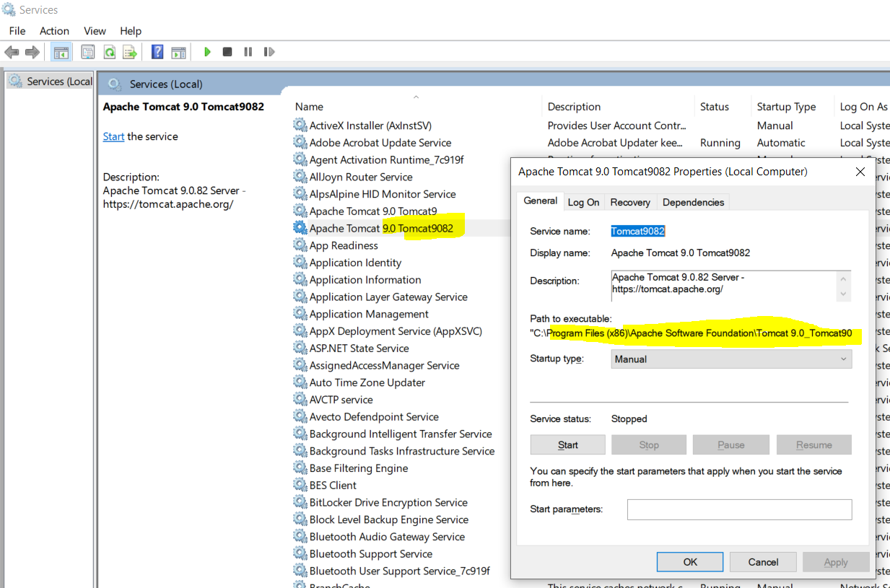
In the Windows lower left corner,  search for ‘Configure Tomcat ‘
- Open ‘Configure Tomcat’
- Go to the ‘Java’ Upper Tab
- 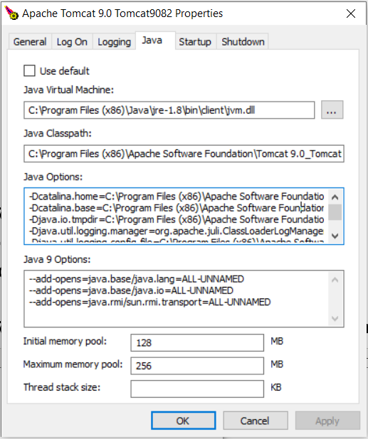
Make sure Java Options is set to:
-Dcatalina.home=C:\Program Files\Apache Software Foundation\Tomcat 9.0_Tomcat901
-Dcatalina.base=C:\Program Files\Apache Software Foundation\Tomcat 9.0_Tomcat901
-Djava.io.tmpdir=C:\Program Files\Apache Software Foundation\Tomcat 9.0_Tomcat901\temp
-Djava.util.logging.manager=org.apache.juli.ClassLoaderLogManager
-Djava.util.logging.config.file=C:\Program Files\Apache Software Foundation\Tomcat 9.0_Tomcat901\conf\logging.properties
-Djava.net.preferIPv4Stack=true
-DserverType=DEVL
-DvcrSystem=MTE
-Ddnweb.overrides.json.file=C:\dnweb-overrides\dn1p\dnweb-json-overrides.json
-Ddnweb.overrides.prop.file=C:\dnweb-overrides\dn1p\dnweb-db-external.properties
-Ddnweb.overrides.json.file=C:\dnweb-overrides\dn1p\dnwsc-json-overrides.json

Make sure Java 9 Options is set to:
--add-opens=java.base/java.lang=ALL-UNNAMED
--add-opens=java.base/java.io=ALL-UNNAMED
--add-opens=java.rmi/sun.rmi.transport=ALL-UNNAMED

If you did not set up a user to log into the manager, it can be done by editing the tomcat-users.xml file in your Catalina directory.
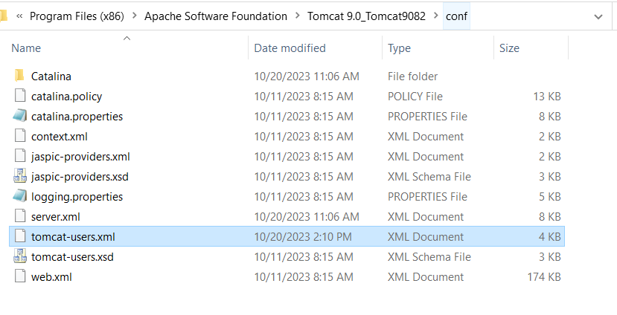
This will require a restart of Tomcat. You can then enter the manager through the url… http://localhost:8080/manager
- Services -> restart the tomcat service
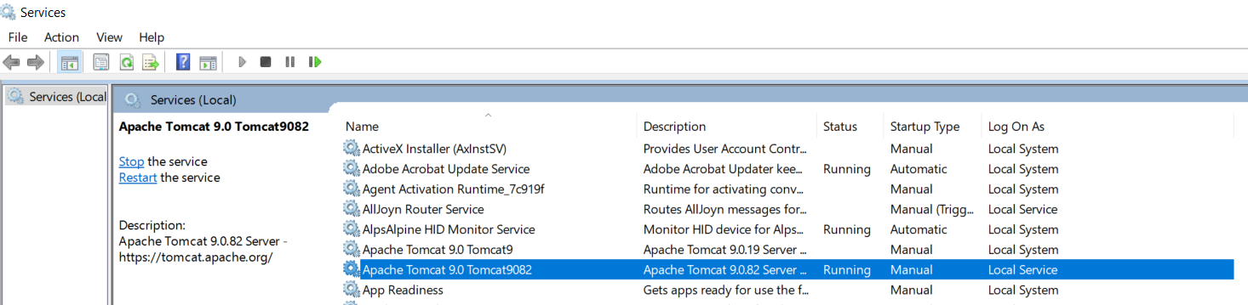
- It worked with Adm/Adm that gave manager-gui role access from
  - C:\Program Files (x86)\Apache Software Foundation\Tomcat 9.0_Tomcat9082\conf\tomcat-users.xml
Next, get the WAR file from here:
\\vwmazpdofile01.fisdev.local\DN\WEB\Client\V034AR010

After starting tomcat, drop the WAR file in here:
{tomcat dir path}\webapps

In windows explorer, go to the {tomcat dir path}\webapps\DNWebUI\WEB-INF\classes\dn and open the application.properties file and look up the ReleaseNumber property. This value will be the version of DN Server needed to run the DN Web. For example:
ReleaseNumber=V03_4A_R010_U23149
That will be version V03.4A.R010. Checkout that version listed in the properties file in Visual Studio and build that code for your alpha/bin folder.

Make updates to application.properties:
Get the IP address of LOCALHOST by running ping LOCALHOST in cmd.exe.
In the file, update #HostIPName=DOE1.metavante.com line to HostIPName=127.0.0.1 (yes remove # symbol)
Update #HostIPPortNumber=53203 to HostIPPortNumber=30000

Update HOST.TXT
Update the server name to LOCALHOST, so…
- DHOST GDDN01 SERVNAME to DHOST GDDN01 LOCALHOST+

Make sure all GDCI01, CRQ, and GDGM DN services are stopped, before starting them. Start them in that order: CI01, CRQ, and GM. Before starting the webpage, log into the tomcat manager and make sure that your DNWeb instance is started in the manager. When started, you can access the tool via the this URL… http://localhost:8080/DNWeb/startApplication.do?who=DNSERVER It might need to be updated based on the install directory for the DN Web application.

