Java Basic

1

© Capgemini 2017. All rights reserved

|

Presentation Title | Author | Date



**Strengths**

**Achivement**

**Education and certificates**

**Base Location:**

**Email ID:**

**Mobile No:**

**Grade:**



**AirLine Reservation System**

Completed end to end case study of

AirLine reservation

System Using SQL and PL/SQL on Oracle 11G

**Professional Summary**

* Overall 6 months of experience in TnL operations as SQL developer and Hand on experience on SQL data Analysis
* Hands on experience on Oracle SQL developer to load the files and execute queries.
* Experience on performing analytical strategies to solve travel ticket issues-this involves gathering data, understanding issue and resolving them using the SQL queries.
* Monitored and performed daily checks on database server to ensure data integrity and detect data errors.
* Tools : Oracle SQL developer, WinSCP, Putty

[-](https://sad-bardeen-ceb858.netlify.app/)

[-](https://sad-bardeen-ceb858.netlify.app/)

[/](https://sad-bardeen-ceb858.netlify.app/)

Analyst/Software Engineer

Mumbai

vamshi.basaram@capgemini.com

+91

7995288121

•

Software Engineer Who is Strong in design and integration with Intuitive problem-skills. Passionate about implementing and launching new projects

•

Ready to learn new technologies and

implement them to further improve my knowledge.

•

A team player with good communication skill always

ready to work for the enrichment of knowledge.

•

Has working Knowledge on Oracle SQL , PostgreSQL and PL/SQL

Bachelor of Technology

Computer Science : 2017

-

2021

**Skills**

Oracle SQL

Unix

MONGODB

**Database**

SQL database

- MySQL

No SQL database

PostgreSQl

–

MongoDB

**Additional Details**

Team Player

Adaptability and quick learner

**Areas of Interest and Hobbies**

Fitness

Photography

Travelling

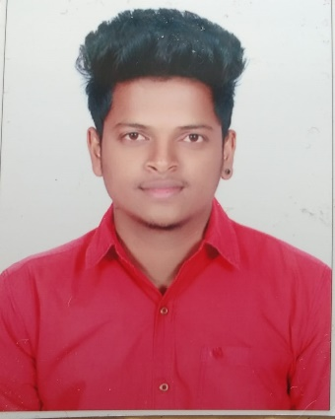

**Vamshi Basaram**



A4