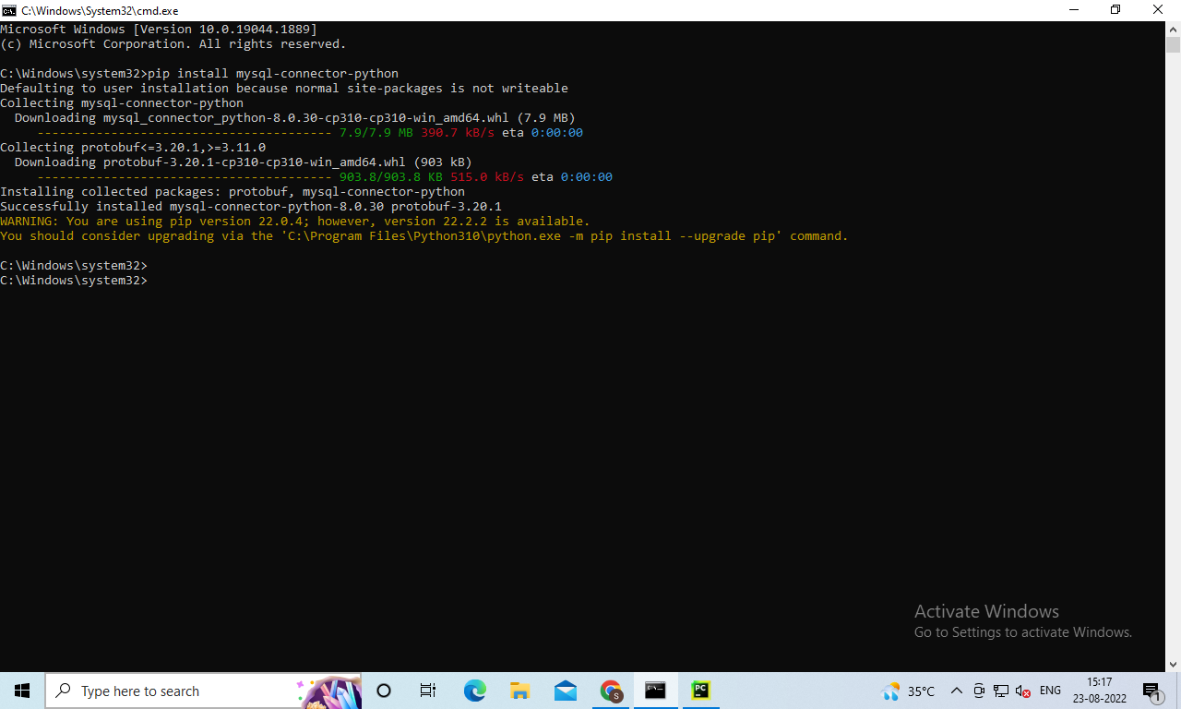

Create a database user



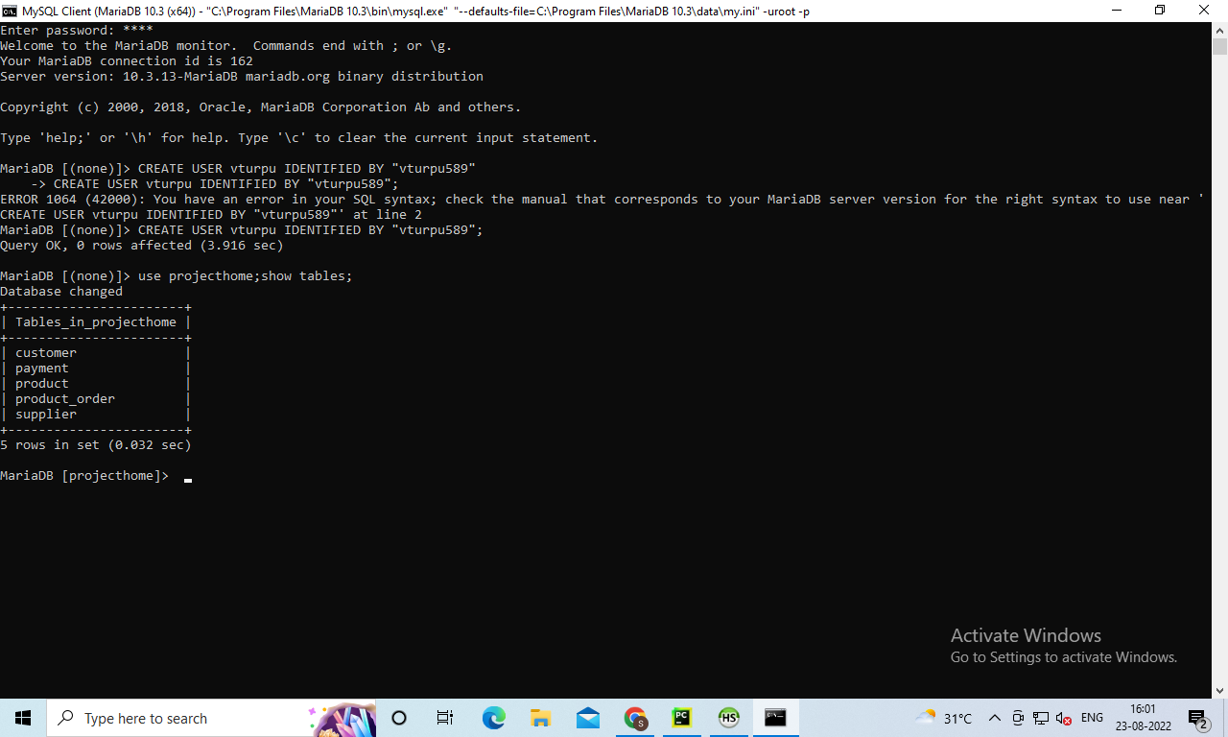



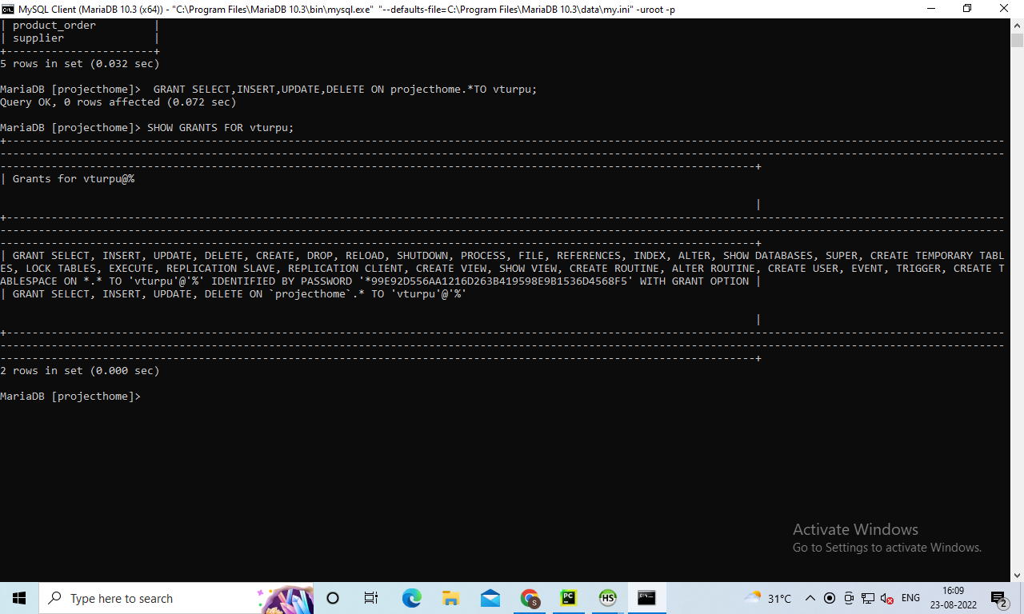

Connecting to MySQL DB

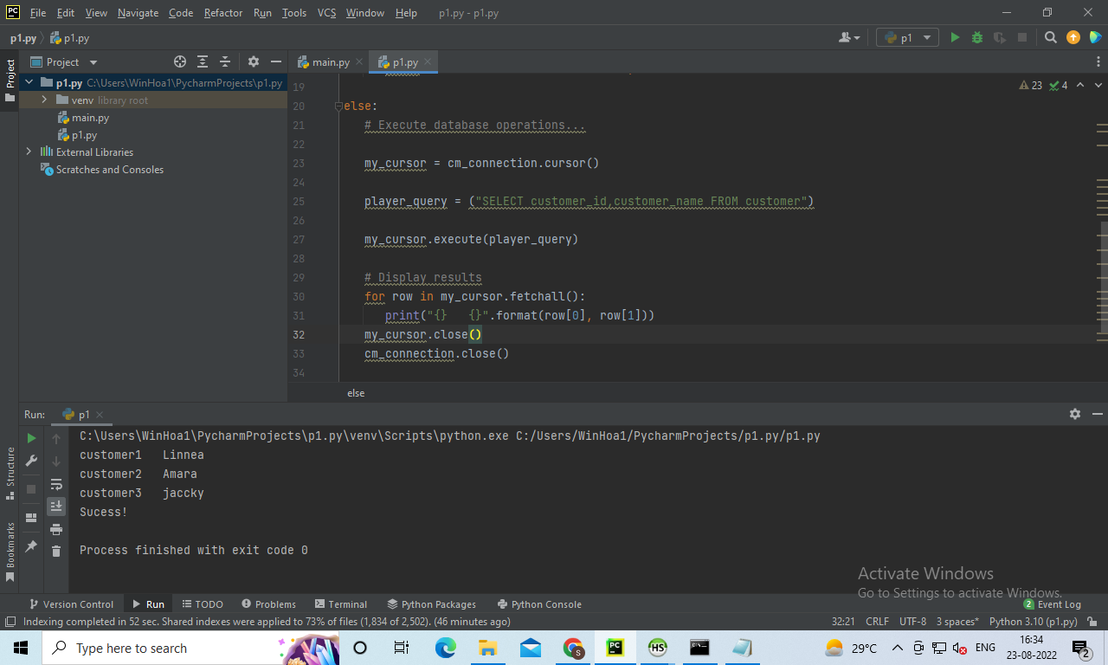

Queries are:

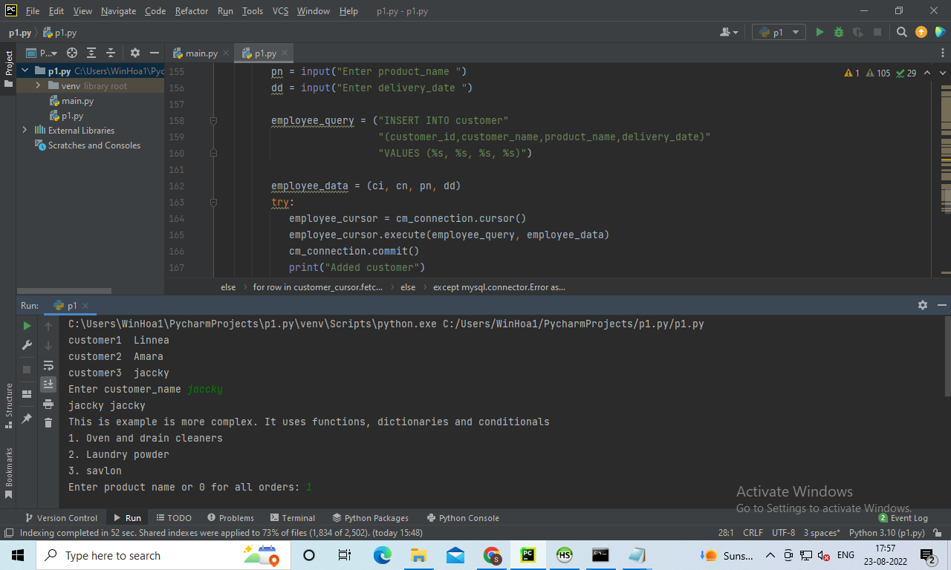

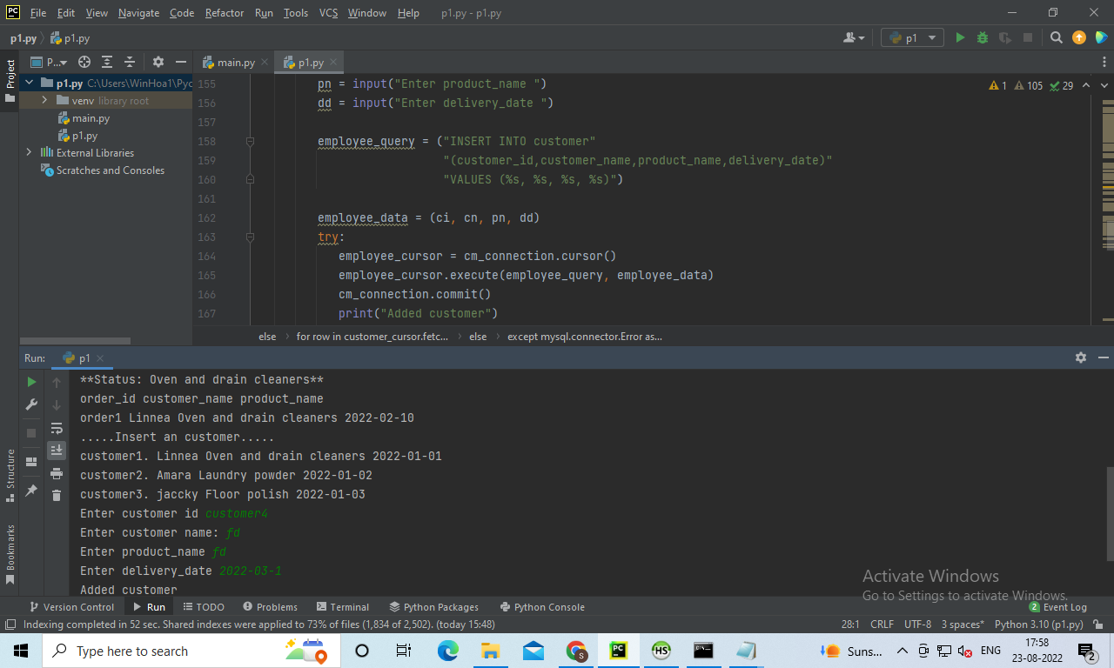

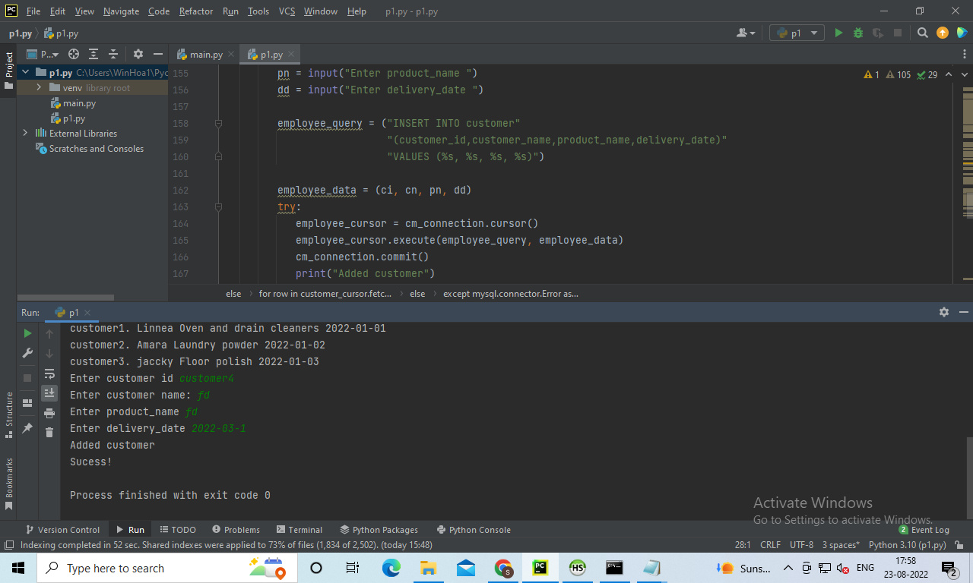

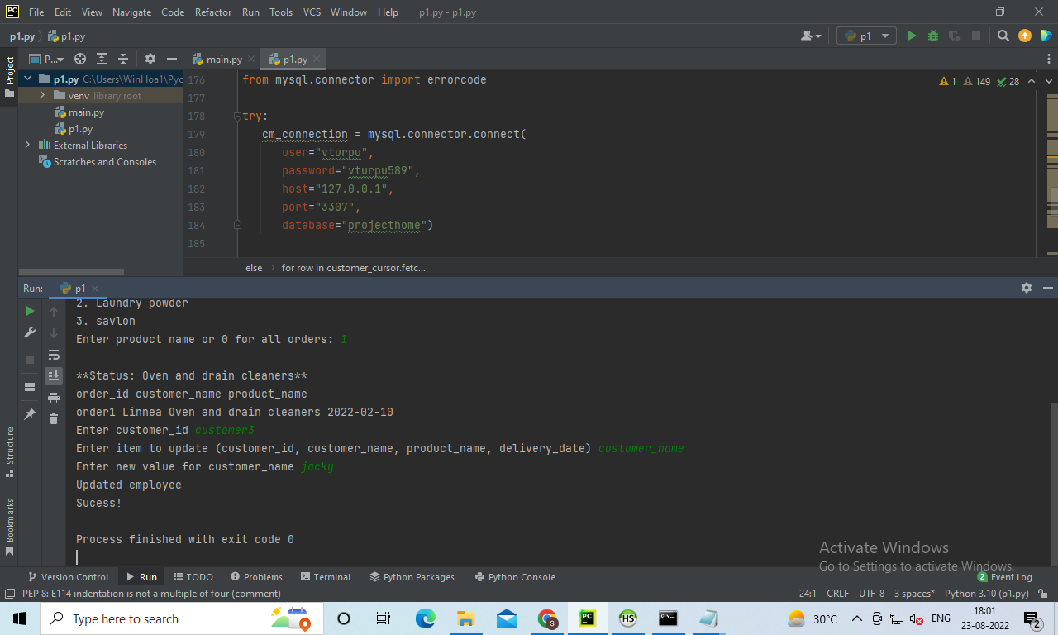

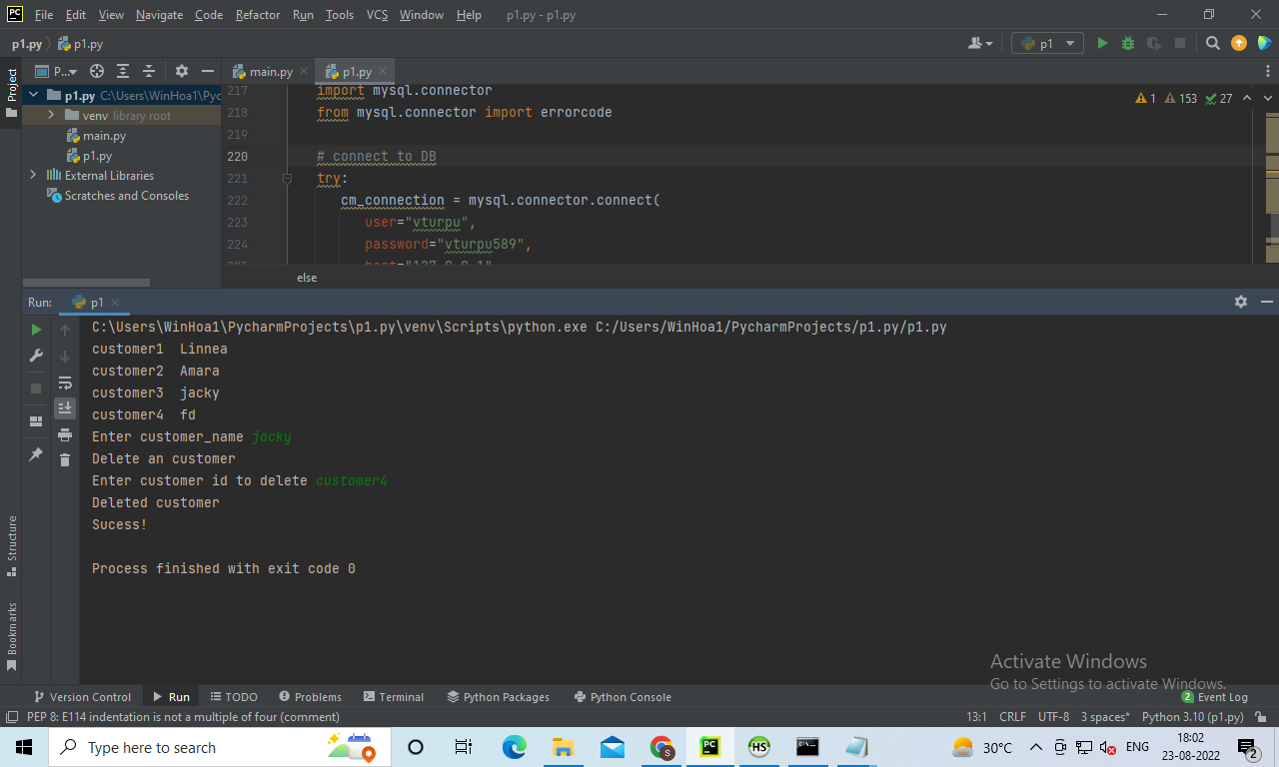

10 points for Internal comments – they must accurately describe each of the following:

The purpose of the program

The connection to the database

The creation of the cursor object

The SQL query string and execution

**Answer:** A web application hasbeen built up for grocery items where all the process of shopping will be accomplished digitally. The end user will buy the product through the payment gateway. The interface will be showing the pictures of grocery products to the end user. Python has been chosen as a programming language which is connected with SQL to store, modify and retrieve information. ‘heidisql’ is a kind of editor or a platform where all the functionalities will be happening. By looking at the object, the activities can be predicted. Hence, customer_details, order_details, order_status, payment and reviews are those essential objects which have been incorporated in the interface of grocery web applications. Subsequently, the data values will be inserted in the mysql database system. MySQL queries will be runned to manage the data like insertion, updation and deletion. Consequently, one to many relationship has been established.