**ABSTRACT:**

This project investigates the pervasive impact of climate change on global agriculture. Employing a comprehensive multidisciplinary approach, the study analyzes historical data and employs advanced modeling techniques to project future scenarios. The research delves into the economic, social, and environmental consequences of climate-induced shifts in agricultural patterns, proposing effective adaptation and mitigation strategies. The findings underscore the critical need for immediate policy interventions to ensure global food security and sustainable agricultural practices.

**EXISTING:**

Existing research reveals a growing consensus on the adverse effects of climate change on agriculture. Rising temperatures, altered precipitation patterns, and increased frequency of extreme weather events pose substantial challenges. Regional variations and vulnerabilities are highlighted, emphasizing the urgent need for adaptive measures. Current strategies focus on sustainable practices, crop diversification, and resilient infrastructure.

**PROPOSED:**

The proposed approach integrates historical data and climate models to assess the specific impact of climate change on global agriculture. A comprehensive economic analysis explores the implications for food production, prices, and trade. The study recommends adaptive measures such as precision agriculture, resilient crop varieties, and policy interventions to mitigate the adverse effects. The proposed strategies aim to enhance the resilience of agricultural systems and contribute to global food security.

**SOFTWARE REQUIREMENTS:**

* Python
* MySql
* Java
* Html, Css & Javascript

**ER MODEL:**

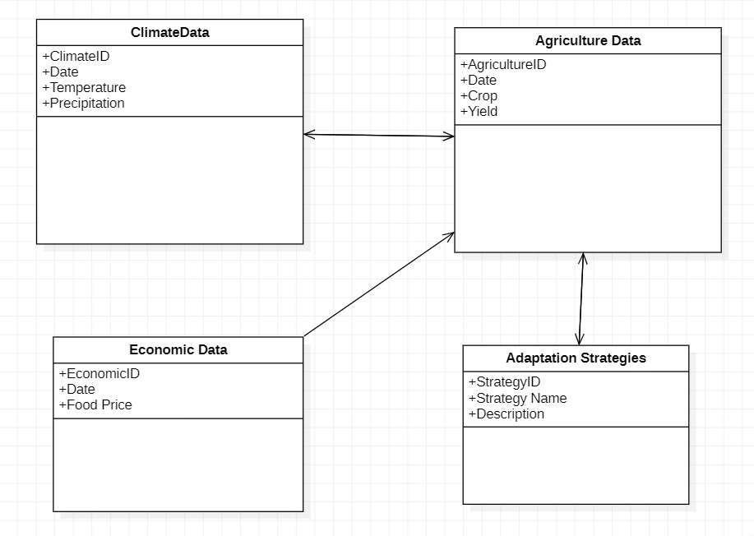

**CONCLUSION:**

The study underscores the urgent need for proactive measures to address the multifaceted challenges posed by climate change to global agriculture. The proposed strategies, backed by robust data analysis, offer a pathway toward sustainable and resilient agricultural systems. Immediate policy interventions are crucial to ensuring food security and mitigating the far-reaching consequences of climate-induced shifts in agricultural patterns.