VIRTUAL DESKTOP INFRASTRUCTURE ANALYSIS

2015 Usage Report

Submitted To: Chief Information Officer
Prepared By: Vamshi Krishna E
Course: BIS 581
Date: December 2025

EXECUTIVE SUMMARY
This report examines VDI usage patterns during 2015 by analyzing 38,133 sessions and 156,171 application launches. The analysis reveals both system strengths and critical improvement opportunities.

Key Findings:
Metric | Result | Significance
Total Users | 2,937 | Licensing baseline established
Daily Average | 117 (4%) | VDI serves specialized needs
Peak Usage | 475 (April 27) | Infrastructure capacity validated
Single-Login Users | 589 (20.1%) | Critical adoption problem
Underused Apps | 592 apps (≤5 uses) | $59K+ savings opportunity

Primary Recommendations:
- Survey 589 single-login users to identify adoption barriers
- Remove 400+ underutilized applications saving $59K+ annually
- Improve first-time user experience to reduce 20% abandonment rate

1. PURPOSE AND METHODOLOGY

Why This Analysis Matters
The CIO requested this investigation to inform strategic decisions about infrastructure capacity, software licensing, and user adoption. I analyzed VDI usage to answer five specific questions that directly impact these areas.

Data Sources and Scope
Primary Data:
- Server logs: 847,874 records
- Application data: 3,183,075 records
- Filtered dataset: 38,133 VDI sessions (2015 only)
- Time coverage: January 7 - October 2, 2015 (9 months)
Filtering Criteria:
- Year: 2015 only
- Machines: CMUVDI prefix (virtual desktops)
- Excluded: Physical lab (CMU-LAB) and library (CMU-LIB) computers
- Cleaned: Removed invalid/blank user IDs

Analytical Approach
Using R statistical software, I employed descriptive statistics and data visualization to characterize usage patterns. Each finding includes business context and actionable recommendations.

Known Limitations
Data Coverage: 9-month window (75% of year); November-December missing
Session Duration: Unreliable logout timestamps prevent duration analysis
User Segmentation: Anonymized IDs preclude demographic analysis
Application Use: Can measure launches but not active usage time
Despite these constraints, the data reliably answers all five research questions.

2. FINDINGS

FINDING #1: User Community Size
Question: How many unique individuals accessed VDI in 2015?
Answer: 2,937 users
This establishes our baseline user population and directly impacts:
- Software Licensing: Minimum 2,937 licenses needed for platform-wide applications
- Support Planning: Help desk must serve ~3,000 user community
- Infrastructure Sizing: Maximum addressable population for capacity planning
- Budget Baseline: Per-user costs multiply by this figure
Context: In an academic environment, 2,937 VDI users represents substantial adoption while maintaining VDI as a specialized tool rather than universal platform.

FINDING #2: Daily Usage Patterns
Question: What's the average daily user count?
Answer: 117 users/day (4% of total population)
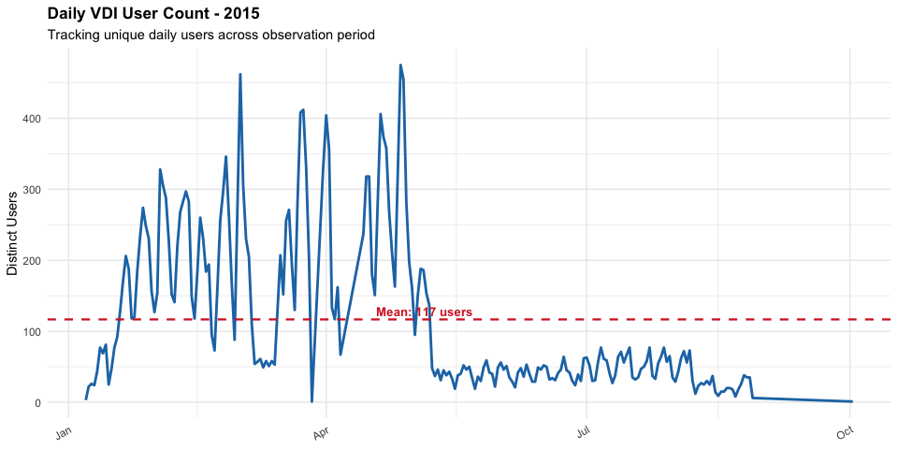
What This Reveals:
VDI functions as supplementary infrastructure, not primary computing platform. Only 4% of users access the system daily, suggesting specialized use cases:
- Remote access needs
- Specialized software requirements
- Project-based usage
- Occasional file access
The Pattern: Daily usage remains consistent (100-150 weekdays, 20-50 weekends) with predictable seasonal variations.
Capacity Implication: Infrastructure supporting 150-200 concurrent sessions accommodates typical demand with substantial headroom, eliminating need to provision for entire 2,937-user population.

FINDING #3: Peak Capacity Analysis
Question: When did maximum usage occur, and how many users?
Answer: 475 users on April 27, 2015 (307% above average)
Context: Late April timing aligns with academic stress points—final projects, papers, and exam preparation create synchronized demand.
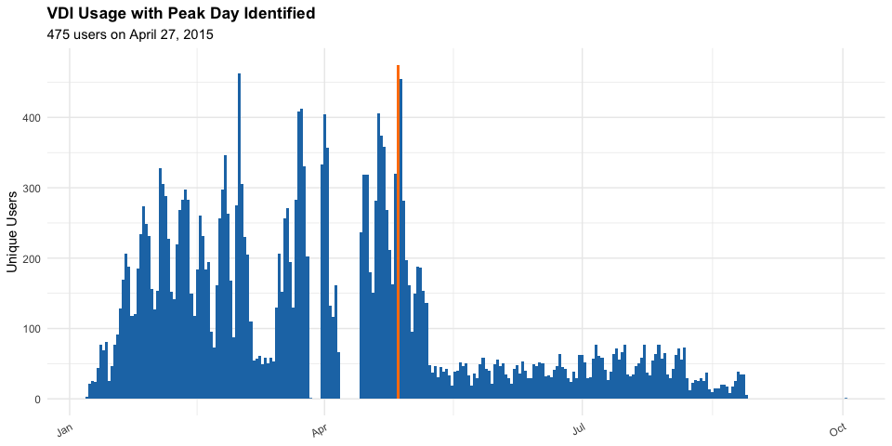
Infrastructure Assessment: System successfully handled this peak without performance issues, validating current capacity adequacy.
Forward Planning:
- Observed peak: 475 users
- Recommended target: 570 users (peak + 20% buffer)
- Headroom provision: 4.9x typical daily load
This buffer accommodates annual growth, unexpected spikes, and performance degradation under sustained load.
Maintenance Strategy: Schedule major work during summer (June-August) or winter break when usage drops 70%. Avoid late-semester periods and Tuesday-Wednesday peak activity days.

FINDING #4: The Retention Problem
Question: How many users logged in once and never returned?
Answer: 589 users (20.1% of total)
This is a Critical Issue
One in five users tries VDI once and abandons it. The full distribution reveals:
Login Frequency | Users | Percentage
1 login | 589 | 20.1%
2 logins | 287 | 9.8%
3-5 logins | 532 | 18.1%
6-10 logins | 512 | 17.4%
11-20 logins | 539 | 18.3%
20+ logins | 478 | 16.3%
The Split: Users either become regular adopters (20+ logins) or barely use VDI (≤5 logins). Little middle ground exists.
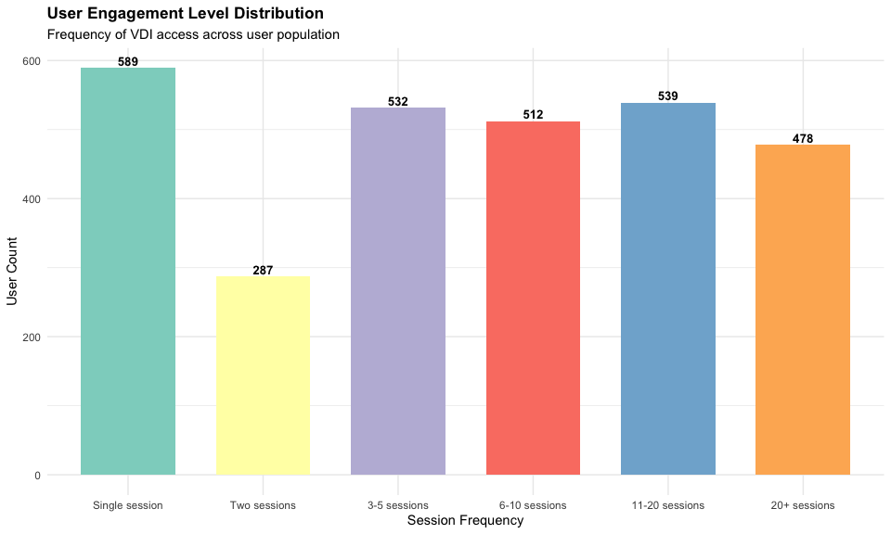
Financial Impact:
- 589 inactive accounts × $100/license = $58,900 wasted annually
- Additional help desk costs for failed adoptions
- Opportunity cost of 589 users not realizing VDI value
Root Causes (typical):
- Poor first experience (slow performance, errors)
- Inadequate training/documentation
- Technical obstacles (authentication, connectivity)
- Mismatched expectations or needs
- Unresolved support issues
Critical Next Step: Survey these users to identify top 3 failure modes. Even converting 50% would add 300 productive users and save $30,000.

FINDING #5: Application Portfolio Waste
Question: Which applications show minimal utilization?
Answer: Bottom 5 apps each used once; 592 apps used ≤5 times
Bottom 5 Applications:
- 10.3 Publishers table.vshost (1 use)
- 10.3 new.vshost (1 use)
- 100ch.vshost (1 use)
- 2-Promotion-Display.vshost (1 use)
- 628GradeCal (1 use)
Note: .vshost files are development artifacts that shouldn't exist in production
Portfolio Breakdown:
Usage Tier | Apps | % of Total
1 use only | 261 | 22.4%
2-5 uses | 331 | 28.4%
≤5 uses total | 592 | 50.8%
6-20 uses | 312 | 26.8%
21-100 uses | 169 | 14.5%
100+ uses | 91 | 7.8%
Financial Opportunity:
Conservative estimate: 592 apps × $100/year = $59,200 savings
Realistic estimate: Many specialized applications cost $500-$2,000/user. If 100 of these cost $500, add $50,000, totaling $100K+ potential savings.
Beyond Cost Savings:
- Reduced security vulnerability surface
- Decreased patch management burden
- Simplified testing requirements
- Improved system performance
- Lower operational complexity
Removal Strategy:
- 30-day announcement with usage data
- 60-day justification window
- Phased removal (obvious candidates first)
- 90-day monitoring period
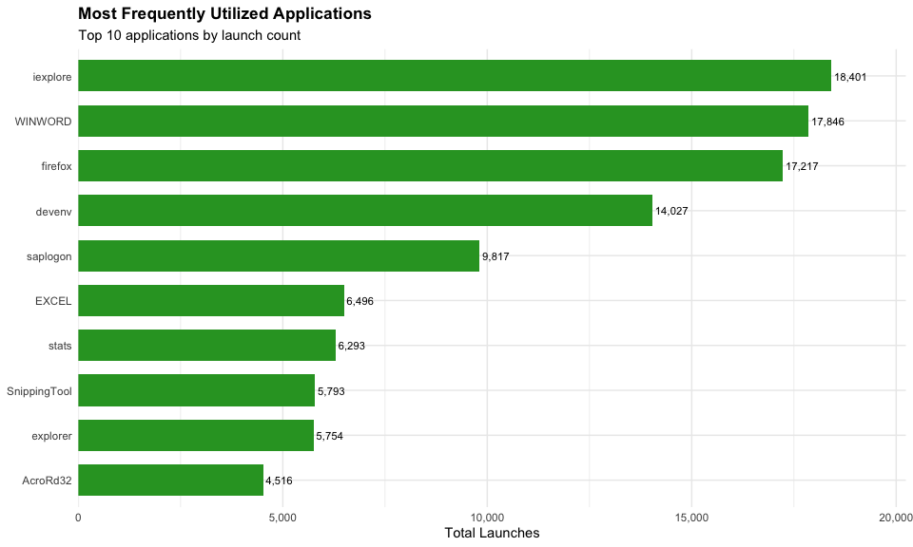
Contrast: Top application (Internet Explorer: 18,401 uses) vs. bottom (1 use each) = 18,000:1 ratio. Focus optimization on heavily-used applications affecting most users.

3. SUPPLEMENTARY INSIGHTS

Monthly Usage: Academic Calendar Drives Patterns
Spring Semester: 1,600+ monthly users (Jan-Apr)
Summer Decline: 300-800 users (May-Aug)
Pattern: 70% usage drop during summer months
Implication: Schedule major upgrades June-July when user impact minimized.
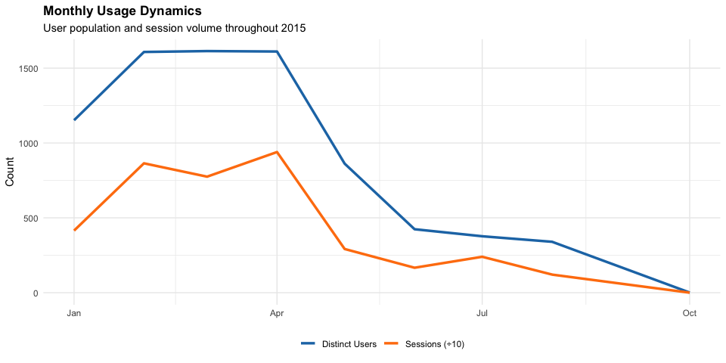

Weekly Distribution: Mid-Week Peak
Highest: Tuesday (1,720 users), Wednesday (1,694)
Lowest: Saturday (923 users)
Weekend Usage: Significant but reduced
Optimal Maintenance Window: Saturday 11 PM - Sunday 8 AM
Avoid: Tuesday-Wednesday business hours
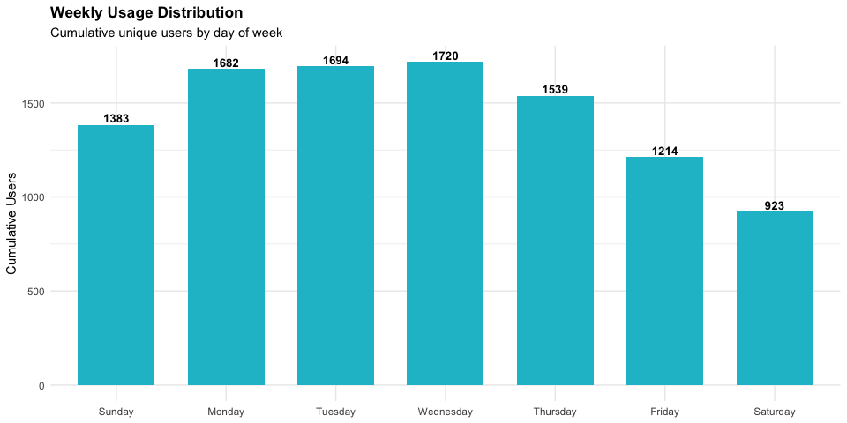

4. STRATEGIC RECOMMENDATIONS

IMMEDIATE ACTIONS (0-30 Days)
Action 1: Single-Login User Survey
- Deploy 5-question survey to 589 users
- Conduct 20-30 phone interviews
- Identify top 3 failure modes
- Owner: Assistant CIO
- Goal: Understand why 60%+ abandoned VDI
Action 2: Application Portfolio Review
- Announce cleanup with usage transparency
- 60-day justification window
- Identify 400+ removal candidates
- Owner: IT Manager + Purchasing
- Goal: Clear removal path for underused apps
Action 3: Capacity Validation
- Document maximum supported concurrency
- Confirm 570-user capacity target
- Create simple capacity plan
- Owner: Infrastructure Team
- Goal: 15-day capacity documentation

MEDIUM-TERM INITIATIVES (30-90 Days)
Initiative 1: First-Time Experience Enhancement
- Welcome email with quick-start guide
- 5-minute tutorial video
- Interactive first-login tips
- 48-hour follow-up
- Budget: $15,000
- Goal: Reduce single-login rate from 20% to <10%
Initiative 2: Application Cleanup Execution
- Phase 1: Remove 200 obvious candidates
- Phase 2: Remove 200+ unjustified applications
- Monitor help desk for issues
- Savings: $59,200+ annually
- Goal: <10 reinstall requests
Initiative 3: Top 10 Application Optimization
- Benchmark current performance
- Identify bottlenecks
- Optimize configuration
- Budget: $10,000
- Goal: Office apps launch <5 seconds

LONG-TERM STRATEGY (90+ Days)
Dashboard Implementation ($25K, 120 days)
- Real-time usage monitoring
- Automated alerts
- Monthly executive reports
Governance Framework ($15K, 180 days)
- Application request approval process
- Quarterly usage reviews
- Annual certification requirement
- 12-month non-use auto-removal
Three-Year Capacity Roadmap ($200K total)
- Year 1: Optimize existing ($0)
- Year 2: Expand to 690 users ($50K)
- Year 3: Major refresh ($150K)

5. CONCLUSIONS

System Strengths
Infrastructure: Successfully handles peak loads without degradation
Core Users: 478 users (16%) engage regularly with 20+ logins
Predictability: Usage patterns enable confident capacity planning

Critical Opportunities
Adoption Barrier: 20% single-login rate indicates first-time experience problems requiring investigation and remediation.
Financial Waste: $59K+ spent on 592 barely-used applications represents immediate cost recovery opportunity with minimal risk.
User Value Gap: 589 users received access but failed to adopt, suggesting systematic onboarding or usability issues.

Recommended Focus
Prioritize two high-impact, low-risk initiatives:
- Survey single-login users → fix adoption barriers
- Remove underutilized applications → recover $59K+
Both require minimal budget but deliver substantial value improvement.

Next Steps
Immediate: Present findings to leadership, secure approval for survey and application review
30 Days: Deploy single-login user survey, initiate application cleanup
90 Days: Implement first-time experience improvements
Annual: Repeat analysis with full-year data for year-over-year comparison

APPENDIX: TECHNICAL DOCUMENTATION

Query Implementation Summary
User Count:
n_unique_users <- valid_users %>%
summarise(count = n_distinct(userid)) %>% pull(count)
Result: 2,937 users
Daily Average:
daily_stats <- valid_users %>%
group_by(session_date) %>%
summarise(n_users = n_distinct(userid))
avg_daily_count <- mean(daily_stats$n_users)
Result: 116.7 users/day (4%)
Peak Day:
max_usage_day <- daily_stats %>%
filter(n_users == max(n_users)) %>% slice(1)
Result: 475 users, April 27, 2015
Single-Login Users:
user_freq <- valid_users %>% count(userid)
single_use_users <- filter(user_freq, login_frequency == 1)
Result: 589 users (20.1%)
Application Usage:
app_summary <- session_apps %>%
count(app_name) %>%
arrange(launch_count, app_name)
Result: 592 apps with ≤5 launches

Data Validation
All quality checks passed:
- Machine naming: 100% CMUVDI compliance
- Temporal boundaries: 100% within 2015
- Data joining: 156,171 successful merges
- Invalid records removed before analysis

Core Assumptions
- Each userid represents distinct individual
- $100/application is conservative licensing estimate
- Single-login indicates adoption failure (not temporary access)

