Course End Project Report
on
“ALOHA vs CSMA Performance Analyzer”
For the Course of
COMPUTER NETWORKS(22ITC04N)
in
B.E, INFORMATION TECHNOLOGY
Submitted by
Hari Niveditha Dharmagadda (160124737007)
Vamshika Mittakola (160124737016)
Under the guidance of Course Faculty:
Ms P.Kiranmayee,Asst.Professor, Dept of IT.
DEPARTMENT OF INFORMATION TECHNOLOGY
CHAITANYA BHARATHI INSTITUTE OF TECHNOLOGY(A)
(Affiliated to Osmania University; Accredited by NBA,NAAC A++,ISO)
Kokapet(V),Gandipet(M),Hyderabad, Telangana, India -500075
website: www.cbit.ac.in

CONTENTS
1. ABSTRACT
2. PROBLEM STATEMENT
3. OBJECTIVES
4. BACKGROUND / THEORY
5. SYSTEM ARCHITECTURE
6. METHODOLOGY & PERFORMANCE METRICS
7. APPLICATION SCREENSHOTS
8. CONCLUSION

ABSTRACT
In a shared communication channel with no central coordinator, multiple nodes decide independently when to transmit. When two or more nodes transmit in overlapping time windows, their signals collide and both transmissions are lost, requiring retransmission. This project implements three random-access MAC protocols — Pure ALOHA, Slotted ALOHA, and 1-Persistent CSMA — as actual discrete-event simulations. By building a simulation engine that generates Poisson-distributed packet traffic, this project evaluates the protocols under varying traffic conditions. The system quantifies performance using standard metrics: throughput, collision rate, average delay, retransmissions, dropped packets, and channel utilization. The project provides an interactive Streamlit dashboard for configuring parameters and exploring results live, demonstrating how different access protocols manage shared resources.

PROBLEM STATEMENT
In a shared communication channel with no central coordinator, multiple nodes decide independently when to transmit. When two or more nodes transmit in overlapping time windows, their signals collide and both transmissions are lost, requiring retransmission. This is the classic random-access MAC (Medium Access Control) problem — the core question is how different access protocols manage this shared resource, and how well each performs under varying traffic conditions. Traditional theoretical models provide only analytical throughput bounds, lacking empirical simulation of real packet-level traffic. There is a need for a reliable discrete-event simulation engine to validate simulated results against known analytical bounds and study scalability under increasing offered load and node counts.

OBJECTIVES
• Implement three random-access MAC protocols — Pure ALOHA, Slotted ALOHA, and 1-Persistent CSMA — as actual discrete-event simulations, not theoretical calculators.
• Quantify performance using standard metrics: throughput, collision rate, average delay, retransmissions, dropped packets, and channel utilization.
• Ensure fair comparison by running all three protocols on identical generated traffic.
• Validate simulated results against known analytical throughput bounds.
• Study scalability under increasing offered load and increasing node count.
• Provide an interactive tool for live parameter exploration, not just static output.

BACKGROUND / THEORY
Slotted ALOHA halves the vulnerability window (2T) by synchronizing transmissions to slots. CSMA further shrinks the collision-prone window to approximately the propagation delay, but does not eliminate collisions entirely: two nodes can both sense an apparently idle channel within the propagation delay of each other, before either transmission has physically reached the other node, and therefore collide.
Pure ALOHA: transmit instantly; two transmissions collide if start times overlap; exponential random backoff is used after a collision.
Slotted ALOHA: packets wait for the next slot boundary; a collision occurs when two or more nodes transmit in the same slot index; retry attempts are scheduled in future slots.
1-Persistent CSMA: sense the channel before transmitting; wait while the channel is busy; the collision window is defined by propagation delay.

SYSTEM ARCHITECTURE
The system architecture consists of a UI Layer, a Simulation Engine, and a Visualization Layer.
The UI Layer (Streamlit / app.py) interacts with the Simulation Engine which handles the data models, packet arrival generation, and MAC rules execution (Pure ALOHA, Slotted ALOHA, CSMA). It computes pure functions for throughput, delay, and collision rates. The Visualization Layer generates timelines and load analysis charts.
The simulation engine is fully decoupled from the user interface. This allows the networking logic to be tested independently before any UI code is involved.

METHODOLOGY & PERFORMANCE METRICS
1. User selects protocol and simulation parameters in Streamlit.
2. Traffic generator creates a reproducible packet-arrival trace.
3. The selected protocol processes the packets according to its MAC rules.
4. Overlapping transmissions are detected as collisions according to the protocol model.
5. Collided packets are retransmitted subject to the configured retry/backoff rules.
6. Metrics are calculated from the resulting packet list and channel activity log.

APPLICATION SCREENSHOTS
The following screenshots demonstrate the interactive ALOHA vs CSMA Performance Analyzer application, showing the Dashboard, Packet-Level Transmission Table, Channel Activity Timeline, Protocol Comparison, and Parametric Load Sweep Results.
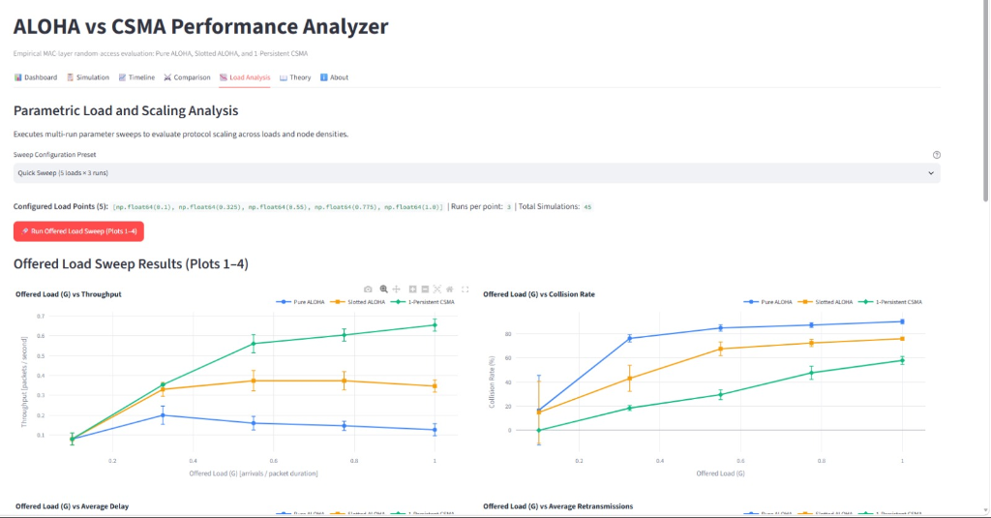

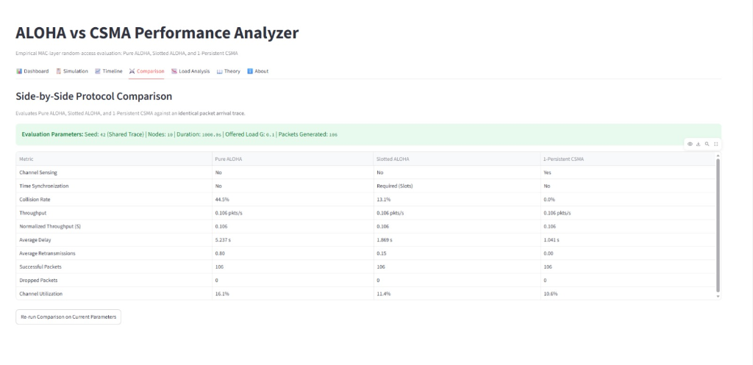

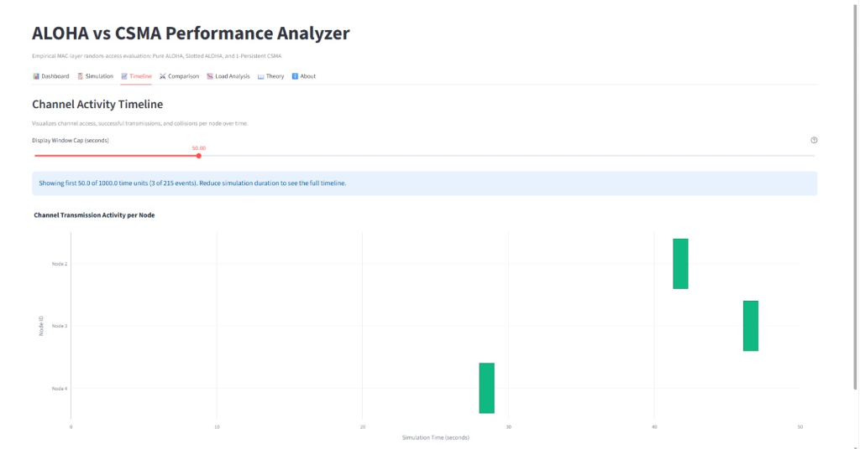

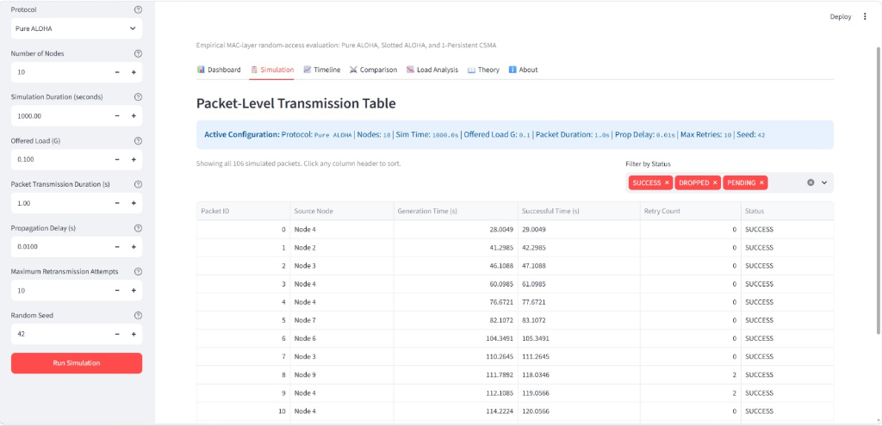

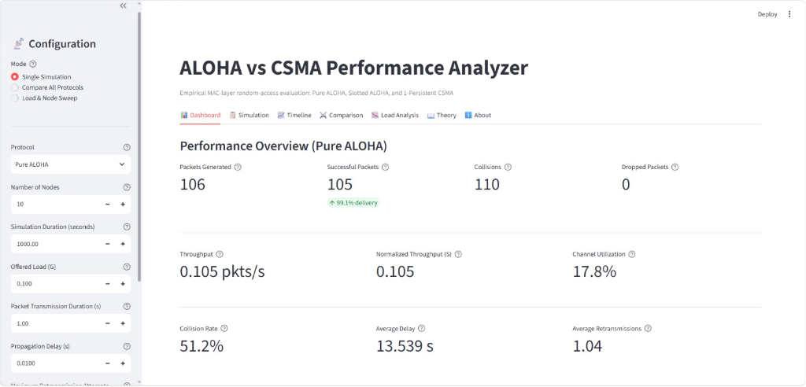

CONCLUSION
In conclusion, the developed discrete-event simulation effectively models and compares the Pure ALOHA, Slotted ALOHA, and 1-Persistent CSMA protocols. The results align with theoretical expectations, highlighting the superior channel utilization and throughput of CSMA under moderate loads, while demonstrating the vulnerability window effects of both ALOHA variants. The interactive UI provides an excellent pedagogical and analytical tool for random-access MAC evaluation.

