Ideation Phase

Brainstorm & Idea Prioritization Template

|  |  |
| --- | --- |
| Date |  |
| Team ID | LTVIP2025TMID38966 |
| Project Name | GRAINPALETTE |
| Maximum Marks | 4 Marks |

# Brainstorm & Idea Prioritization Template:

Brainstorming provides a free and open environment that encourages everyone within a team to participate in the creative thinking process that leads to problem solving. Prioritizing volume over value, out-of-the-box ideas are welcome and built upon, and all participants are encouraged to collaborate, helping each other develop a rich amount of creative solutions.

Use this template in your own brainstorming sessions so your team can unleash their imagination and start shaping concepts even if you're not sitting in the same room.

Reference: <https://www.mural.co/templates/brainstorm-and-idea-prioritization>

# Step-1: Team Gathering, Collaboration and Select the Problem Statement

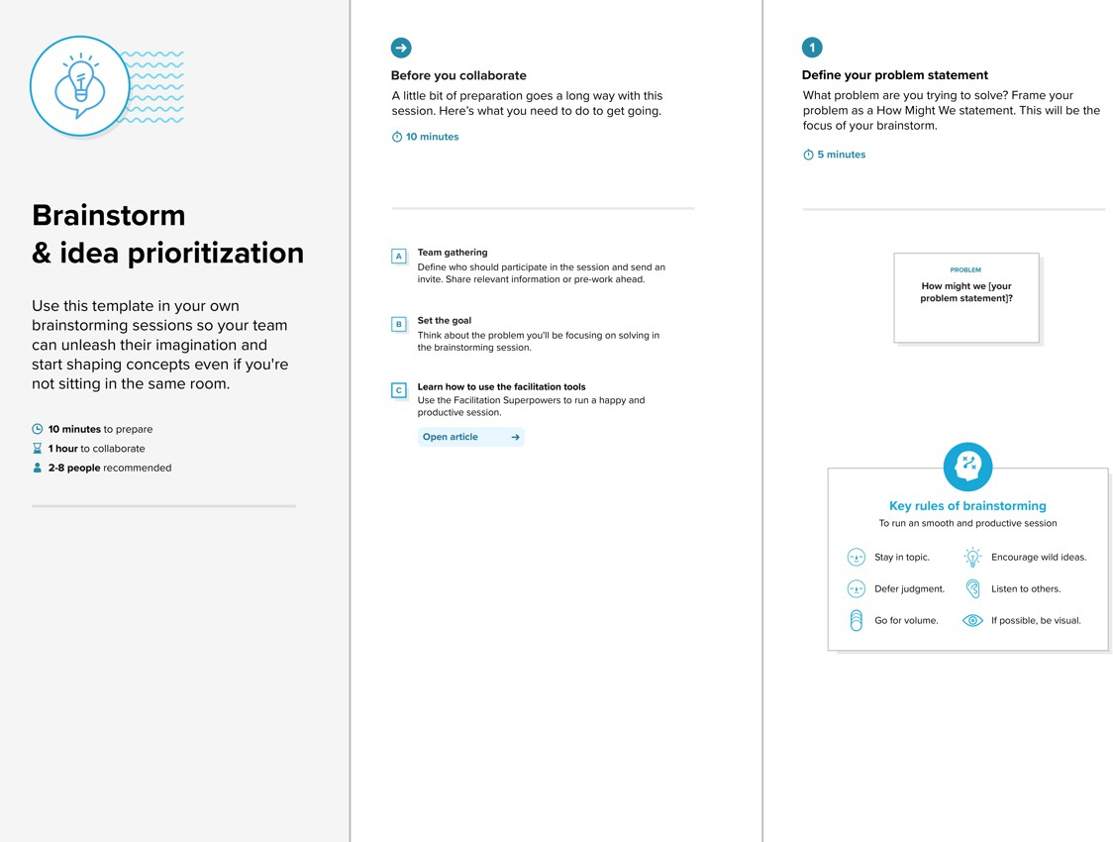Our team discussed the common issues faced by farmers and agriculture researchers in identifying rice types manually. We agreed to tackle the problem of misclassification in rice grain identification using AI-based image classification. This will reduce human error, speed up identification, and support informed agricultural decisions.

**Step-2: Brainstorm, Idea Listing and Grouping**

Ideas listed by the team:  
- Use Convolutional Neural Networks (CNN) for rice grain image classification  
- Apply Transfer Learning with MobileNetV2  
- Build a web interface using Flask, HTML, CSS  
- Allow users to upload rice images from their device  
- Provide real-time feedback for unclear or invalid images  
- Keep the UI intuitive and user-friendly for non-technical users  
- Include 5 rice varieties: Arborio, Basmati, Ipsala, Jasmine, Karacadag  
- Visualize training progress with accuracy/loss plots and confusion matrix

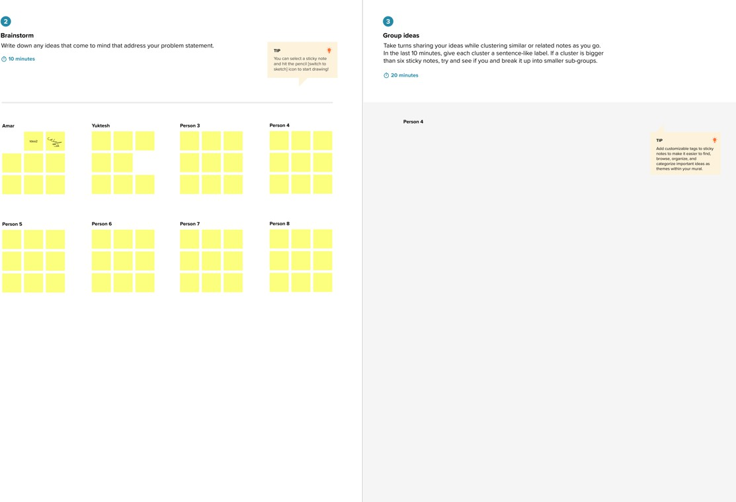

**Step-3: Idea Prioritization**

High Priority:  
- Image upload and prediction system using MobileNetV2  
- User-friendly web interface with clear feedback  
- Fast and accurate rice type classification  
  
Medium Priority:  
- Visualization of training metrics  
- Feedback for invalid or unclear images  
  
Low Priority:  
- Option to retrain the model with new data  
- Multiple language support in the web app

