Week 01 – C# Language & Object Foundations

Sectoin – A : Learnings

Day 01 : Toolchain and Git

Task 1.1:
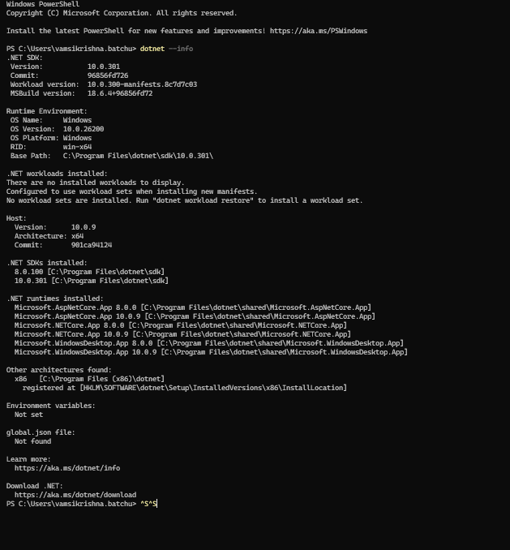

Task 1.2
Screenshot:
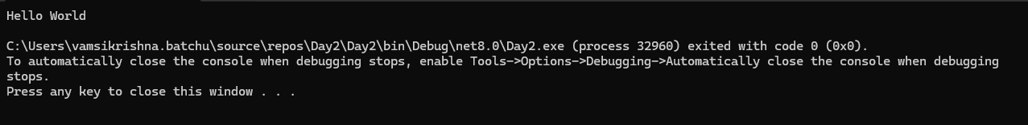

Task 1.3: Adding my git hub repo here
Vamsi-Batchu/impact-dotnet-vamsik
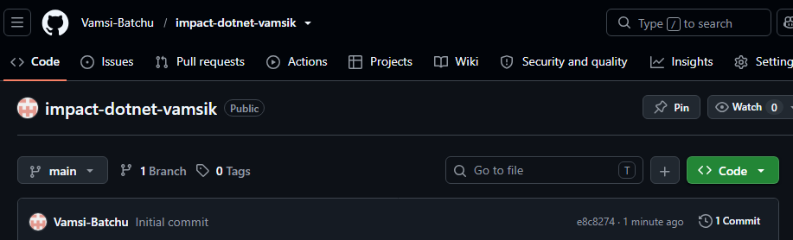

Task 1.4:
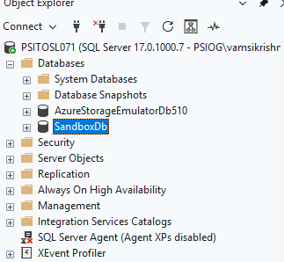

Day 02 : Namespaces, Identifiers, Preprocessors

Task 1.5:

Task 1.6:

Task 1.7:

Task 1.8:
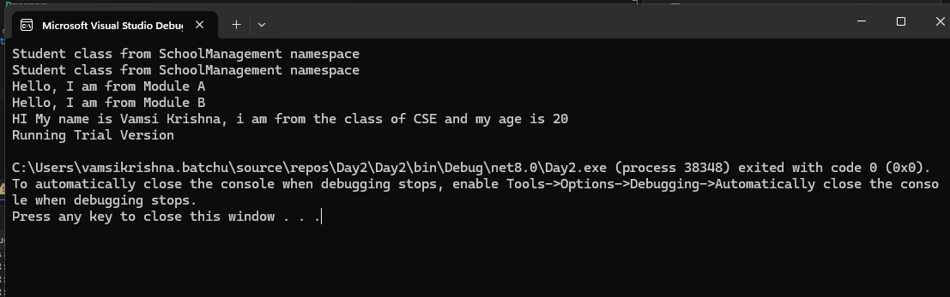

Day 03 : Memory, Model, Enums, Nullable, Conversion

Task 1.9:

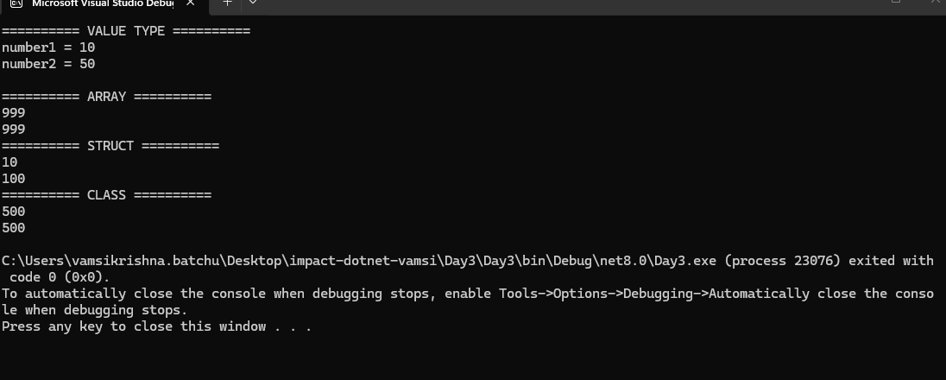

Task 1.10:
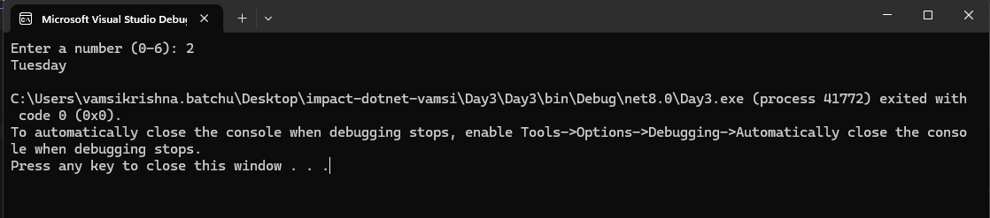

Task 1.11:
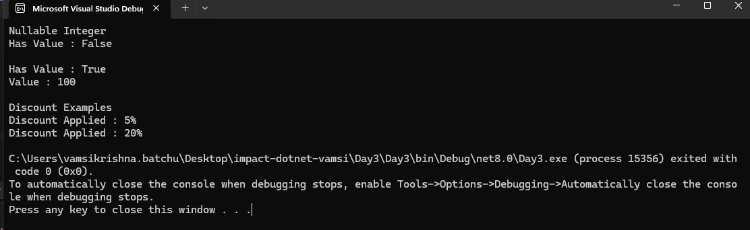

Task 1.12:
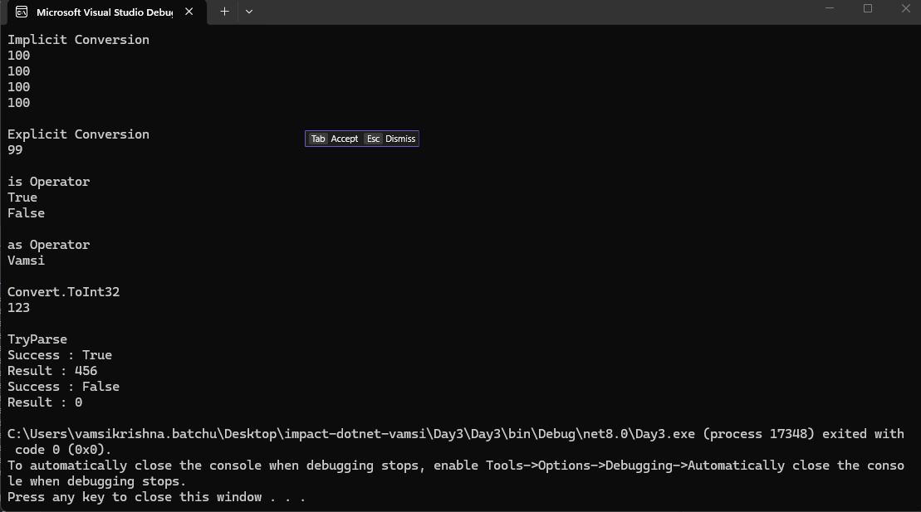

Day 04 : Modern Syntax + Class Anatomy

Task 1.13:
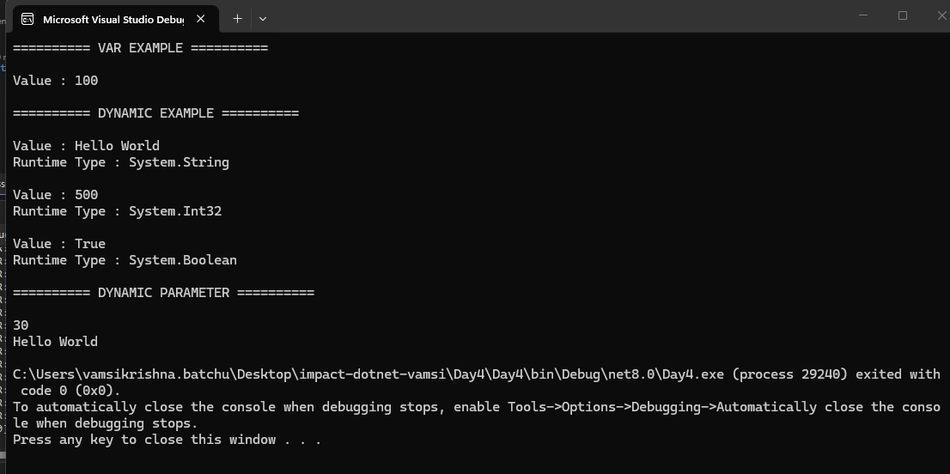

Task 1.14:
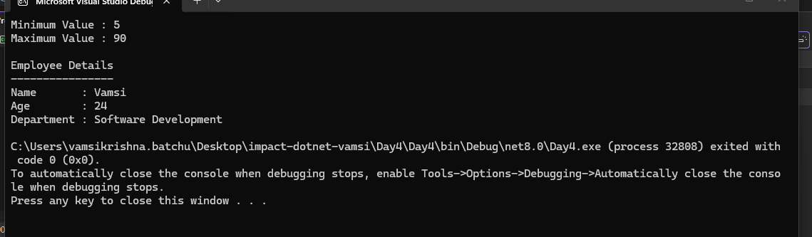

Task 1.15:
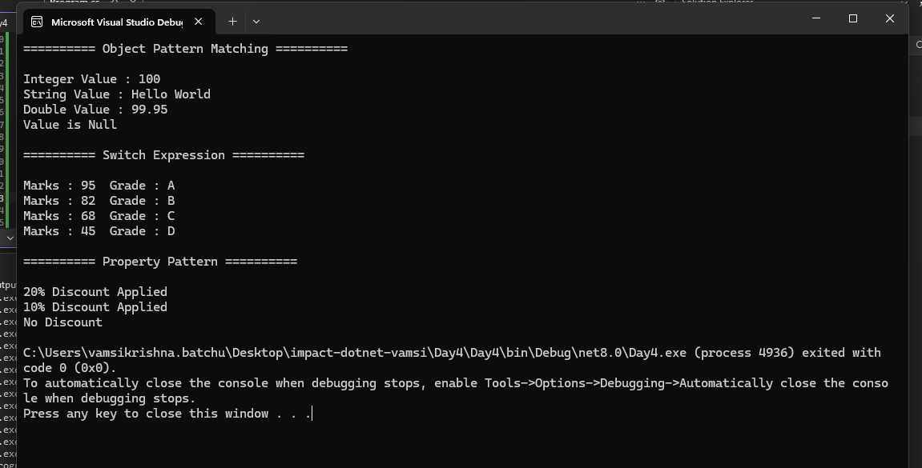

Task 1.16:
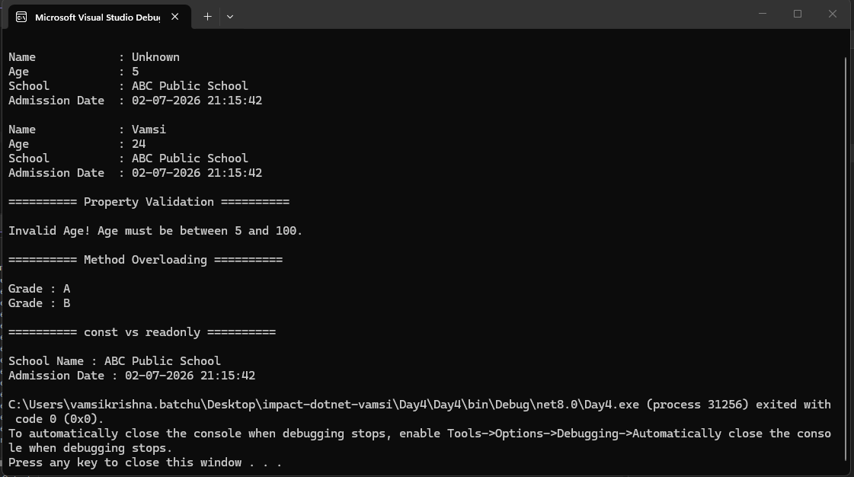

Day 05 : Partial, Access, Strings, Records, Idexers + Mini-Projects

Task 1.17:
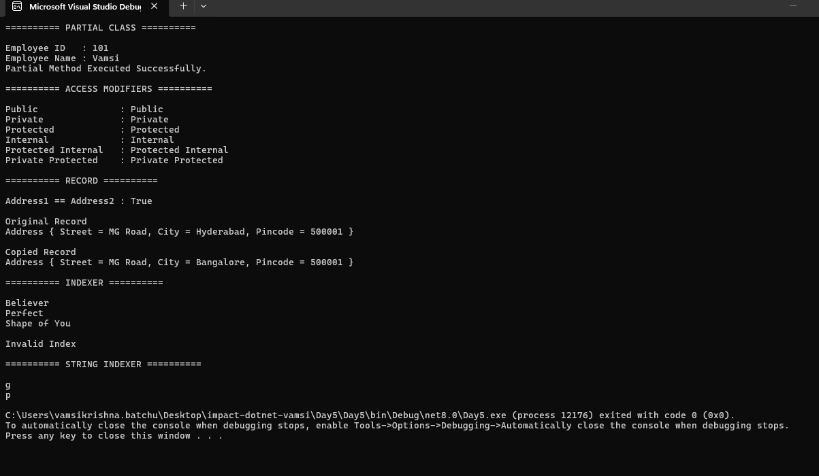

MiniQ1 – Product catalog
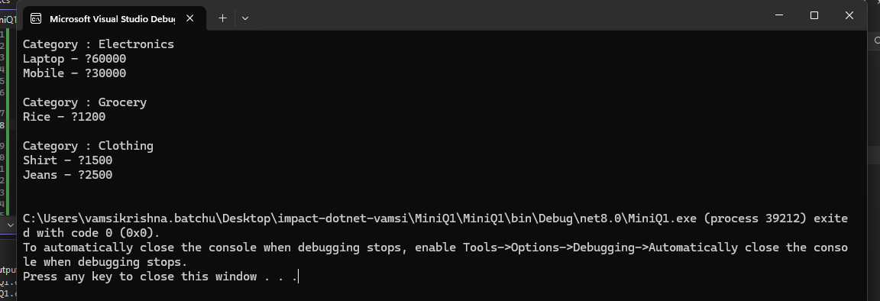

Mini Q2 – Temperature converter
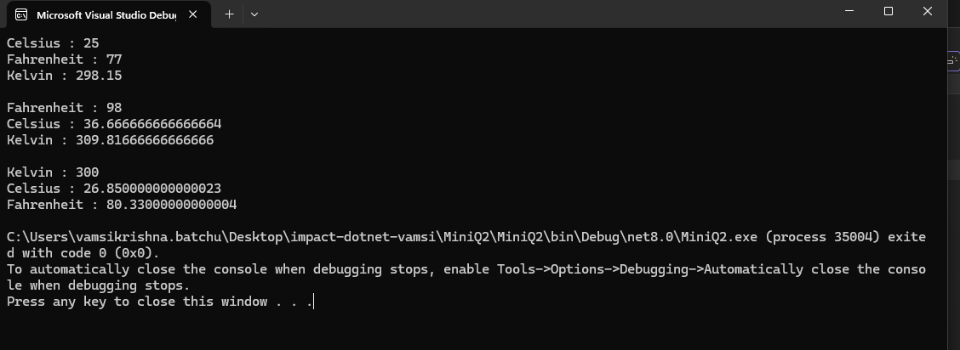

Mini Q3 – Contact card
