**CS594: Responsible AI Engineering**

**Lab-3: Apache Kafka**

**Name: Meka Vamsi Dath**

**UIN: 660130568**

**Approach to the Lab Assignment – 3**

**Step-1: Installation of required packages**

* Initialized a conda environment and installed ‘*python*’ and activated it.

$ conda create --name cs594 python=3.10

$ conda activate cs594

* Installed ‘*kafka-python*’ and ‘*kcat*’

$ python -m pip install kafka-python

$ brew install kcat

**Step-2: Established a secure SSH tunnel to the Kafka server**

* Used SSH to create a tunnel to the Kafka server and ran it in background using -NTf and local port forwarding -L

$ ssh -o ServerAliveInterval=60 -L 9092:localhost:9092 vmeka@cs594.cs.uic.edu -NTf

* entered the password for my NetID after issuing the command and did the demo for lab.

**Step-3: Implemented the Producer Mode**

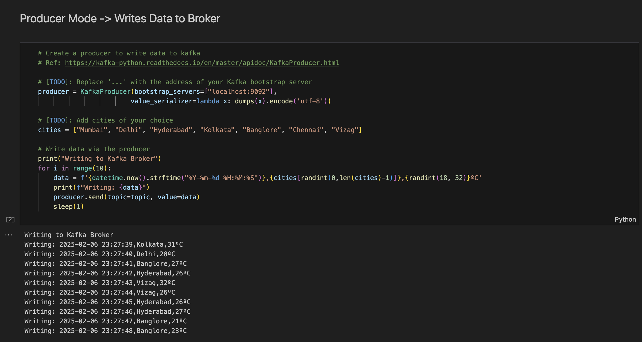

**Step-4:** **Implemented the Consumer Mode**

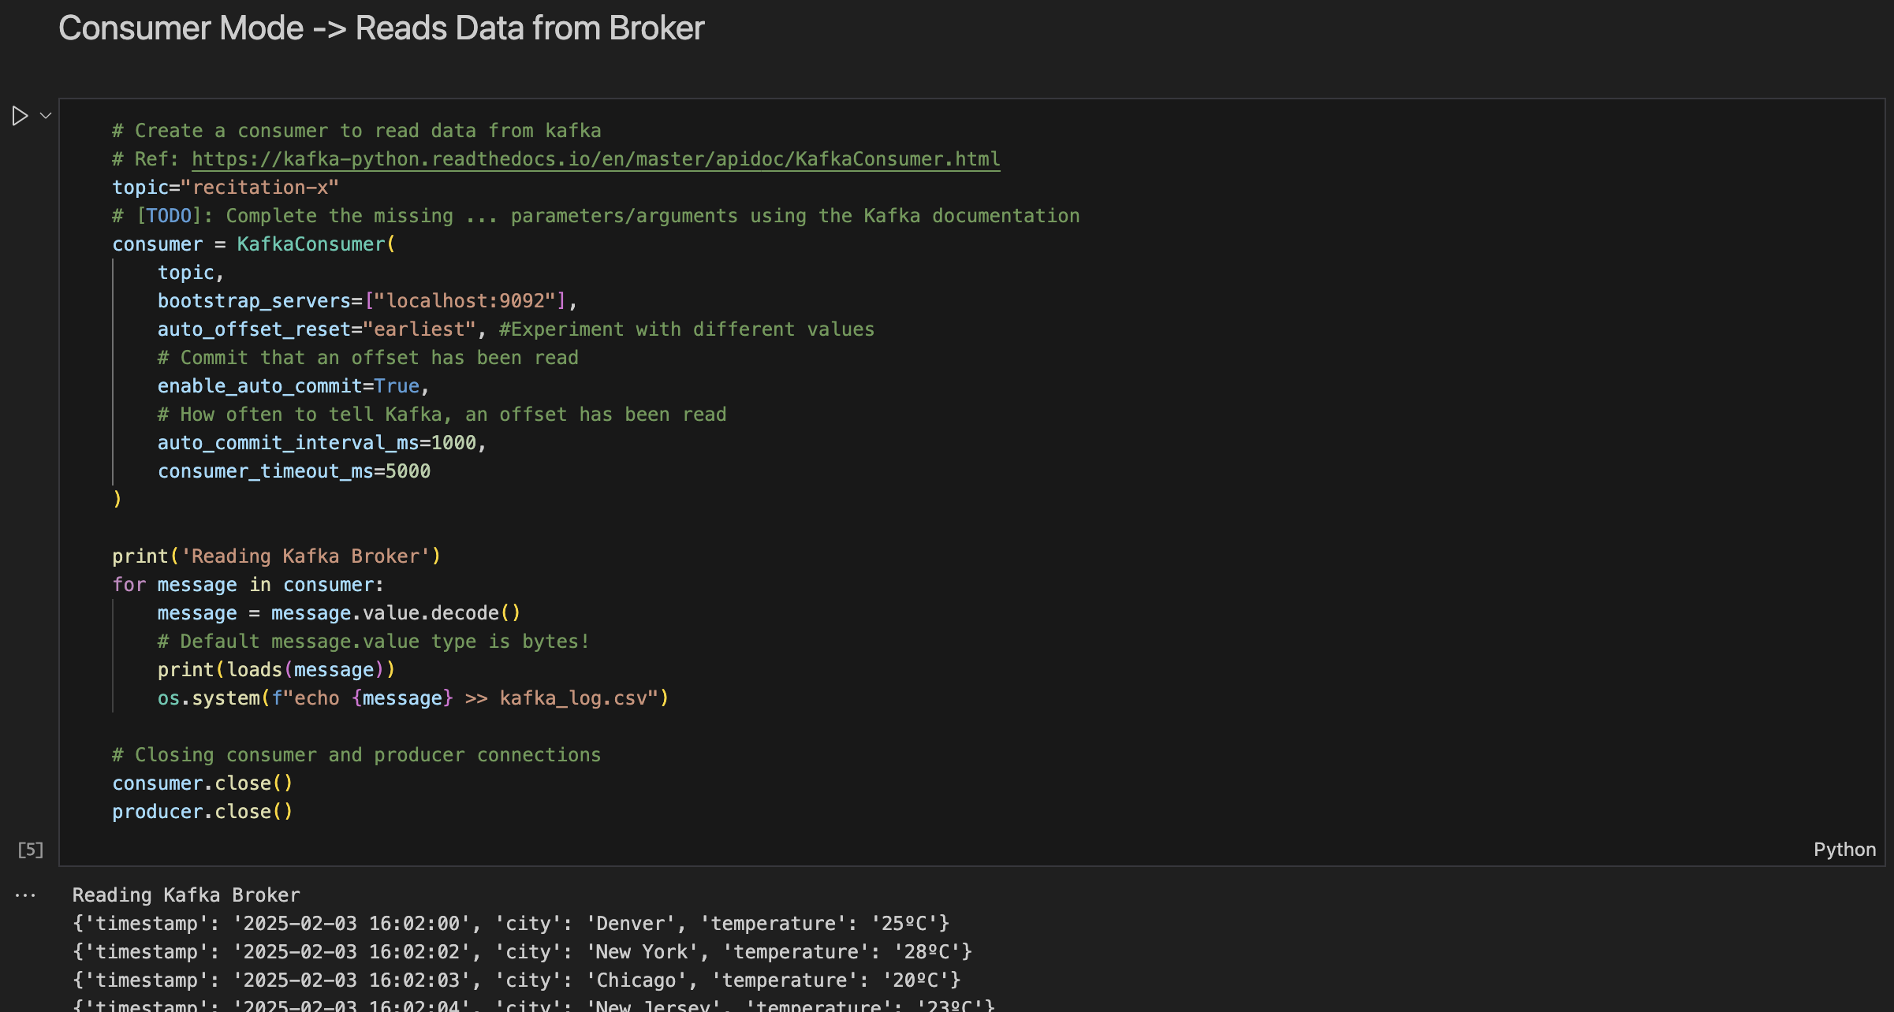

**Step-5 Verified Kafka_log.csv**

**Step-6: Used Kafka's CLI tool kcat to manage and monitor Kafka topics and messages**

$ kcat -b localhost:9092 -t recitation-x -o beginning -C -f '\nKey (%K bytes): %k\t\nValue (%S bytes): %s\nTimestamp: %T\tPartition: %p\tOffset: %o\n--\n' -e

$ kcat -b localhost:9092 -L

**Step-7: (Optional) Reading movielog streams**

* found the list of all topics and then read some movielog streams to get an idea of what the data looks like and saved them into a csv file

$ kcat -b localhost:9092 -t movielog2 -C -e > movies_data.csv

**Step-8: Closed the SSH tunnel to the Kafka server**

* Killed the connection using the kill command after looking up the process id with the port and passing it as arguments.

$ lsof -ti:9092 | xargs kill -9