1. **. Introduction:**

Understanding credit card due is very important for any banking or financial company, here we are having a credit card due dataset provides credit card due amount, which is influenced by other factors also, we performed data analysis on this data understand the data how many entries and how many features are available in this dataset, we performed missing value analysis.

In chapter two performed descriptive analysis, we analyze some important variables applied histograms, bar plots and boxplots. Also, we retrieve the descriptive statistics and pivot charts of the variables draws good insights.

In chapter three we performed regression analysis income, car value and mall trips with credit card due, we interpreted all the results we got from regression summary, draws the insights from R squared value, p value and t-statistic.

In chapter four we written managerial implications and insights by getting all the insights from descriptive analysis and regression summary, finally we conclude the report with what we have done and what we can do in future studies.

**2.0. Descriptive analysis:**

Descriptive statistics describe, show, and summarize the basic features of a dataset found in each study, presented in a summary that describes the data sample and its measurements.

**2.1. Data understanding:**

We have a data contains total 856 records having 13 columns like person age, type of salary, income, Gender etc. below figure shows the

**Figure 1. Sample data**

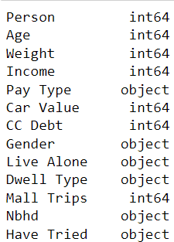There are 7 numerical variables, 6 categorical variables shown in below figure 2.

**Figure 2. Data types of credit data**

**2.2. Income:**

Income is a numerical variable it gives the information about people income; statistical analysis gives the more information about income how it varies to all the persons.

**Figure 3. Descriptive statistics of Income**

Figure 3 show the descriptive statistics of Income variable the mean income is 45266 pounds, with median that means 50% percentile value is 39950 pounds, which indicates data is skewed with positive side, the minimum income is 2600 and the maximum income is 19,0500.

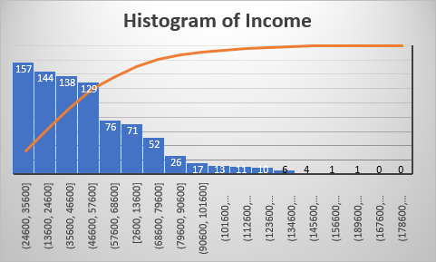

**Figure 4. Histogram of Income**

Above figure shows majority of income falls between 24600 pounds and 57600 pounds there are almost 568 people having income in theses range, also it showing some candidates are having income is very high, but they are less in number we can say those candidates are outliers and this analysis we can show by using boxplot.

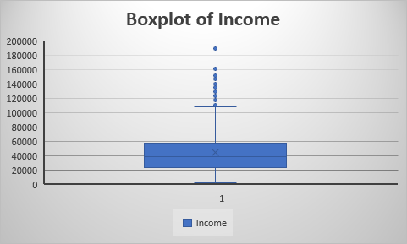

**Figure 5. Box plot of Income**

Figure 5 clearly shows there are many outliers in income variable means some people are having income more than 100000 pounds which are very less candidates.

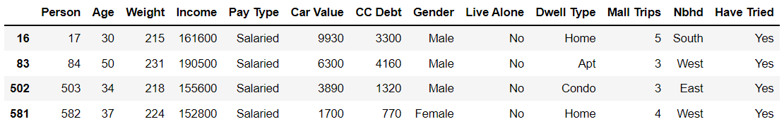

**Figure 6. High Income people data**

**2.3. Income and Pay type analysis:**

Income with respect to pay type gives good analysis while understanding the candidate credibility, so here we are performing multivariate analysis.

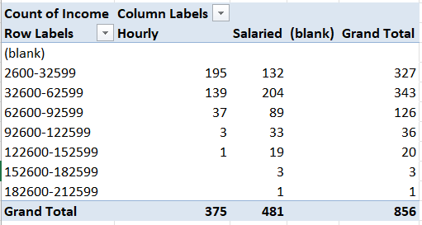

**Figure 7. Multivariate analysis between the Income and Pay type**

Figure 7 show the analysis between income and pay type there 70% people are having income between 62599 pounds in that hourly type and salary type people are almost equal but while income increasing hourly candidates are reduced, all high-income people are under salary category. There are around 6% more people has higher income those are salaried people.

**Figure 8. Bar graph between hourly and salaried people with respect to income**

**2.4. CC debt:**

Credit card debt is a numerical variable which provides the information about credit card due details. It is a numerical variable so we can get an idea by using statistical analysis, by using descriptive statistics in excel will get the analysis.

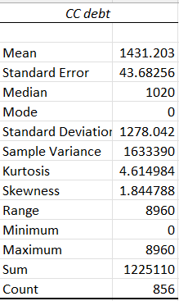

**Figure 9. Descriptive analysis of CC Debt**

Figure 9 shows the descriptive analysis of Credit card debt, the mean debt value is 1431.2 pounds which means on of average each person in this data having credit card due amount of 1431 pounds. The Median value is 1020 pounds, minimum credit due is zero, and maximum due amount is 8960.

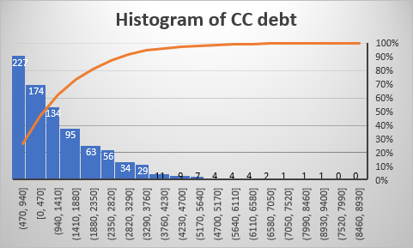

**Figure 10. Histogram plot of Credit card debt**

There are so many candidates are having below 1400 pounds around 535 people, will observe weather these values could be outlier or not by showing by box plot.

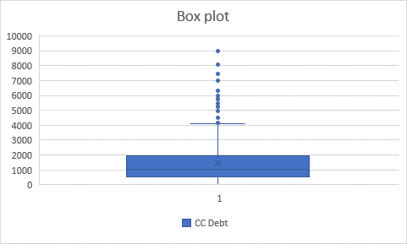

**Figure 11. Box plot of credit card debt**

Figure 11 shows the box plot of credit card debt more than 4000 pounds the data having outliers the median value of 1020 also shown in figure.

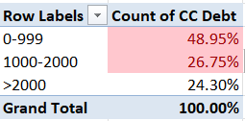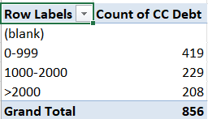

**Figure 12. Pivot table of Credit card debt**

Figure 12 shows the count of credit debt in different group of dues, below 2000 pounds there are 648 members, which is 75.70% percentage and also approximately 50% percentage of people are having due less than 1000 pounds.

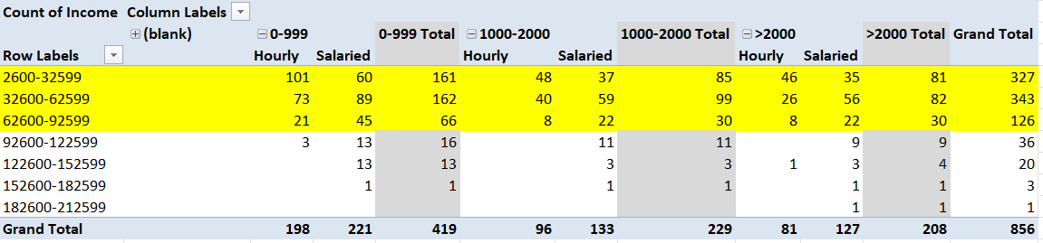

**Figure 13. Multi variate analysis between the Income, CC debt and the Pay type**

**3.0. Regression analysis:**

Regression analysis is a reliable method of identifying which variables have impact on a topic of interest. The process of performing a regression allows you to confidently determine which factors matter most, which factors can be ignored, and how these factors influence each other.

$$Dependent variable=intercept+coefficient* Independent caraible$$

**3.1. Regression between CC debt and Income variable:**

It is interesting to see how what parameters are affecting credit card due, here will do the analysis between income and credit card debt

**Figure 14. Correlation plot between CC debt and Income**

Figure 14 shows the correlation between credit card debt and income it has not showing as much as song we expected, the T square value I just 0.0013 it is even not closed to 1% both having almost orthogonal to each other.

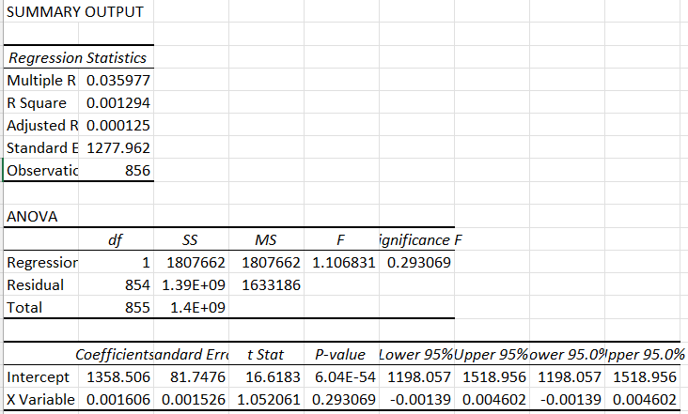

**Figure 15. Regression summary between Cc debt and Income**

We already seen there is no strong relationship between credit card debt and income, the p-value is 0.29 it is much high if p value less than 0.05.

**3.2 Regression between CC debt and Mall trips:**

It is interesting to see how what parameters are affecting credit card due, here will do the analysis between Mall trips and credit card debt

**Figure 16. Correlation plot between CC debt and Mall trips**

Figure 16 shows the correlation between credit card debt and Mall trips it has shown a moderate relationship we expected, the R square value is 0.24 which means cc debt variable explained about Mall trips by 24% percentage, this is somewhat good compare to other variables

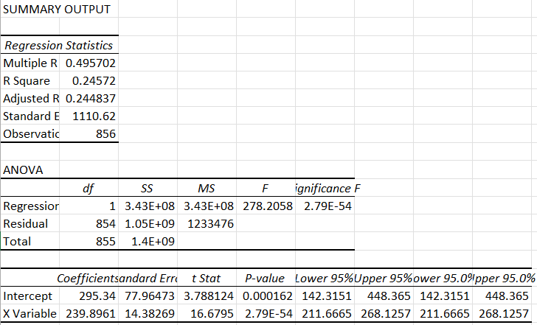

**Figure 17. Regression summary between Cc debt and Mall trips**

. $$CC Debt=295.34+239.8961* Mall trips$$

Above equation shows the relation between mall trips and cc debt variable both having a moderate relation ship with R square value as 0.24, intercept value is 295.34 which means if mall trips value is zero even though we have a cc debt value as 295.34, x coefficient is 239.89 which means if you increase mall trips by one unit then cc debt increase by 239.89 times, also the p value is 2.79E-54 it is less than 0.005 so it is one important variable to explain about CC debt.

**4.0 Managerial Interpretations and implications:**

This credit data set has lot of variables included such as age, gender, income, car value, cc debt and mall trips, descriptive analysis shows us very good results we have seen most of the age groups having the records below 47 years and most of the people are Male persons , we also identified the income variable it has many outliers majority of people having income less than 1,00,000 pounds only some percentage of people are having more than 1,00,000 pounds.

We also observe the pay type there are two types are available hourly basis and salaried nothing but monthly basis majority of the people having income type as salary but those people are getting more salary are salaried type, hourly basis type people are not fall in hifhr income. The credit card due variable is important in this dataset every person in this dataset having credit due with minimum credit due is 2600 pounds, those are having higher income having less credit due, 70% percentage people having credit due are having income less than 1,00,000 pounds.

We also performed regression analysis and plot correlation between cc debt with income, car value and mall trips, out of these three variables only mall trips is having some moderate relationship with cc debt with r square value 0.24, many of the other variables are not explained well the credit due variable, need to check with other categorical variables relation with credit card due in future studies.

**5.0. Conclusion:**

Understanding of credit card due is very important in any banking or financial industry there might be influence this by many factors, understanding of good factor is very important in this report we have understood mall trips place the very important role to have credit due, we analysed other variables income and car value but none of variables shows strong relation ship as shown by mall trips, which indicated life style might cause the issue get more credit value, of course car value variable also kind of life style but it is not showing much relationship, in future need to study with other variables to know the exact answer.