$$classification Algorithms$$

$Decision Tree:$

$It is also a classification algorithms$

$It is like a tree structure$

$Tree has branches, leafs, roots$

$Root is the very very important for tree$

$From roots only we can make branches$

$Finally from branches we can get leafs$

$In the Decision Tree Roots and Branches means input features$

$Leafs means output data lables$

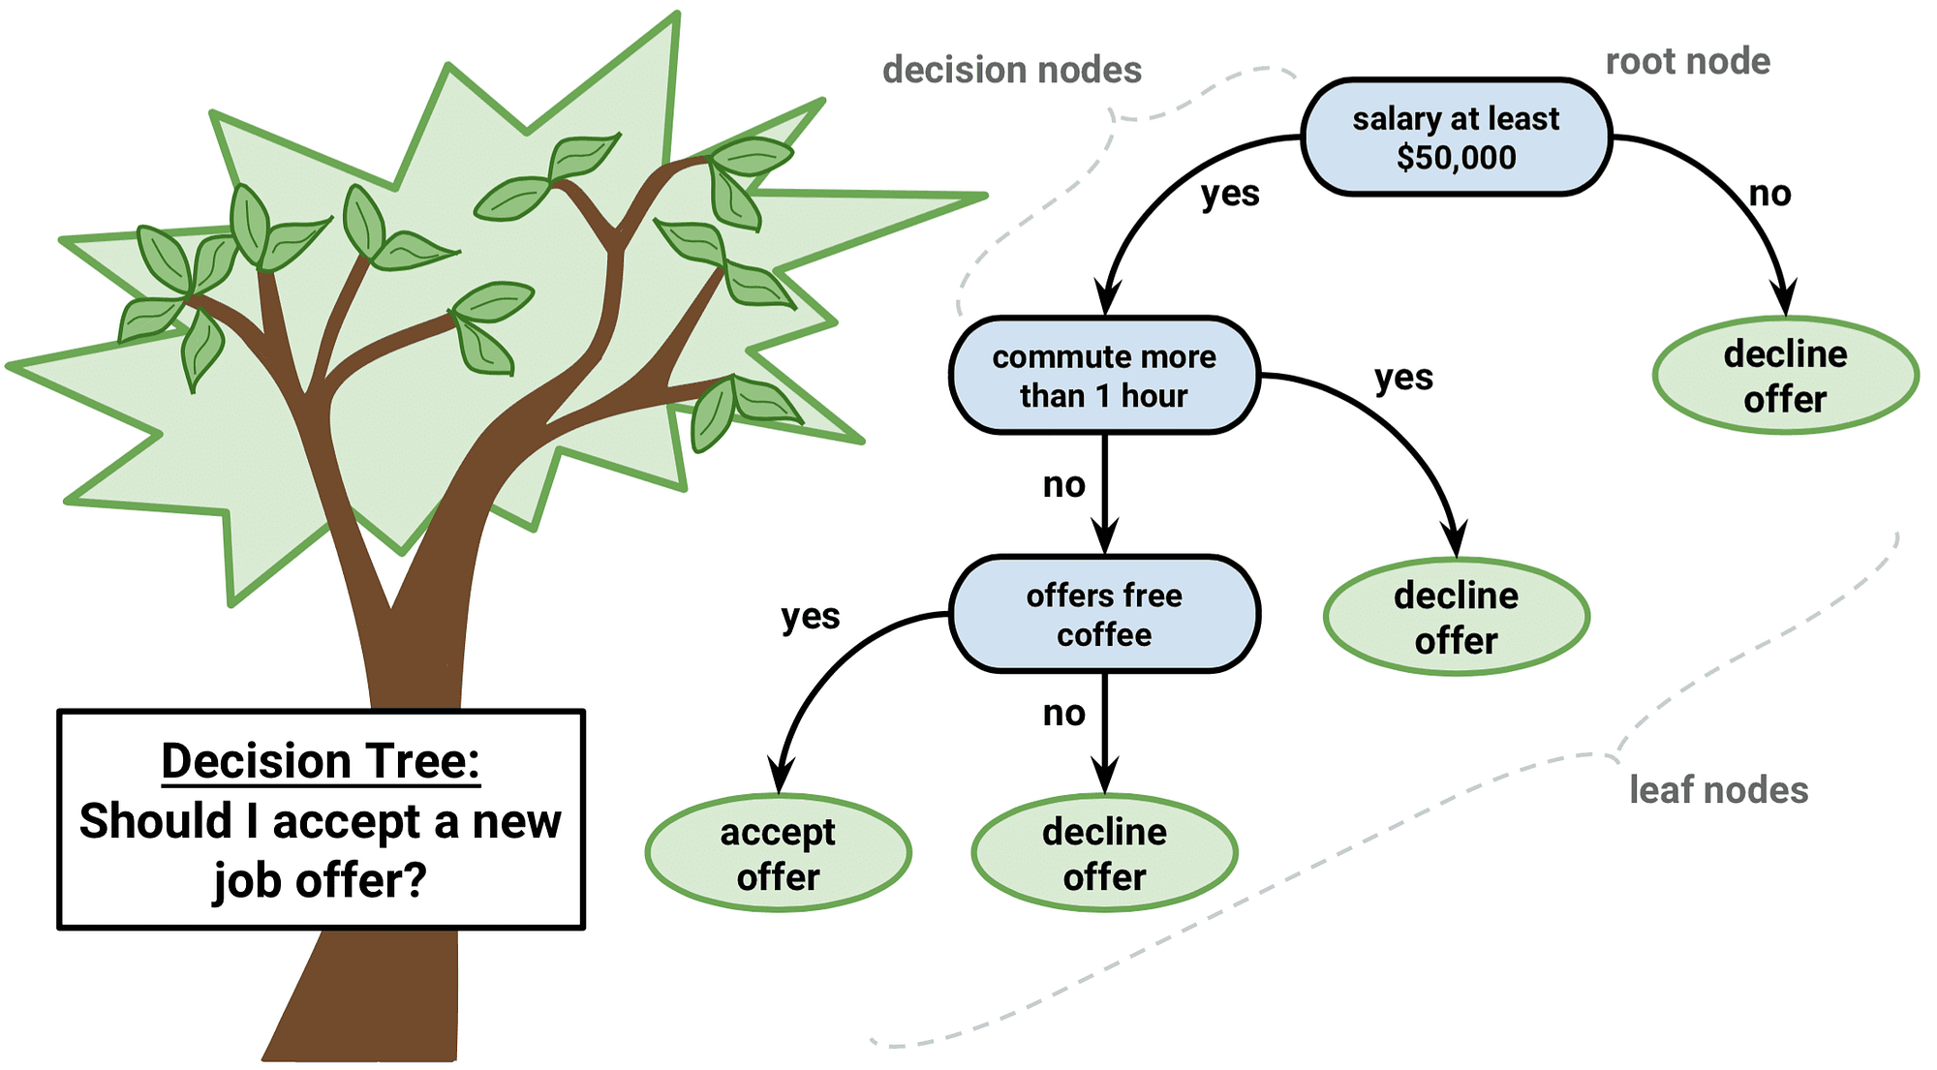

$$age gender income Cr Buy-a-computer$$

$$In Decision Tree The main Goal is : Idenitfy the Root node$$

$which column I need to choose to start with Decision, That is Called Root Node features$

$$Root Node :Good Leader$$

$Good leader :Focus is More$

$BAD leader :His Mindset in not clear \left( More random guy\right)$

$Root node behaviour: Random ness should be very very less$

$Ajay and Aravind very very close frineds$

$There is a Family function going on at ajay home$

$For that ajay and aravind working together$

$ajay is calling night time 2am is calling$

$He knows the information======No random ness$

$When you dont know the information====More random ness$

$ind vs Aus :No information(proper)====More random ness$

$ind vs zim:$

$This concept is identified by a scientist : Shannon Information creteria$

$Entropy:$

$H= -\sum_{i=1}^{n}{p_{i}*\log_{2}{p_{i}}}$

$Entropy gives an Idea ,$

$If we dont know about information, The H will be high$

$Whcih indicates more random ness$

$Where p=probability$

$\log_{2}{pi} base:2 is because information passes in the form of bits$

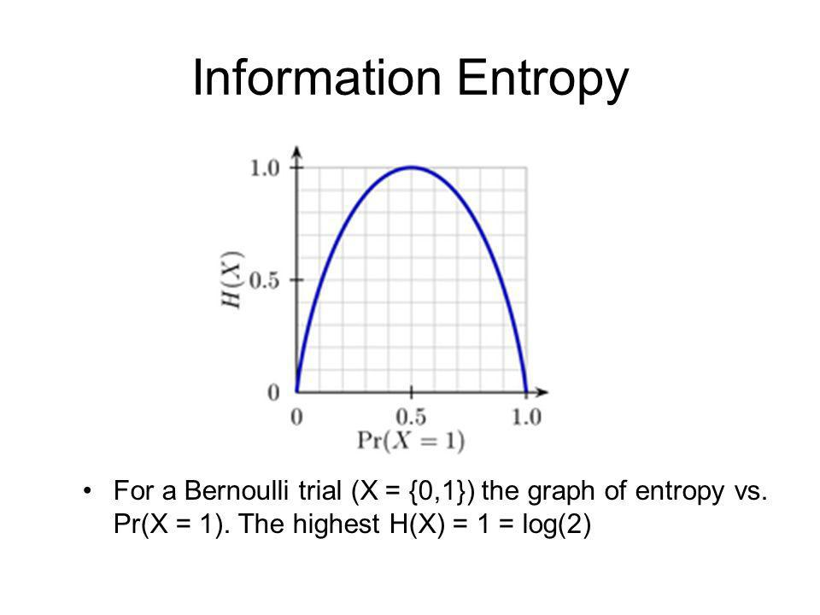

$$Toss a Coin$$

$$Two possible outcome Head,Tail$$

$$P\left(H\right)=0.5, P\left(T\right)=0.5$$

$$H= -\sum_{i=1}^{n}{p_{i}*\log_{2}{p_{i}}}$$

$$H= -\sum_{i=1}^{n=2}{p_{i}*\log_{2}{p_{i}}}=-p_{1}*\log_{2}{p_{1}}-p_{2}*\log_{2}{p_{2}}$$

$$H=-p_{h}*\log_{2}{p_{h}}-p_{t}*\log_{2}{p_{t}}$$

$$H=-0.5*\log_{2}{0.5}-0.5*\log_{2}{0.5}$$

$$H=-0.5*\log_{2}{\frac{1}{2}}-0.5*\log_{2}{\frac{1}{2}} \frac{1}{2}=2^{-1}$$

$$H=-0.5*\log_{2}{2^{-1}}-0.5*\log_{2}{2^{-1}} \log_{a}{a^{x}=x*\log_{a}{a}}$$

$$H=-0.5*\left(-1\right)*\log_{2}{2}-0.5*\left(-1\right)*\log_{2}{2} \log_{a}{a}=1$$

$$H=0.5*1+0.5*1$$

$$H=0.5+0.5=1$$

$$Hence entropy concept is Proved$$

$$More randomness===Not Proper information$$

$$More randomness===More entropy$$

$$Not proper information===More Randomness===More entropy$$

$$In the Decision Tree , we need a Root node$$

$Root node should have proper information$

$Root node should have less randomness$

$Root node should have less entropy$

$we will caclualte , Entropy for each varaible$

$Which variable has less Entropy , That is our Root Node$

$$Process$$

|  |  |  |
| --- | --- | --- |
| $$Id$$ | $$Age$$ | $$Buys a computer(Target)$$ |
| $$1$$ | Youth | No |
| 2 | Youth | No |
| 3 | Middle Aged | Yes |
| 4 | Senior | Yes |
| 5 | Senior | Yes |
| 6 | Senior | No |
| 7 | Middle Aged | Yes |
| 8 | Youth | No |
| 9 | Youth | Yes |
| 10 | Senior | Yes |
| 11 | Youth | Yes |
| 12 | Middle Aged | Yes |
| 13 | Middle Aged | Yes |
| 14 | Senior | No |

$$Entropy of Age: H\left(Age\right)$$

$$Age has three lables$$

$Youth$

$Middile Aged$

$Senior$

$$H\left(Age\right)=H\left(youth\right)+H\left(MA\right)+H\left(Senior\right)$$

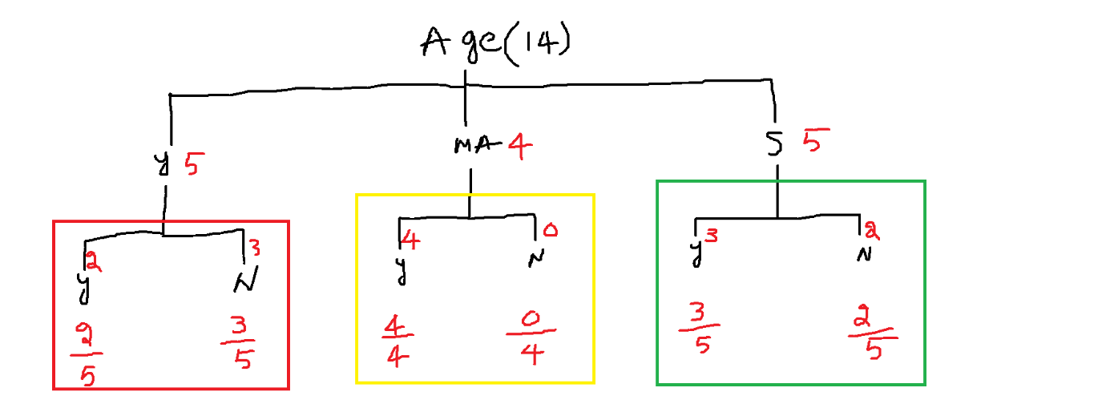

$$H= -\sum_{i=1}^{n}{p_{i}*\log_{2}{p_{i}}}$$

$$H\left(Youth\right): Youth have two outcomes, so Two Probabilities$$

$$H_{youth}= -\sum_{i=1}^{n=2}{p_{i}*\log_{2}{p_{i}}}=-p_{1}*\log_{2}{p_{1}}-p_{2}*\log_{2}{p_{2}}$$

$$H_{youth}=-p_{yes }*\log_{2}{p_{yes}}-p_{no}*\log_{2}{p_{no}}$$

$p_{yes }=\frac{2}{5}, p_{no}=\frac{3}{5}$

$$H_{youth}=-\frac{2}{5}*\log_{2}{\frac{2}{5}}-\frac{3}{5}*\log_{2}{\frac{3}{5} (Do not calculate answers)}$$

$$H\left(MA\right): MA have two outcomes, so Two Probabilities$$

$$H_{MA}= -\sum_{i=1}^{n=2}{p_{i}*\log_{2}{p_{i}}}=-p_{1}*\log_{2}{p_{1}}-p_{2}*\log_{2}{p_{2}}$$

$$H_{MA}=-p_{yes }*\log_{2}{p_{yes}}-p_{no}*\log_{2}{p_{no}}$$

$p_{yes }=\frac{4}{4}, p_{no}=\frac{0}{4}$

$$H_{MA}=-\frac{4}{4}*\log_{2}{\frac{4}{4}}-\frac{0}{4}*\log_{2}{\frac{0}{4}}$$

$$H\left(Senior\right): Senior have two outcomes, so Two Probabilities$$

$$H_{Senior}= -\sum_{i=1}^{n=2}{p_{i}*\log_{2}{p_{i}}}=-p_{1}*\log_{2}{p_{1}}-p_{2}*\log_{2}{p_{2}}$$

$$H_{Senior}=-p_{yes }*\log_{2}{p_{yes}}-p_{no}*\log_{2}{p_{no}}$$

$p_{yes }=\frac{3}{5}, p_{no}=\frac{2}{5}$

$$H_{Senior}=-\frac{3}{5}*\log_{2}{\frac{3}{5}}-\frac{2}{5}*\log_{2}{\frac{2}{5}}$$

$$H\left(Age\right)=H\left(youth\right)+H\left(MA\right)+H\left(Senior\right)$$

$$H\left(Age\right)= \left[-\frac{2}{5}*\log_{2}{\frac{2}{5}}-\frac{3}{5}*\log_{2}{\frac{3}{5}}\right]$$

$$+\left[-\frac{4}{4}*\log_{2}{\frac{4}{4}}-\frac{0}{4}*\log_{2}{\frac{0}{4}}\right]$$

$$+[-\frac{3}{5}*\log_{2}{\frac{3}{5}}-\frac{2}{5}*\log_{2}{\frac{2}{5}]}$$

$Weighatge concept:$

$$Never add the different group values directly$$

$Provide some weightage$

$$H\left(Age\right)=W_{y}*H\left(youth\right)+W_{MA}*H\left(MA\right)+W_{s}* H\left(Senior\right)$$

$$H\left(Age\right)= W_{y} \left[-\frac{2}{5}*\log_{2}{\frac{2}{5}}-\frac{3}{5}*\log_{2}{\frac{3}{5}}\right]$$

$$+W_{MA}\left[-\frac{4}{4}*\log_{2}{\frac{4}{4}}-\frac{0}{4}*\log_{2}{\frac{0}{4}}\right]$$

$$+W_{S}[-\frac{3}{5}*\log_{2}{\frac{3}{5}}-\frac{2}{5}*\log_{2}{\frac{2}{5}]}$$

$$Weighatge means Contribution$$

$$Out of total data what is the Youth Contribution$$

$$There are total 14 observations$$

$In that 5 are Youth :W_{y}=\frac{5}{14}$

$$Out of total data what is the MA Contribution$$

$$There are total 14 observations$$

$In that 4 are MA :W_{MA}=\frac{4}{14}$

$$Out of total data what is the Senior Contribution$$

$$There are total 14 observations$$

$In that 5 are Senior :W_{S}=\frac{5}{14}$

$$H\left(Age\right)= \frac{5}{14}*\left[-\frac{2}{5}*\log_{2}{\frac{2}{5}}-\frac{3}{5}*\log_{2}{\frac{3}{5}}\right]$$

$$+\frac{4}{14}*\left[-\frac{4}{4}*\log_{2}{\frac{4}{4}}-\frac{0}{4}*\log_{2}{\frac{0}{4}}\right]$$

$$+\frac{5}{14}*[-\frac{3}{5}*\log_{2}{\frac{3}{5}}-\frac{2}{5}*\log_{2}{\frac{2}{5}]}$$

$$Step-1:Calculate the Individual input fetaure entropy$$

$H\left(Age\right)=W_{y}*H\left(youth\right)+W_{MA}*H\left(MA\right)+W_{s}* H\left(Senior\right)$

$H\left(Income\right)=W_{H}*H\left(High\right)+W_{M}*H\left(M\right)+W_{L}* H\left(Low\right)$

$H\left(student\right)= W_{yes}*H\left(Yes\right)+W_{No}*H\left(No\right)$

$H\left(Credi_{rating}\right)=W_{Fair}*H\left(F\right)+W_{Excellent}*H\left(Excellent\right)$

$$Assuming$$

$$H\left(Age\right)= 0.2, H\left(Income\right)=0.3,H\left(student\right)=0.4,H\left(Credi_{rating}\right)=0.5$$

$Step-2: We need to calculate total data entropy: Before split$

$Total yes=9;Total No=5$

$p\left(yes\right)=\frac{9}{14};p\left(no\right)=\frac{5}{14}$ $${ H}_{Total}= -\sum_{i=1}^{n=2}{p_{i}*\log_{2}{p_{i}}}=-p_{yes}*\log_{2}{p_{yes}}-p_{no}*\log_{2}{p_{no}}$$

$${ H}_{Total}=-p_{yes}*\log_{2}{p_{yes}}-p_{no}*\log_{2}{p_{no}}$$

$${ H}_{Total}=-\frac{9}{14}*\log_{2}{\frac{9}{14}}-\frac{5}{14}*\log_{2}{\frac{5}{14}}=0.940$$

$Step-3:(Information Gain)$

$with only entropy we can not identify the root node$

$entropy will explain about random ness$

$in order to find to root node we need to calculate information gain$

$Information gain measures how much uncertainity reduce by a particule feature$

$Before split there is so much uncertainity$

$Due to feature split ness the uncertainity will be reduces$

$Gain will give the idea, which feature reducing more uncertainity$

$The feature which has more information gain , that become root node$

$$Gain_{feature}=H_{Total}-H_{feature}$$

$Gain_{age}=H_{Total}-H_{age}=0.9-0.2=0.7$

$Gain_{income}=H_{Total}-H_{income}=0.9-0.3=0.6$

$Gain_{student}=H_{Total}-H_{student}=0.9-0.4=0.5$

$Gain_{cr}=H_{Total}-H_{cr}=0.9-0.5=0.4$

$$Conclusion: In order to get a root Node which variable has highest IG that become root node$$

$$1) You should not compare different features on the same level$$

$$age vs income vs student vs cr$$

$$2) Entropy is tell about random ness :how data is splitted ramdomly$$

$$3) Gain is tell about clarity:how a data is splitted well$$

$You can talk in postive way :Gain concept$

$You can talk in negative way:Entropy$

$Gain_{feature}=H_{Total}-H_{feature}$

$$4) This is we called as Information gain$$

$$5) The entire concept name is :Information gain$$

$$6) The maths we are using in this concept is :Entropy$$

$$Information Gain:$$

$$Step-1:Calculate Individual Feature entropy$$

$$Step-2:Calculate Total data entropy$$

$$Step-3:Calculate the Gain$$

$$Conclusion:Which have heighest gain, that is the root node$$

$$For example assume that : Age is the root node$$

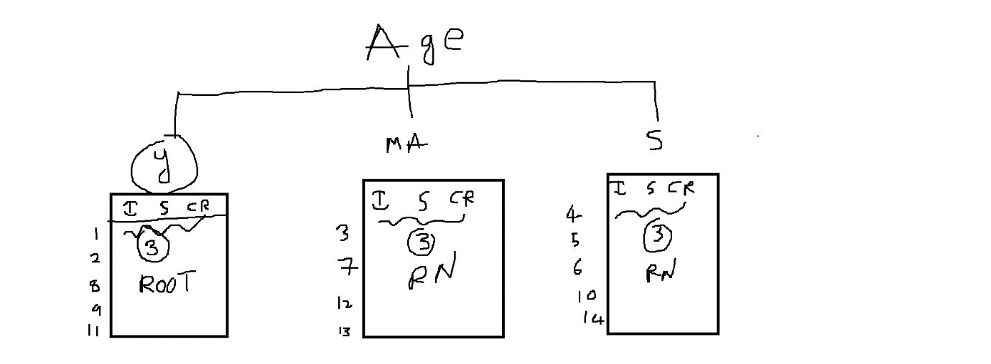

$$Every new table also have output column$$

$$Draw back:$$

$Information gain fails because of ID type of columns$

$Calculate entropy for ID column$

$${ H}_{ID}=H_{1}+H_{2}+….H_{14}$$

$$H\left(ID\right)=W_{1}*H_{1}+W_{2}*H_{2}….W_{14}* H_{14}$$

$$W_{1}=W_{2}=w_{3}=…=w_{14}=\frac{1}{14}$$

$$weighate means contribution$$

$$H_{1}=H_{2}=H_{3}=…=H_{14}=-\sum_{i=1}^{n=1}{p_{i}*\log_{2}{p_{i} =}}-p_{1}*\log_{2}{p_{1}}$$

$$-1*\log_{2}{1}=-\log_{2}{1}=0$$

$$H\left(ID\right)=W_{1}*H_{1}+W_{2}*H_{2}….W_{14}* H_{14}$$

$$H\left(ID\right)=-[\frac{1}{14}*\log_{2}{1}+\frac{1}{14}*\log_{2}{1}…\frac{.1}{14}*\log_{2}{1]}$$

$$H\left(ID\right)=\frac{-1}{14}\left[0+0+…+0\right]=0$$

$we already know that for root node , entropy should low and gain will high$

$for ID the entropy is zero, Gain=0.94-0=0.94$

$Gain is very high$

$if you include ID then automatically , information gain concept consider ID as Root Node$

$This leads No pattern learning, Model become overfit$

$That^{'}s why we always drop the ID column or fetaures which have more lables$

$$Information Gain$$

$$Step-1:Calculate Individual entropy$$

$$Step-2:Calculate total entropy$$

$$Step-3:Calculate gain$$

$$Conclusion:Which feature has heighest gain , That becomes a root node$$

$$Draw back:$$

$Any feature has more splits , Gain might be more$

$For example ID has more splits, Entropy become zero$

$Gain has more, so we misconclude ID as a Root node$

$Generally we will drop the more spliting columns$

$Example id, zip id,phone numbers etc$

$$I dont want drop it, still I want to avoid this draw back$$

$$Split Information Ratio:$$

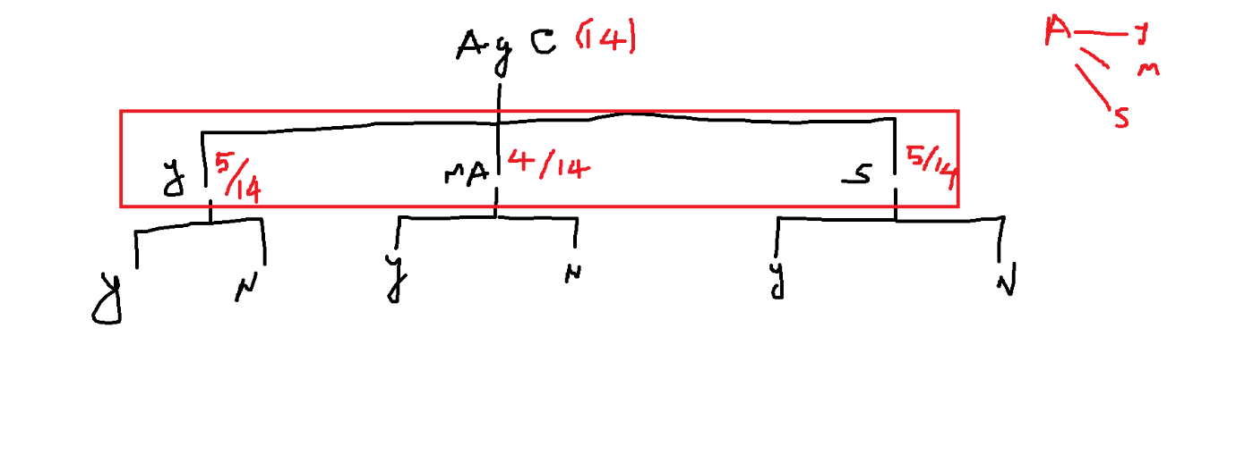

$we need to calculate entropy at split level$

$$Age is divided into 3 splits$$

$youth=p\left(youth\right)=\frac{5}{14}$

$MA=p\left(MA\right)=\frac{4}{14}$

$Senior=p\left(Senior\right)=\frac{5}{14}$

$$split information\left(Age\right)$$

$$=-\sum_{i=1}^{n=3}{p_{i}*\log_{2}{p_{i}=}}$$

$${=-p}_{youth}*\log_{2}{p_{youth}-p_{ma}*\log_{2}{p_{ma}-p_{s}*\log_{2}{p_{s}}}}$$

$$=-\frac{5}{14}*\log_{2}{\frac{5}{14}-\frac{4}{14}*\log_{2}{\frac{4}{14}-\frac{5}{14}*\log_{2}{\frac{5}{14}}=}}$$

$$Split information will give how broadly the feature is splitted$$

$we want less split information$

$$Step-1:Calculate Individual entropy$$

$$Step-2:Calculate total entropy$$

$$Step-3:Calculate gain$$

$$Step-4:Split information of each feature$$

$$Step-5:Gain Ratio$$

$$Gain ratio=\frac{Gain}{split information}$$

$$Gain ratio\left(Age\right)=\frac{Gain\left(Age\right)}{split information(Age)}$$

$$Gain ratio\left(income\right)=\frac{Gain\left(income\right)}{split information(income)}$$

$$Gain ratio\left(Student\right)=\frac{Gain\left(student\right)}{split information(student)}$$

$assume that Split information of ID column becomes maximum$

$That means denomenator is maximum$

$then total value less$

$Conclusion: Higest Gain Ratio is our root node$

$$Information gain$$

$$Step-1:Calculate Individual entropy$$

$$Step-2:Calculate total entropy$$

$$Step-3:Calculate gain=H_{Total}-H_{feature}=step_{2}-step_{1}$$

$$Step-4:Split information of each feature$$

$$Step-5:Gain ratio=\frac{Gain}{Split information}=\frac{step3}{step4}$$

$$entropy: will indicate random ness this should be low$$

$$total entropy:will indicate entropy of data generally this is high$$

$$gain :will indicate uncertainity while split the data , this should be high$$

$$Split information:will indicates how feature is splitted, this should be low$$

$$Gain ratio :it is a normalized form of information gain, this should be high$$

$$First 3 steps combinley called as ID3 :Iterative dechtomiser$$

$$Last 2 steps combinley called as C4.5$$