$$Classification Algorithms$$

$$ML algorithms divided into$$

$Supervised algorithms$

$Regression$

$Linear regression$

$Ridge regression$

$Lasso Regression$

$Elastic net regression$

$Classificaton$

$Logistic Rgression$

$Decision Tree$

$Naive Bayes$

$KNN$

$SVM$

$Ensembel methods$

$Bagging$

$Random Forest$

$Boosting$

$Ada boost$

$Gradient Boost$

$XG boost$

$Unsupervised$

$Rienforcement$

$$Classification$$

$$The data has both input data and output data,$$

$output data$ $type of categorical data$

$$Example: Visa data set the Target column:case-status$$

$Certified$

$Denied$

$$Which means we are classifying the Observations$$

$$Example: Bank loan defualters :Col=Loan defualter$$

$Yes$

$No$

$$First example and second example the target column has only two classes$$

$$Bi-classification problem$$

$$Example: Based On your marks , You want to divide the students$$

$Topper$

$Average$

$Dull$

$$the target column has more than two classes$$

$$Multi-classification problem$$

$$Example:Google maps$$

$The location might be correct or wrong$

$The Marker might be corect or wrong$

$Both location and Marker are wrong$

$$Logistic Regression$$

$$Objective:I want to Know the subscription of magzine based on age$$

|  |  |
| --- | --- |
| $$Age$$ | $$Subscription$$ |
| **30** | **Yes** |
| **20** | **No** |
| **40** | **Yes** |
| **25** | **?** |

|  |  |  |
| --- | --- | --- |
|  |  |  |
| **30** | **Yes** | **1** |
| **20** | **No** | **0** |
| **40** | **Yes** | **1** |
| **25** | **?** | **?** |

|  |  |  |  |
| --- | --- | --- | --- |
|  |  |  |  |
| **30** | **Yes** | **1** | **10+20*30=610** |
| **20** | **No** | **0** |  |
| **40** | **Yes** | **1** |  |
| **25** | **?** | **?** |  |

$$The equation \left(2\right) problem is$$

$$We are expecting RHS :b_{o}+b_{1}*age from 0 to 1$$

$$but RHS varies from-\inf{ to inf}$$

$$Subscription=b_{o}+b_{1}*age=========\left(1\right)$$

$$It is not a regression problem, It is a classification$$

$$Classification needs only yes \left(1\right) and No \left(0\right)$$

$$p(Subscription)=b_{o}+b_{1}*age=========\left(2\right)$$

$$probability ranges only 0 to 1, but my RHS is giving-\inf{ to inf}$$

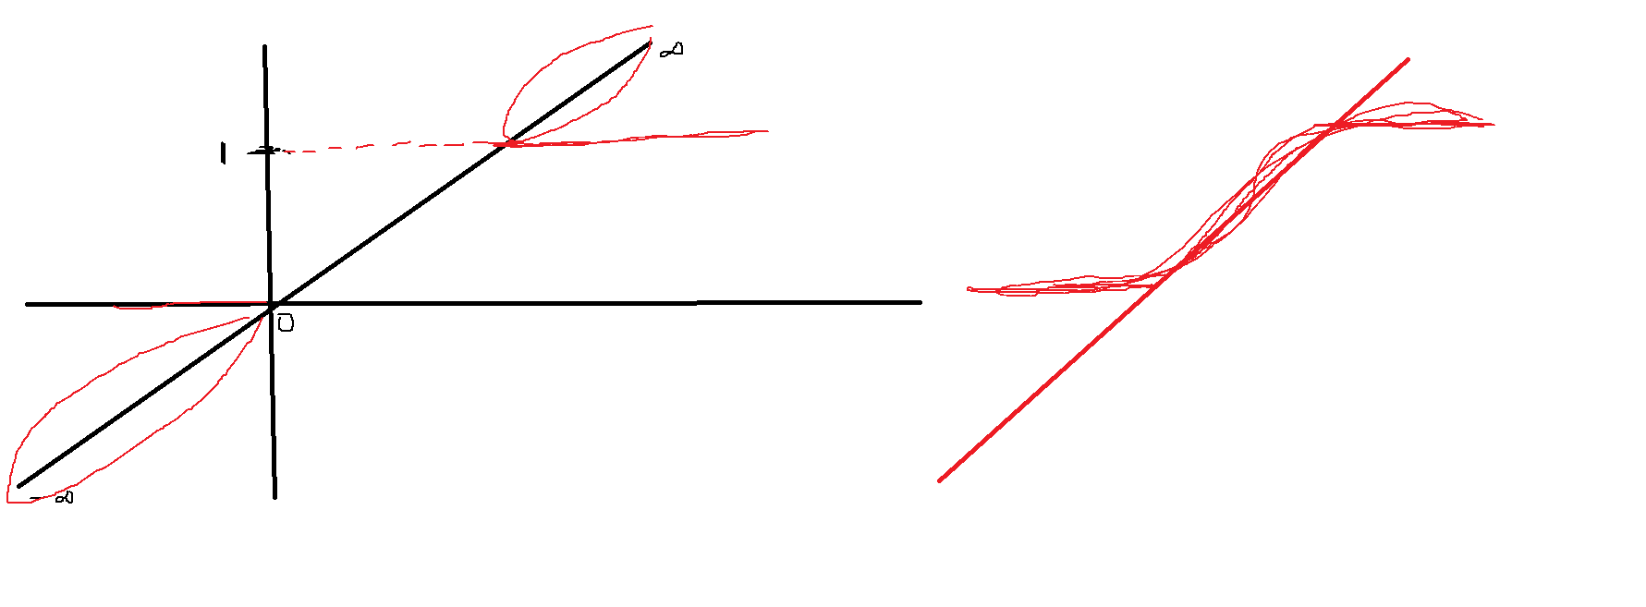

$Idea is :RHS equation need to modify, such way that we need to get only 0 and 1$

$$Rule-1 : It should be postive value$$

$$Rule-2:The value ranges only 0 to 1$$

$$Qn:which math equation will help us to get the answer$$

$$The answer is : Sigmoid Function$$

$σ\left(x\right)=\frac{1}{1+ⅇ^{-x}}$

$$σ\left(y\right)=\frac{1}{1+ⅇ^{-y}}$$

$$σ\left(z\right)=\frac{1}{1+ⅇ^{-z}}$$

$Sigmoid function value ranges from 0 to 1$

$The curve look like{{}_{}^{'}s}^{'} curve$

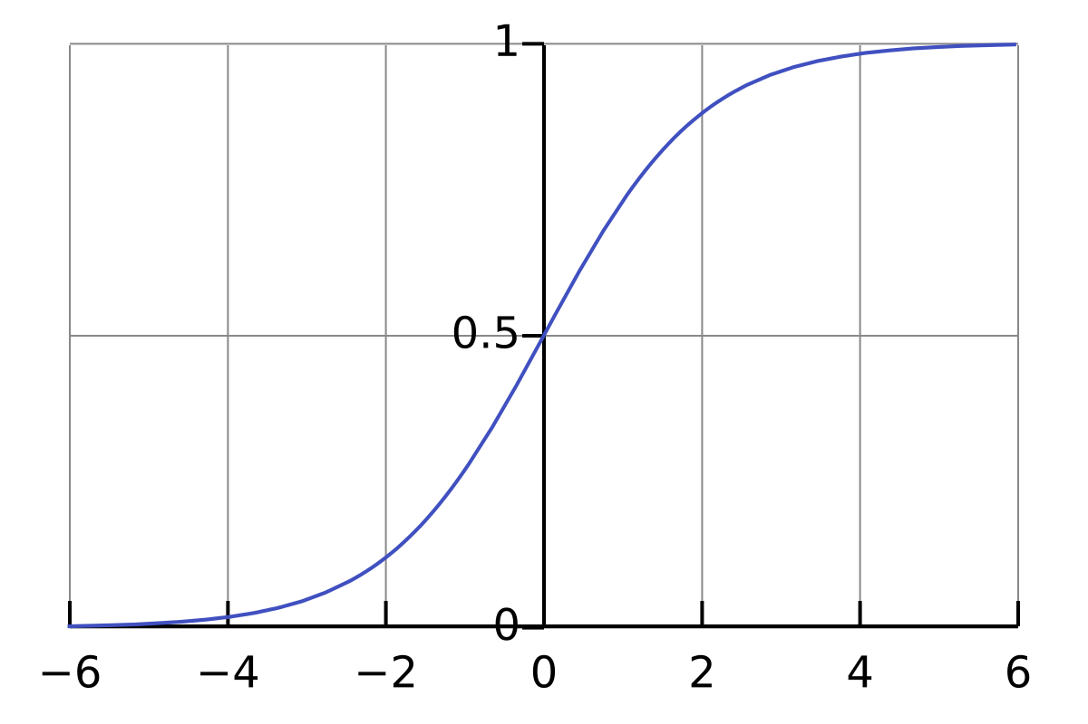

$$p(Subscription)=σ(b_{o}+b_{1}*age)$$

$$p(Subscription)=\frac{1}{1+ⅇ^{-(b_{o}+b_{1}*age)}}$$

$$p\left(y\right)=\frac{1}{1+ⅇ^{-\left(b_{o}+b_{1}*x_{1}+b_{2}*x_{2}+…+b_{n}*x_{n}\right)}}======(3)$$

$$we wil calculate b_{1}, b_{2} ols method$$

$$we will substitute our data x_{1} and x_{2}$$

$$\frac{1}{1+ⅇ^{-\left(b_{o}+b_{1}*x_{1}+b_{2}*x_{2}+…+b_{n}*x_{n}\right)}}===between 0 to 1$$

$$\frac{1}{1+ⅇ^{-\left(b_{o}+b_{1}*x_{1}+b_{2}*x_{2}+…+b_{n}*x_{n}\right)}}=0.6$$

$$p\left(y\right)=0.6==== >y=1 yes$$

$$\frac{1}{1+ⅇ^{-\left(b_{o}+b_{1}*x_{1}+b_{2}*x_{2}+…+b_{n}*x_{n}\right)}}=0.2$$

$$p\left(y\right)=0.2==== >y=0 no$$

$$Why sigmoid$$

$sigmoid is also called as an Activation function$

$Activation functions introduce Non linearity in the Neurons$

$So the neuron able to understand the complex patterns easily$

$we have sigmoid, softmax,Tanh,RelU, Leaky RelU$

$will learn more in Deep learning$

$$Subscription=b_{o}+b_{1}*age=========\left(1\right)$$

$$p(Subscription)=b_{o}+b_{1}*age=========\left(2\right)$$

$$p\left(Subscription\right)=\frac{1}{1+ⅇ^{-\left(b_{o}+b_{1}*age\right)}}=====(3)$$

$$σ\left(x\right)=\frac{1}{1+ⅇ^{-x}}$$

$$case-1 : x= -inf$$

$$σ\left(-inf\right)=\frac{1}{1+ⅇ^{-(-inf)}}$$

$$σ\left(-inf\right)=\frac{1}{1+ⅇ^{inf}}$$

$$σ\left(-inf\right)=\frac{1}{1+inf}$$

$$σ\left(-inf\right)=\frac{1}{inf}=0$$

$$case-2 : x= inf$$

$$σ\left(inf\right)=\frac{1}{1+ⅇ^{-(inf)}}$$

$$σ\left(inf\right)=\frac{1}{1+ⅇ^{-inf}}$$

$$σ\left(inf\right)=\frac{1}{1+0}$$

$$σ\left(inf\right)=1$$

$$case-3 : x= 0$$

$$σ\left(0\right)=\frac{1}{1+ⅇ^{-(0)}}$$

$$σ\left(0\right)=\frac{1}{1+ⅇ^{-0}}$$

$$σ\left(0\right)=\frac{1}{1+1}$$

$$σ\left(0\right)=0.5$$

|  |  |
| --- | --- |
| $$x$$ | $$σ\left(x\right)=\frac{1}{1+ⅇ^{-x}}$$ |
| -inf | 0 |
| 0 | 0.5 |
| Inf | 1 |

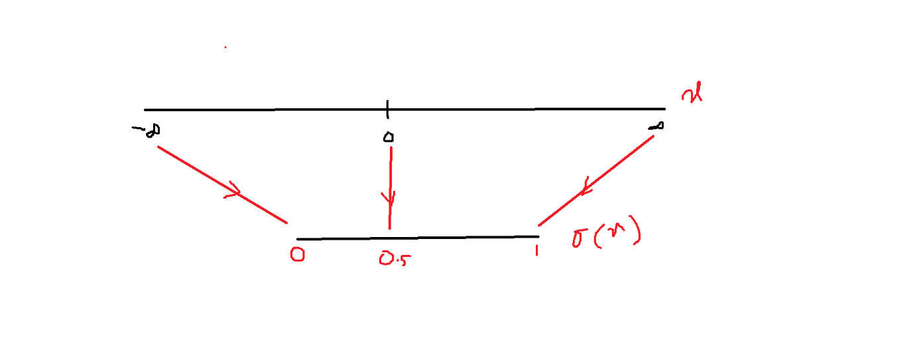

$$p\left(Subscription\right)=\frac{1}{1+ⅇ^{-\left(b_{o}+b_{1}*age\right)}}=====\left(3\right)$$

$$Problem in Equation-3$$

$$Interpreation of equation-3$$

$$y=b_{o}+b_{1}*x_{1}$$

$$b_{1}: If we increase x_{1} by one unit then y is increasing by b_{1} times$$

$$p\left(Subscription\right)=\frac{1}{1+ⅇ^{-\left(b_{o}+b_{1}*age\right)}}=====\left(3\right)$$

$$Interpreation of b_{1} from equation-3$$

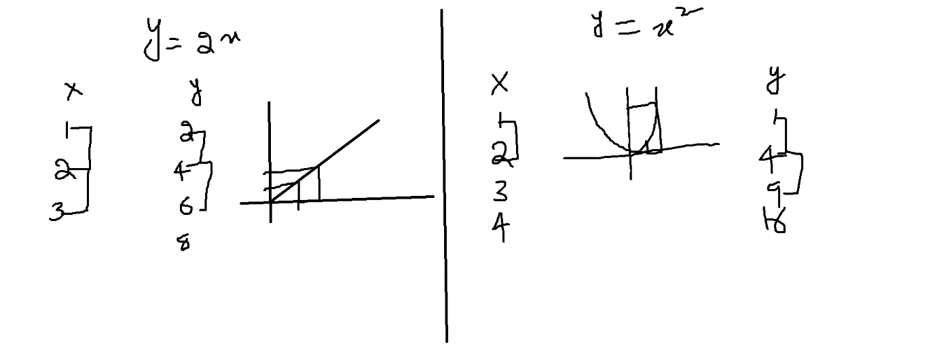

$$Interpretation is Not possibile$$

$Because equation-3 is a sigmoid function$

$It is looks like s curve$

$Which is A non linear equation$

$$Note:Only Linear eqautions we can interprate$$

$Non linear equation we can not interprate$

$$Solutions:Convert Non linear equation to Linear equation$$

$$p\left(y\right)=\frac{1}{1+ⅇ^{-\left(b_{o}+b_{1}*x_{1}+b_{2}*x_{2}+…+b_{n}*x_{n}\right)}}$$

$${y=b}_{o}+b_{1}*x_{1}+b_{2}*x_{2}+…+b_{n}*x_{n}$$

$$p\left(y\right)=\frac{1}{1+ⅇ^{-y}}$$

$$p\left(y\right)\left[1+e^{-y}\right]=1$$

$$p\left(y\right)+p\left(y\right)*e^{-y}=1$$

$$p\left(y\right)*e^{-y}=1-p(y)$$

$$e^{-y}=\frac{1-p\left(y\right)}{p(y)}$$

$$e^{y}=\frac{p\left(y\right)}{1-p(y)}$$

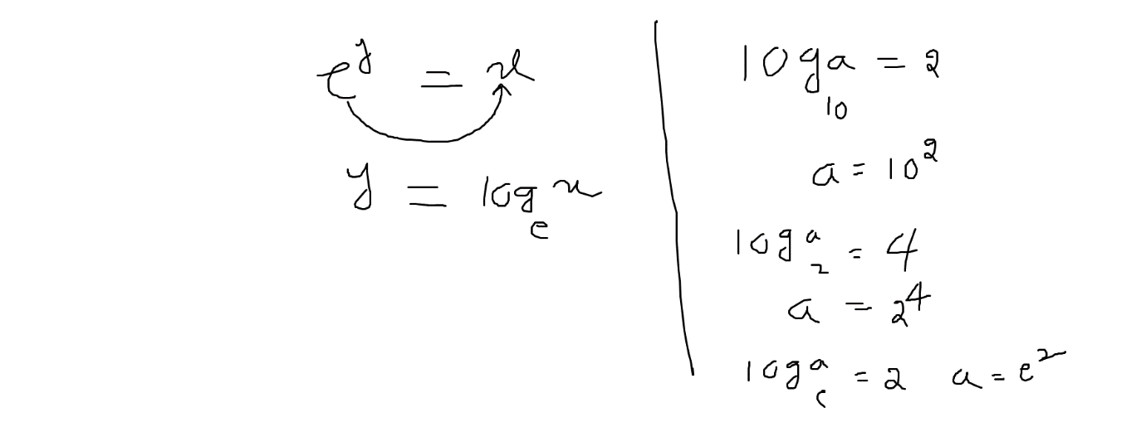

$$e^{y}=\frac{p\left(y\right)}{1-p(y)}$$

$$y=\log_{e}\left(\frac{p\left(y\right)}{1-p\left(y\right)}\right)$$

$$\log_{e}\left(\frac{p\left(y\right)}{1-p\left(y\right)}\right)=y$$

$$\log_{e}\left(\frac{p\left(y\right)}{1-p\left(y\right)}\right)=b_{o}+b_{1}*x_{1}+b_{2}*x_{2}+…+b_{n}*x_{n}===(4)$$

$$\log_{e}\left(\frac{p\left(y\right)}{1-p\left(y\right)}\right)=\ln\left(\frac{p\left(y\right)}{1-p\left(y\right)}\right)=2.303{*log}_{10}\left(\frac{p\left(y\right)}{1-p\left(y\right)}\right)$$

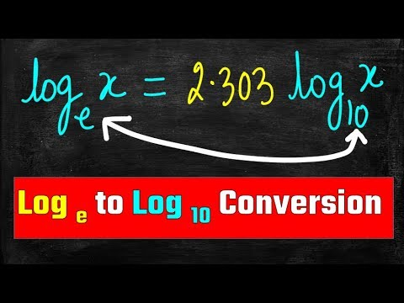

$$Subscription=b_{o}+b_{1}*age===\left(1\right) [Draw back :It is a regression but we want class]$$

$$p\left(Subscription\right)=b_{o}+b_{1}*age==\left(2\right)[RHS= -\inf{ to\inf{ we want ony 0 to 1}}]$$

$$p\left(Subscription\right)=\frac{1}{1+ⅇ^{-\left(b_{o}+b_{1}*age\right)}}==\left(3\right)[Non linearity]$$

$$\log_{e}\left(\frac{p\left(y\right)}{1-p\left(y\right)}\right)=b_{o}+b_{1}*x_{1}+b_{2}*x_{2}+…+b_{n}*x_{n}===(4)$$

$$Interpretation:$$

$$y=b_{o}+b_{1}*x_{1}$$

$$if we incresae x_{1} by one unit , y will incresae by b_{1} times$$

$$\log_{e}\left(\frac{p\left(y\right)}{1-p\left(y\right)}\right)=b_{o}+b_{1}*x_{1}$$

$$if we increase x_{1} by one unit , \log_{e}\left(\frac{p\left(y\right)}{1-p\left(y\right)}\right) will increase by b_{1} times$$

$$\log_{e}\left(\frac{p\left(y\right)}{1-p\left(y\right)}\right)=\log{odds ratio}$$

$$\log{odds ratio}:$$

$$odds means different different$$

$$p\left(y\right) and 1-p\left(y\right)$$

$$p\left(y\right)=yes 1-p\left(y\right)=NO$$

$$p\left(y\right)=0.6 yes$$

$$1-p\left(y\right)=0.4 no$$

$$\frac{p\left(y\right)}{1-p\left(y\right)}=odds ratio$$

$$\frac{p(yes)}{p(no)}=odds ratio$$

$$\log_{e}\left(\frac{p\left(y\right)}{1-p\left(y\right)}\right)=\log{ odds ratio}$$

Sir suppose we have three unique labels then how the ratio will diffe

Rich poor middile

Rich vs poor+middile

$$if we increase x_{1} by one unit , \log{odds ratio} will increase by b_{1} time$$

$What is the meaning of classification problem$

$we achived a logistic regression equation$

$sigmoid equation=\frac{1}{1+e^{-x}}$

$p\left(y\right)=\frac{1}{1+ⅇ^{-\left(b_{o}+b_{1}*x_{1}\right)}}$

$\log_{e}\left(\frac{p\left(y\right)}{1-p\left(y\right)}\right)=b_{o}+b_{1}*x_{1}$

$\log{odds ratio}$

$$p\left(y=yes\right)=\frac{1}{1+ⅇ^{-\left(b_{o}+b_{1}*x_{1}\right)}}$$

$$p\left(y=no\right)=\frac{1}{1+ⅇ^{-\left(b_{o}+b_{1}*x_{1}\right)}}$$

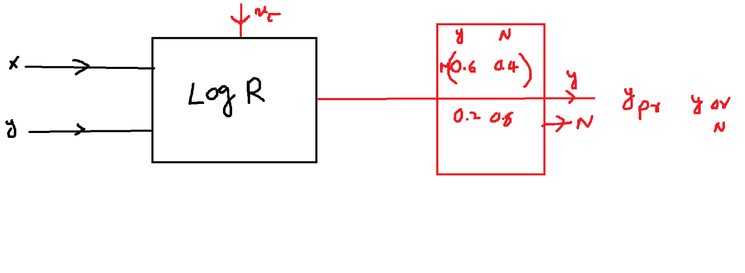

$$Suppose a data set has 3 output labels$$

$$Output column name:zone$$

$$Lables:Red, yellow, green$$

$$whenever you pass the test data model will give 3 probabilties$$

$$P\left(zone=RED\right), p\left(zone=Yellow\right), p(zone=Green)$$

$$P\left(zone=RED\right)=0.7$$

$$P\left(zone=Yellow\right)=0.2$$

$$P\left(zone=Green\right)=0.1$$

$$maximum probability p\left(zone=Red\right)=0.7, model$$

$$will give directly answer :RED zone$$

$$Metrics are same for Regression$$

$$Metrics are same for classification$$

$$Metrics are same for cluster problems$$

Then why we are learning this math sir?

We need to learn ==== we need phd

How the models are developed ==== create our own models( We are not doing)

$$Why we are learning==ChatGPT$$

may be project timeline is big factor not to develop new algo

Rani

Sir will we do comparison between writing Linear Regression algorithm from scratch and using sklearn which one performs better ?

Distance between two points =