Assignment 4: Implementing Control Structures
Employee Schedule Management in Python and Java

Vamsi Matta
University of the Cumberlands
Advanced Programming Languages
September 20, 2026

1. Overview and Language Selection
This assignment implements the same employee scheduling application in Python and Java to demonstrate conditionals, loops, branching, collections, validation, and controlled random selection. Python and Java provide a clear contrast: Python is dynamically typed and concise, while Java is statically typed and more explicit. Using the same rules in both languages highlights differences in control-flow syntax without changing program behavior.
The application covers seven days and three shifts: Morning, Afternoon, and Evening. Employees may provide ranked preferences for each day, implementing the optional bonus. The scheduler enforces one shift per employee per day, a five-day weekly maximum, and two employees per shift. When preferred staffing is insufficient, an eligible least-used employee is selected, with a fixed random seed in demo mode for reproducible output.

2. Scheduling Rules and Control Structures
Requirement | Implementation | Control Structures
Seven-day schedule | Nested day/shift collections | for loops
One shift per day | assignedToday set prevents duplicates | if conditions and set membership
Maximum five days | daysWorked counter checked before assignment | if conditions
At least two per shift | while loop fills shortages | while loop and branching
Preference conflicts | Alternate ranked shift is selected when first choice is full | if/else and list ranking
Random fallback | Eligible least-used candidates are randomly selected | filtering, min selection, random choice
Validation | Final assertions/checks verify every scheduling rule | nested loops and exception/assert branches

3. Python Implementation
The Python version stores the weekly schedule in nested dictionaries and shift assignments in lists. A set tracks employees already assigned on the current day, while a dictionary counts weekly workdays. The scheduler first attempts to satisfy first-choice preferences. It then uses a while loop to fill any shift with fewer than two employees. Eligible employees must not already be working that day and must have worked fewer than five days. Among the least-used eligible employees, preference ranking is considered before the random fallback choice is made.
Python's concise syntax makes the filtering logic readable through list comprehensions and built-in functions. The validate function checks the finished schedule and raises an error if an employee appears twice on the same day, exceeds five days, or a shift violates the staffing requirement. Demo mode intentionally gives many employees the same first preference so that the conflict-resolution branch is exercised and visible in the output.

4. Java Implementation
The Java version applies the same algorithm using ArrayList, LinkedHashMap, HashSet, Comparator, and Random. Java requires explicit generic types and a small Result class to group the schedule, workday counts, and conflict messages. Enhanced for loops traverse days, shifts, and employees, while while loops fill understaffed shifts. Conditional statements enforce daily and weekly limits before any assignment is added.
The Java implementation is more verbose than Python, but its explicit types make the structure of the scheduling data clear. The validate method throws IllegalStateException when a rule is violated. Both implementations use the same employee data and scheduling constraints, so the assignment demonstrates the syntactic differences between the languages without changing the underlying control-flow requirements.

5. Testing and Results
Both programs were compiled or executed successfully using demo data with nine employees. The completed schedule contains 42 assignments: 7 days x 3 shifts x 2 employees. No employee works more than one shift in a day or more than five days in the week. The demo also produces preference conflicts because the first-choice Morning shift fills quickly; the remaining employees are reassigned to Afternoon or Evening according to their ranked preferences and eligibility. Each implementation finishes by printing a validation-passed message.

Python Final Schedule Output
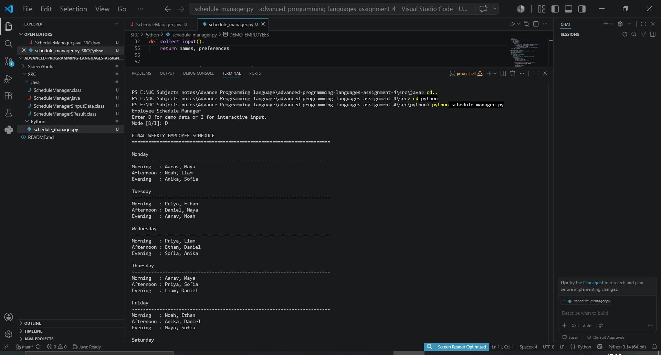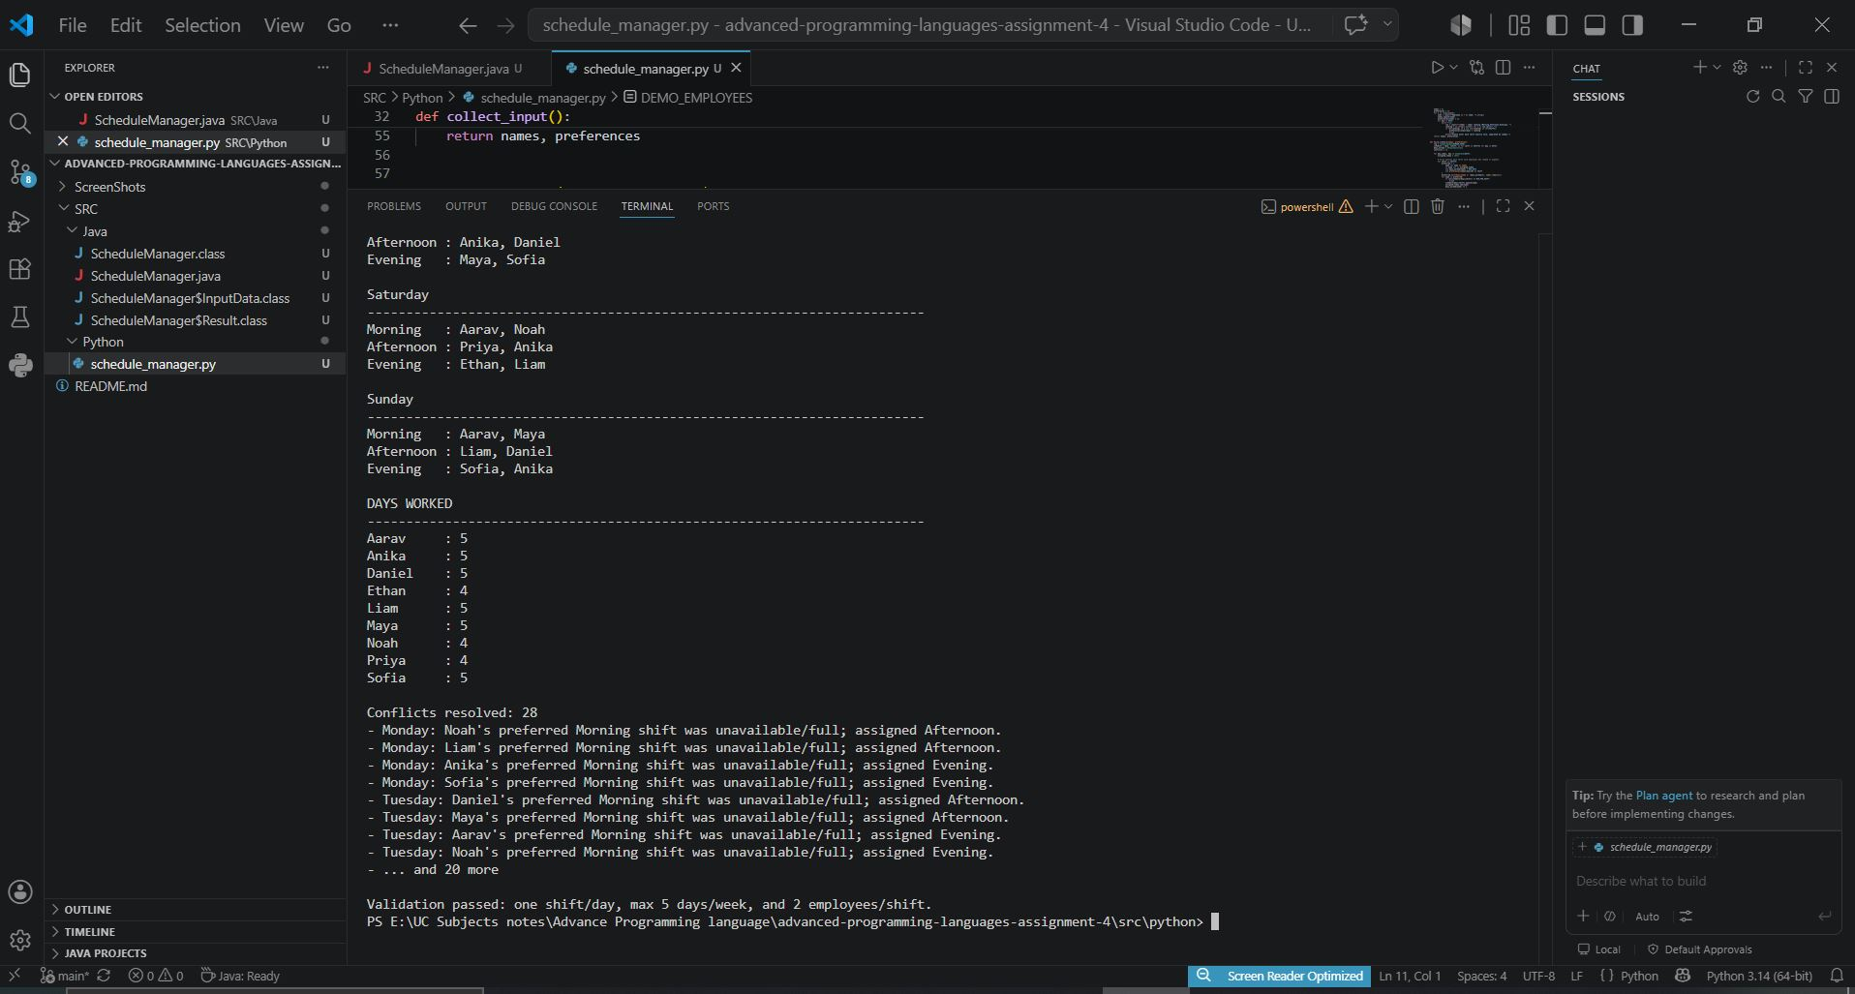

Java Final Schedule Output
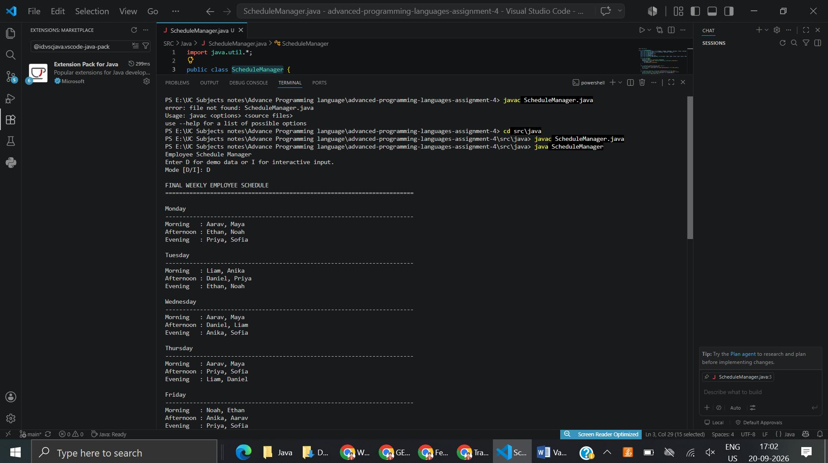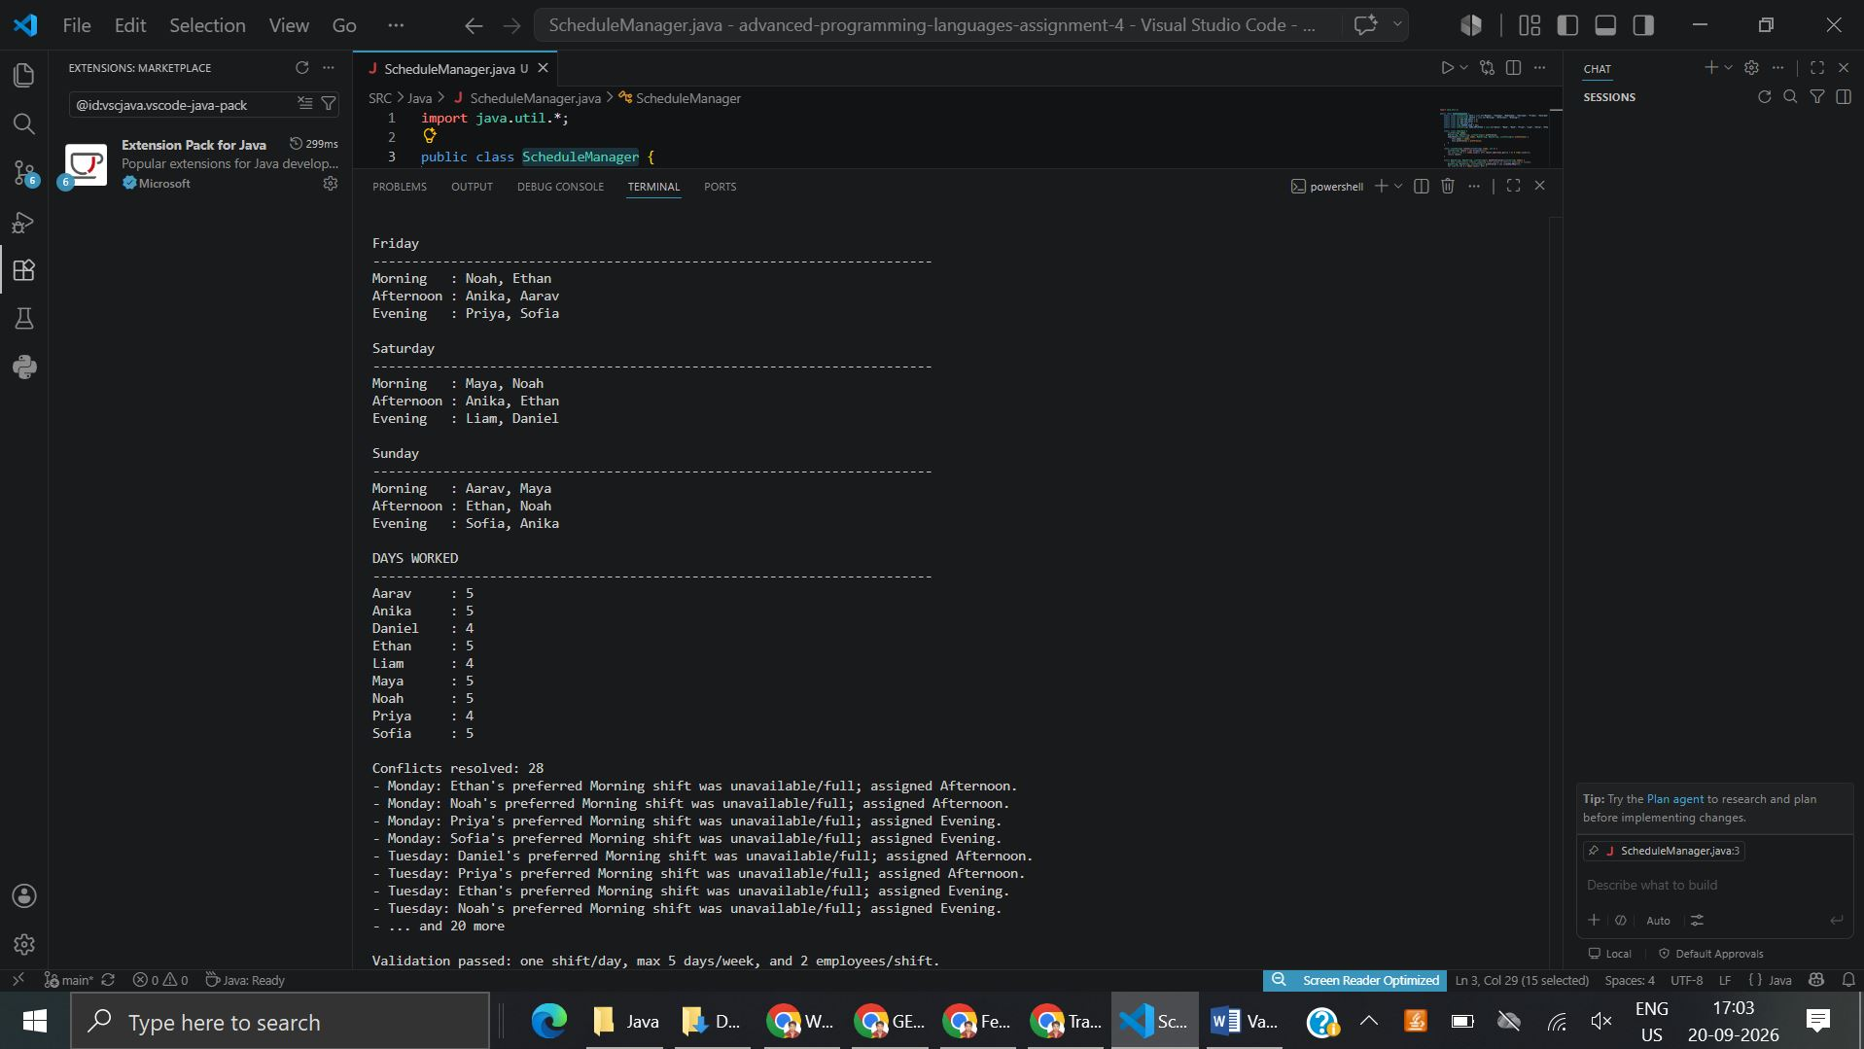

6. GitHub Repository and Submission
Recommended public repository name: advanced-programming-languages-assignment-4
GitHub repository link: https://github.com/Vamsi-Matta/advanced-programming-languages-assignment-4
The repository should contain the Python source file, Java source file, README.md, and the two final schedule screenshots. The source package supplied with this report is already organized for upload. After creating the public repository, replace the placeholder above with the actual repository URL before submitting this document to Blackboard.

7. Conclusion
The assignment demonstrates that conditionals, loops, branching, collections, and validation can implement the same scheduling behavior in two languages with different design styles. Python provides compact expressions and minimal syntax, whereas Java provides explicit types and class-based organization. In both versions, the control structures enforce staffing requirements, resolve preference conflicts, prevent duplicate daily assignments, limit weekly workdays, and produce a readable final weekly schedule.

