Assignment 6: Multi-threaded Data Processing System
Vamsi Matta
University of the Cumberlands
Advanced Programming Languages
October 2026

Multi-threaded Data Processing System
This project implements a concurrent ride-request processing system in Java and Go. Both implementations use a shared task queue, three workers, simulated processing delays, a shared results collection, and file output. Ten ride requests were processed in each observed run. The two versions demonstrate how language-specific concurrency primitives can coordinate shared work while preventing duplicate queue retrievals.

Java Concurrency and Exception Handling
The Java version uses a LinkedList task queue with synchronized addTask() and getTask() methods. Each queue operation holds the class monitor while adding or removing a task, so two workers cannot remove the same queue entry. An ExecutorService fixed thread pool runs three Worker instances. A Collections.synchronizedList stores results, and synchronized iteration is used when displaying and saving them. Thread.sleep(500) represents processing time. The program shuts down the executor and waits with awaitTermination(), with shutdownNow() as a timeout or interruption fallback (Oracle, n.d.).
Java handles failures using try-catch-finally. Workers catch InterruptedException, restore their interrupted status, and log errors; a finally block logs worker termination. FileWriter is opened using try-with-resources, which closes the writer automatically, and IOException is caught and reported. The observed run completed all ten rides and saved processing_results.txt. This confirms the demonstrated workload succeeded, although more stress and fault-injection testing would be needed to evaluate all failure conditions.

Go Concurrency and Error Handling
The Go version uses a buffered channel as a concurrency-safe task queue. The producer adds ten Task values and closes the channel after submission; workers receive until the channel is drained and closed. Three goroutines process requests, and sync.WaitGroup waits for all workers to finish. A sync.Mutex protects additions to and copying from the shared results slice. time.Sleep(500 * time.Millisecond) simulates work. Results are sorted by ride ID before display and writing, making the final summary easy to verify (Go Authors, n.d.).
Go uses explicit error values rather than Java-style exceptions. The saveResults function checks errors returned by os.Create and fmt.Fprintln and returns descriptive wrapped errors. The caller logs an error and stops if saving fails. defer closes the file and ensures each worker calls WaitGroup.Done(). The observed Go run displayed all ten distinct ride IDs, worker completion messages, and successful file output. A further improvement would be to check and report errors from file.Close(), since deferred close errors are not currently inspected.

Comparison and Conclusion
Java emphasizes thread-based execution with ExecutorService and synchronized monitors, whereas Go emphasizes lightweight goroutines and channel-based task distribution. Both implementations still require care when updating shared result collections. Java uses exception handling and try-with-resources; Go favors returned error values and defer. In the observed executions, both programs processed ten unique ride requests using three workers and terminated successfully. These results illustrate effective basic coordination, while additional race-detection, stress, and error-path tests would strengthen reliability claims.

GitHub Repository
Repository URL: https://github.com/Vamsi-Matta/advanced-programming-languages-assignment-6

References
Go Authors. (n.d.). Effective Go. https://go.dev/doc/effective_go
Oracle. (n.d.). Concurrency. The Java Tutorials. https://docs.oracle.com/javase/tutorial/essential/concurrency/

Appendix A: Java Execution Screenshot
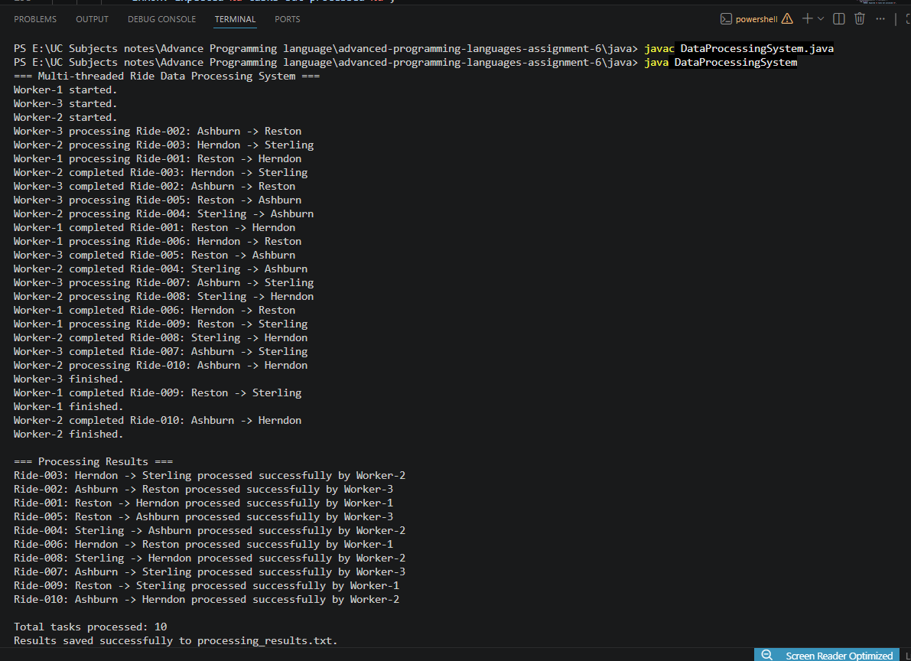

Appendix B: Go Execution Screenshot
