Syntax, Semantics, and Memory Management Across Programming Languages
Vamsi Matta
University of the Cumberlands
Advanced Programming Languages
September 2026

Introduction
This report examines syntax and semantics in Python, JavaScript, and C++, followed by a comparison of memory-management strategies in Rust, Java, and C++. The first part intentionally introduces syntax errors and records the diagnostics produced by the interpreter or compiler. It then compares the languages through the lens of type systems. The second part demonstrates three distinct memory-management approaches: Rust ownership and borrowing, Java garbage collection, and explicit dynamic allocation and deallocation in C++. The examples were maintained as separate source files suitable for revision control in GitHub.
GitHub repository: https://github.com/Vamsi-Matta/advanced-programming-languages-assignment

Part 1: Analyzing Syntax and Semantics

Section 1: Syntax Error Comparison
The assignment-provided sum examples were first corrected conceptually so that the intended algorithm was clear. One new syntax error was then deliberately introduced in each language. The objective was not to compare the same typo, but to observe how each language reports a parsing or compilation failure.

Python
In Python, the colon after the for statement was removed. The interpreter stopped before executing the program and reported “SyntaxError: expected :” while placing a caret at the end of the malformed for statement. This diagnostic is concise and points very close to the true source of the error. Python parses the file before normal execution, so an invalid statement prevents the program from running.
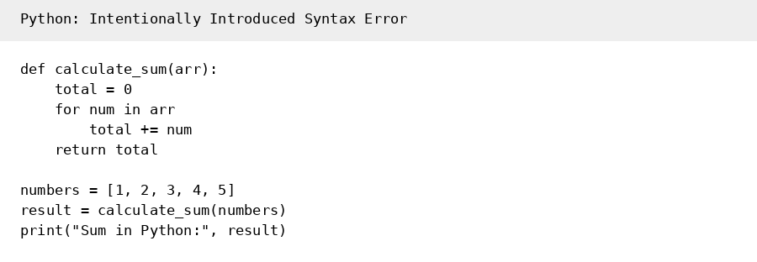
Figure 1. Python program with an intentionally missing colon.
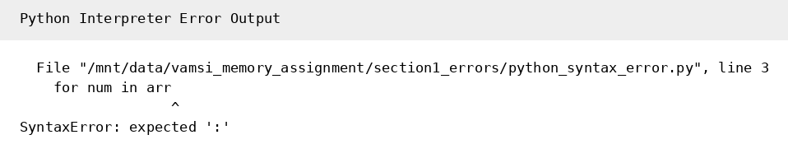
Figure 2. Python syntax-error output.

JavaScript
In JavaScript, the closing parenthesis was removed from the calculateSum(numbers) call. Node.js reported “SyntaxError: missing ) after argument list” and showed the location of the malformed call. Like Python, JavaScript source must be parsed before the surrounding code can execute. A syntax error therefore prevents the script from starting. JavaScript SyntaxError objects represent code that cannot be parsed according to the language grammar (MDN Web Docs, 2025).
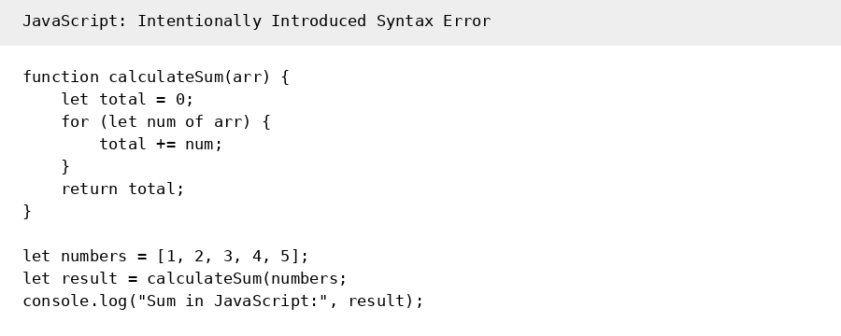
Figure 3. JavaScript program with a missing closing parenthesis.
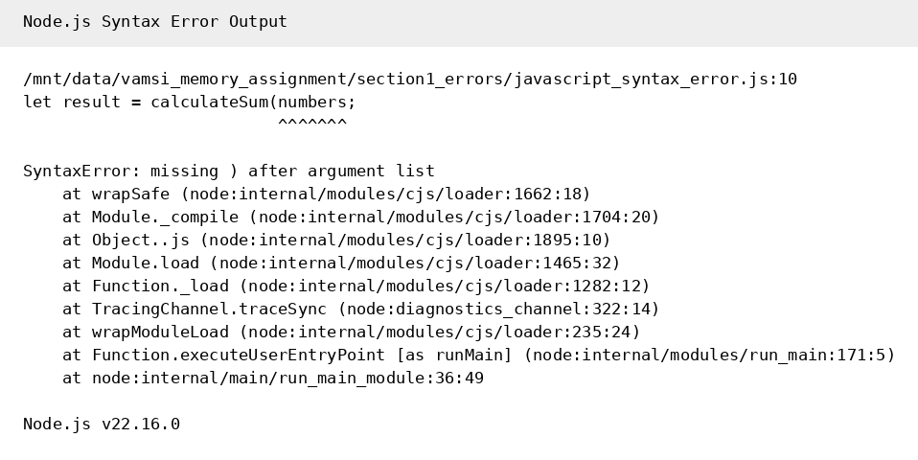
Figure 4. Node.js syntax-error output.

C++
In C++, the semicolon after int total = 0 was removed. The g++ compiler reported an error at the following for statement: “expected , or ; before for.” It then produced an additional error stating that i was not declared. This illustrates a common characteristic of compiled-language diagnostics: one syntax defect can cause later tokens to be interpreted incorrectly and produce cascading messages. The first compiler error is usually the most important one to fix.
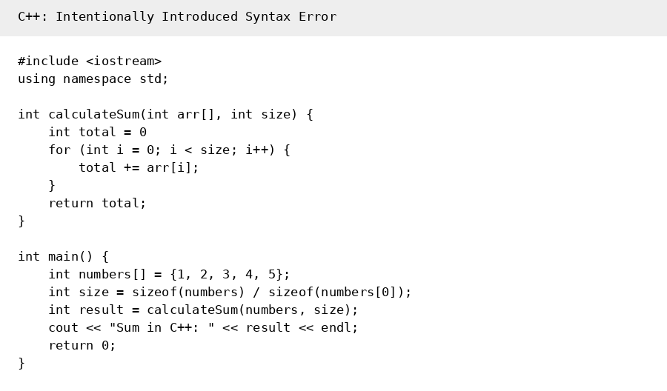
Figure 5. C++ program with a missing semicolon.
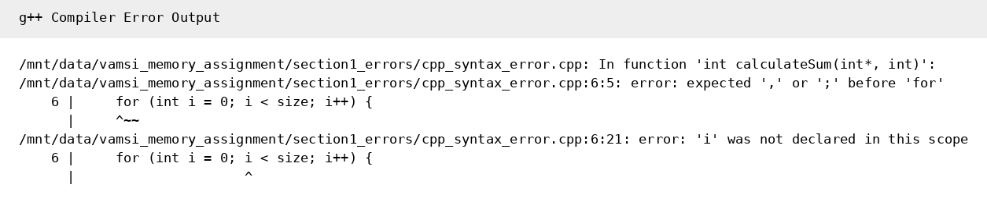
Figure 6. g++ compiler diagnostics.
Overall, Python provided the most direct message for this particular error, JavaScript also clearly identified the expected token, and C++ generated more than one diagnostic because the missing semicolon affected how the compiler parsed the following statement. All three detect these syntax errors before normal program execution, but their diagnostic wording and amount of follow-on information differ.

Section 2: Type-System Analysis
The custom programs compare how Python, JavaScript, and C++ handle types. This feature was selected because type rules directly influence program behavior, error detection, flexibility, and performance.

Python: Dynamic and Strong Typing
Python variables are names bound to objects, and a name can later be rebound to an object of a different type. In the example, value first refers to an integer and then to a string. Python permits this because type checking is primarily performed at runtime. At the same time, Python generally does not silently combine incompatible values in arbitrary ways; for example, adding an integer directly to a string raises a TypeError. Numeric types such as int and float can participate in arithmetic with conversion to an appropriate numeric result.
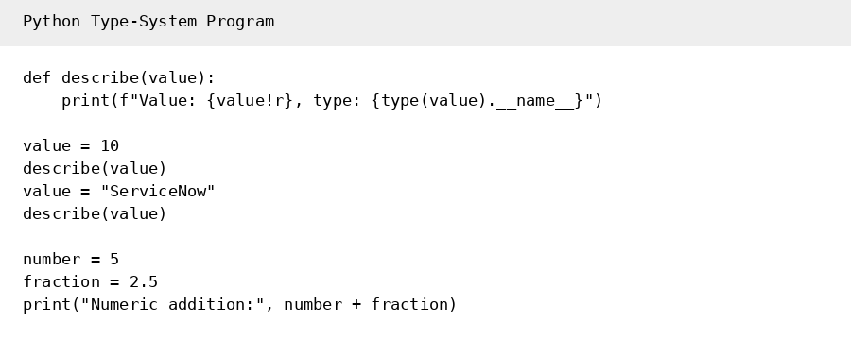
Figure 7. Python type-system demonstration.

JavaScript: Dynamic Typing and Coercion
JavaScript is also dynamically typed, so the same variable can hold a number and later a string. A major semantic difference is JavaScript coercion. The expression "5" + 2 produces the string "52" because + can perform string concatenation, while "5" - 2 produces the numeric value 3 because subtraction triggers numeric conversion. This flexibility can reduce code verbosity but can also introduce behavior that is surprising if the developer does not understand the coercion rules.
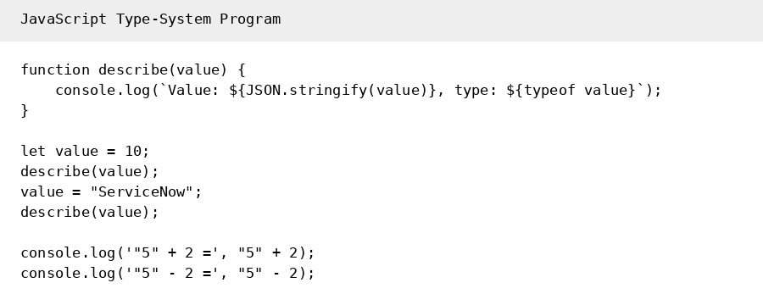
Figure 8. JavaScript type-system and coercion demonstration.

C++: Static Typing
C++ is statically typed. The variable value is declared as int and cannot later hold a std::string. An incompatible assignment such as value = "ServiceNow" would be rejected at compile time. C++ does allow defined numeric conversions, so adding an int and a double produces a double result. Static typing allows many type errors to be detected before execution and gives the compiler substantial information for optimization, although it requires developers to declare and respect types more explicitly.
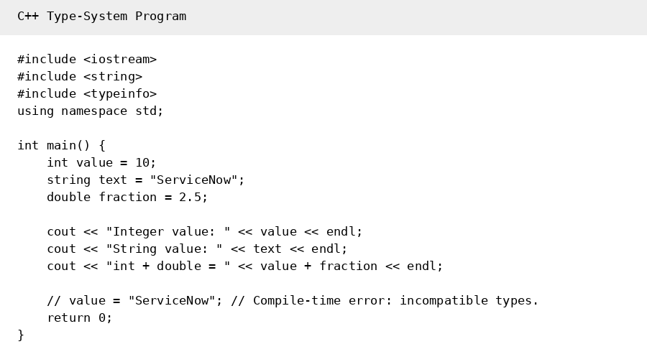
Figure 9. C++ static type-system demonstration.
Three important semantic differences affect behavior and performance:
Semantic Feature | Python | JavaScript | C++
Type binding | Dynamic; names may refer to different types over time. | Dynamic; variables may hold values of different types. | Static; declared variable types are checked at compile time.
Implicit coercion | Limited compared with JavaScript; incompatible operations often raise runtime errors. | Extensive coercion can change values between strings, numbers, and booleans. | Conversions are governed by static type and conversion rules; many invalid operations fail at compile time.
Performance implications | Runtime object/type handling adds overhead but improves flexibility. | Dynamic lookup and coercion add runtime work; modern JIT engines can optimize hot code. | Ahead-of-time compilation and static type information often enable predictable low-level optimization.
For enterprise developers, these differences change how defects surface. Python and JavaScript can accept a broader range of assignments during development, but some mistakes appear only when the affected path executes. C++ moves more type checking to compilation, which can make the development cycle stricter but can reduce certain categories of runtime type errors.

Part 2: Memory Management

Section 3: Rust, Java, and C++
Memory management is one of the clearest differences among Rust, Java, and C++. The programs below allocate heap memory but rely on different mechanisms for determining when that memory can be reclaimed.

Rust: Ownership and Borrowing
Rust manages memory through ownership rules checked by the compiler rather than through a tracing garbage collector. Each value has an owner, references can borrow a value without taking ownership, and owned resources are dropped when their owner goes out of scope. The Rust documentation explains that violations of ownership rules prevent compilation and that ownership itself adds no garbage-collection runtime pause (Klabnik et al., 2026). In the program, Box::new allocates an integer on the heap, show_value borrows it through a reference, and a Vec allocates a larger heap buffer. Both allocations are automatically released at the end of their owners’ scopes.
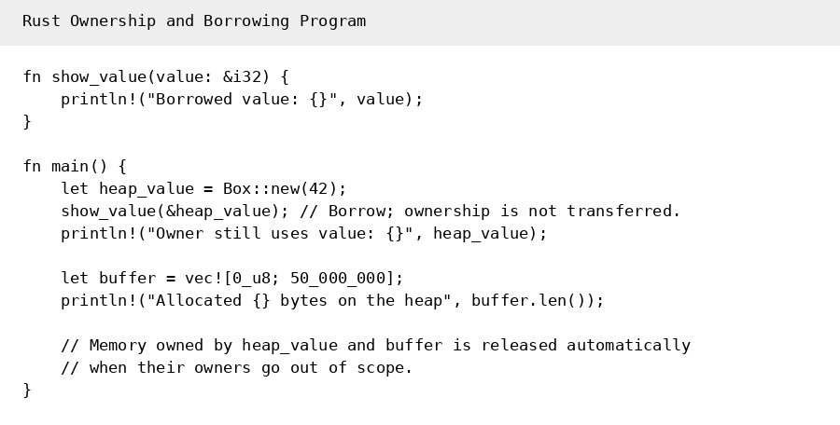
Figure 10. Rust ownership and borrowing example.
This approach prevents many use-after-free and double-free defects in safe Rust because invalid ownership and borrowing patterns are rejected before the program runs. The trade-off is development complexity: developers must learn ownership, moves, borrowing, and lifetimes. A Rust compiler was not available in the execution environment used to prepare this report, so no Rust runtime measurement is presented as an observed value. The included repository contains the exact rustc and /usr/bin/time commands needed to produce the measurement in an environment with Rust installed.

Java: Garbage Collection
Java allocates ordinary objects on a JVM-managed heap. When objects are no longer reachable, the garbage collector can reclaim their memory. Oracle describes the Java heap as a region managed by the garbage collector, which identifies unreachable objects and recycles their storage (Oracle, 2026). In the demonstration, five byte arrays totaling approximately 50 MB are allocated and then the references are cleared. System.gc() requests collection, but the JVM controls when and how collection occurs.
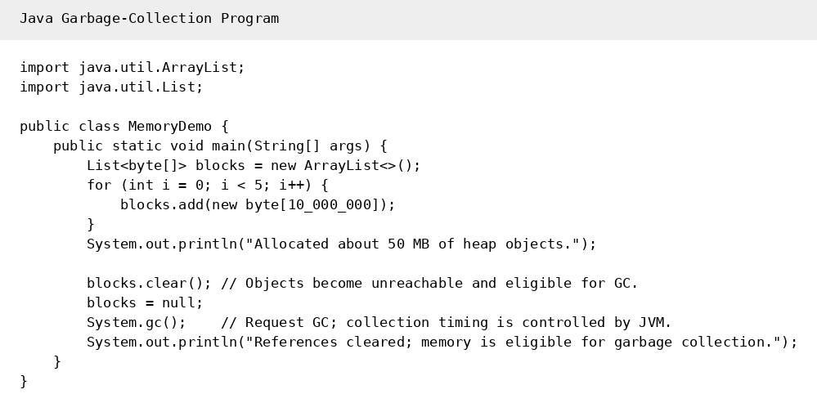
Figure 11. Java garbage-collection example.
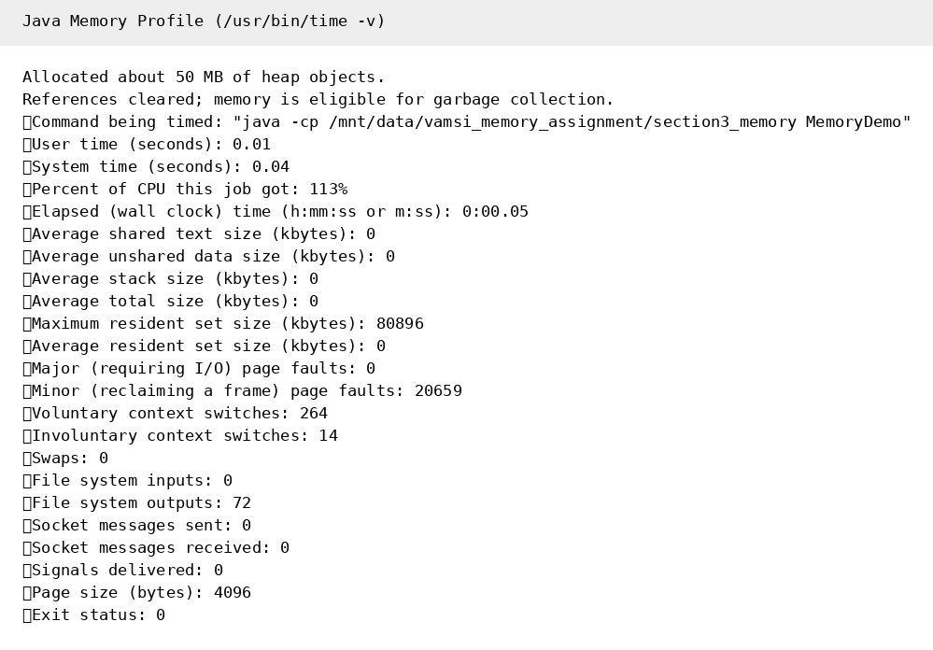
Figure 12. Java memory profile captured with /usr/bin/time -v.
The measured Java run reached a maximum resident set size of about 80,896 KB and completed in about 0.05 seconds in this environment. This value includes JVM runtime overhead in addition to the allocated arrays, so it should not be interpreted as the exact heap size. Java simplifies development because programmers usually do not explicitly free individual objects, and dangling references to reclaimed Java objects are avoided. The trade-off is garbage-collector overhead and less deterministic reclamation timing.

C++: Explicit Dynamic Memory Management
C++ permits explicit dynamic allocation with new/new[] and deallocation with delete/delete[]. The example allocates approximately 50 MB, touches the memory so the pages become observable, explicitly releases it with delete[], and sets the pointer to nullptr. C++ documentation notes that dynamically allocated objects persist until a corresponding delete expression is used; losing the original pointer before deletion creates a memory leak (cppreference.com, 2026).
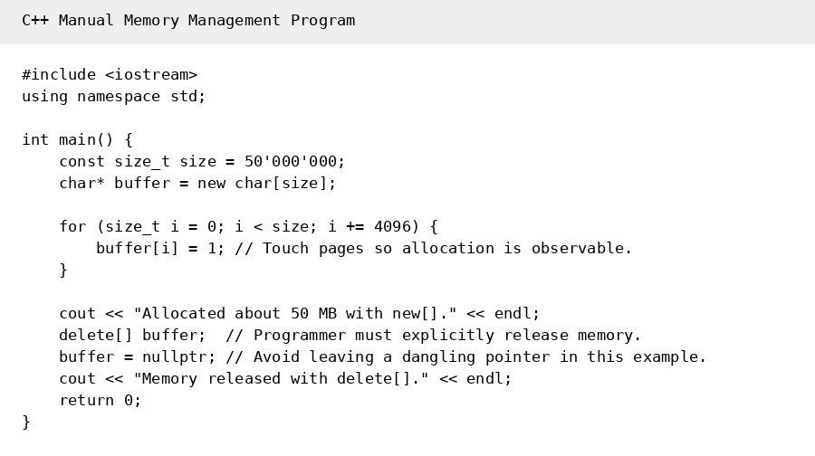
Figure 13. C++ explicit allocation and deallocation example.
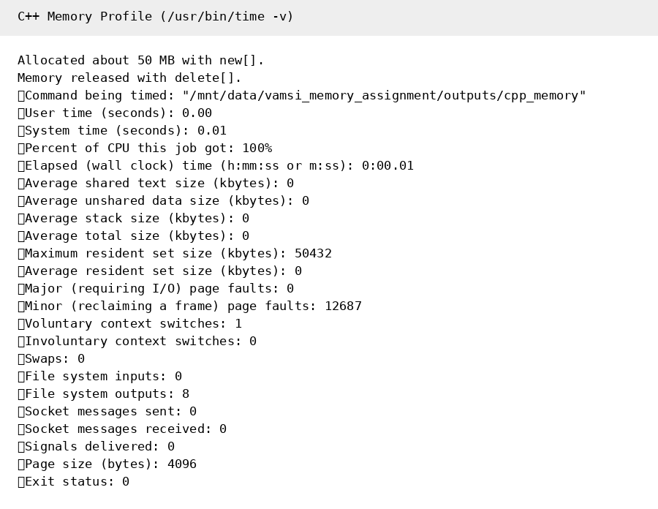
Figure 14. C++ memory profile captured with /usr/bin/time -v.
The measured C++ run reached a maximum resident set size of about 50,432 KB and completed in about 0.01 seconds in this environment. This small demonstration shows lower process overhead than the measured Java run, but it is not a universal benchmark: startup behavior, compiler optimization, garbage-collector configuration, operating system caching, and workload size can all change the result. The main point is that C++ gives the programmer direct control over allocation lifetime. That control can be valuable for performance-sensitive systems, but failing to delete memory can leak it, and using a pointer after deletion can create a dangling pointer and undefined behavior. Modern C++ frequently reduces these risks through RAII and smart pointers such as std::unique_ptr.

Memory-Management Comparison
Criterion | Rust | Java | C++
Primary strategy | Ownership/borrowing checked at compile time; deterministic drop. | Tracing garbage collection on JVM heap. | Programmer-controlled lifetime with RAII, smart pointers, or explicit new/delete.
Ease for developers | Steeper learning curve, but compiler guides safe ownership. | Usually easiest for routine application developers. | Most responsibility when raw pointers/manual allocation are used.
Safety | Strong memory-safety guarantees in safe Rust. | Prevents manual use-after-free of managed objects; GC handles unreachable objects. | Can be safe with disciplined RAII/smart pointers, but raw-pointer misuse can leak or dangle.
Runtime cost | No tracing GC; ownership checks are primarily compile time. | GC consumes runtime resources and reclamation timing is managed by JVM. | No mandatory GC; explicit or RAII destruction can be deterministic.
Typical fit | Systems, infrastructure, security-sensitive and performance-sensitive software. | Enterprise applications, backend services, large managed runtimes. | Systems, games, embedded and latency/performance-sensitive software.
For a ServiceNow developer, Java’s managed-memory model is the easiest to relate to because enterprise platform development typically operates at a higher level of abstraction than explicit pointer management. Java generally offers the simplest developer experience of these three approaches. Rust provides a strong balance of performance and safety when low-level control matters, while C++ is preferred when existing ecosystems, deterministic resource management, hardware access, or maximum implementation control are primary concerns.

Profiling Method and Limitations
The Java and C++ examples were profiled with /usr/bin/time -v, which reports process-level metrics such as elapsed time and maximum resident set size. This tool is useful for a simple comparison, but it is not a full heap profiler. The Java result includes JVM startup and runtime memory, while the C++ result reflects a native executable. Therefore, the measurements demonstrate observable differences for these specific sample programs rather than proving that one language always uses less memory or runs faster. For a stronger experiment, each program should be executed repeatedly with comparable workloads and language-specific profilers, such as Java Flight Recorder or VisualVM for Java, Valgrind/Massif or heaptrack for C++, and heaptrack or platform profiling tools for a compiled Rust executable.

Revision Control and Submission
All source files for this assignment are maintained in the public GitHub repository linked near the beginning of this report. The repository should contain the Python, JavaScript, C++, Rust, and Java source files along with the screenshots/output evidence used for the assignment. Git revision history provides a record of changes to the programs. The public repository is: https://github.com/Vamsi-Matta/advanced-programming-languages-assignment

Conclusion
Python, JavaScript, and C++ demonstrate different philosophies for syntax diagnostics and type semantics. Python and JavaScript are dynamically typed, while C++ performs extensive static checking before execution. JavaScript further distinguishes itself through implicit coercion rules. Rust, Java, and C++ likewise represent different memory-management philosophies. Rust shifts ownership verification to compile time, Java delegates reclamation to garbage collection, and C++ allows deterministic programmer-controlled resource management. The preferred strategy depends on the application: managed enterprise software often benefits from Java’s simplicity, systems software can benefit from Rust’s combination of safety and control, and C++ remains valuable where direct resource management, mature native ecosystems, and predictable low-level behavior are required.

References
cppreference.com. (2026). New expression. https://en.cppreference.com/w/cpp/language/new
Klabnik, S., Nichols, C., & Krycho, C. (2026). The Rust programming language: What is ownership? Rust Project. https://doc.rust-lang.org/book/ch04-01-what-is-ownership.html
MDN Web Docs. (2025). SyntaxError. Mozilla. https://developer.mozilla.org/en-US/docs/Web/JavaScript/Reference/Global_Objects/SyntaxError
Oracle. (2026). On-heap and off-heap memory. Java SE documentation. https://docs.oracle.com/en/java/javase/24/core/heap-and-heap-memory.html
Python Software Foundation. (2026). Errors and exceptions. Python documentation. https://docs.python.org/3/tutorial/errors.html
Sebesta, R. W. (2019). Concepts of programming languages (12th ed.). Pearson.

