Ride Sharing System: Object-Oriented Programming in Smalltalk and C++
Vamsi Matta
University of the Cumberlands
Advanced Programming Languages
October 2026

Ride Sharing System
This assignment implements the same class-based Ride Sharing System design in C++ and Smalltalk. The system contains a base Ride abstraction, StandardRide and PremiumRide specializations, a Driver, and a Rider. Both implementations demonstrate the three required object-oriented programming principles: encapsulation, inheritance, and polymorphism. The application also stores multiple ride types in collections and calculates fares according to the actual ride type.

Encapsulation
Encapsulation is demonstrated by keeping an object's data inside its class and providing methods that control how the data is used. In the C++ implementation, the Ride data members and the Driver's assignedRides collection are private. Public methods such as addRide() and getDriverInfo() provide controlled access. Rider similarly manages requested rides through requestRide() and viewRides(). In Smalltalk, state is stored in instance variables and behavior is exposed through messages such as addRide:, requestRide:, and viewRides. This design keeps collection-management responsibilities inside the appropriate objects.

Inheritance
Inheritance is demonstrated through StandardRide and PremiumRide. In C++, both classes derive from Ride and reuse the common ride information while supplying ride-specific behavior. In Smalltalk, StandardRide and PremiumRide are subclasses of Ride. This avoids duplicating the shared ride ID, pickup location, drop-off location, and distance behavior. The subclasses specialize only the behavior that differs between ride categories.

Polymorphism
Polymorphism is demonstrated by overriding fare behavior. StandardRide calculates fare at $2.00 per mile in both implementations. In the submitted C++ implementation, PremiumRide calculates fare at $3.50 per mile, while the tested Smalltalk implementation calculates PremiumRide fare at $3.00 per mile. The C++ program stores shared pointers to different Ride subclasses in one vector and invokes fare() and rideDetails() through the base type, so virtual method dispatch selects the correct implementation at runtime. The Smalltalk version stores different ride objects in an OrderedCollection and sends each object the same fare and rideDetails messages. Each object responds according to its class. Although the premium-rate constants differ between the two submitted implementations, both correctly demonstrate runtime polymorphism through subclass-specific fare behavior.

Testing and Results
The implementations were tested with sample Rider, Driver, StandardRide, and PremiumRide objects. Smalltalk tests confirmed that requestedRides and assignedRides collections initialize correctly and accept ride objects; Rider and Driver identifiers, names, and ratings can be stored and retrieved; and ride details such as pickup location, drop-off location, and distance are accessible. For a distance of 10 miles, the Smalltalk tests returned a StandardRide fare of 20 and a PremiumRide fare of 30. The C++ output in Appendix A shows successful ride creation, driver/rider information, collection handling, and subclass-specific fare calculations. These results provide execution evidence for encapsulation, inheritance, collection management, and polymorphic fare behavior.

Comparison of the Two Languages
C++ makes the class hierarchy and access control explicit through class declarations, private/public sections, inheritance syntax, and virtual functions. Smalltalk uses a more message-oriented model in which objects receive messages and subclasses redefine inherited behavior. Although the syntax is very different, both implementations organize the application around reusable objects and demonstrate the same three OOP principles. Developing the application in both languages illustrates that object-oriented design concepts can remain consistent even when language syntax and runtime mechanisms differ.

GitHub Repository
GitHub URL:
https://github.com/Vamsi-Matta/advanced-programming-languages-ride-sharing

References
Standard C++ Foundation. (n.d.). Standard C++. https://isocpp.org/
Pharo Consortium. (n.d.). Pharo. https://pharo.org/

Appendix A: C++ Code and Output
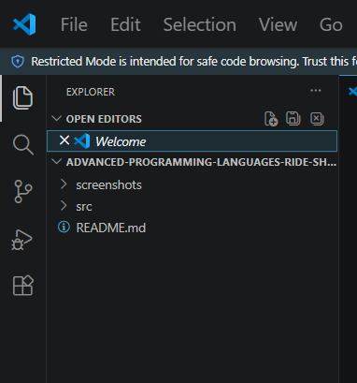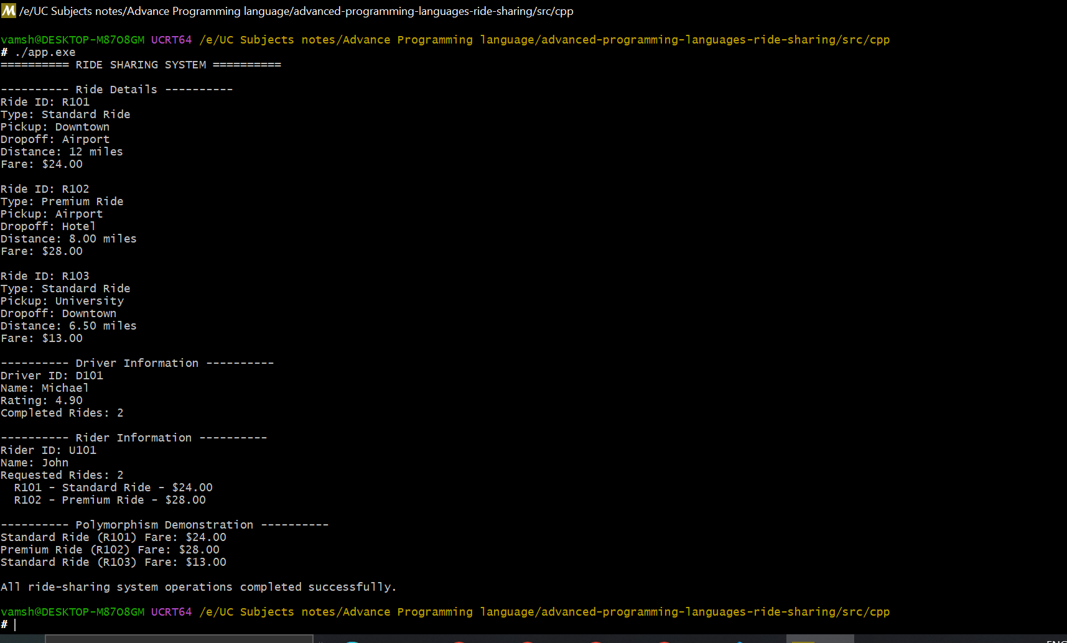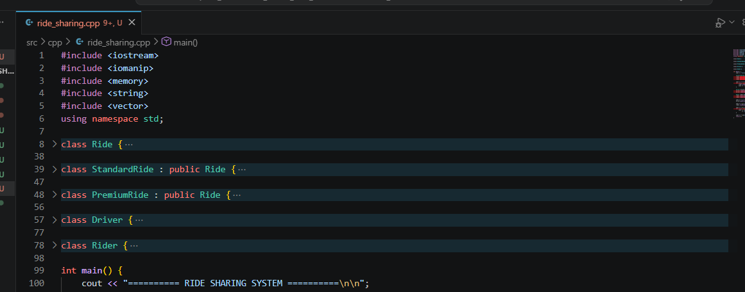

Appendix B: Smalltalk Code and Output
