Diagnosis of Alzheimer's Disease Using Convolutional Neural Network With Select Slices by Landmark on Hippocampus in MRI Images

To run web code run all blocks in JUPYTER and when you run last block then FLASK server will start and then will get below screen

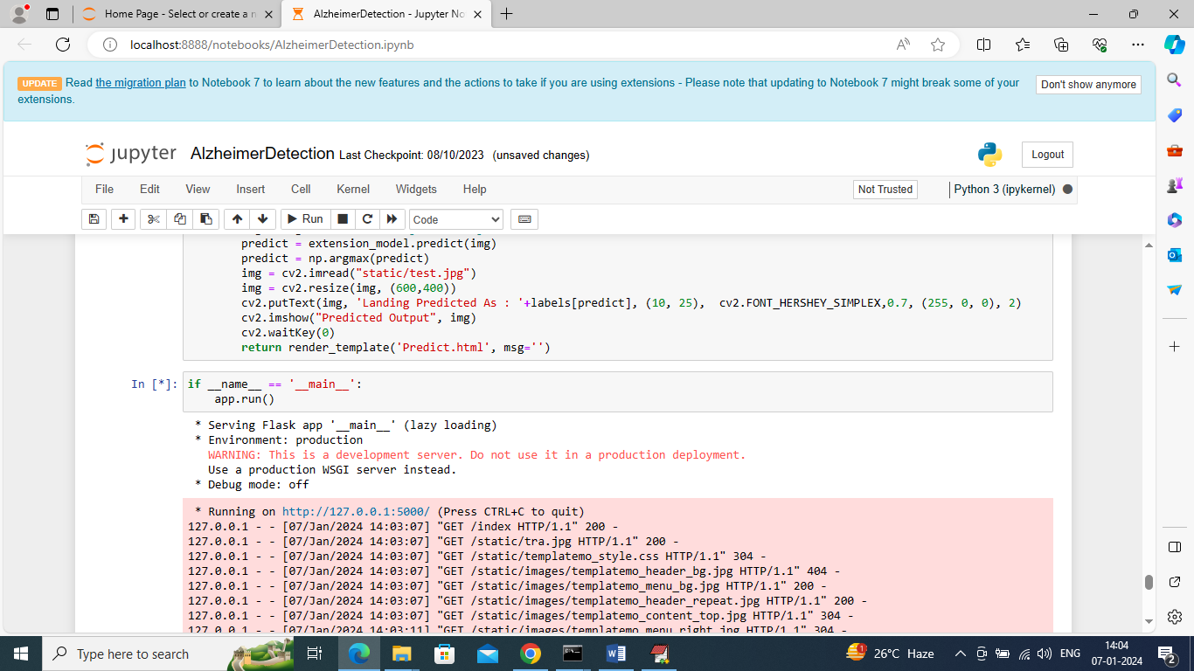

In above screen flask server started and now open browser and enter URL as <http://127.0.0.1:5000/index> and then press enter key to get below page

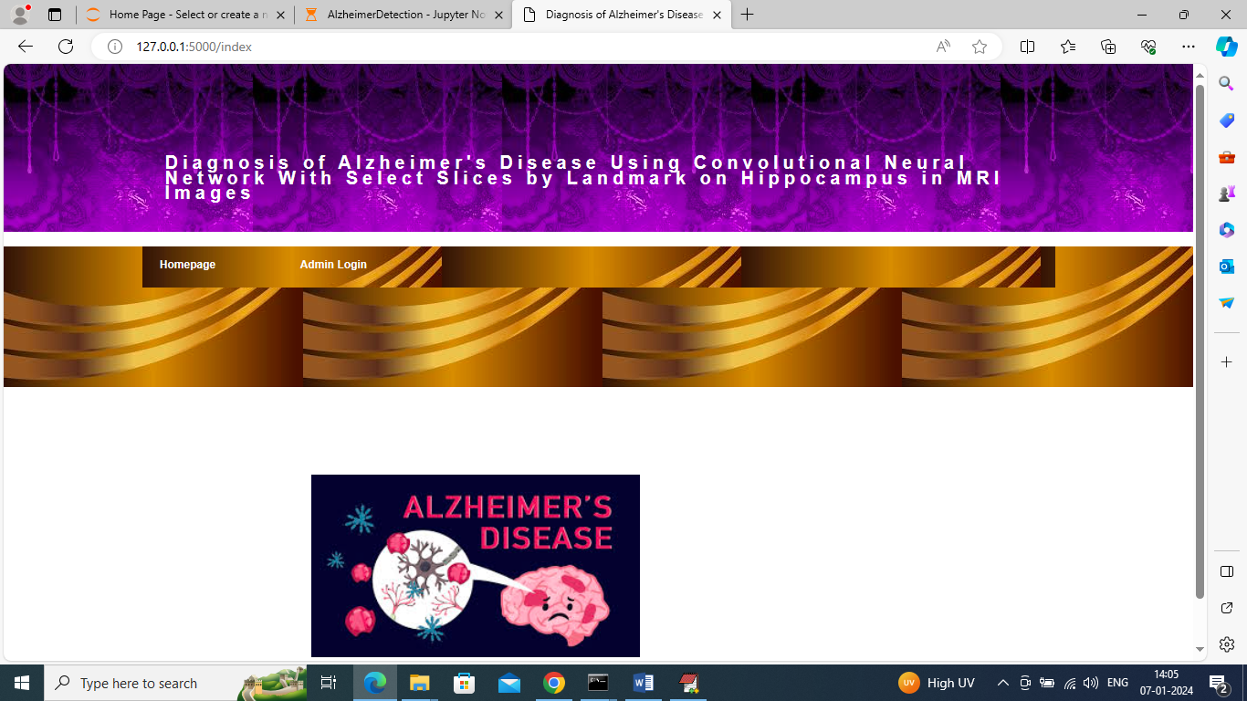

In above screen click on ‘Admin Login’ link to get below page

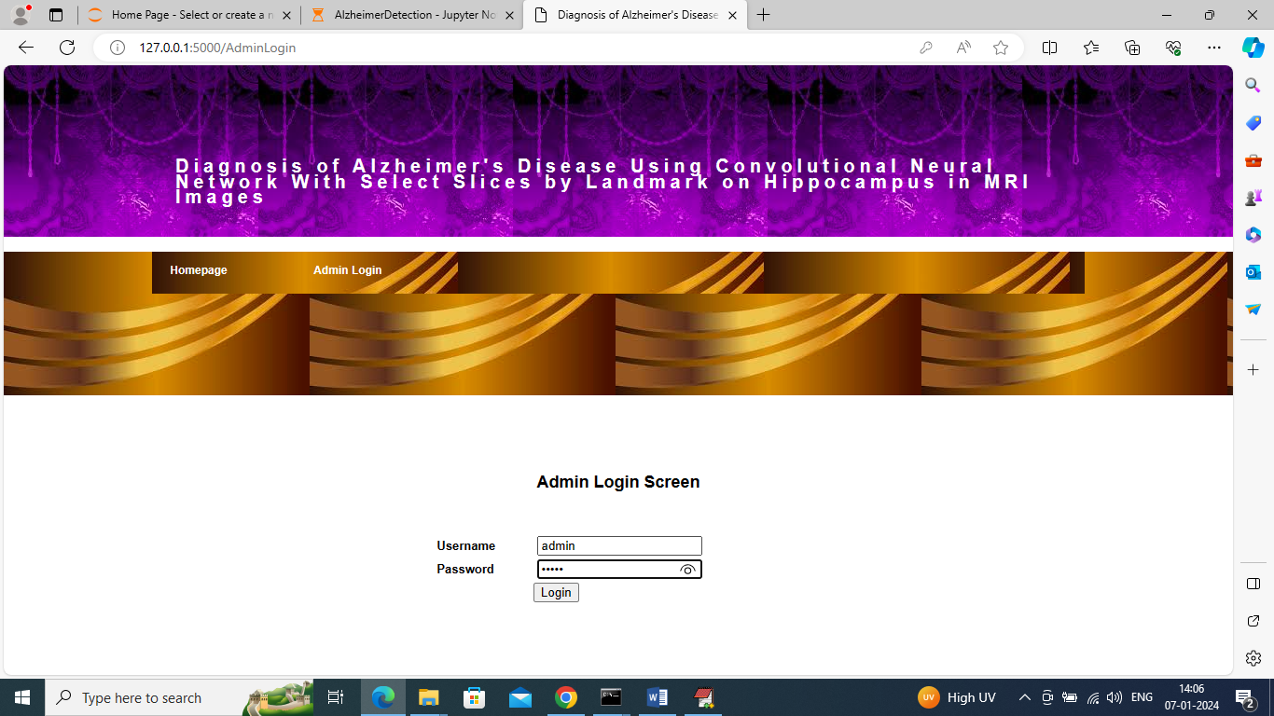

In above screen admin is login and after login will get below page

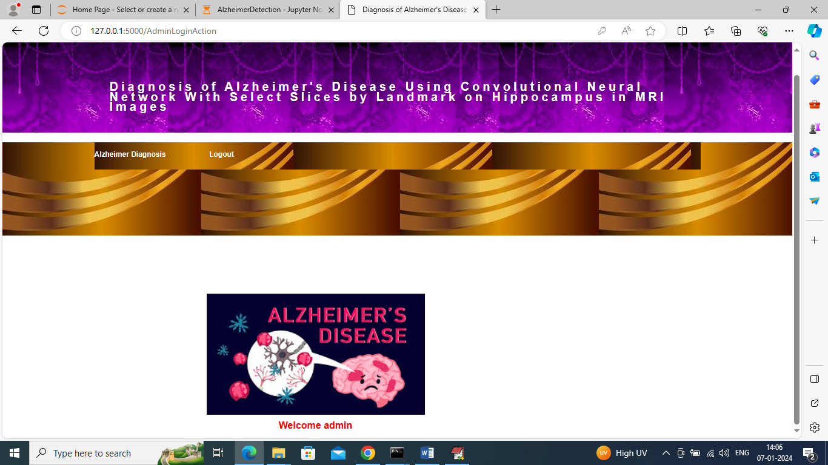

In above screen click on ‘Alzheimer Diagnosis’ link to get below page

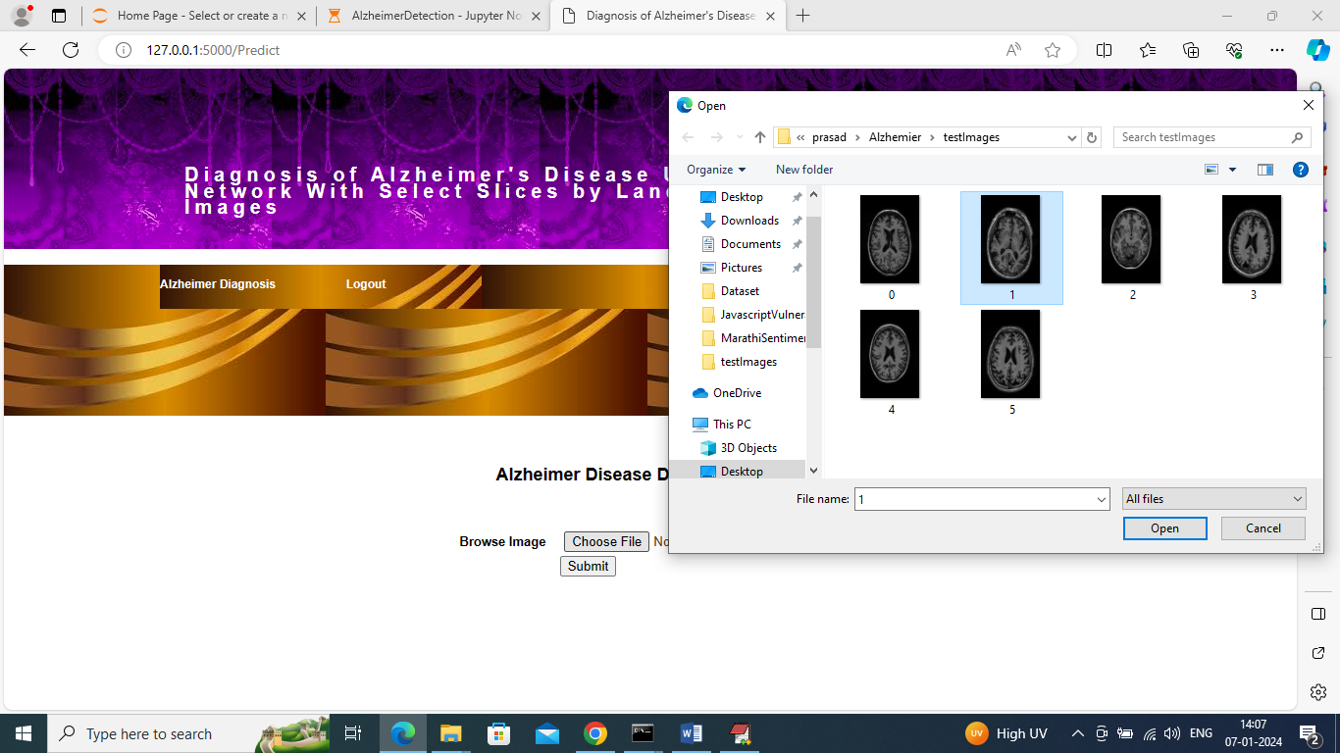

In above screen select and upload test image and then press button to get below output

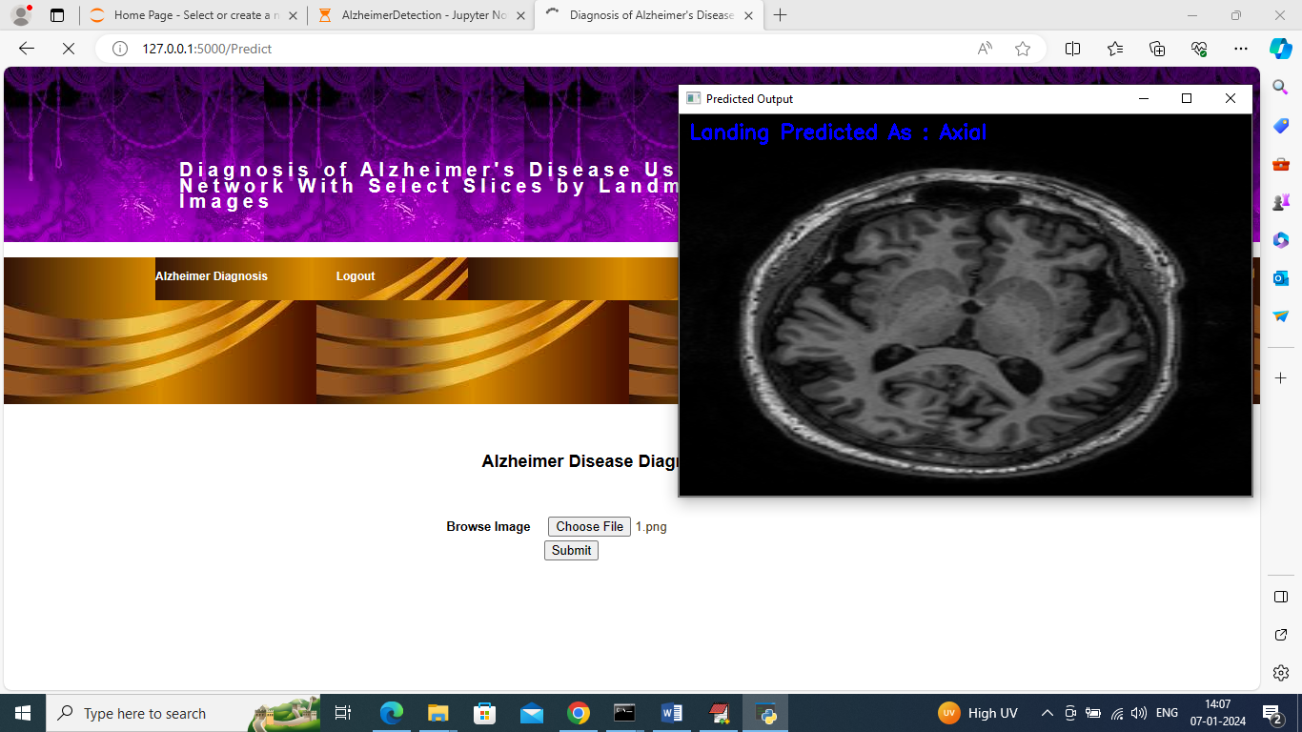

In above screen in blue colour text can see predicted disease type and similarly you can upload and test other images