**KNN**

Since we have around 5000 plus columns we applied PCA using prcom (PCA using correlation matrix

And got the following confusion matrix and accuracy of 0.9 and P value of 0.046

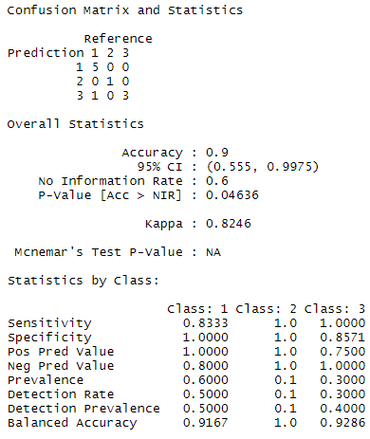

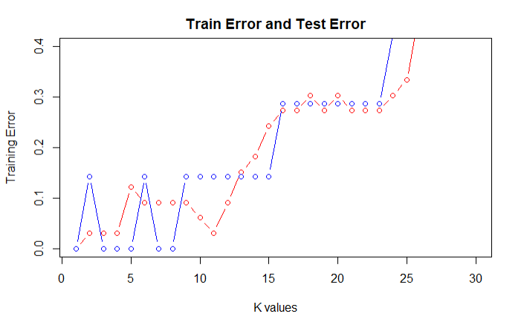

From the above plot we can we can see that when we have K = 4 we get a low train and test error and optimal value for K will be 4

As we have huge only 40 rows of data K fold cross validation Is applied with 10-fold cross validations for the model, from the graph below we can having K = 10 we get low train and test error

