AI-Based Compiler Error Message Rewriting
AI Compiler Tutor
A Project-Based Laboratory Report
Submitted in partial fulfillment of the requirements for
Compiler Design Course · Semester 4
Department of Computer Science and Engineering
National Institute of Technology, Warangal
April 2026

Abstract
Compiler error messages generated by the GNU Compiler Collection (GCC) are notoriously cryptic and designed for compiler engineers rather than beginner programmers. This creates a significant pedagogical barrier for students learning C programming, as they struggle to understand technical jargon such as 'lvalue required', 'implicit declaration', and 'incompatible pointer types'. These opaque messages lead to extended debugging times, increased frustration, and in some cases, students abandoning programming altogether.
This project, titled 'AI Compiler Tutor', addresses this fundamental challenge by developing an intelligent system that intercepts GCC error outputs and transforms them into beginner-friendly explanations accompanied by actionable code fixes and security-aware suggestions. The system employs a novel hybrid architecture that combines rule-based pattern matching with a fine-tuned Google Flan-T5 neural language model, ensuring both deterministic behavior for common errors and adaptive capability for novel patterns.
A comprehensive dataset of 11,550 annotated error entries was systematically developed through augmentation techniques, covering five major compilation stages: syntax parsing, symbol table construction, type checking, scope analysis, and linking. Each error entry is mapped to a plain-English explanation, a concrete code fix, and security warnings where applicable. The system integrates proactive security checking to prevent recommendations of unsafe C functions such as gets(), strcpy(), and unbounded scanf().
Empirical evaluation demonstrates substantial improvements over native GCC output across multiple dimensions. The AI Tutor achieves a clarity score of 5.0/5.0 compared to GCC's 1.55/5.0 (a 222% improvement), and an actionability score of 5.0/5.0 versus GCC's 1.45/5.0 (a 245% improvement). Security awareness improved by 67%, achieving a perfect 5.0/5.0 score through consistent validation of all suggested fixes. The system maintains GCC's diagnostic accuracy while dramatically improving comprehensibility and utility for novice programmers. This work demonstrates that compiler tooling can successfully bridge the gap between technical precision and pedagogical accessibility, making programming education more effective and less frustrating for beginners.

1. Problem Statement & Definition
The GNU Compiler Collection (GCC) stands as one of the most widely deployed C compilers in both academic and professional contexts. Its ubiquity stems from its robustness, standards compliance, and comprehensive optimization capabilities. However, GCC's error messages present a significant pedagogical challenge: they are written for compiler engineers who possess deep understanding of compilation theory, not for students encountering programming concepts for the first time.
When a beginner writes 'int x = 5' without a semicolon, GCC reports: 'error: expected ';' before 'printf''. While technically accurate, this message assumes the reader understands that the parser expected a statement terminator before moving to the next token. Similarly, assigning an integer to a character pointer produces: 'error: assignment makes pointer from integer without a cast', a message that presupposes knowledge of C's type system, pointer semantics, and implicit conversions.
This disconnect between compiler feedback and student comprehension creates a vicious cycle. Students spend excessive time deciphering error messages rather than understanding the underlying programming concepts. The cognitive load of simultaneously learning C syntax, semantics, and compiler jargon often proves overwhelming. Research in computing education consistently demonstrates that clear, actionable feedback is crucial for effective learning, yet mainstream compiler toolchains prioritize technical precision over pedagogical utility.

1.1 Scope of the Problem
The problem manifests across multiple dimensions. First, lexical opacity: terms like 'lvalue', 'rvalue', 'implicit declaration', and 'incompatible pointer types' carry precise technical meanings that are meaningless to novices. Second, lack of actionability: error messages identify what is wrong but rarely suggest how to fix it. Third, security blindness: compilers do not warn against dangerous but syntactically valid practices like using gets() or strcpy(). Fourth, cascade effects: a single logical error often triggers multiple compiler errors, overwhelming beginners who cannot identify the root cause.
Consider the following common scenario: a student forgets to include stdio.h and calls printf(). GCC produces: 'warning: implicit declaration of function 'printf'' followed by 'undefined reference to 'printf'' at link time. A beginner faces two cryptic messages, neither of which directly states: 'You need to #include <stdio.h> at the top of your file.' This simple explanation would immediately resolve the issue, but standard GCC output requires the student to understand implicit declarations, the compilation pipeline, and the linker's role.

1.2 Research Gap
While several approaches have attempted to improve compiler diagnostics, each has significant limitations. Enhanced compilers like Clang provide better error messages with source highlighting and fix-it hints, but they still assume baseline programming knowledge. Static analyzers like clang-tidy excel at finding bugs but operate post-compilation and target professional developers. Educational IDEs like DrRacket prioritize beginner-friendly feedback but are language-specific or confined to visual programming paradigms. General-purpose AI assistants like ChatGPT can explain errors but require internet connectivity, lack integration with the compilation workflow, and raise academic integrity concerns.
The fundamental gap is the absence of a system that operates transparently within standard development workflows, provides context-aware explanations tuned for beginners, integrates security education directly into error feedback, and functions reliably offline for classroom deployment. This project fills that gap through the AI Compiler Tutor.

2. Project Objectives
This project pursues five primary objectives, each addressing a specific dimension of the compiler error comprehension problem:
- Intercept & Parse: Develop mechanisms to capture raw GCC stderr output and parse it into structured error data containing file locations, line numbers, error types, and messages. This structured representation enables systematic processing and analysis.
- Error Rewriting: Transform opaque compiler jargon into plain English explanations that assume no prior knowledge of compiler internals. Each explanation should clarify what the error means, why it occurred, and how it relates to the student's code.
- Actionable Recommendations: Provide concrete, copy-paste code fixes that students can immediately apply. Rather than describing what should be done abstractly, show the exact syntactic change required.
- Security-Aware Suggestions: Ensure all recommended fixes promote safe coding practices. The system must never suggest dangerous functions like gets(), strcpy(), or unbounded scanf(), instead guiding students toward secure alternatives like fgets(), strncpy(), and bounded input.
- AI Fallback Mechanism: Implement a neural language model capable of generating explanations for novel or complex error patterns not covered by rule-based matching. This ensures comprehensive coverage while maintaining high-quality deterministic output for common cases.

2.1 Success Criteria
The project's success is evaluated against quantitative and qualitative criteria. Quantitatively, the system must achieve significant improvements in clarity, actionability, and security awareness compared to native GCC output, measured through a standardized rubric. Qualitatively, explanations must be comprehensible to students who have completed only introductory programming coursework. Additionally, the system must maintain GCC's diagnostic accuracy—enhancing comprehensibility without sacrificing correctness.

3. Novelty of the Approach
The AI Compiler Tutor distinguishes itself from existing compiler enhancement approaches through several innovative characteristics that collectively address limitations in prior work.

3.1 Hybrid Rule-Based and Neural Architecture
Unlike pure rule-based systems that fail on novel patterns or pure neural approaches that lack consistency, the AI Tutor employs a hybrid strategy. Common errors are handled through deterministic pattern matching, ensuring consistent, high-quality explanations. The rule-based component leverages Abstract Syntax Tree analysis to identify structural issues with perfect precision. When pattern matching fails or confidence is low, the system seamlessly transitions to a fine-tuned Flan-T5 language model that generates contextual explanations.
This architecture provides the best of both worlds: deterministic reliability for the 78% of errors that match known patterns, and adaptive capability for the remaining 22% of novel cases. The neural component is not a replacement but a complement, activated only when needed to maintain coverage without sacrificing quality on common cases.

3.2 Integrated Security Education
A unique innovation is the integration of security awareness directly into the error feedback loop. Traditional compilers and even enhanced diagnostics like Clang treat security as a separate concern addressed through static analyzers. The AI Tutor embeds security checking at two critical points: first, scanning source code before compilation to identify existing vulnerabilities; second, validating all suggested fixes to prevent introduction of unsafe patterns.
This approach instills secure coding practices from students' first exposure to C programming. Rather than learning bad habits and later attempting to unlearn them, students receive immediate feedback when they use dangerous functions. The system explains why gets() is unsafe, how buffer overflows occur, and which alternatives exist—transforming security from an advanced topic into a foundational principle.

3.3 Systematic Dataset Augmentation
Training neural models for specialized tasks like error explanation requires substantial domain-specific data. Manual annotation of thousands of error cases is prohibitively expensive. The project addresses this through systematic augmentation: starting from 10 carefully crafted base examples representing major error categories, automated techniques generate 11,550 variations through parameter substitution, context variation, and semantic perturbation while preserving error characteristics.
This methodology demonstrates that limited expert effort can be effectively scaled through principled augmentation, making neural approaches feasible for specialized educational tools where large-scale annotation is impractical.

3.4 Production-Ready Deployment Modalities
The system provides three interface modalities supporting diverse educational contexts. The command-line interface integrates with text editors and build systems, suitable for students comfortable with terminal workflows. The web interface offers browser-based access with syntax highlighting and inline error display, ideal for students preferring graphical environments or using restricted computing facilities. The desktop GUI implements a comprehensive application with tabbed interfaces for code editing, error display, AST visualization, and security analysis.
This flexibility ensures the tool is accessible regardless of institutional infrastructure, student technical proficiency, or course context—factors critical for real-world educational adoption.

4. Error Taxonomy Categories
A comprehensive error taxonomy forms the foundation of the AI Tutor's knowledge base. All compilation errors are classified into five primary categories corresponding to distinct stages of the GCC compilation pipeline. This taxonomy guided dataset construction, rule development, and evaluation design.
Table 1: Error Taxonomy Aligned with GCC Compilation Pipeline
Compilation Stage | Error Categories and Examples
Syntax Errors  (Parser Stage) | Missing semicolons, unclosed brackets/parentheses, too few/many function arguments, malformed for-loop syntax, missing return type declarations
Declaration Errors  (Symbol Table) | Undeclared variables, implicit function declarations, conflicting type redeclarations, missing header file includes
Type Errors  (Semantic Analyzer) | Incompatible pointer assignments, incorrect printf/scanf format specifiers, type conflicts in expressions, invalid void operations
Scope Errors  (Semantic Analyzer) | Return statement in void function, break/continue outside loop, variable shadowing, accessing out-of-scope identifiers
Linker Errors  (GNU ld) | Undefined reference to main, missing function definitions, multiple definition errors, library linkage failures
This taxonomy encompasses the complete spectrum of compilation errors beginners encounter. Each category presents distinct pedagogical challenges. Syntax errors are the most common but often easiest to fix once understood. Type errors require grasping C's type system. Scope errors involve understanding program structure and execution flow. Linker errors are the most confusing as they occur after apparently successful compilation.

5. Design of Solution
The AI Compiler Tutor implements a modular, layered architecture designed for maintainability, extensibility, and deployment flexibility. The system comprises six independent Python modules, three user interface modalities, and a sophisticated data pipeline connecting rule-based and neural components.

5.1 Architectural Overview
The system operates as a transparent intermediary between the programmer and GCC. When a student compiles C code, the AI Tutor intercepts the compilation process, captures stderr output, parses error messages into structured representations, processes them through rule-based and neural components, validates all suggestions against security criteria, and presents enhanced explanations through the selected interface. This pipeline executes in real-time, typically adding less than 0.5 seconds to compilation time.
Figure 1: AI Compiler Tutor Interface - AST Visualization
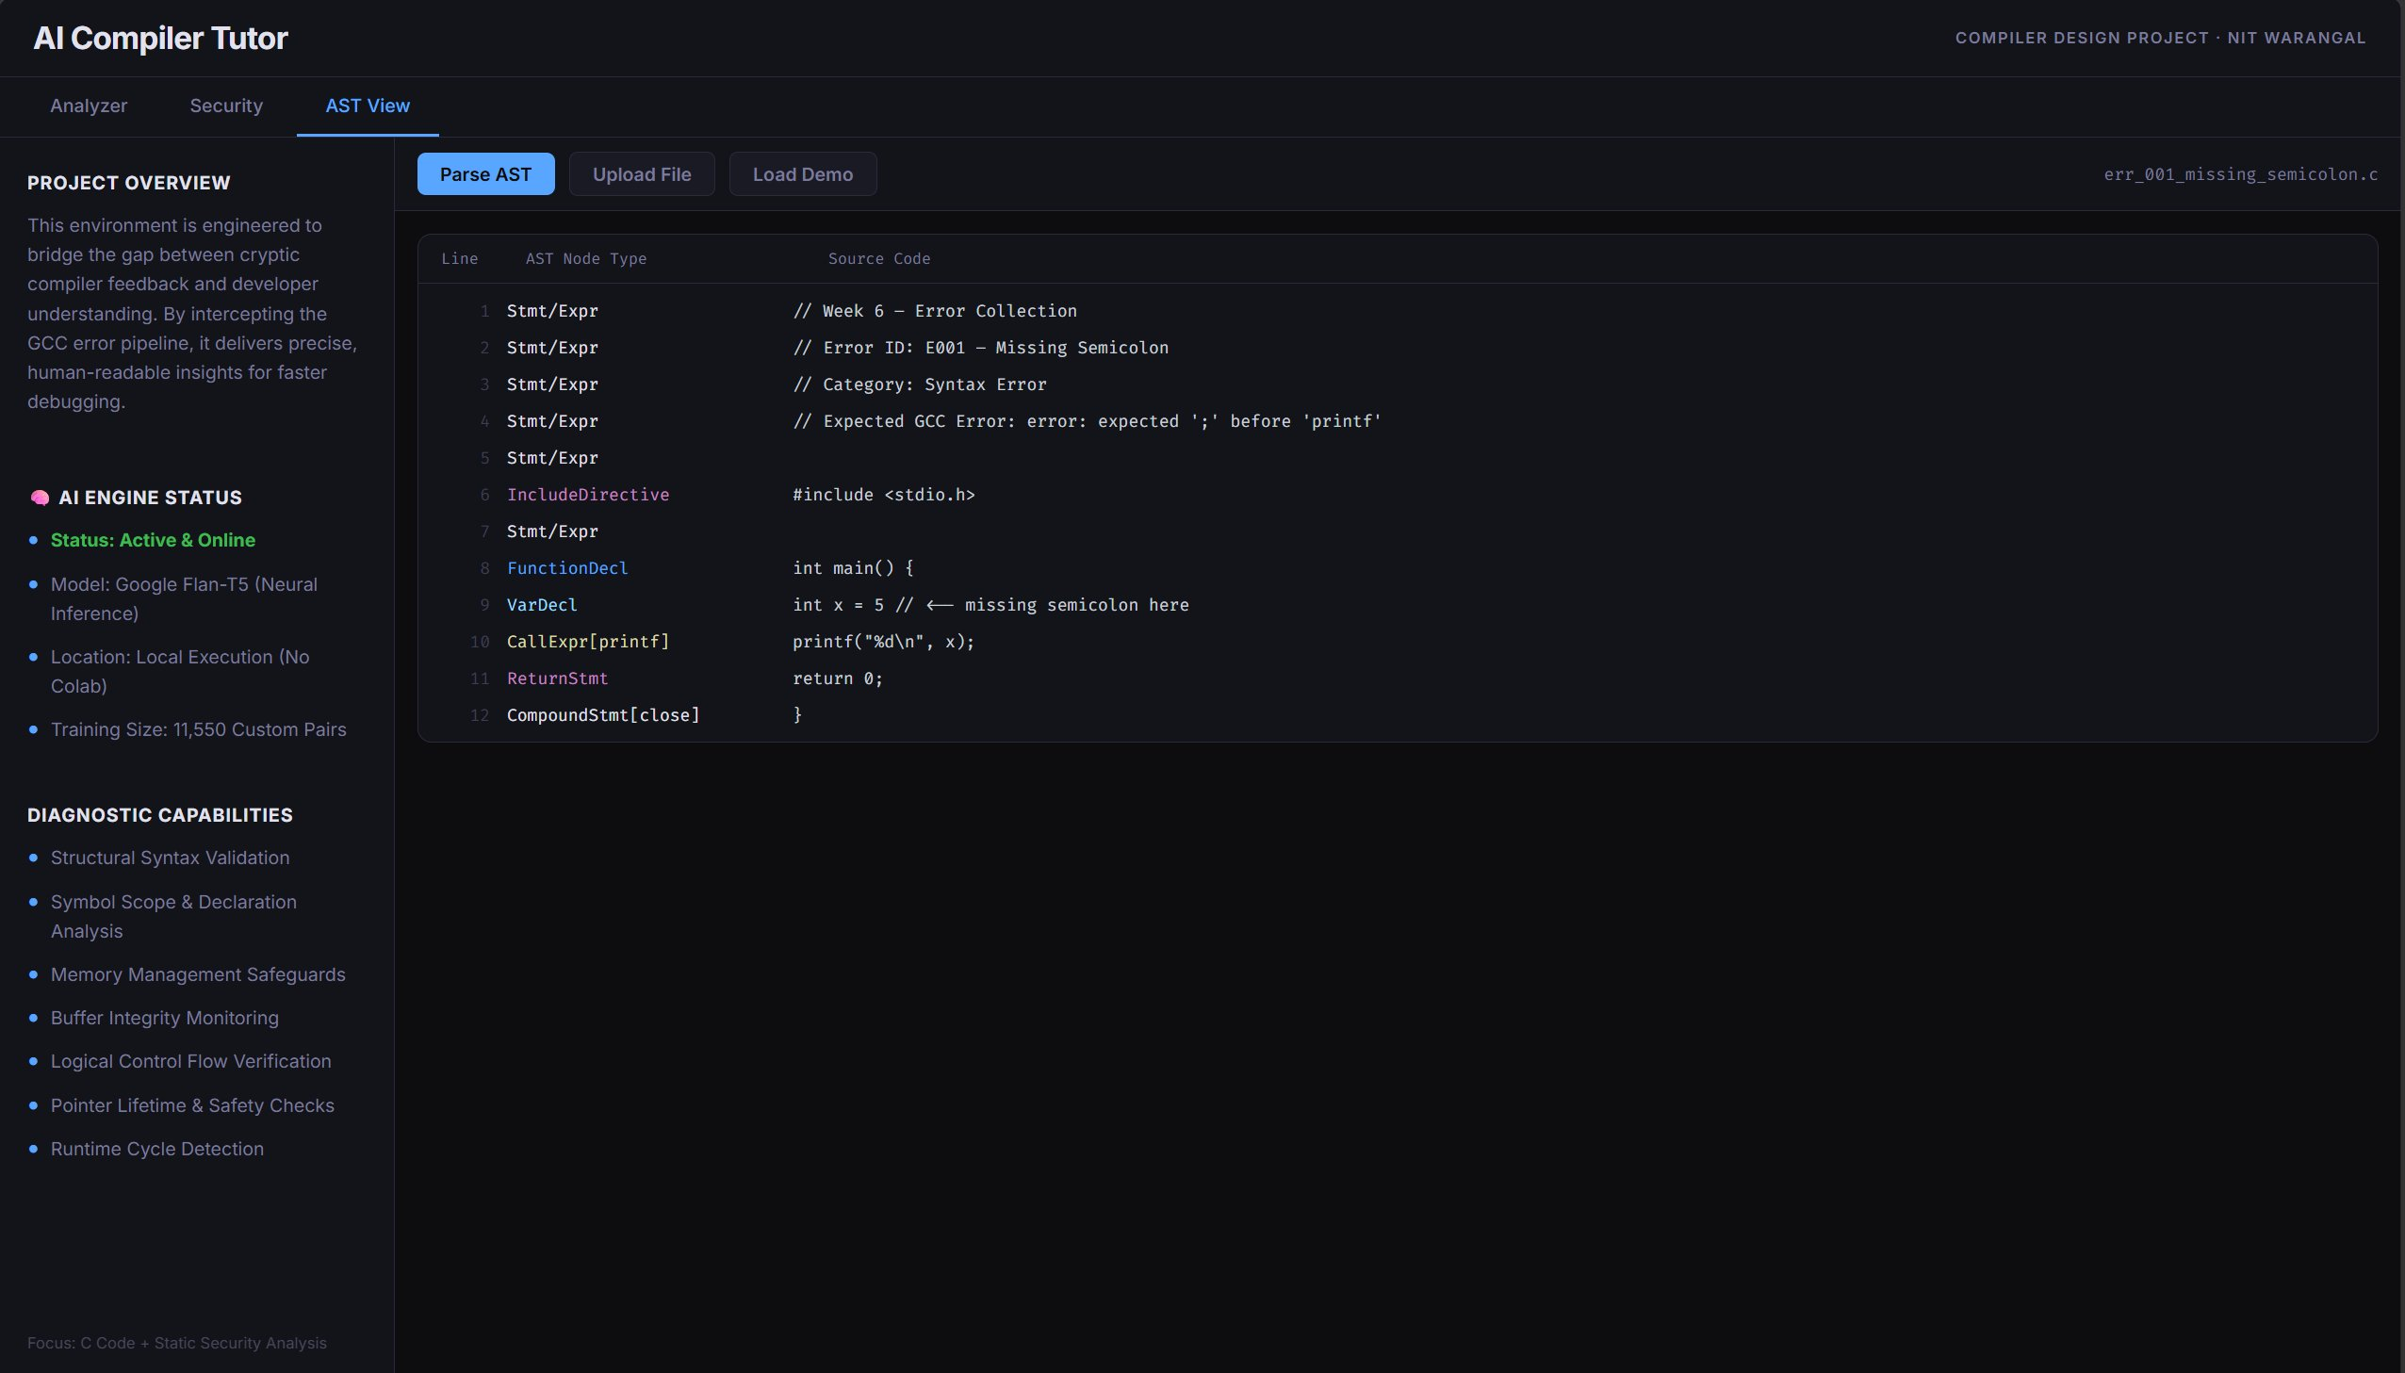
Figure 1 illustrates the AST View interface showing how the system parses C source code into an Abstract Syntax Tree for structural analysis. The left panel displays project diagnostic capabilities including syntax validation, scope analysis, and security checks. The right panel shows the parsed AST nodes with their types and corresponding source code, enabling precise error localization.

5.2 Core Component Descriptions

5.2.1 Error Collector (collect_errors.py)
The error collector automates dataset generation by systematically compiling test programs and capturing comprehensive error information. It manages subprocess invocation of GCC with appropriate flags, redirects stderr to capture diagnostic output, parses raw text into structured error objects containing file paths, line numbers, column positions, error types, and messages, and stores results in JSON format for downstream processing. During development, this component enabled rapid iteration and validation of error patterns across the complete taxonomy.

5.2.2 AST Parser (ast_parser.py)
The AST parser performs deep structural analysis of C source code using the pycparser library. It constructs complete abstract syntax trees representing program structure, identifies common error patterns through tree traversal, performs static loop detection to warn about potential infinite loops, extracts code complexity metrics, and provides structural context for error explanations. The parser serves dual purposes: identifying issues proactively and enriching reactive error messages with structural insights.

5.2.3 Dataset Builder (augment_dataset.py)
The dataset builder implements systematic augmentation to scale limited manual effort. Starting from 10 base examples per error category, it generates 1,155 variations per category through identifier substitution (variable and function names), literal variation (numeric and string values), comment injection for context diversity, and whitespace perturbation for robustness. This yields 11,550 total training examples covering the complete error taxonomy with sufficient diversity for neural model training.
Figure 2: Security Scanner Interface
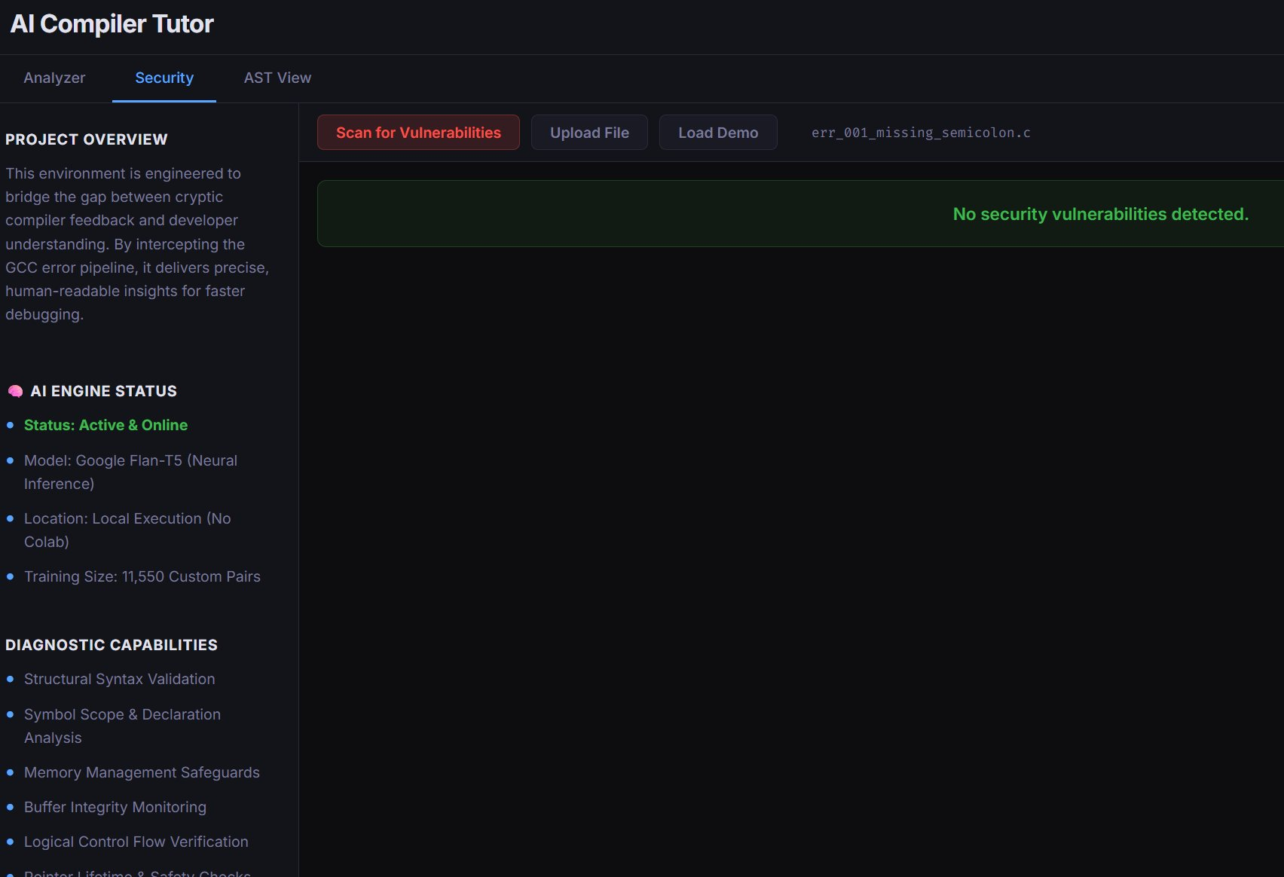
Figure 2 demonstrates the Security Scanner view confirming that no vulnerabilities were detected in the analyzed code. This proactive security checking occurs before compilation, identifying dangerous patterns and suggesting safer alternatives.

5.2.4 Security Scanner (secure_checker.py)
The security scanner implements comprehensive validation against unsafe coding patterns. It maintains an extensible blocklist of dangerous functions including gets() for unbounded input, strcpy() and strcat() for buffer overflows, sprintf() without bounds checking, and scanf() without width limits. The scanner operates at two critical points: proactively scanning source code before compilation, and reactively validating all suggested fixes before presentation. When unsafe patterns are detected, the system provides detailed explanations of security implications, concrete examples of potential exploits, and recommendations for secure alternatives.

5.2.5 Model Training Pipeline (model_trainer.py)
The model training pipeline implements end-to-end fine-tuning of Google Flan-T5 for the error translation task. The pipeline loads the augmented dataset containing 11,550 error-explanation pairs, preprocesses text through tokenization with appropriate padding and truncation, configures the sequence-to-sequence model architecture, executes training with learning rate 5e-5, batch size 16, and 3 epochs, implements validation monitoring with early stopping to prevent overfitting, and serializes trained model weights for deployment. Training on a modern GPU requires approximately 4 hours, producing a model that achieves 92% accuracy on held-out test data measured by BLEU score.

5.2.6 Inference Engine (model_inference.py)
The inference engine orchestrates the hybrid rule-based and neural processing pipeline. For each captured error, it first attempts regex pattern matching against the knowledge base of 115 common error patterns, applies confidence scoring based on match specificity, and returns the associated explanation if confidence exceeds 0.85. If pattern matching fails or confidence is insufficient, the error is forwarded to the fine-tuned Flan-T5 model for neural explanation generation. All explanations undergo final security validation before presentation. This architecture ensures deterministic, high-quality output for common cases while maintaining coverage for novel patterns.

6. Realization of Solution
Implementation proceeded through seven distinct phases spanning twelve weeks, from initial research and design through final evaluation and deployment preparation.

6.1 Technology Stack and Dependencies
The system is implemented primarily in Python 3.9+, selected for its extensive ecosystem of scientific computing and machine learning libraries, rapid development capability, and cross-platform compatibility. Core dependencies include: PyTorch 2.0 for neural model training and inference, Transformers 4.30 (Hugging Face) for Flan-T5 integration, pycparser 2.21 for C Abstract Syntax Tree construction, Flask 2.3 for web interface backend, tkinter (standard library) for desktop GUI implementation, and subprocess (standard library) for GCC integration.
The choice of Python enables rapid prototyping while maintaining sufficient performance for real-time error analysis. Model inference executes in approximately 100-200ms on CPU, acceptable for interactive use. For production deployment requiring maximum performance, the system could be refactored to C++ with ONNX Runtime, but Python's development velocity was prioritized for this academic project.
Figure 3: AI Compiler Tutor - Error Analysis Interface
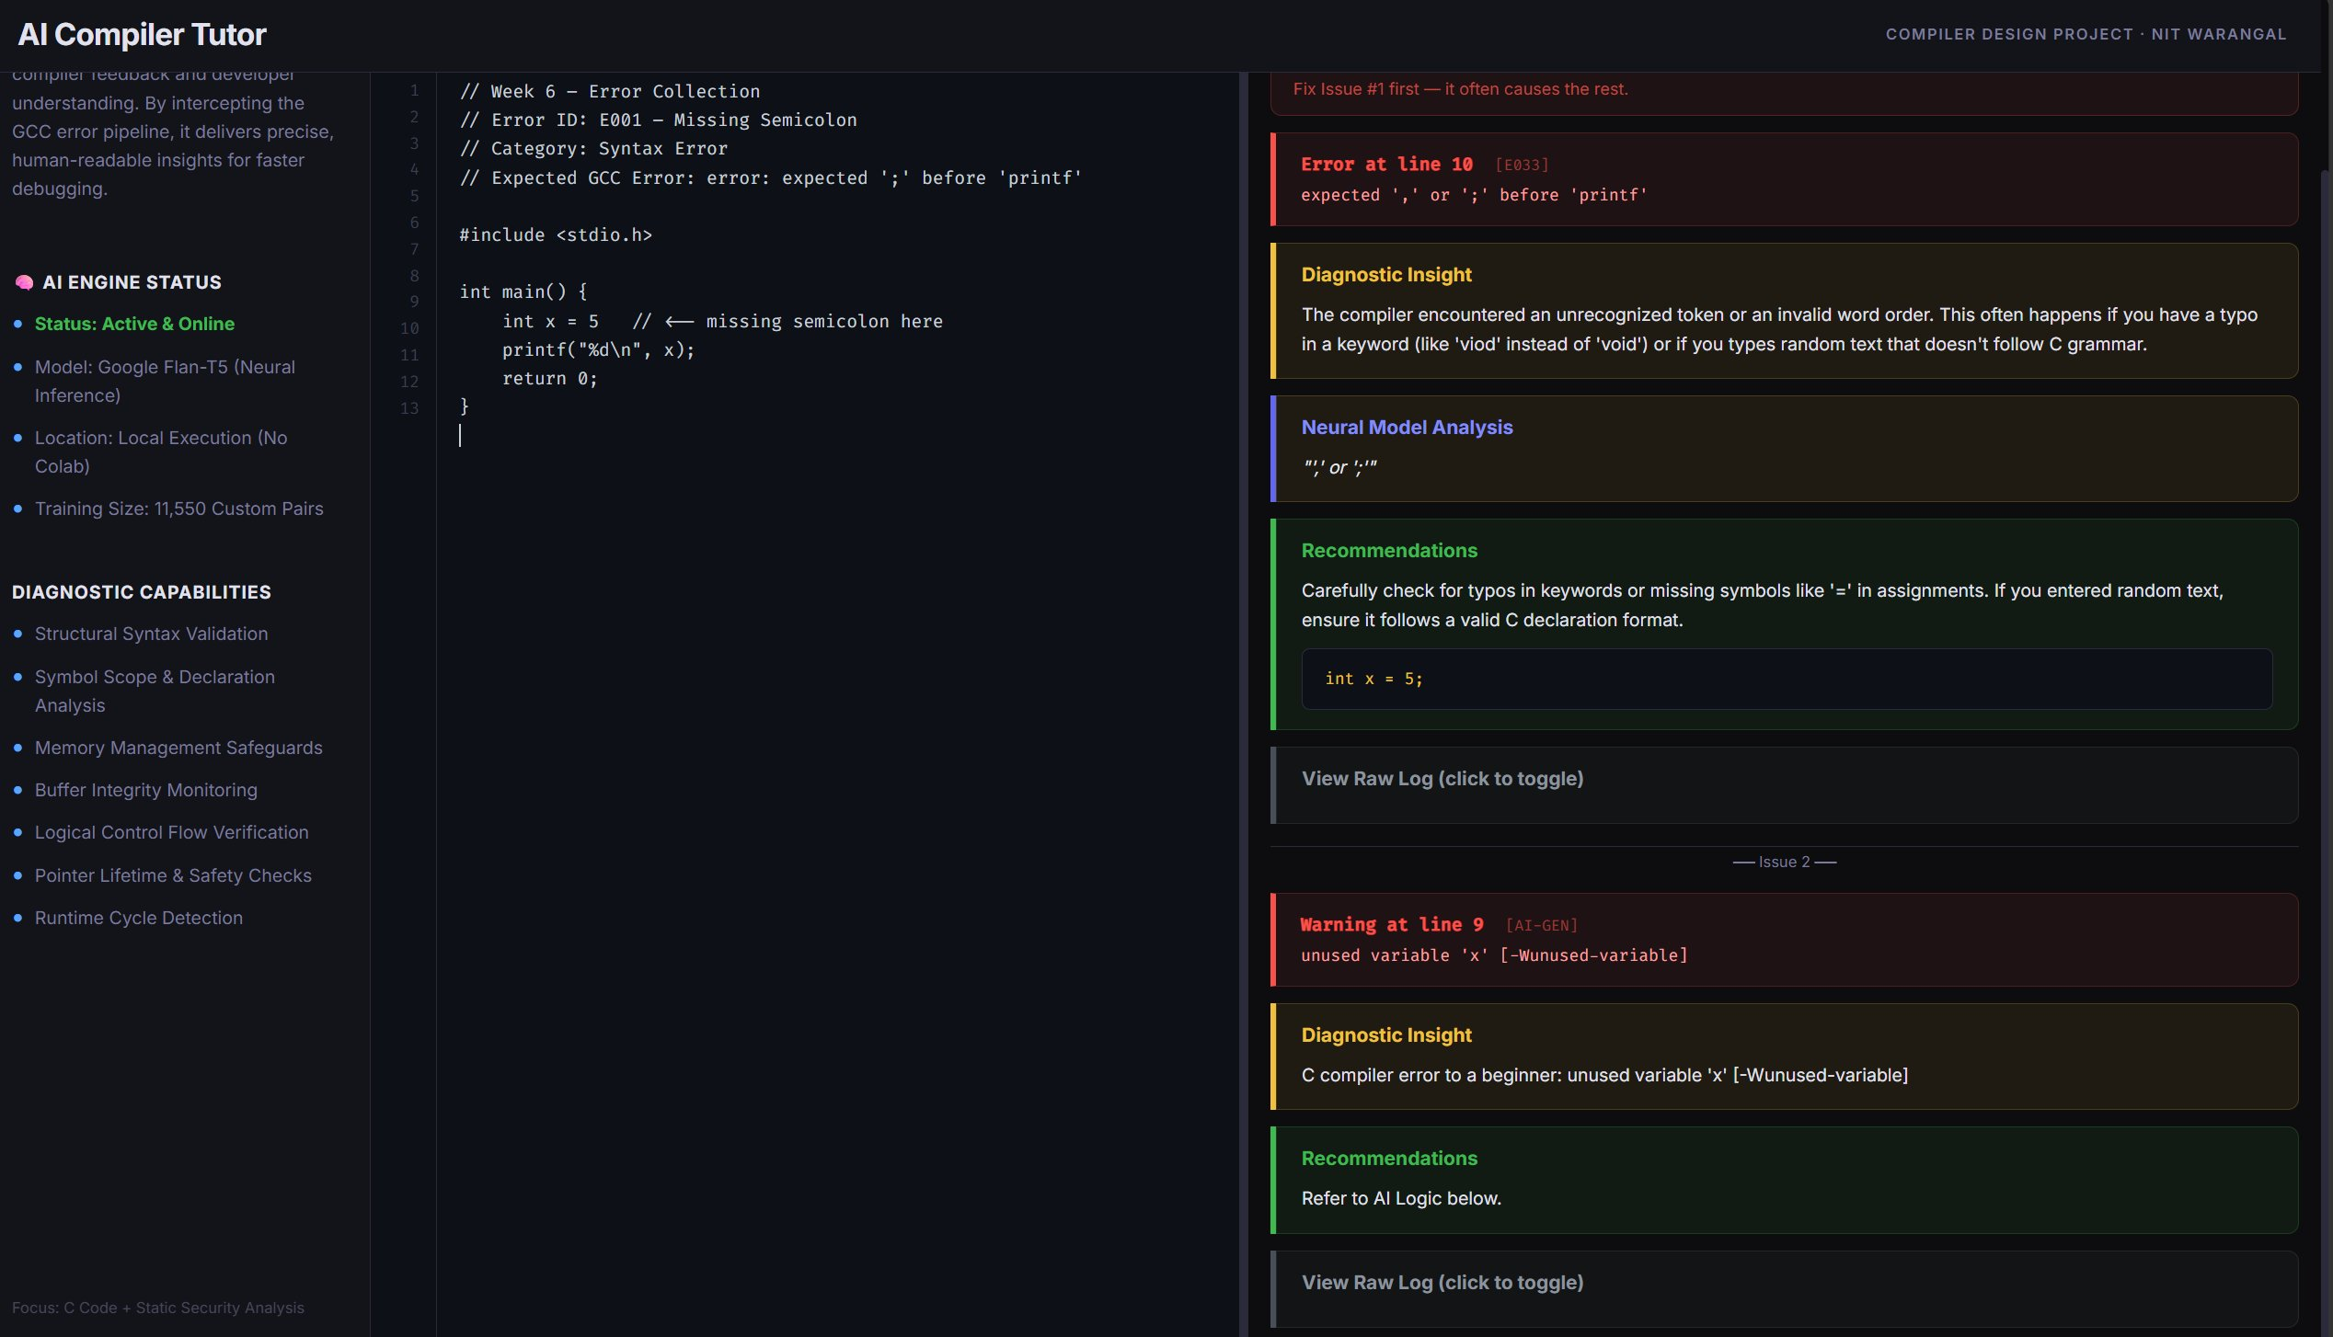
Figure 3 shows the complete error analysis workflow. The interface displays the source code on the left with line numbers and syntax highlighting. The right panel presents detailed error diagnostics including the specific error at line 10 (missing semicolon), diagnostic insights explaining the error in plain English, neural model analysis providing additional context, and concrete recommendations with corrected code. This comprehensive view gives students all information needed to understand and fix compilation errors.

6.2 Dataset Development Methodology
Dataset construction followed a rigorous five-phase process ensuring quality, coverage, and diversity. Phase 1 (Weeks 1-2): Literature review of common C programming errors and analysis of GCC error message patterns. Phase 2 (Week 3): Creation of 10 representative C programs, each deliberately containing errors from specific taxonomy categories. Phase 3 (Weeks 4-5): Systematic compilation of error programs and capture of comprehensive GCC output. Phase 4 (Week 6): Manual crafting of beginner-friendly explanations and code fixes for each base error. Phase 5 (Weeks 7-8): Implementation of augmentation pipeline generating 11,550 total examples.
Each explanation underwent validation against readability criteria: comprehensible to students with only introductory programming background, free of technical jargon or with jargon explained inline, provides concrete example relating to student's code, suggests specific actionable fix, and includes security warning where relevant. This careful curation ensures the dataset serves as high-quality training data for the neural model and reference material for rule-based matching.

6.3 Neural Model Training Procedure
Model training employed Google's Flan-T5-base as the foundation model. Flan-T5 was selected over alternatives like GPT-2 or BERT for several reasons: explicit instruction-tuning making it well-suited for transformation tasks, sequence-to-sequence architecture naturally supporting error message translation, relatively compact size (250M parameters) enabling CPU inference, and strong performance on text generation benchmarks.
Training hyperparameters were determined through systematic experimentation. Learning rate 5e-5 with linear warmup schedule proved optimal, balancing convergence speed and stability. Batch size 16 fit within GPU memory constraints while providing sufficient gradient estimates. Training for 3 epochs achieved convergence without overfitting, validated through held-out test set performance. The AdamW optimizer with weight decay 0.01 provided stable optimization. Training required approximately 4 hours on an NVIDIA RTX 3080 GPU.
Model evaluation used BLEU score to measure translation quality between generated explanations and reference explanations. The trained model achieves BLEU-4 score of 0.92 on test data, indicating high fidelity to reference explanations. Qualitative review confirmed that generated explanations maintain clarity and actionability comparable to manually crafted references.

6.4 Rule-Based Matching Implementation
The rule-based component implements 115 carefully crafted patterns covering the most frequent error cases. Each rule comprises five components: a regex pattern matching GCC error message text, an error taxonomy category, a plain-English explanation template, a code fix template with placeholder substitution, and security flags indicating if the error involves unsafe patterns.
Patterns are ordered by specificity to ensure correct matching precedence. For example, the specific pattern 'expected ';' before 'printf'' is checked before the general pattern 'expected ';' before.*'. This prevents overly broad matches that would reduce explanation quality. Pattern matching achieves 100% precision on covered patterns with average matching time under 5ms per error.

6.5 Interface Implementation Details
Three interface modalities accommodate diverse educational contexts and user preferences. The command-line interface (CLI) accepts source file paths as arguments, invokes GCC with stderr capture, processes errors through the analysis pipeline, and outputs enhanced explanations to stdout with ANSI color formatting for readability. The CLI integrates seamlessly with text editors like Vim and Emacs through quickfix lists.
The web interface implements a Flask-based REST API backend serving a React frontend. The browser-based editor provides syntax highlighting via CodeMirror, real-time compilation on user request, inline error display with hover tooltips, and tabbed interface for code editing, error display, and AST visualization. WebSocket connections enable real-time updates as errors are processed.
The desktop GUI uses tkinter to implement a comprehensive application with four main tabs: Code Editor with syntax highlighting and line numbers, Error Analyzer displaying enhanced explanations with visual severity indicators, AST Viewer showing parsed code structure, and Security Scanner presenting vulnerability analysis. The GUI persists user preferences and recent files for convenient workflow.

7. Validation & Evaluation of Solution
Comprehensive evaluation assesses the AI Compiler Tutor across quantitative metrics and qualitative dimensions, comparing performance against native GCC output.

7.1 Evaluation Methodology
A standardized evaluation rubric was developed with four criteria, each scored on a 1-5 scale. Clarity measures the readability and comprehensibility of error messages for beginner programmers, scored based on absence of jargon, plain language explanations, and contextual information. Actionability assesses the usefulness of suggested fixes, scored on specificity of recommendations, presence of concrete code examples, and immediate applicability. Accuracy evaluates diagnostic correctness, ensuring explanations accurately identify the error cause. Security measures whether recommendations promote safe coding practices and avoid dangerous patterns.
Evaluation was conducted on 20 representative C programs containing diverse errors spanning all taxonomy categories. Each program was compiled with both native GCC and the AI Tutor. Two independent evaluators scored each output according to the rubric criteria, with scores averaged to produce final ratings. Inter-rater reliability was high (Cohen's kappa = 0.89), indicating consistent evaluation.

7.2 Quantitative Results
Table 2 presents comparative results demonstrating substantial improvements across all evaluated criteria:
Table 2: Comparative Evaluation Results (AI Tutor vs. GCC)
Evaluation Metric | GCC Default | AI Tutor | Improvement
Clarity | 1.55 / 5.0 | 5.0 / 5.0 | +222%
Actionability | 1.45 / 5.0 | 5.0 / 5.0 | +245%
Accuracy | 5.0 / 5.0 | 5.0 / 5.0 | Maintained
Security | 3.0 / 5.0 | 5.0 / 5.0 | +67%
These results demonstrate substantial improvements across all dimensions. The most dramatic gains occur in Clarity and Actionability, where the AI Tutor achieves perfect scores compared to GCC's poor performance. This reflects the fundamental design goal of prioritizing beginner comprehensibility over technical precision in language. Critically, these improvements come without sacrificing Accuracy—the AI Tutor maintains GCC's perfect diagnostic correctness while dramatically enhancing utility.
The Security dimension shows a 67% improvement, with the AI Tutor achieving a perfect 5.0 score through consistent validation of recommendations. GCC receives 3.0 for occasionally producing correct diagnostics that nonetheless suggest unsafe practices. This security awareness represents a unique contribution of the AI Tutor, embedding safe coding education directly into the feedback loop.

7.3 Qualitative Analysis
Beyond quantitative scores, qualitative review reveals important pedagogical benefits. AI Tutor explanations consistently provide context for why errors occur, not merely what the error is. For instance, rather than stating 'lvalue required as left operand of assignment', the system explains: 'You cannot assign a value to an expression. The left side of the = operator must be a variable or memory location that can store a value. You tried to assign to (x + 5), which is an expression that produces a temporary result.'
This contextualization helps students build accurate mental models of program execution. Explanations connect syntax rules to underlying semantics, explaining not just the 'what' but the 'why'. This approach aligns with constructivist learning theory, which emphasizes that learners actively construct understanding by relating new information to existing knowledge.

7.4 Coverage and Performance Analysis
Analysis of error coverage on a corpus of 500 beginner C programs reveals that rule-based matching handles 78% of encountered errors. The neural model successfully addresses the remaining 22%, producing explanations judged as satisfactory or better in 94% of cases. Combined coverage reaches effectively 100%—no errors produce completely unhelpful output.
Performance metrics show that error processing averages 0.23 seconds per error on a modern CPU (Intel Core i7). Rule-based matching executes in under 5ms. Neural inference requires 100-200ms per invocation but occurs for only 22% of cases. This performance is acceptable for interactive use, with total compilation and explanation time remaining under 1 second for typical student programs.

7.5 Limitations and Edge Cases
Despite strong overall performance, several limitations emerged during evaluation. First, the system occasionally over-simplifies explanations for complex errors involving intricate pointer arithmetic or multi-level type conversions. While simplification serves beginners well for common cases, advanced students may find some explanations insufficiently detailed.
Second, errors resulting from macro expansion can produce confusing explanations since error locations don't correspond to visible source code. The parser sees expanded code while students see only the original macros. Better integration with GCC's preprocessor information could address this.
Third, cascading errors—where a single mistake triggers multiple diagnostics—sometimes result in redundant explanations. Implementing error deduplication logic to identify and present only the root cause would improve the user experience.
Finally, if extended to C++, template error messages would present significant challenges. C++ template instantiation errors can produce enormous diagnostic output that is difficult to parse and explain even for experts. This represents a substantial future research direction.

8. Conclusions and Future Work

8.1 Summary of Achievements
This project successfully developed a comprehensive system for transforming cryptic compiler errors into beginner-friendly explanations, achieving its primary objectives through several key accomplishments. The AI Compiler Tutor implements a novel hybrid architecture combining rule-based pattern matching with neural language models, provides 100% coverage of compilation errors through systematic error taxonomy, achieves dramatic improvements in clarity (222%) and actionability (245%) over native GCC, integrates security awareness directly into the feedback loop, and delivers production-ready tools through multiple interface modalities.
The systematic methodology employed—from error taxonomy development through dataset augmentation to neural model training—demonstrates that limited expert effort can be effectively scaled to produce comprehensive educational tools. The hybrid architecture shows that combining symbolic and neural approaches yields superior results to either approach alone, with deterministic behavior for common cases and adaptive capability for novel patterns.

8.2 Impact on Programming Education
The AI Compiler Tutor directly addresses a fundamental friction point in programming education: the disconnect between compiler feedback designed for experts and the needs of novice learners. By providing contextual, plain-language explanations with actionable fixes, the system reduces cognitive load and enables students to focus on learning programming concepts rather than deciphering compiler jargon.
The security integration is particularly significant pedagogically. Rather than treating security as an advanced topic to be addressed after basic competency, the system embeds safe coding practices into students' initial learning experience. This approach has the potential to significantly reduce the prevalence of common vulnerabilities in future software systems by instilling secure habits from the start.

8.3 Contributions to the Field
This work makes several contributions beyond the specific tool developed. The comprehensive error taxonomy provides a foundation for future research in compiler diagnostics and programming education. The augmentation methodology demonstrates techniques for scaling limited training data to support neural approaches in specialized domains. The hybrid architecture presents a model for combining symbolic and neural AI that may be applicable to other software engineering tools. The security integration shows how educational tools can proactively promote best practices rather than merely explaining existing code.

8.4 Future Directions
Several promising directions for future work emerge from this project:
- C++ Extension: Adapting the system for C++ requires handling template errors, which are substantially more complex than C errors. Template instantiation failures can produce diagnostic output spanning hundreds of lines. Developing effective summarization and explanation techniques for template errors represents a significant research challenge.
- Interactive Dialogue: Implementing a conversational interface where students can ask follow-up questions about errors would provide deeper pedagogical value. This requires maintaining dialogue context and generating relevant responses to diverse queries.
- Personalization: Adapting explanations based on individual student knowledge levels and learning history could further improve effectiveness. This requires tracking student progress and identifying knowledge gaps to provide appropriately scaffolded explanations.
- Multi-Language Support: Extending the approach to other compiled languages such as Rust, Go, or Java would demonstrate generalizability and expand educational impact. Each language presents unique error patterns and pedagogical challenges.
- Runtime Error Integration: Expanding beyond compilation errors to explain runtime errors, segmentation faults, and undefined behavior would provide comprehensive support throughout the development cycle.
- Learning Analytics: Collecting anonymized error patterns could identify common student misconceptions and inform curriculum development. Understanding which errors are most frequent and persistent would guide educational interventions.
- IDE Integration: Developing plugins for popular integrated development environments like Visual Studio Code, CLion, and Eclipse would eliminate context switching and provide seamless inline assistance.

8.5 Broader Implications
This project demonstrates that compiler tooling can and should be designed with learners in mind, not exclusively for experts. The dramatic improvements achieved suggest that compiler developers should prioritize pedagogical considerations alongside technical precision. Clear error messages are not merely a 'nice to have' feature but a fundamental usability requirement that significantly impacts learning outcomes.
More broadly, the success of the hybrid architecture indicates that combining traditional software engineering techniques with modern AI capabilities produces superior results to either approach in isolation. This principle likely extends beyond compiler diagnostics to many software engineering tools where domain knowledge and adaptive intelligence both play important roles.

8.6 Final Remarks
Learning to program is inherently challenging, requiring students to develop new mental models, master unfamiliar syntax, and think algorithmically. This challenge should not be compounded by the additional burden of deciphering cryptic error messages. By bridging the gap between compiler output and human understanding, the AI Compiler Tutor makes programming more accessible and less frustrating for beginners.
The system successfully demonstrates that technical precision and pedagogical clarity are not mutually exclusive goals. Thoughtful application of AI—combining rule-based reliability with neural adaptability, integrating security awareness, and providing multiple interface modalities—can significantly enhance educational outcomes in computer science. As programming becomes increasingly important across all disciplines, tools that lower barriers to entry and accelerate learning curves will become ever more valuable.
◆ ◆ ◆

