Experiment-5

Create a simple cloud software application for Library book reservation system for SIMATS library using any Cloud Service Provider to demonstrate SaaS

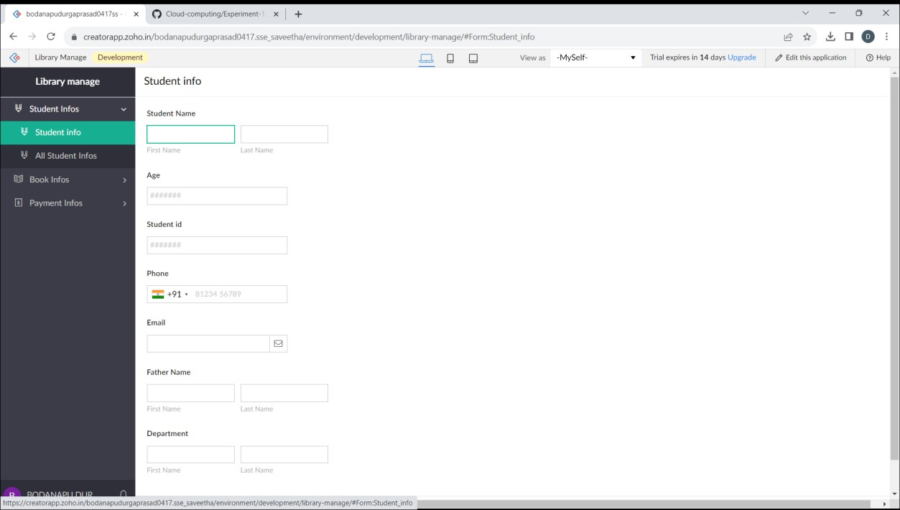

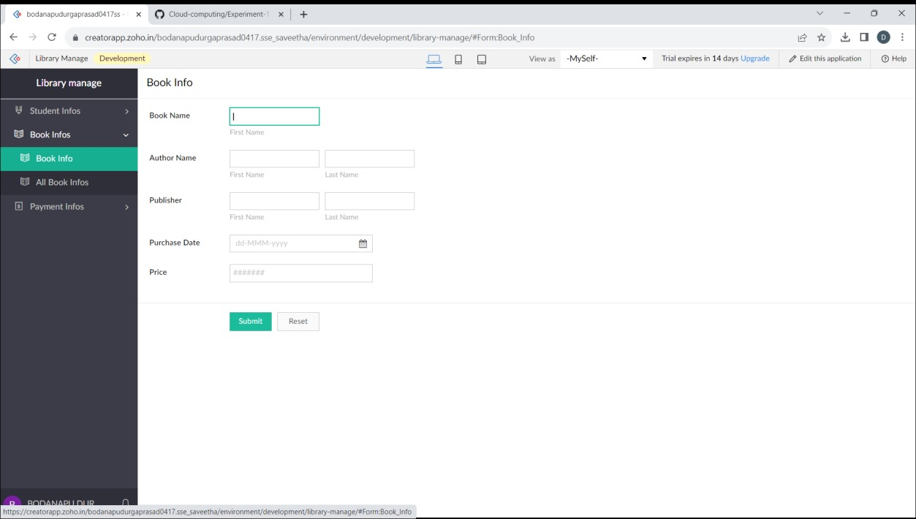

1. Vamsi K {192210355}

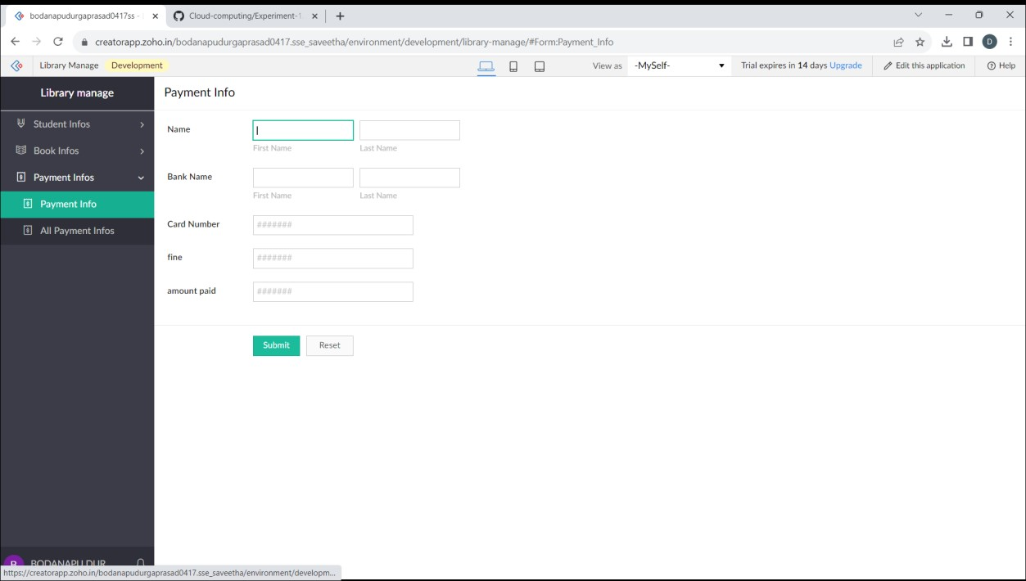

1. Vamsi K {192210355}