Architect — Step-by-Step Guide
Build a complete working app from one plain-English sentence: design, test, approve and deploy — no coding required.
Example used in this guide: a todo app with due dates and filters.

The example we will build
This is the entire input — one sentence:
"A todo app where users add tasks with due dates, mark them done, and filter tasks by today or this week."
From this sentence Architect designs the whole app, writes tests for it, and deploys it. Follow the steps below.

Step 1 — Open the app and describe what you want
- Open the app URL in your browser (your live link, or http://localhost:3000 when running locally).
- No sign-up is needed to try — signing in only saves your projects between visits.
- Find the big text box on the Home page and type (or paste) the sentence above.
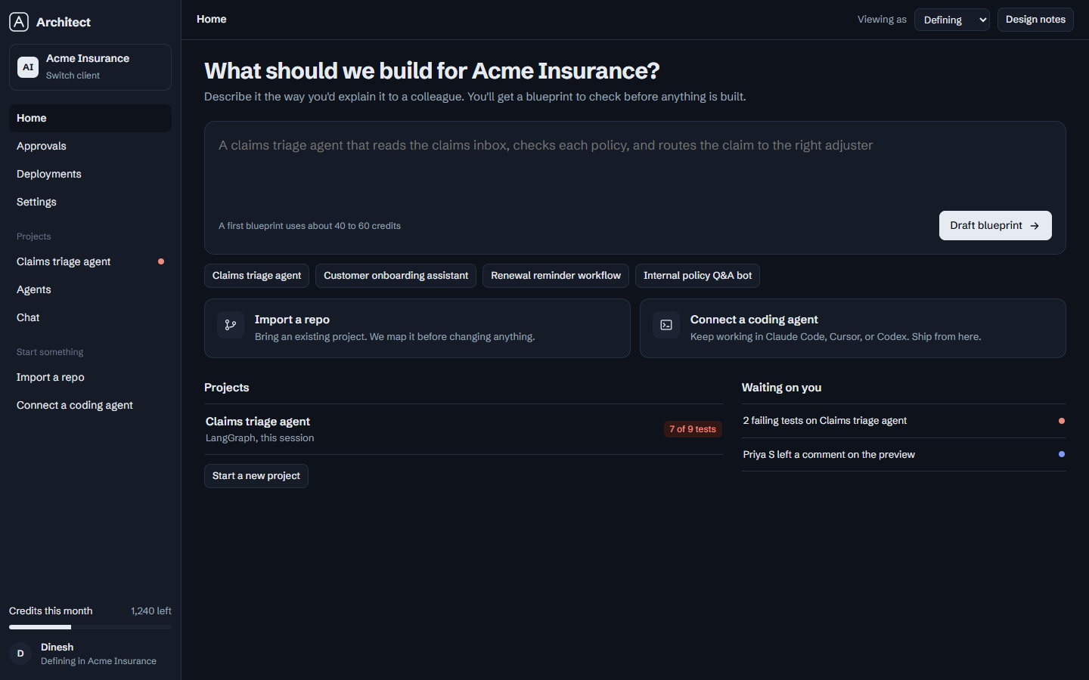
The Home page — one text box is all you need.
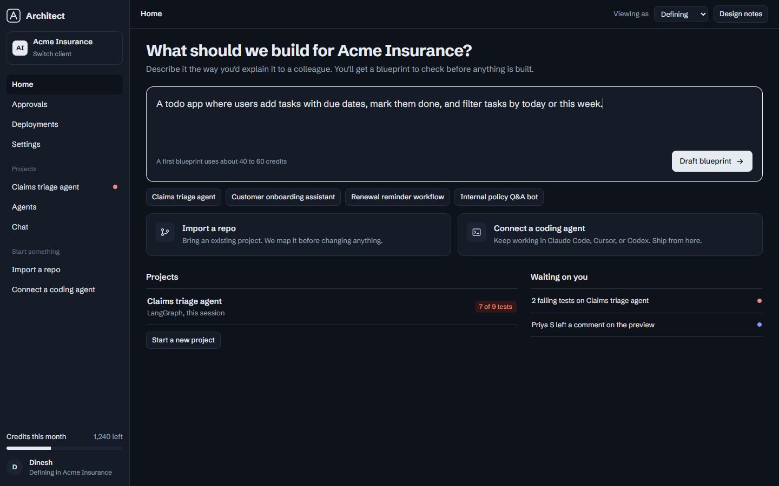
Type one plain sentence describing your app.

Step 2 — Draft the blueprint
- Click "Draft blueprint".
- In about 15–30 seconds the design draws itself on screen: Screens, Agents, Data tables and Connections.
- This blueprint is the plan of your app — nothing is built yet, so you stay in control.
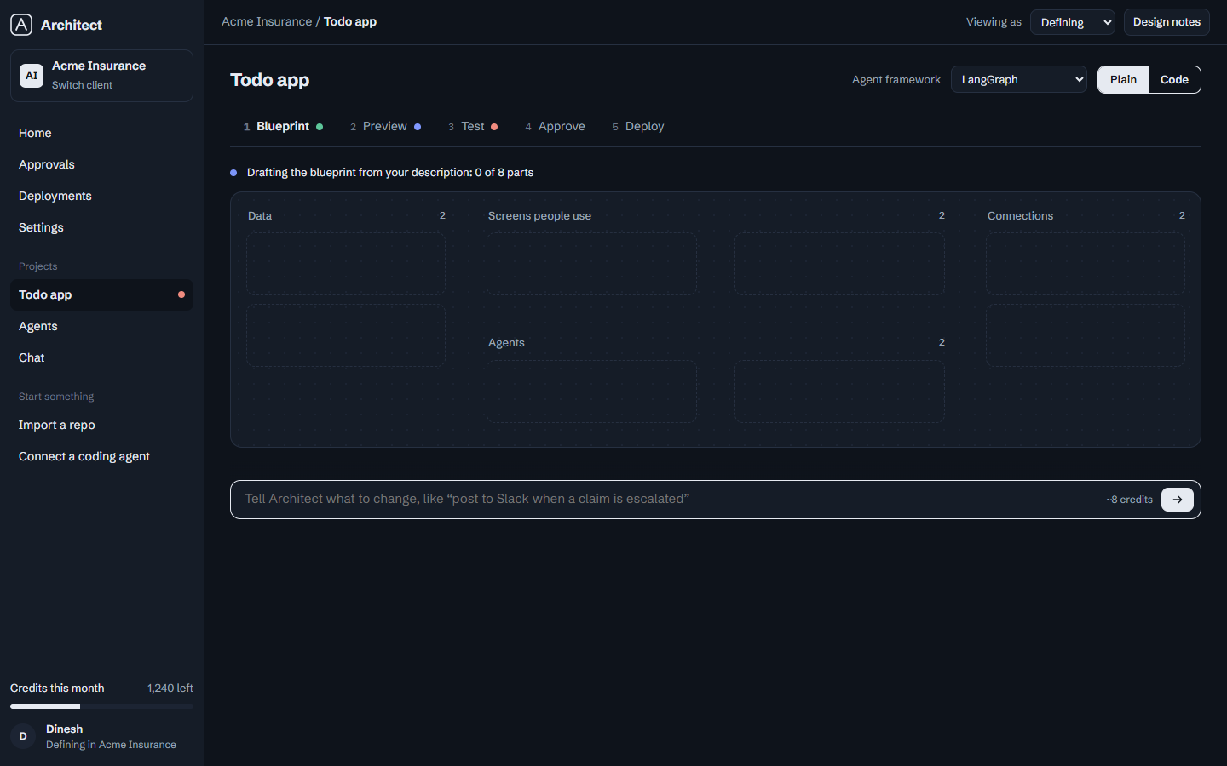
The blueprint is drawing itself…
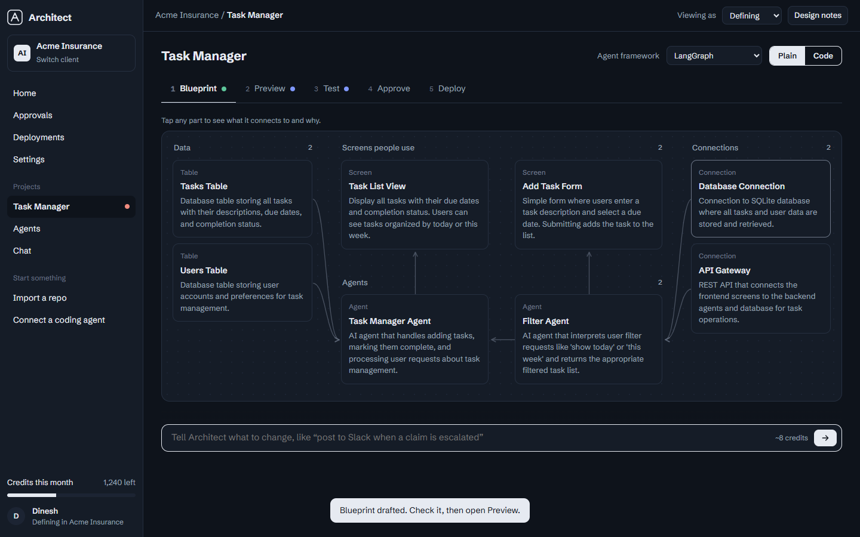
The finished blueprint: every part of your app on one screen.
- Click any block to see what it connects to and why.
- Use the Plain / Code toggle (top right): Plain explains each part in everyday language; Code shows the real React / Python / SQL.

Step 3 — Ask questions in Chat (optional)
- Open "Chat" in the left sidebar.
- Architect knows your project — ask things like "Review my blueprint" and get answers about YOUR app.
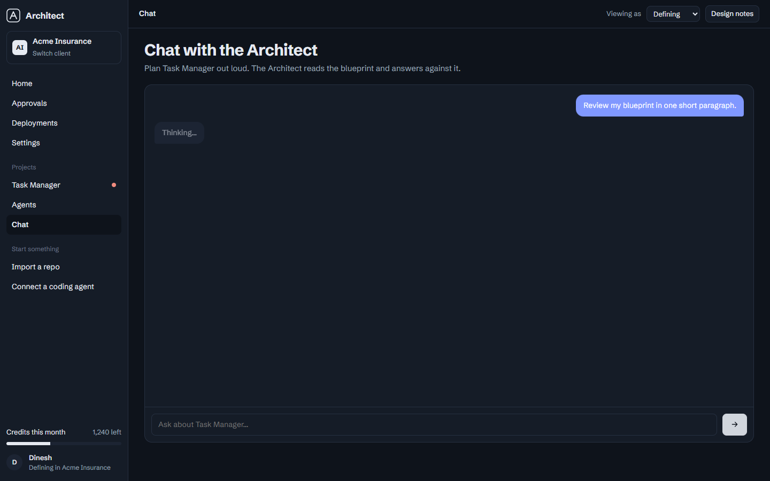
Chat answers in the context of your blueprint.

Step 4 — Inspect the agents
- Open "Agents" in the left sidebar.
- Each agent card shows its job, the tools it can use, and a Test button.
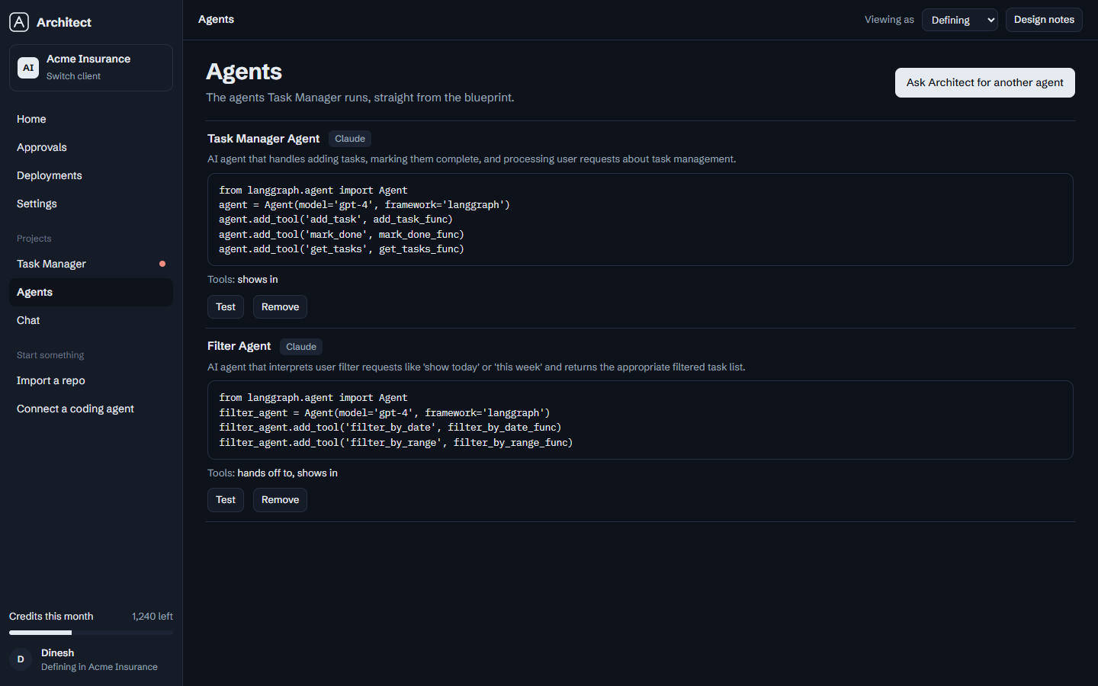
Every AI worker in your app, its tools, and a way to test it.

Step 5 — Preview with your data and comment
- Open the "Preview" tab.
- You see the app running with data from YOUR tables — on desktop or phone.
- Turn on Comment, click any row, and leave feedback. Clients can comment from a shared link — no account needed.
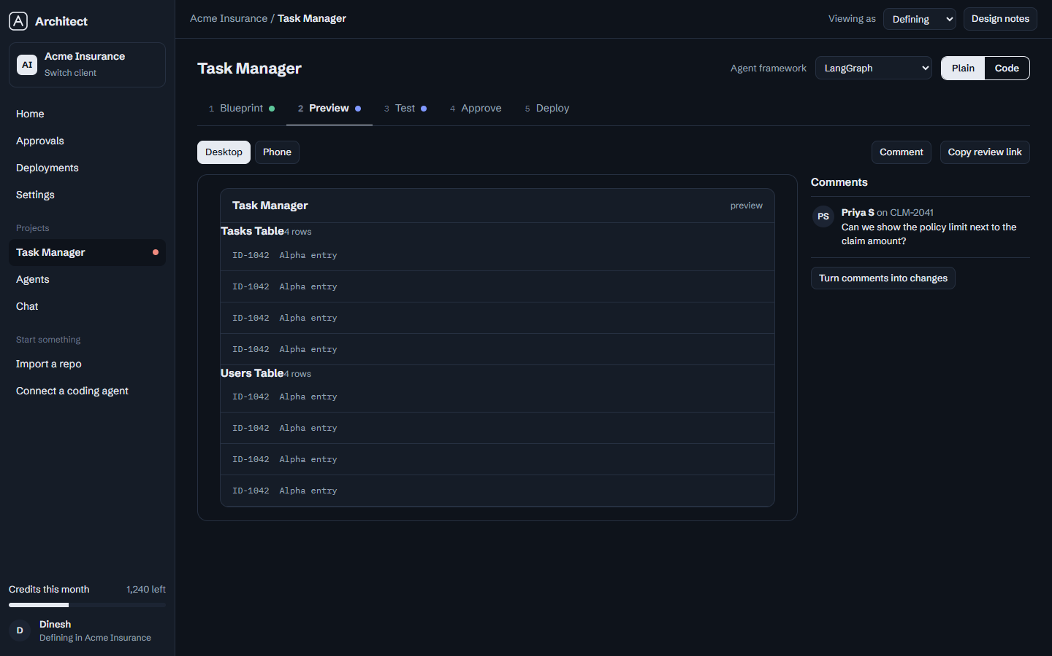
The preview shows your real tables filled with sample data.
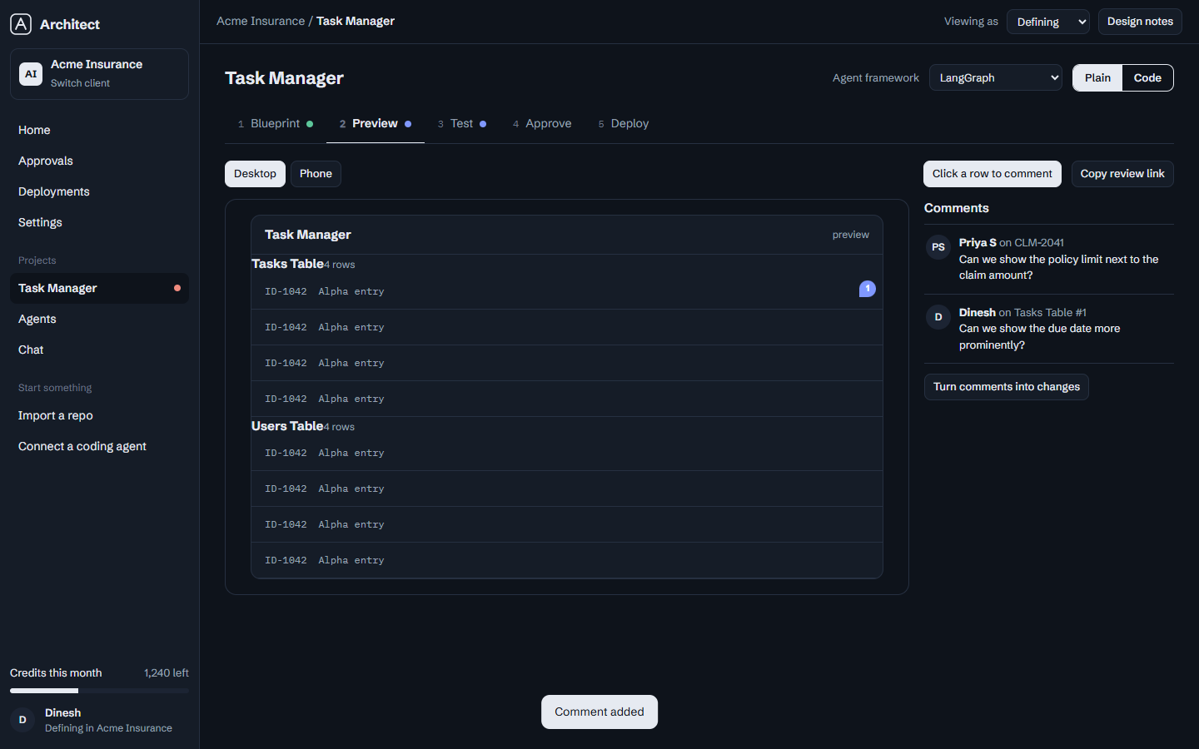
Click any row and comment — feedback stays attached to the data.

Step 6 — Test it like a QA team
- Open the "Test" tab.
- Architect wrote these scenarios specifically for your app (add a task, mark done, filter by today…).
- Click a scenario to run it for real. If one fails, click "Ask Architect to fix this" — it repairs the blueprint and re-runs the test.
- On the right, review what the agents are allowed to do — anything that sends email or writes data waits for a human.
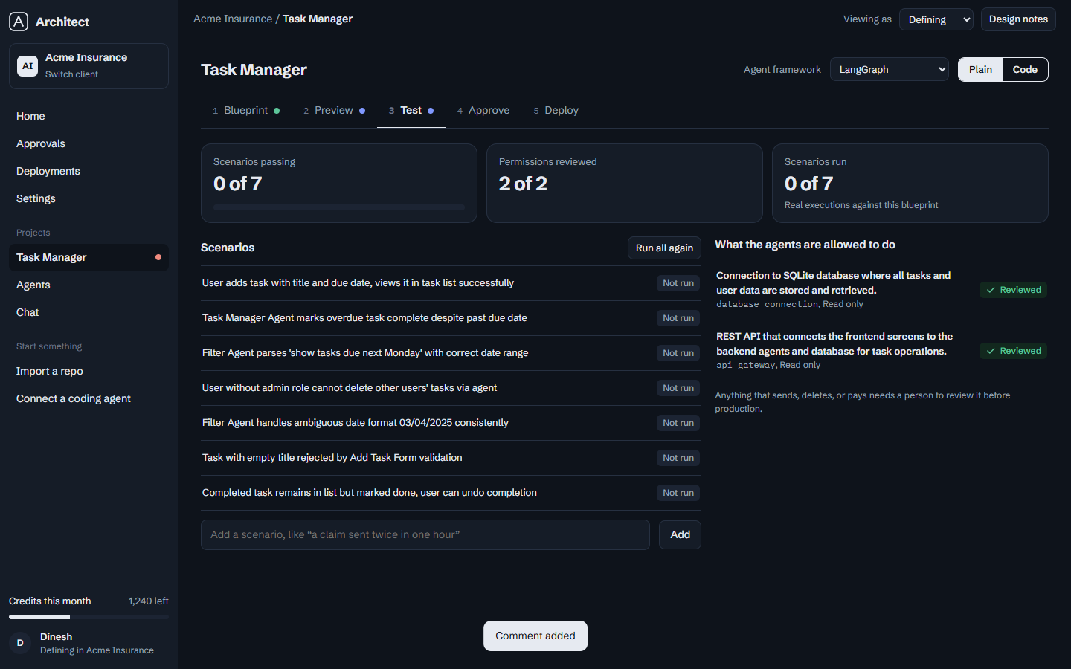
Scenarios generated for this exact app.
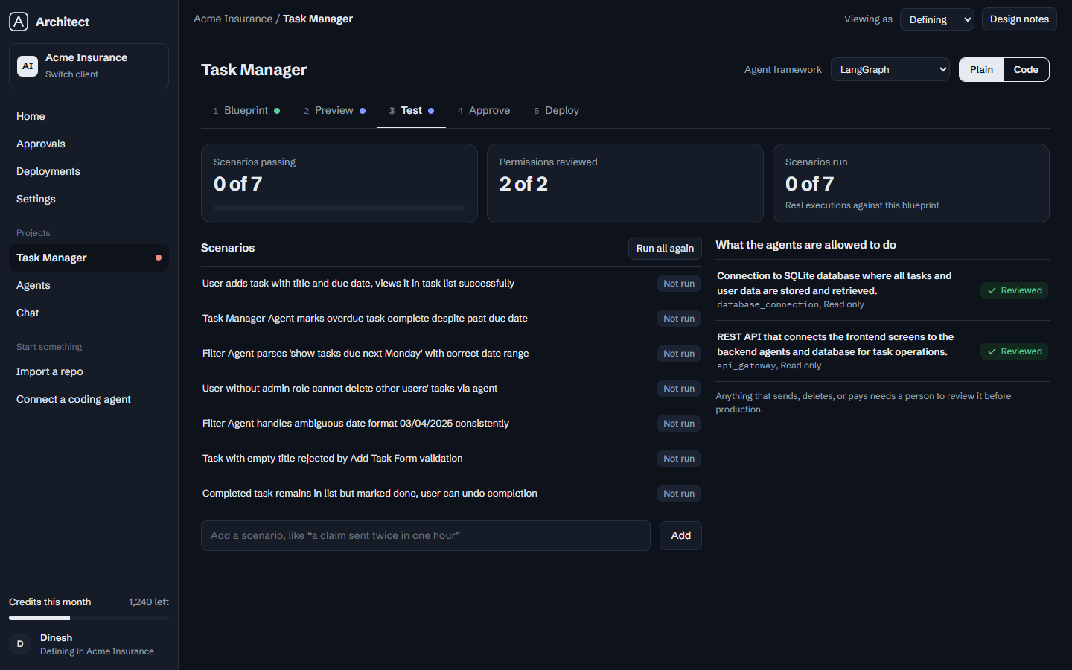
Each scenario runs against the real blueprint and reports Pass or Fail with a trace; failures get a one-click fix.

Step 7 — Connect GitHub and deploy
- Open the "Deploy" tab.
- Click "Connect GitHub" (prototype flow) — your repo and branch appear.
- Click "Deploy to staging". Staging is always open so people can try things.
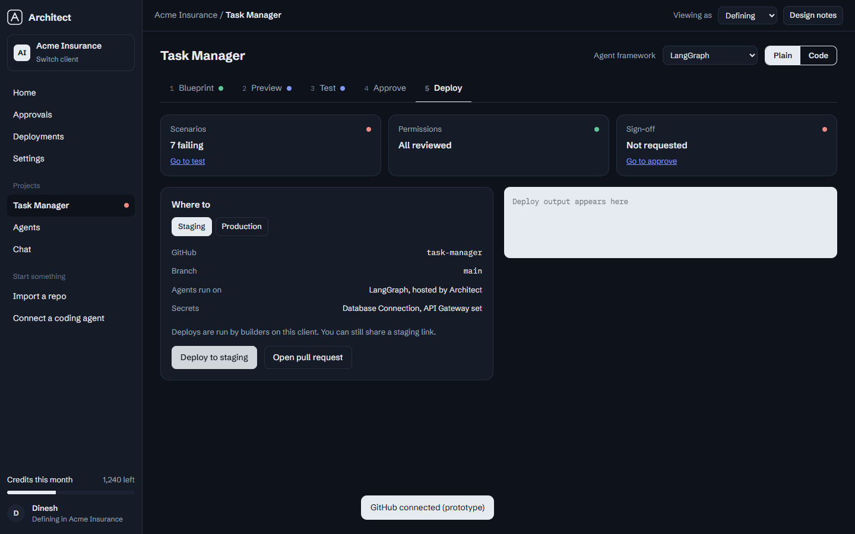
The deploy screen: staging one click away; production stays locked until checks pass.
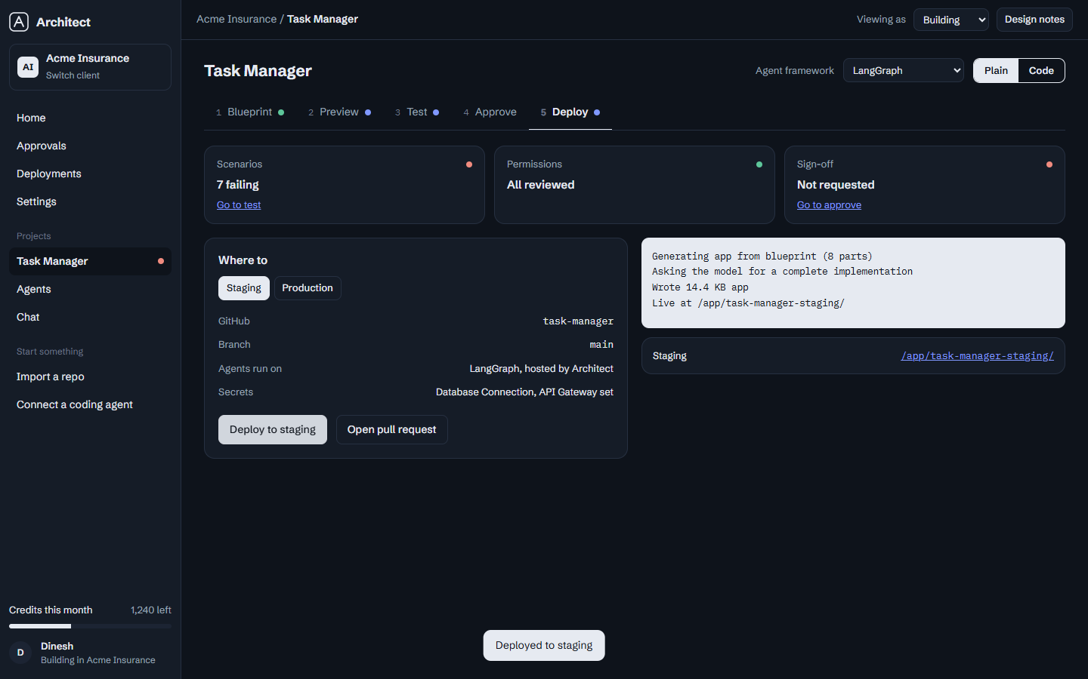
Deploy finished — the live link appears.

Step 8 — Open your live app
- Click the staging link.
- A real, working app opens: add a task, mark it done, filter by today or this week.
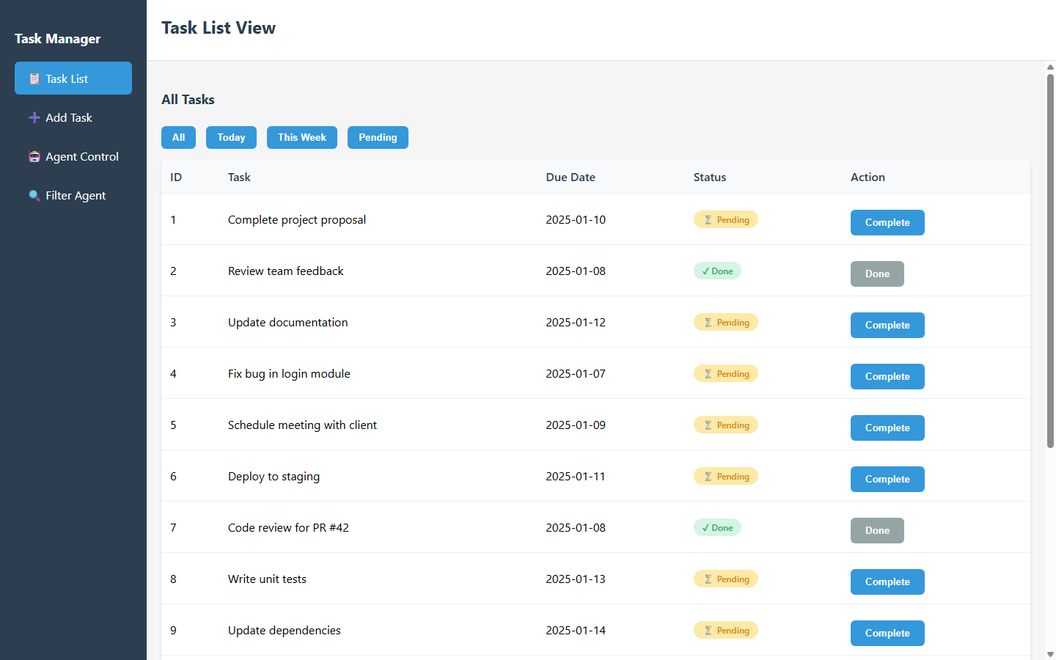
The generated app, live and working.

The one rule that keeps it safe
Staging is open, Production is earned.
Anyone can experiment in staging. Nothing reaches your users until the tests pass, the permissions are reviewed, and a person approves the release. The platform enforces this — you do not have to remember it.

Quick reference
I want to… | Where
Create an app | Home → type a description → Draft blueprint
Change something | Blueprint → type in the command bar, or use Chat
See what it looks like | Preview tab
Check it works | Test tab → run scenarios
Control what agents may do | Test tab → permissions
Get client feedback | Preview → Comment → Copy review link
Try it live | Deploy tab → Deploy to staging
Go live for real | Deploy tab → approve → Production

