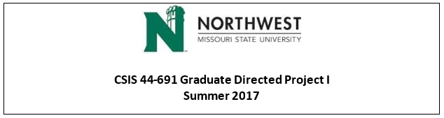

**Team B - CodeGreen - Student Attendance Tracking**

**Client name:** Dr. Michael Oudshoorn

**Team Logo:**



**Team Members** **and Respective responsibilities**

Vanamali, Sirisha - Primary Contact

Sadhu, Rohith Babu - Client management

Mamidala, Sri Sai Ram Kumar - Data management

Madadi, Vipul Reddy - Requirements management

Devalla, Vamsi - Quality and Testing management

Pothireddy, Subba Reddy - Issues management

Vallapurapu, Shankar Rao - Communications and Documentation management

