**Code Green Test Plan**

**Introduction:**

The student attendance tracking system is combination of a standalone application and a mobile application. The main objective of the project is to determine the proof of concept of one the possible smart and easy ways of automatic attendance tracking.

**Scope:**

Our project scope is to track the student attendance by generating QR code. To elaborate, we have provided more functionalities to the department head and instructor, they can view the student attendance as well as they can see the number of students present in class on a particular day with representation of bar graph, they can manage courses as per CRN and they can add a course likewise they can remove the course too. Students can view the attendance and we have limited the access for students like one user can only scan QR code with one mac address.

**Test Strategy:**

The following are the test cases needed to be tested before the product is delivered to the client:

* We have different test suites for each module. A student test suite and an instructor test suite.
* The division of test suites will let us test the application from different levels of access to the application.
* This division of test cases will let us identify the bugs and there will be division of responsibilities according to the module developer and thereby nib the bugs.
* We have 4 builds having several core functionalities being developed in an incremental fashion.
* Each build is a collection of several functionalities which are tested by the responsible individual.
* Each build went through rigorous testing after every release.
* We have used the test suite to test each build and respective functionality.

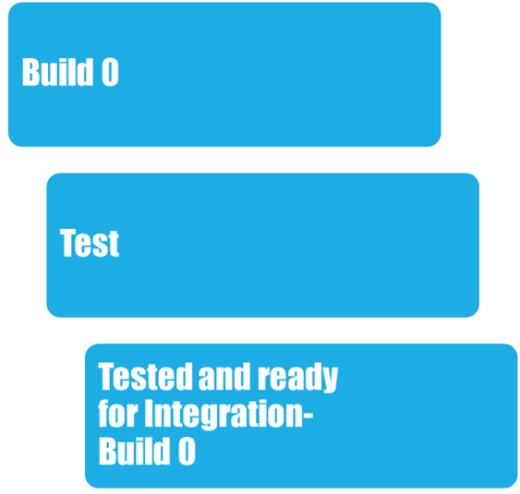

**Environment Requirements:**

* Manual testing
  + Testing the functionalities of the application
* Unit testing
  + Testing each method of the application
* W3c tool
  + For validating the Html and CSS files
* Validation testing
  + For testing the input fields