**NAME: DIVYA TEJASWI EJJUROTHU**

**STUDENT ID :700745894**

**EXECUTION GUIDELINES AND ACTUAL OUTPUTS:**

**STEP 1 :**

Firstly, I went through the neo4j auradb video, followed all the steps, and created 3 nodes.

Characters { name, height, mass, skin_colors, hair_colors, eye_colors, birth_year, gender, homeworld, species }

Species { name, classification, designation, average_height, skin_colors, hair_colors, eye_colors, average_lifespan, language, homeworld }

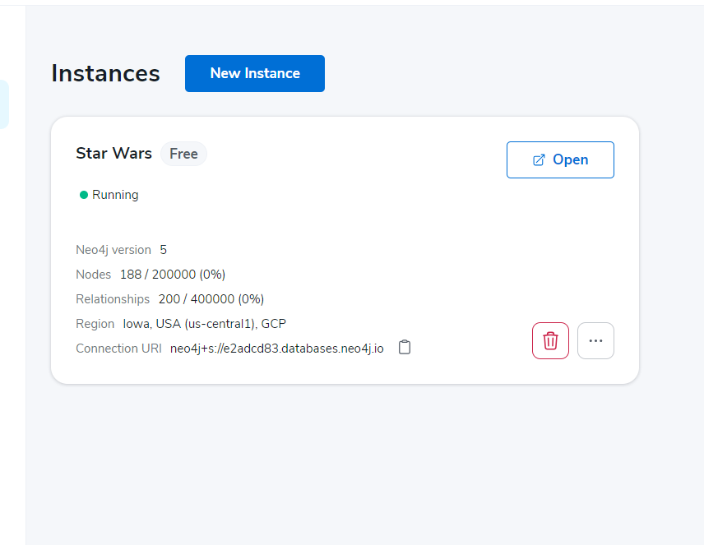

**STEP 2 :**

Run the code , you will get output

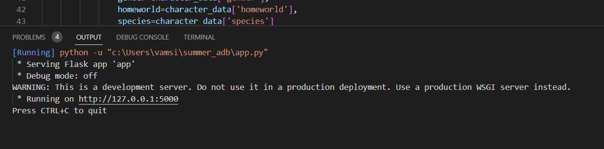

Copy the 127.0.0.1:5000 number to execute in postman

**STEP 3**: I wrote a code for get all characters, get character by name, delete character,insert character, update character

**1.GET_ALL_CHARACTERS:**

*open postman: method: GET 127.0.0.1:5000/chars , Then click on send

**2.GET_CHARACTER_BY_NAME :**

In the above we got all the information copy any name , if that name having spaces,replace

Space with %20

Example :

I copied this name ,which having space :

**Owen Lars**

**TO**

**Owen%20Lars**

**Method : GET 127.0.0.1:5000/chars/Owen%20Lars**

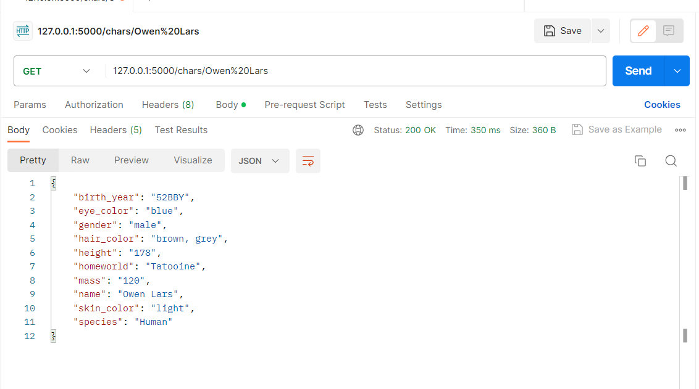

**3. DELETE CHARACTER USING NAME :**

METHOD : DELETE 127.0.0.1:5000/chars/Owen%20Lars CLECK ON SEND

To check whether your character was deleted or not try again with the same name to delete

Character not found means ,character deleted successfully

**4.INSERT NEW CHARACTER :**

METHOD: POST 127.0.0.1:5000/chars

AND SELECT **BODY**

IN THAT SELECT **RAW**

IN THAT DROP DOWN SELECT **JSON**

In the body you must provide new character information

{

"name": "Lufgke Skywalker",

"height": "172",

"mass": "77",

"skin_colors": "fair",

"hair_colors": "blond",

"eye_colors": "blue",

"birth_year": "19BBY",

"gender": "male",

"homeworld": "Tatooine",

"species": "Human"

}

Click on send.

Try to insert the same name, when I am creating a characters node in neo4j aura dB I gave the name as id which means the name should be unique, so in that body write the already existing name.

{

"name": "Luke Skywalker",

"height": "172",

"mass": "77",

"skin_colors": "fair",

"hair_colors": "blond",

"eye_colors": "blue",

"birth_year": "19BBY",

"gender": "male",

"homeworld": "Tatooine",

"species": "Human"

}

**5.UPDATE CHARACTER INFORMATION**

Method : PATCH <http://127.0.0.1:5000/chars/Beru%20Whitesun%20lars>

Select body , raw and json ,write update information (like below image),click on send

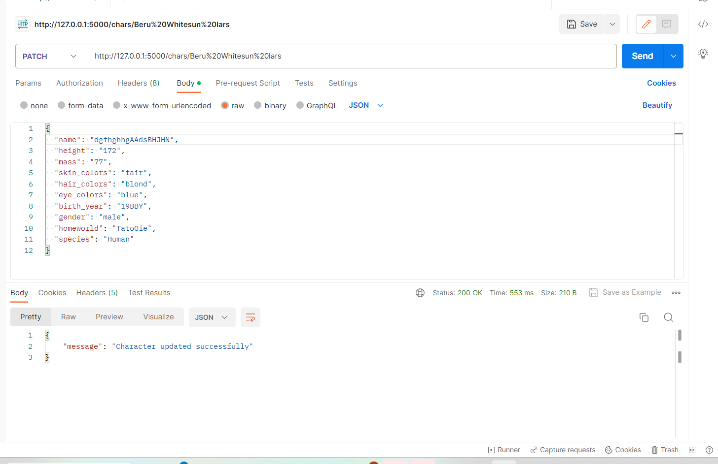

To see whether data updated or not using get character by name api

