**Industrial Internship Report on**

**URL Shortener**

**Prepared by**

**K.Vamsi**

|  |
| --- |
| *Executive Summary* |
| This report provides details of the Industrial Internship provided by upskill Campus and The IoT Academy in collaboration with Industrial Partner UniConverge Technologies Pvt Ltd (UCT).  This internship was focused on a project/problem statement provided by UCT. We had to finish the project including the report in 6 weeks’ time.  My project was URL Shortener using python Flask, it converts long URL into shorted URL  This internship gave me a very good opportunity to get exposure to Industrial problems and design/implement solution for that. It was an overall great experience to have this internship. |

**TABLE OF CONTENTS**

1 Preface 3

2 Introduction 4

2.1 About UniConverge Technologies Pvt Ltd 4

2.2 About upskill Campus 8

2.3 Objective 9

2.4 Reference 9

2.5 Glossary 10

3 Problem Statement 11

4 Existing and Proposed solution 12

5 Proposed Design/ Model 13

5.1 High Level Diagram (if applicable) 13

5.2 Low Level Diagram (if applicable) 13

5.3 Interfaces (if applicable) 13

6 Performance Test 14

6.1 Test Plan/ Test Cases 14

6.2 Test Procedure 14

6.3 Performance Outcome 14

7 My learnings 15

8 Future work scope 16

# Preface

Summary of the whole 6 weeks’ work.

About need of relevant Internship in career development.

Brief about Your project/problem statement.

Opportunity given by USC/UCT.

How Program was planned

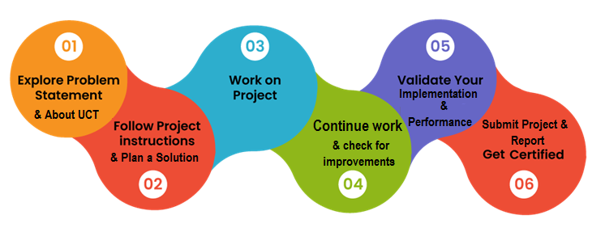

Your Learnings and overall experience.

Thank to all (Ankit), who have helped you directly or indirectly.

Your message to your juniors and peers.

"Hello everyone,

As some of you may know, I recently completed an internship at Upskill Campus, and I wanted to take a moment to share my experience with all of you.

First and foremost, I must say that my time at Upskill Campus was incredibly rewarding and enriching. The virtual internship provided me with invaluable opportunities to learn and grow in my chosen field.

One of the aspects I appreciated most about this internship was the hands-on experience I gained. Through various projects and assignments, I was able to apply the knowledge I had acquired in a real-world setting, which helped me develop practical skills that will undoubtedly benefit me in my future career.

Moreover, the mentorship and guidance I received from the professionals at Upskill Campus were exceptional. They were always willing to offer support and advice, helping me navigate challenges and seize opportunities for growth.

Additionally, the virtual format of the internship was incredibly convenient and flexible. It allowed me to balance my responsibilities effectively while still fully immersing myself in the learning experience.

Overall, I can confidently say that my internship at Upskill Campus has been instrumental in shaping my professional journey. To my juniors, I would highly recommend seizing the opportunity to participate in this virtual internship program. It's an experience that will undoubtedly help you gain valuable skills, expand your network, and pave the way for future success.

Thank you."

# Introduction

## About UniConverge Technologies Pvt Ltd

A company established in 2013 and working in Digital Transformation domain and providing Industrial solutions with prime focus on sustainability and RoI.

For developing its products and solutions it is leveraging various**Cutting Edge Technologies e.g. Internet of Things (IoT), Cyber Security, Cloud computing (AWS, Azure), Machine Learning, Communication Technologies (4G/5G/LoRaWAN), Java Full Stack, Python, Front end**etc.

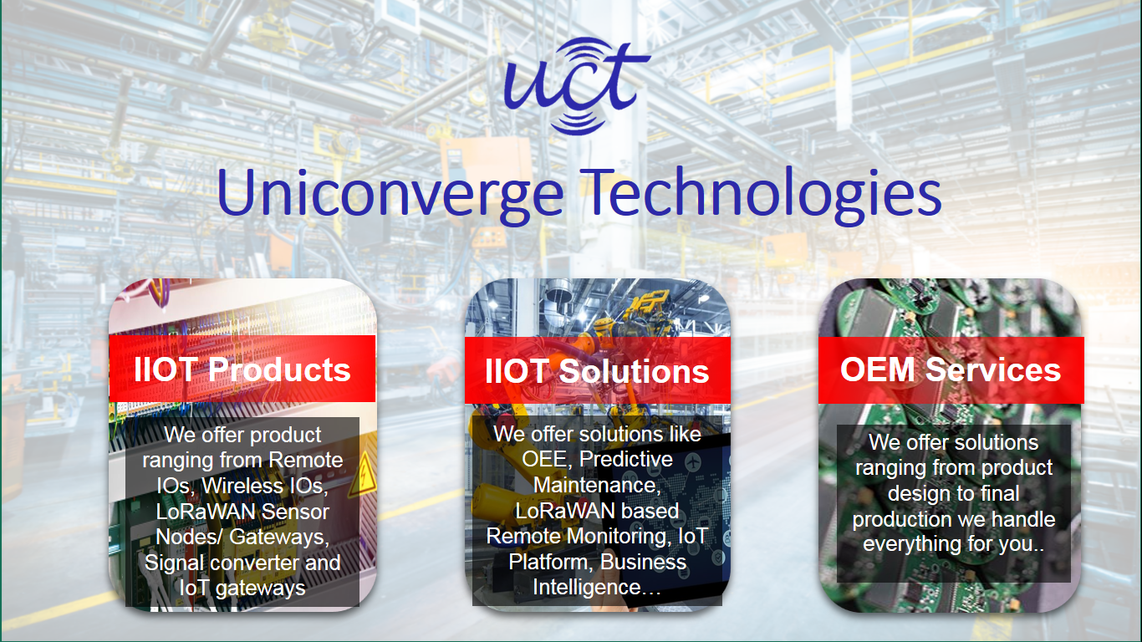

1. UCT IoT Platform **(****)**

**UCT Insight** is an IOT platform designed for quick deployment of IOT applications on the same time providing valuable “insight” for your process/business. It has been built in Java for backend and ReactJS for Front end. It has support for MySQL and various NoSql Databases.

* It enables device connectivity via industry standard IoT protocols - MQTT, CoAP, HTTP, Modbus TCP, OPC UA
* It supports both cloud and on-premises deployments.

It has features to  
• Build Your own dashboard  
• Analytics and Reporting  
• Alert and Notification  
• Integration with third party application(Power BI, SAP, ERP)  
• Rule Engine

 

1. **Smart Factory Platform (****)**

Factory watch is a platform for smart factory needs.

It provides Users/ Factory

* with a scalable solution for their Production and asset monitoring
* OEE and predictive maintenance solution scaling up to digital twin for your assets.
* to unleased the true potential of the data that their machines are generating and helps to identify the KPIs and also improve them.
* A modular architecture that allows users to choose the service that they what to start and then can scale to more complex solutions as per their demands.

Its unique SaaS model helps users to save time, cost and money.

 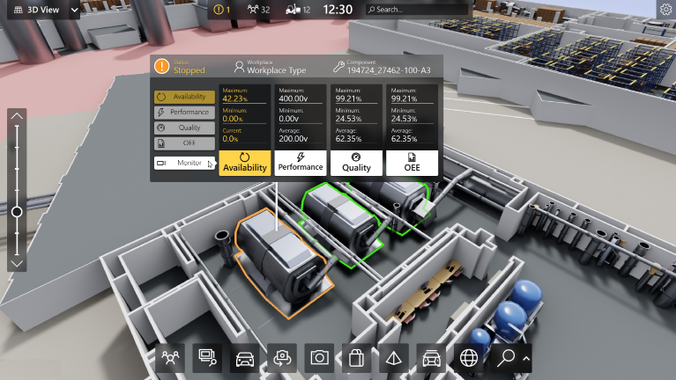

1. 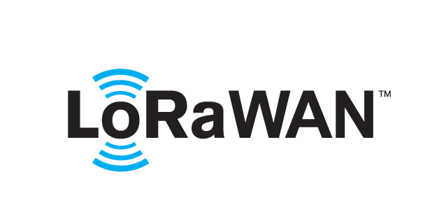 based Solution

UCT is one of the early adopters of LoRAWAN teschnology and providing solution in Agritech, Smart cities, Industrial Monitoring, Smart Street Light, Smart Water/ Gas/ Electricity metering solutions etc.

1. Predictive Maintenance

UCT is providing Industrial Machine health monitoring and Predictive maintenance solution leveraging Embedded system, Industrial IoT and Machine Learning Technologies by finding Remaining useful life time of various Machines used in production process.



## About upskill Campus (USC)

upskill Campus along with The IoT Academy and in association with Uniconverge technologies has facilitated the smooth execution of the complete internship process.

USC is a career development platform that delivers **personalized executive coaching** in a more affordable, scalable and measurable way.



Seeing need of upskilling in self paced manner along-with additional support services e.g. Internship, projects, interaction with Industry experts, Career growth Services

<https://www.upskillcampus.com/>

upSkill Campus aiming to upskill 1 million learners in next 5 year

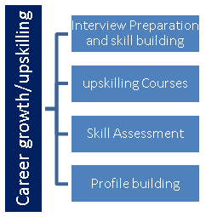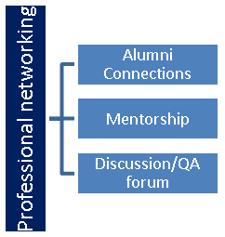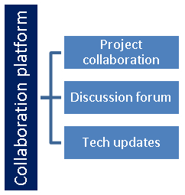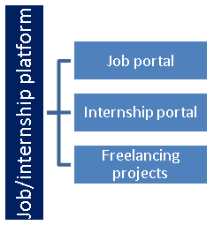

## The IoT Academy

The IoT academy is EdTech Division of UCT that is running long executive certification programs in collaboration with EICT Academy, IITK, IITR and IITG in multiple domains.

## Objectives of this Internship program

The objective for this internship program was to

 ☛ get practical experience of working in the industry.

 ☛ to solve real world problems.

 ☛ to have improved job prospects.

 ☛ to have Improved understanding of our field and its applications.

 ☛ to have Personal growth like better communication and problem solving.

## Reference

[1] https://learn.upskillcampus.com/s/courses/656d72afe4b0c8074bb749cb/take?freecourseenrol=success

[2] https://www.geeksforgeeks.org/courses?source=google&medium=cpc&device=c&keyword=geeksforgeeks&matchtype=e&campaignid=20039445781&adgroup=147845288105&gad_source=1&gclid=Cj0KCQjwn7mwBhCiARIsAGoxjaKyxwDEpZDHNZF-ABHDYkfvqFO-raTrTQNpI8K6y0LweqMSeH9ZLdgaAnRcEALw_wcB

[3] https://www.w3schools.com/

## Glossary

|  |  |
| --- | --- |
| Terms | Acronym |
|  |  |
|  |  |
|  |  |
|  |  |
|  |  |

# Problem Statement

In the assigned problem statement

The problem statement for a URL shortener typically revolves around the need to efficiently convert long URLs into shorter, more manageable versions while still maintaining functionality and accessibility. Here's a breakdown of the key components of the problem statement:

Long URLs are Unwieldy: Long URLs can be cumbersome and difficult to share, especially in contexts like social media posts, SMS messages, or printed materials where character limits may apply.

Need for Conciseness and Efficiency: Users often require shortened URLs that are concise and easy to remember or type. This is particularly important in situations where space or character count is limited.

Maintaining Functionality: Despite being shortened, the URLs must still be functional and direct users to the intended destination reliably. Any URL shortening solution must ensure that shortened URLs redirect users seamlessly to the original long URLs.

Tracking and Analytics: Many users and organizations require the ability to track usage statistics and analytics associated with the shortened URLs. This includes metrics such as the number of clicks, geographic location of users, referral sources, etc.

Scalability and Performance: The URL shortening service should be able to handle a large volume of requests efficiently and maintain high performance even during peak usage times. It should also be scalable to accommodate growth in users and usage over time.

Security and Reliability: The service must prioritize security to prevent misuse or abuse, such as malicious link insertion or unauthorized access to analytics data. Additionally, it should be reliable, with minimal downtime or service disruptions.

Customization Options: Some users may require customization options for their shortened URLs, such as the ability to choose a custom alias or customize the shortened URL's appearance.

Overall, the problem statement for a URL shortener involves creating a solution that efficiently converts long URLs into shorter versions while ensuring functionality, reliability, security, and performance. Additionally, the solution should offer tracking and analytics capabilities, scalability, and customization options to meet the diverse needs of users and organizations.

# Existing and Proposed solution

Provide summary of existing solutions provided by others, what are their limitations?

What is your proposed solution?

What value addition are you planning?

## Code submission

## ( https://github.com/VamsiK-03/Upskill-Campus/blob/d1ab8c1371e7b4529437dbfdc8b54eeceb7af9af/URLShortener.py )

## Report submission

## ( <https://github.com/VamsiK-03/Upskill-Campus/blob/3cf16295bbe0c6b7c6f5e300dc538e3492366140/URL_Shortner_K.Vamsi_USC_UCT.docx> )

# Proposed Design/ Model

Given more details about design flow of your solution. This is applicable for all domains. DS/ML Students can cover it after they have their algorithm implementation. There is always a start, intermediate stages and then final outcome.

# Performance Test

This is very important part and defines why this work is meant of Real industries, instead of being just academic project.

Here we need to first find the constraints.

How those constraints were taken care in your design?

What were test results around those constraints?

Constraints can be e.g. memory, MIPS (speed, operations per second), accuracy, durability, power consumption etc.

In case you could not test them, but still you should mention how identified constraints can impact your design, and what are recommendations to handle them.

## Test Plan/ Test Cases

## Test Procedure

## Performance Outcome

# My learnings

During my virtual internship at Upskill Campus, I underwent significant learning experiences that have greatly contributed to my personal and professional development. Here's a summary of my key takeaways and how they will help me in my career growth:

Practical Skills Acquisition: Through hands-on projects and assignments, I acquired practical skills relevant to my chosen field. These skills include [list specific skills], which are essential for success in [mention specific industry or career path]. This hands-on experience has provided me with a solid foundation that I can build upon as I progress in my career.

Mentorship and Guidance: The mentorship and guidance provided by professionals at Upskill Campus were invaluable. They offered support, advice, and feedback, helping me navigate challenges and capitalize on opportunities. The insights I gained from my mentors have broadened my perspective and equipped me with strategies to overcome obstacles in my career journey.

Networking Opportunities: Participating in the virtual internship program exposed me to a diverse network of professionals in my field. Building these connections has expanded my network and opened doors to potential future collaborations, job opportunities, and mentorship relationships. Networking is crucial in today's professional landscape, and the relationships I've formed during my internship will undoubtedly be beneficial for my career growth.

Adaptability and Remote Work Skills: The virtual format of the internship enhanced my adaptability and remote work skills. I learned to effectively manage my time, communicate efficiently in virtual settings, and collaborate with team members remotely. These skills are increasingly relevant in today's digital age and will undoubtedly be advantageous in my future career endeavors, especially considering the rise of remote work opportunities.

Professional Development and Growth Mindset: Engaging in the virtual internship program at Upskill Campus has instilled in me a growth mindset and a commitment to continuous learning and professional development. I recognize the importance of staying updated with industry trends, acquiring new skills, and seeking out opportunities for growth. This mindset will serve as a driving force in my career journey, enabling me to adapt to changes, embrace challenges, and strive for excellence.

In conclusion, my virtual internship experience at Upskill Campus has been immensely beneficial for my career growth. It has equipped me with practical skills, valuable insights, and a network of connections that will undoubtedly propel me forward in my professional endeavors. I am grateful for the opportunity and confident that the lessons learned during my internship will serve as a solid foundation for my future success.

# Future work scope

You can put some ideas that you could not work due to time limitation but can be taken in future.