Router 1x3 Project:
INTRODUCTION:
- A router is a networking device that forwards data packets between computer LANs.
- It follows TCP/IP layer 3 network layer protocol and does routing of te packets.

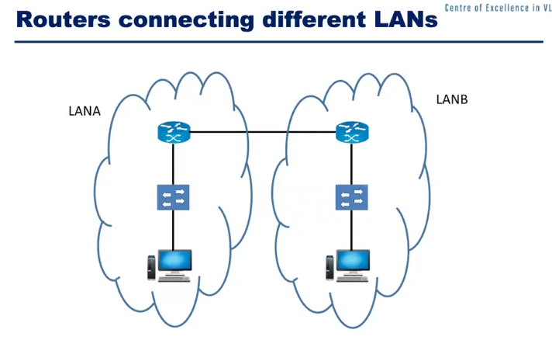
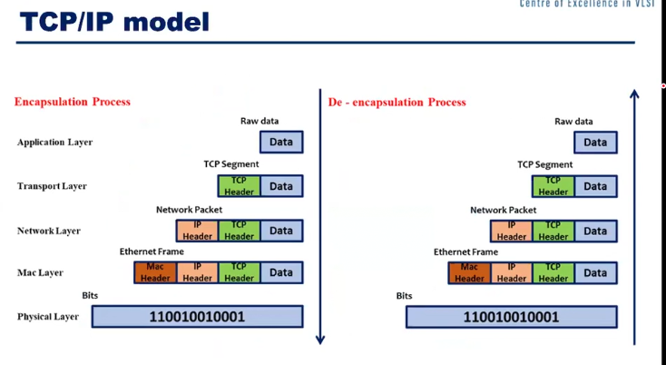

TOP BLOCK:
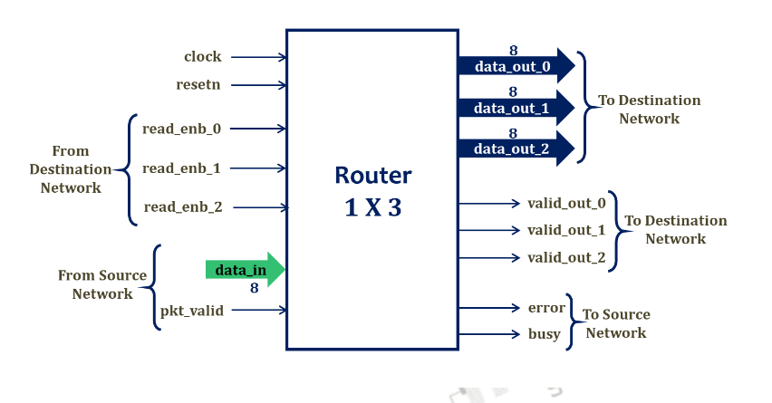
Interface:

Busy: if all FIFOs are full then no new data will be accepted
Valid_out: indicates weather destination is ready to accept data
read_enb: if valid out is high, it indicates there is data available to read then read_enb can be made high, then data can be read by the destination.
If readenb is not made high for 30 clocks CLKs after valid_out is made high then a soft reset is triggered which will wipe out the entire FIFO.
error:

If destination is not active but data is continously read then it will be stored in FIFO blocks indicated ny data_out_0, data_out_1, data_out_2.
When valid_out is enabled, read_enb for particular FIFO will be high and the data stored in the FIFO is read by the destination.

pkt_valid: pkt_valid will be high from header to payload
Busy: if busy is high, it stops receiving new bytes and continues till the it is high

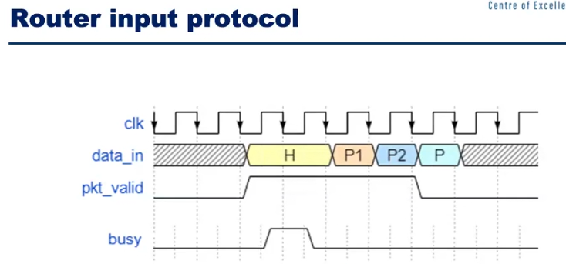

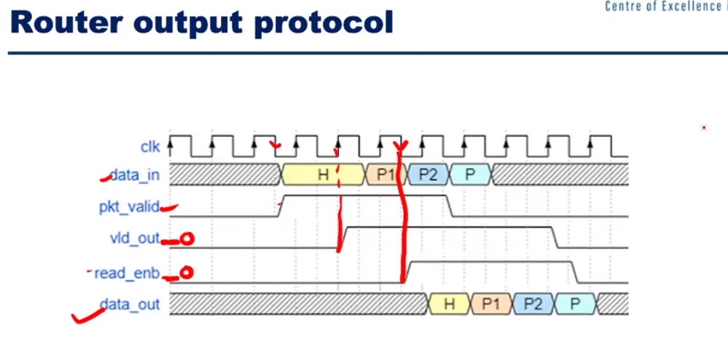

Various Blocks inside the Router:
1) Loadable Register: Data goes to register from source. If destination is accepting th data it will be sent to FIFO to store.
2) FIFOs : Acts as buffer between source and destination
3) Synchronizer : two imporant jobs i) to generate soft reset if read_enb is not made high after 30 clock clks of valid_out high.
ii) to make valid_out high once data is transfered from register to FIFO
4) FSM: Controls all the blocks as a controller
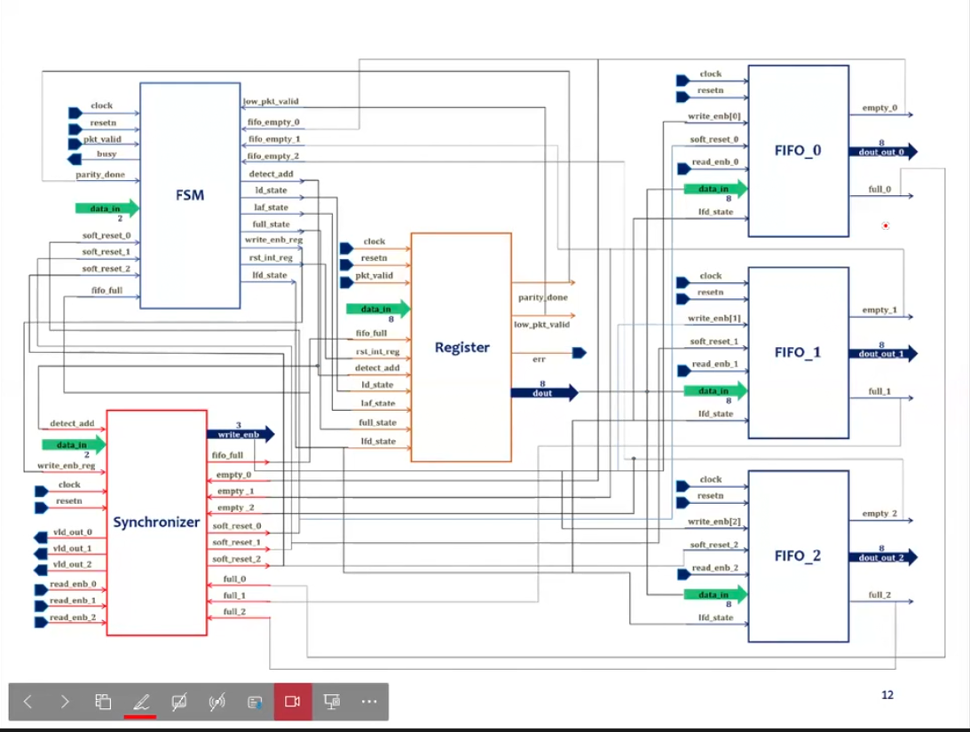

ROUTER PACKET STRUTURE:

- Packet Format: The Packet consists of 3 parts i.e Header, payload and parity.

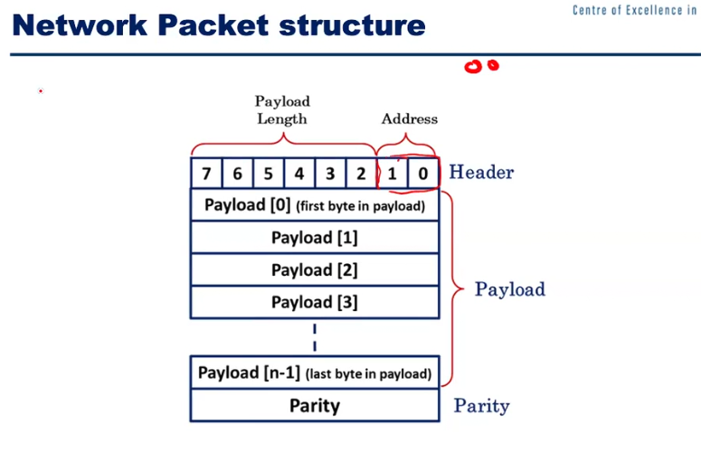

Header: Destination Address,
Address
2-bit address,
00 --> D0
01 --> D1
10 --> D2
Payload length: 6-bits
Range of Payload 0 to 2^6
Parity: Calculate Packet Parity and internal parity (bit parity)

FIFO Block :
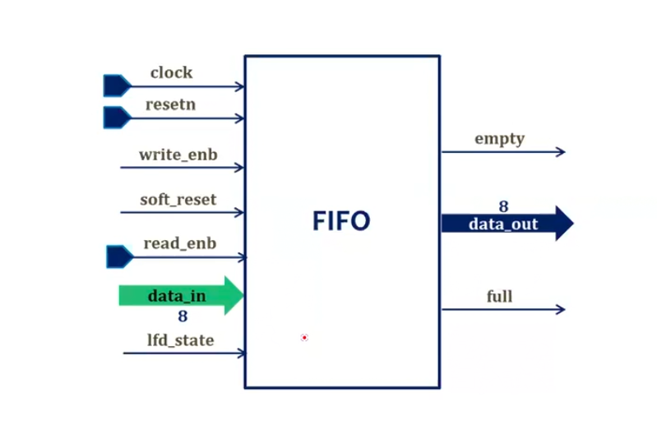

lfd_state: is used to identify the header byte. It will be high for header byte and low for remaining payload. lfd_state is generated by FSM.

soft_reset: Clears the FIFO contents, similar to reset
full: when FIFO is full, a full signal is sent to Synchronizer, when in return send a fifo_full signal to FSM and FSM will send the busy signal to source.
When busy is high no new data is accepted from source

