Basics of web development and internet

What is the internet?
- The Internet is a global physical network of connected computers and hardware. The Internet allows multiple devices to communicate with each other and share information.

What is WWW?
- The world wide web is just a collection of information that we access using the internet/global network.

How does the web work?

Web works in client-server architecture. Where both are different APIs and communicate with each other using API Request/HTTP requests.

Client - Client is a device that requests resources from a server.
Server - server is a hardware device where it contains logic and data. Provides resources to the client when request arrives.

Client sends request to server
Server responds and sends back response

API - Application programming interface
API acts as a digital middleman, delivering a request from one system to another and bringing back the response.

Example: System.out.print(): // local API
https://google.com // Web API
https://localhost:8080 // Local web API

Authentication of the user also checks by API, when a request hits the Server, initially it authenticates the request. Then allows it into server

Types of API request:
POST - creates information in the server
GET - retrieves information from the server
PUT - modifies the existing information from the server
DELETE - deletes the information from the server

REST API - representation state transfer application programming interface
- Uses HTTP requests to access and use data.
- Data is in the form of JSON/XML.
- REST is stateless. Means server did not hold any specific data of previous requests. So every request should contain all required data from the client to validate.
- Client - server architecture
- Cached - clients can cache the response to improve performance.

HTTP vs HTTPS

HTTP stands for “Hypertext transfer protocol”

HTTP and HTTPS are protocols used by clients and server to communicate over a network. The difference is that HTTPS wraps HTTP inside a secure Transmission Layer Security (TLS/SSL).

How Does HTTPS Work internally?

Client -> TCP -> HTTP -> Server

- Client initializes a TCP connection (3 way handshake SYN, SYN-ACK, ACK) on port 80.
- Client sends a request in plain text
Request:
GET /products?id=10 HTTP/1.1
Host: example.com
User-Agent: Chrome
Accept: text/html
Cookie: session=abc123
- Server sends back a response in plain text
Response:
HTTP/1.1 200 OK
Content-Type: application/json
Content-Length: 45
{
"id": 10,
"name": "Laptop"
}
- Connection closes or ends.

The problem with HTTP here is, No identity verification and encryption. Hackers can see and modify the data on request in the middle of transit.

Imagine, if our request contains username and password. Hackers can easily see them. So most of the companies use HTTPS
How does HTTPS work internally?

Client -> TCP -> TLS Encryption -> HTTP -> Server

After establishing TCP on port 443, client and server perform TLS handshake.

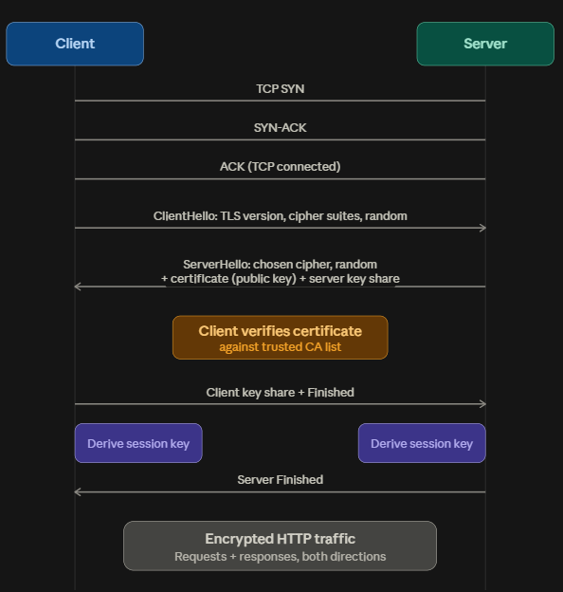

ClientHello: Client sends the information such as supported TLS versions, cryptographic algorithms/cipher suites and random numbers

ServerHello: server picks a suitable TLS version, cipher suite/cryptographic algo and sends back clients own random number along with a digital certificate containing public key.

Certificate verification: The client checks if the certificate was signed by a trusted Certificate Authority (CA) (Let's Encrypt, DigiCert, Google Trust Services etc.) whose root cert is baked into the OS/browser. This proves "this really is the server it claims to be," preventing man-in-the-middle attacks.
Note: Your operating system/browser maintains a set of trusted CA roots.

Key exchange: both sides use asymmetric cryptography (usually ECDHE — Elliptic Curve Diffie-Hellman) to agree on a shared secret, without ever transmitting that secret itself.

Session key derivation: both sides independently compute the same symmetric session key from that shared secret.

After establishing successful encryption. Data sends in a sequence of packets, which are not readable.

example :

What client initially send:

GET /bank/account HTTP/1.1
Host: bank.com
Cookie: session=XYZ

What actually data looks like in transit
17 03 03 AF 82 91 C3 28
91 EF 22 B4 0A 6F A8 23

What HTTPS actually guarantees
- Confidentiality — no one can read the traffic in transit
- Integrity — no one can tamper with it undetected (MACs/AEAD ciphers)
- Authentication — you know you're actually talking to the domain you typed, not an impostor

Spring Framework

What is a web framework?
Web framework is a collection of tools and modules that is needed to do standard tasks across every web application.
Spring simplifies enterprise application development.
Principles
- Simplicity
- Modularity
- Testability
Coupling:
Coupling refers to the interdependence between different classes or components.
Tight coupling: tight coupling means classes or components are highly dependable on each other.
Loose coupling: loose coupling is a design principle that aims to reduce dependency between components in the system.
It is very important to have loose coupled components in our system. It gives advantage of
- Flexibility and maintainability
- Scalability
- Testing
How can we achieve loose coupling?
- Interfaces and abstraction
- Dependency injection
- Event driven architecture
Example: List<T> is an interface
- ArrayList<T> is class : List<Integer> list = new ArrayList<>();
- Vector<T> is class : List<String> vector = new Vector<>();
These classes make use of declared methods in List interface to implement the logic of their classes.
Inversion of Control (IoC):
Inversion of control is a design principle where the control of object creation and objects life cycle management is transferred from the application code to an external container or framework.
- Spring framework manages object life cycle management using spring container.
Dependency Injection:
- Dependency Injection is a designed pattern commonly used in object oriented programming with the dependency of a class being provided externally rather than being created within the class itself.
- We use DI to achieve the loose coupling between classes by removing direct dependency.

Bean: Bean is a standard Java object that is completely managed by frameworks known as Bean.

Spring Container : Spring container is a core component and is responsible for managing the life cycle and configuration of objects called beans.
Types of Spring containers:
- BeanFactory
- ApplicationContext
BeanFactory:
The simplest container provides basic IoC features. It is light weight and suitable for simple applications.
BeanFactory context = new ClassPathXmlApplicationContext("applicationBeanContext.xml");
ApplicationContext:
A more advanced container built on top of BeanFactory, offering additional features such as event propagation, declarative mechanisms to create a bean, and various means to look up. It is generally recommended for most applications.
ApplicationContext context = new ClassPathXmlApplicationContext("applicationBeanContext.xml");

How does the container know which objects need to be managed?
We as a developer, create a configuration file. So that bean life cycle would know which objects need to be managed.
Configuration contains bean definitions.

Setting up a Spring Project:
Required Dependencies:
- Spring Core
- Spring Context
Initialize a standard Java application.
Specify the appropriate Java Development Kit (JDK) version.
Select Apache Maven as the build automation tool.
After project:
- Import required dependencies from the public shared repository of maven. Copy them and paste in dependencies tag in pom.xml file
- creation, we have to create a config file which is XML. In that config file we define beans where the spring container needs to be managed.

Bean Definition: A bean definition includes configuration metadata that the container needs to know to create and manage the bean.
Bean Configuration: Bean definitions can be provided in various ways, including XML configuration, Annotations and java-based configuration.

Dependency injection:
- DI is a design pattern used in software development to achieve loose coupling between classes by removing direct dependency instantiation from the dependent class itself.
Types of DI:
- Constructor DI
- Setter DI
Constructor DI:
- Dependencies are provided to the dependent class through its constructor.
- Dependencies are passed through arguments/parameters in constructor when the dependent class is initiated
- Constructor dependency ensures that dependencies are available when objects are being created.
How do we configure dependencies through constructor?
We declare the required dependency classes in the dependent class. Then we create a constructor for the dependent class and pass the dependencies as a parameter in the constructor.
We modify the config class,
- We create beans of dependency class and dependent class.
- We create a sub tag of <constructor-arg> in dependent class bean where we mention the id of dependency class in that tag.
In this way, we let spring know to manage the constructor dependency injection.

Setter DI:
- Dependencies are provided to the dependent class through the setters after creating dependencies class declaration.
How do we configure dependencies through setter dependency?
- We declare dependencies in the dependent class.
- We create setters for these declarations
- Then we create beans of dependency class and dependent class.
- We create a property field of dependency declaration and give ref value as id of dependency class bean.
Autowiring: Autowiring is a design pattern that automatically injects dependent objects into a bean. Reducing the need of explicit configuration in XML.
- Automatically injects dependencies between spring beans
- Reduces boilerplate code and XML configuration
Type of autowiring
- byName
- byTpe
- byConstructor

Autowiring byName: Spring injects the dependency by matching the bean ID with property name of dependency object in dependent class.
- Use setter-based injection and must.
- Property name must be matched with bean ID.

Autowiring byType: Spring injects the dependency based on the ClassName/ClassType.
- This works if bean id and property name are not the same.
- Throws error if multiple beans exist.
Autowiring constructor: spring injects the dependency based on the constructor.
- Uses constructor based injection and constructor is must.
- No need for a setter in dependent class.

Annotations in JAVA

Annotations: annotations in java provides a way to add metadata to our code.
- Adds pre-defined implementations at runTime.
- We use annotations to simplify configuration and runtime behaviour
Most used annotations in spring are,
@Component - this annotation simply marks a java class as a bean. Spring scans the whole project at runtime and manages their life cycle.
@Override - this annotation educates the compiler that the current method in sub class is from parent class and we are modifying the logic and using this implementation instead of parent implementation.

Component:
A component is also an object, which is automatically managed by the Spring IOC container.
- Both are ways to register objects as spring beans, but they work differently
- Components are managed automatically by spring componentScanning. But management of beans requires XML configuration.
- We can use XML and annotations to specify components.
Example:
Using XML:
<bean id = “myClass” class = “com.example.MyClass” />
Using Annotation:
@Component //marks class a spring component
Public class MyClass {
//class implementation
}

Component Scanning: It is a feature that helps to automatically detect and register objects from the packages.
- We specifically mention Package path, so that spring will know which package to scan.
- We can use XML and annotations to specify componentScanning.
Using XML:
<context: component-scan base-package=”com.example” />

@Value: @Value annotation allows you to specify value for property at field level in component class.
- We can specify value from property files, Env files, system properties etc..
- We can place this annotation at field level, parameterized constructor and setter level.
@Value(101)
Private int empId;

Transition from XML to pure Annotation based application:

Configuration class: it is a class which has stereotype annotation @Configuration at class level. Where this class has configurations which replaces the traditional XML configuration file to define, wire, and manage the beans.
@Configuration: annotation marks the class as a configuration class.
- Replaces the traditional XML configuration

@Autowired:
This annotation automatically injects the dependencies via field, constructor and setter.

@Qualifier: This annotation specifies which bean to inject when multiple beans exist in the configuration file.
Example:
One interface, multiple implementation classes, need to specify in the controller while injecting.
Interface PaymentService. Class CreditCard implements paymentService and Class UPI implements PaymentService
Both services have different controllers, so while injecting PaymentService, we specify @Qualifer(--name of service class–).

@Primary: Marks a bean as the default when multiple candidates exist.
We specify this annotation at the class level of service classes. So that class behaves as the primary class to inject.

SpringBoot:
Springboot is an open-source, JAVA based framework used to create stand-alone, production-grade spring-based applications on top of spring framework.
Spring vs springboot
In spring lots of steps involved in setting up, configuration, writing boilerplate code, deployment of the app.
- Manual XML or annotation based configuration
- Manually manage dependencies
- Manually configure server (tomcat, jetty etc…)
Spring boot is designed to reduce boilerplate code and setup complexity. It provides auto configuration, embedded local server and production-ready features.

Springboot = Spring framework + prebuilt-configuration + embedded server.

Springboot components:
- Springboot starters:
Springboot starters are collections of pre-built dependencies which will be helping in built web applications without manual configuration and version checking of each module.
These are in the form of maven/gradle dependencies.
Before starters, while building web applications, we manually add Spring MVC, tomcat server, jackson for JSON and other libraries and we take care of their versions too. If any version mismatches, we face errors.
Currently most used starter dependencies are
- spring-boot-starter-web/spring-boot-starter-webmvc
This dependency includes Spring MVC, embedded tomcat server, Jackson for building RESTful web APIs
- spring-boot-starter-data-jpa
This dependency includes Spring Data JPA, Hibernate, ORM etc..
- spring-boot-starter-security
This dependency includes security/Auth implementations.
- spring-boot-starter-validation
This dependency includes the Bean validation implementation

2) Auto configuration - Springboot automatically configures the project based on dependencies that we added in the pom.xml configuration file. No need to configure manually.
3) Springboot Actuator: This feature helps in monitoring our application metrics.
4) Embedded server: Springboot provides an embedded server which is tomcat server. This server comes with springboot starter web dependency.
5) Springboot devTools: This feature helps in enhancing productivity during application development. Auto application restarts/ auto re deployment.
Advantages:
- Standalone and quick start
- Starter code
- Less configuration
- Reduce cost and development time
Springboot Architecture: SB has a layered architecture. Where layers communicate and share data.
Auto configuration, embedded server, starter dependencies wrapped around the outside to remove boilerplate.
- Presentation layer (REST endpoints)
- Service layer (Business logic)
- Data layer (Data access)
Presentation layer: Presentation layer presents the data on the application features to the user this is the layer where in all the controller classes exist.
Service layer: Service layer is where business logic resides in the application. Tasks such as evaluations, decision making, processing of data is done in this layer.
Data Access layer: Data access layer is the layer where all the repository classes exist. Database related logic.
Client (Browser) -> Controller -> Service -> Repository -> Database
Pom.xml: Project Object model
The Project Object Model file serves as a configuration XML. It provides essential metadata and build instructions that Maven utilizes to manage the application development lifecycle.

@SpringBootApplication: This annotation specifies this project as a springboot application.
This annotation provides Springboot configuration, Auto configuration and componentScan.
Dependencies:
Dependencies are external libraries which are required to make our web application functional.
Springboot uses maven, gradle build tools to manage these dependencies.
We use Pom.xml to manage the dependencies.

Lets build our first RESTful API, for that we need a presentation layer which means, controller class is needed to manage REST endpoints.
@Controller: this annotation specifies the class as a controller class which manages the web requests and responses.
DispatcherServlet:
The DispatcherServlet is the front controller in Spring MVC. A single entry point that receives every incoming HTTP request and routes it to the right handler (controller). Instead of each URL mapping to a separate servlet, all requests go through this one servlet, which then delegates the actual work.

When a request comes in, DispatcherServlet coordinates several components in sequence:
- HandlerMapping — figures out which controller method should handle this URL (based on @RequestMapping, @GetMapping, etc.)
- HandlerAdapter — actually invokes that controller method
- Controller — executes business logic, returns a ModelAndView (or in REST APIs, the response body directly via @ResponseBody/@RestController)

Application.properties:
The application.properties is a file we use to customize the pre-configurations of component logics in springboot.

@PathVariable:
@PathVariable annotation is used to extract dynamic values from the URL path and bind them to method parameters in the Rest controllers.
@GetMapping("/users/{id}")
public String getUserById(@PathVariable int id) {
return "User ID: " + id;
}
We can specify in two ways.
- When the path variable name matches the method parameter name, you can omit the explicit name in the annotation.
- We can explicitly mention in the variable name of annotation in the method parameter.
Example:
@GetMapping("/books/{isbn}")
public String getBook(@PathVariable("isbn") String bookCode) {
return "Book ISBN: " + bookCode;
}
- We can extract and use multiple parameters from the pathVariable.
@GetMapping("/orders/{userId}/order/{orderId}")
public String getOrder(@PathVariable int userId, @PathVariable int orderId) {
return "User ID: " + userId + ", Order ID: " + orderId;
}

ResponseEntity:
ResponseEntity is a wrapper class in Spring that represents the entire HTTP response. This includes status code, headers and body.
When the method returns the ResponseEntity, Spring uses information provided in the method to construct the final HTTP response sent to the client.

ORM (Object Relational Mapping):
Object-Relational Mapping (ORM) is a programming technique that acts as a bridge between object-oriented programming (OOP) languages and relational databases. Instead of writing raw SQL queries, developers work with objects in their code, and the ORM framework automatically translates these operations into SQL statements for the database.

JPA (Java Persistent API):
JPA is a Java specification that makes it easier to work with relational databases. It lets you map Java classes (entities) to database tables and manage data using simple APIs instead of writing complex SQL.
Class = table
Properties = columns
Spring Data JPA:
Spring Data JPA is a highly popular framework within the Spring ecosystem that simplifies database access for Java applications. It acts as an abstraction layer on top of a JPA provider (most commonly Hibernate), drastically reducing the boilerplate code required to build a data access layer.
@Entity: Marks the class as a JPA entity. JPA will manage this object for persistence.
@Table(name = "employees"): Maps the entity to the employees table. Optional if table name is the same as class name.
@Id: Marks the primary key field.
@GeneratedValue(strategy = GenerationType.IDENTITY): Database auto-generates the ID.
@Column(name = "name"): Maps a field to a specific column in the database. Optional if field name matches column name.
Optional:
Optional<T> is a container object used to represent the presence or absence of a value. It prevents NullPointerException (NPE) and makes your APIs cleaner by explicitly telling developers when a value might be missing.

Getters and setters are really needed in the MODEL classes, when we are developing web applications. Without them, we cannot store and fetch values from DB.

Validations in springboot:
Validations in spring boot is all about ensuring the data our application receives meets certain criteria before it proceeds.
For example, when validation applies, fields like email field will allow the correct email formats.
Validation achieves integrity and prevents bad data which consists of errors in application.
Hibernate Validator is the implementation of jakarta bean validation of spring framework.
We specify validations via annotations.
Validations in spring:
@NotNull
@NotEmpty
@Size(min = x, max = y)
@Email
@Min(value)
@Max(value)

Using these validations can throw exceptions, they can be visible in console logs. But the response which will be sent to the client will be 500 internal errors.

For example,
I have category class with categoryId and categoryName, I am sending post request via postman API.
I have placed annotation over categoryName as @NotEmpty(message = “CategoryName cant be blank”)
In JSON request, I set value for categoryName as empty, when I send the request to API,
I get response as 500 internal error.
In console logs, we can able to see exception of constraintsViolation Exception along with message and variable name.

In the process of making this more user friendly, we can use @Valid annotation at controller class.

Using @Valid in controller at parameter level of the request in the method makes little difference and provides more details in the console logs. And specify better understandable response.
After using @Valid annotation, the response will be 400 bad request, and in console logs, we can find exception of MethodArugumentNotValidException and its shows which fields did not pass the validation and specifies the message of validation we mentioned in the POJO class.

To achieve more user-friendly response, we use globalExceptionHandler class, to manage default exception implementation.
@RestControllerAdvice:
@RestControllerAdvice is a specialized version of @ControllerAdvice in Spring Boot, designed to handle exceptions in RESTful APIs. It combines the functionality of @ControllerAdvice and @ResponseBody, making it easier to manage exceptions globally and return JSON responses.
Since @RestControllerAdvice includes @ResponseBody, any object returned from the exception handler methods is automatically serialized into JSON and sent back to the client.

Custom Exceptions: Custom Exceptions are exceptions we create manually, which will be useful for better understanding and readability.

  - We create customException class with extending RuntimeException and implement logic.
  - We manage this custom exception class in the globalExceptionHandler class. We can return ResponseEntity along with exception message.
Example:
@ExceptionHandler(APIException.class)
public ResponseEntity<String> ApiException(APIException exception)
{
String message = exception.getMessage();
return new ResponseEntity<>(message, HttpStatus.BAD_REQUEST);
}

Pagination:
Pagination is a technique of dividing a large body of con tent or data into smaller, discrete and numbered pages.
Advantages:

  - Data splitting: break ups long list of items such as e-commerce products, blogs, search results into manageable chunks.
  - Navigation: Allows user to navigate through content using ‘next’ and ‘previous’ and numerical page number.
  - Performance: Improves website speed and server efficiency by loading only a small subset of records at a time rather than thousands of records at once.

Pagination in Spring boot.
Pagination in Spring Boot is typically handled through Spring Data JPA's Pageable and Page<T> abstractions, which take care of the SQL LIMIT/OFFSET work for you.

To implement pagination, our repositories must extend JpaRepository or PagingAndSortingRepository.

Pageable:
Pageable is the interface that describes what page of data you want. It's just a request object — it doesn't hold any actual data. It carries three things: the page number, the page size, and optionally a Sort. Spring Data's concrete implementation you'll actually construct is PageRequest.

Pageable pageable = PageRequest.of(0, 20); // page 0, 20 items per page
Pageable pageable = PageRequest.of(0, 20, Sort.by("lastName").ascending());
Pageable pageable = PageRequest.of(0, 20, Sort.by("lastName").ascending().and(Sort.by("firstName")));

Page<T>:
Page<T> is what you get back when you pass a Pageable into a query. It extends Slice<T>, and on top of the slice behavior it adds a full count of all matching rows, obtained via a second, separate query. That's the important trade-off to know: under the hood, a Page<T> result triggers two SQL statements, one for the actual page of rows (with LIMIT/OFFSET) and one SELECT COUNT(*) to compute getTotalElements().

Page<Employee> page = employeeRepository.findAll(pageable);
page.getContent(); // List<Employee> — the actual rows
page.getTotalElements(); // total matching rows across all pages
page.getTotalPages(); // ceil(totalElements / pageSize)
page.getNumber(); // current page number (0-indexed)
page.getSize(); // page size
page.hasNext();
page.hasPrevious();
page.isFirst();
page.isLast();

JPA entity Relationships:

Every enterprise level project has multiple entities, some of them also have relationships.
Multiple entities have multiple relationships too.

JPA and relationships:
  - An entity represents a table in database.
  - Each instance of entity is a row in a table.
  - Relationships in JPA defines how entities have related each other.
  - JPA allows us to map these relationships using annotations in java code.
Relationships:
One – One
One – Many
Many – One
Many – Many

Directions of relationships:
Uni-directional: Only one entity knows about the relationship and holds a reference to the other.
Bi-directional:
Both entities know about the relation between them and reference. One side is designated as the owning side (holds the foreign key via @JoinColumn), and the other is the inverse/referencing side (uses mappedBy).

@JoinColumn: this annotation used to explicitly manage the foreign Key in owned side.

@JoinTable:
@JoinTable is used to configure a join (junction/bridge) table for a many-to-many (or sometimes one-to-many/unidirectional) relationship.
Ex: @JoinTable(name = “name”, joinColumns = {@JoinColumn(name = “variable name”)

JoinColumns: foreign key column(s) in the join table that reference the entity that owns/declares the @JoinTable annotation (the "owning side").
InverseJoinColumns: foreign key column(s) in the join table that reference the other entity (the target/related entity).
While creating joinTable, if we include @Column(name = “name” ) for primary key in their classes, it would be good practice to explicitly mention referencedColumn = “exact name of @Column of primary key” in the @JoinColumn annotations of @JoinTable, so spring won’t face ambiguity.
Note: If you skip referencedColumnName, Hibernate assumes it refers to the entity's primary key column by default
MappedBy: we use this attribute in the relationship annotation to specify bi-directional relationship; we include this attribute in referencing side.

Circular reference: this is an issue occurs when we establish bi directional mapping, response would look like user -> userProfile -> user -> userProfile……. Like an infinite JSON file.

Issue: Could not write JSON: Infinite recursion (StackOverflowError)]
To stop this, we have to use @JsonIgnore annotation, we must place this at relation owning side class at the variable which has relation with reference class.
Note: if we are using Lombok, we have explicitly specify the hashCode(), toString(), Equals() methods with only instance variables and exclude relationship related variables.
When we use @Data of Lombok, It generates toString(), equals(), and hashCode() using all fields by default. including relationship fields. So even if JSON ignores socialUsers, Lombok could still recurse through

While adding data, in referenced class, we include owned class data also. But data is not being added. Because we missed to use cascading.
Cascading:
Cascading lets you propagate an operation (save, delete, update, etc.) performed on a parent entity automatically to its related/child entities, without you having to manually persist or remove each one.
When we perform some action on the target entity, the same action will be applied to the associated entity.
Types of cascading:
- ALL
- PERSIST
- MERGE
- REMOVE
- REFRESH
- DETACH
We must specify cascading attribute like @OneToMany(cascade = Cascade.ALL).
It can mostly be used in @OneToOne and @OneToMany relations. We can use in other relationships also but must handle with care and better to use persist and Merge, to don’t delete the shared records.
If we only use persist, new data will be saved but cannot align with existing data. In this situation we require.
Example, we have child with id 4, when creating parent id with 4 which associates with existing child id 4, it cannot establish relation with child and pass null values to DB.
After adding cascading, still we can face that issue.
To fix this, we must explicitly create setters for relationship fields in both referenced class and owning side class, because Lombok provides default implementation of setters.
FetchTypes:
FetchType controls when related entities are loaded from the database relative to their parent entity. It's set on relationship annotations (@OneToMany, @ManyToOne, @OneToOne, @ManyToMany) via the fetch attribute.

FetchType.Eager
The related entity is loaded immediately, at the same time as the parent — even if you never access it.
FetchType.Lazy
The related entity is loaded only when you actually access it (a proxy is used until then).

Spring Security:
Authentication: Authentication proves who you are.
Authorization: Authorization is about what you are allowed to do after your authentication.

Key security principles:
  - Least Privilege
  - Secure by design
  - Fail-safe defaults
  - Input Validation
  - Auditing and logging
  - Regular updates & patch management

Spring Security Architecture:
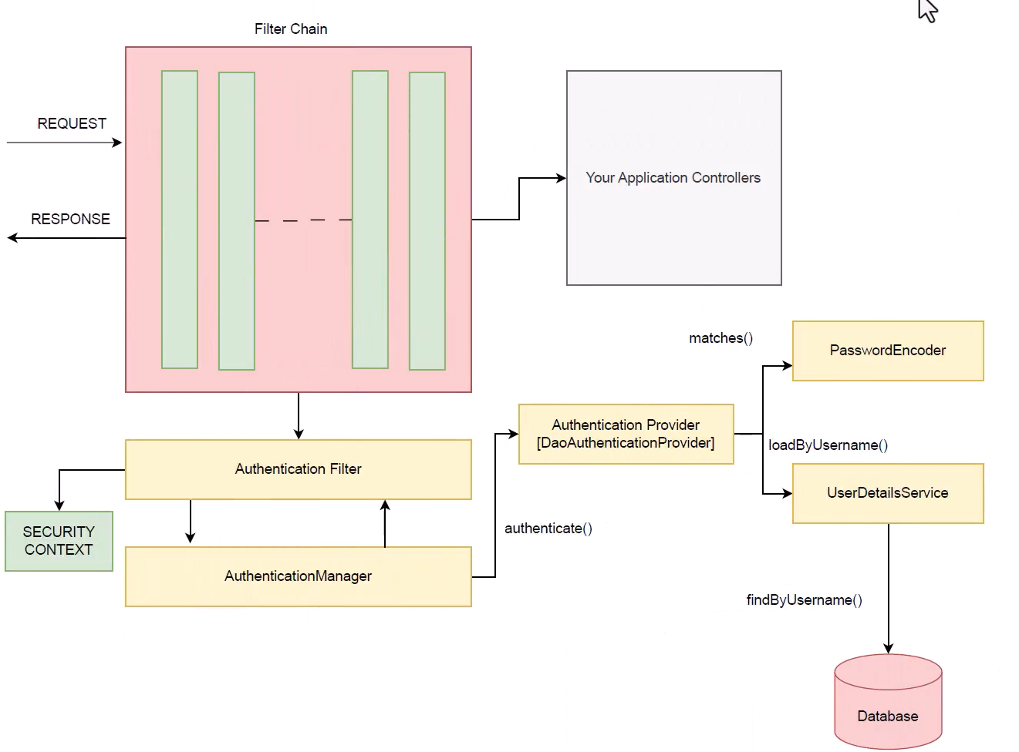
Request → Security Filter Chain → Authentication Filter → AuthenticationManager → AuthenticationProvider → UserDetailsService + PasswordEncoder → SecurityContext → Controller.
Initially client sends a HTTP request (ex: Frontend, UI, Postman API etc...). along with username and password.

Filter chain:
A Filter Chain is a sequence of security filters that process an HTTP request before it reaches your Spring MVC controller.
Authentication filter:
An Authentication Filter extracts authentication information from the incoming request.
And it does not verify the password itself. This filter creates Authentication Object and delegates to AuthenticationManager.
Request -> AuthenticationObject -> AuthenticationManager
AuthenticationManager: (an interface)
AuthenticationManager is responsible for coordinating the authentication process.
ProviderManager.class implements the AuthenticationManager interface.
It uses the lone method authenticate() to authenticate the request. The authenticate() method performs the authentication and returns an Authentication Object on successful authentication or throw an AuthenticationException in case of authentication failure.
The process of authentication in this process is delegated to the AuthenticationProvider.

AuthenticationProvider:

AuthenticationProvider (interface) -> AbstractUserDetailsAuthenticationProvider (class) -> DaoAuthenticationProvider.

The AuthenticationManager is implemented by the ProviderManager which delegates the process to one or more AuthenticationProvider instances. Any class implementing the AuthenticationProvider interface must implement the two methods authenticate() and supports().

support():
It is used to check if the particular authentication type is supported by our AuthenticationProvider implementation class. If it is supported it returns true or else false.

authenticate():
If the authentication type is supported, the process of authentication is started. Here is this class can use the loadUserByUsername() method of the UserDetailsService implementation. If the user is not found, it can throw a UsernameNotFoundException.

onSucess, it confirms creds with DB or inMemoryDB and returns the Authentication Object which will saves in SecurityContext.

UserDetailsService: (interface)
UserDetailsService is a Spring Security interface responsible for loading user information.
Here we inject UserRepository and finds credentials in DB.
It uses loadUserByUsername() method where we can provide our logic to fetch the user details for a user. The method will throw a UsernameNotFoundException if the user is not found.
PasswordEncoder:
Until Spring Security 4, the use of PasswordEncoder was optional. The user could store plain text passwords using in-memory authentication. But Spring Security 5 has mandated the use of PasswordEncoder to store passwords.
Spring Security Context
This is where the details of the currently authenticated user are stored on successful authentication. The authentication object is then available throughout the application for the session. So, if we need the username or any other user details, we need to get the SecurityContext first. This is done with the SecurityContextHolder, a helper class, which provides access to the security context. We can use the setAuthentication() and getAuthentication() methods for storing and retrieving the user details respectively.

InMemoryUserDetailsManager:
This is a class which implements userDetailsService interface, and this class is used to manage in memory credentials of users. Main purpose is for development and testing.

InMemoryUserDetailsManager(user1, user2);

We create customized security configurations to customize default security configurations.
In that class, I have created a UserDetailsService() bean. In that bean I have created users with class User from spring security dependencies, this bean returns the InMemoryUserDetailsManager (class).

There are multiple pre-built classes which implement the UserDetailService interface.

I tried creating user credentials by creating UserDetailsService bean and returning InMemoryUserDetailsManager with User objects are parameter.
Application started successfully, but When I tries to send request, I have faced 401 unauthorized response, because since spring security 5, spring expecting password to be saved as encoded. We definitely include encoded tag along with password. This is where {encoded tag} comes in.
{noop}:
{noop} means the password is stored and compared as plain text.
  - Since Spring Security 5, passwords are expected to be stored in the format.
  - The prefix in curly braces tells Spring Security which PasswordEncoder to use to validate that password.
Ex: password("{noop}admin")
Note: using noop is not good production practice.

Role-based Authorization:

@EnableMethodSecurity:
This annotation activates method-level security in Spring Boot, allowing fine-grained access control on individual methods using annotations like @PreAuthorize, @PostAuthorize, @Secured, and @RolesAllowed.

@PreAuthorize:
This Annotation is used to enforce method-level security. It evaluates a Spring Expression Language (SpEL) expression before a method is executed. If the logged-in user does not meet the criteria, Spring Security throws an AccessDeniedException and blocks execution

This annotation did not work if you don’t mention @EnableMethodSecurity at Configuration class.

CSRF (Cross site request Forgery)

Configuring H2 Database in Spring security.

H2 database is an in-built database provider by springboot. When we include Spring security, we face issues accessing the H2 database.

1). /h2-console/ is authenticated by default.
We have to configure to make it accessible.
http.authorizeHttpRequests((requests) ->
requests.requestMatchers("/h2-console/**").permitAll()
.anyRequest().authenticated());
This syntax can remove authentication for h2 requests.

2). The H2 console internally renders some content using HTML frames.
Spring Security protects your application against framing by default.

By default, Spring Security typically uses behavior frameOptions.deny()
http.headers(frame ->
frame.frameOptions(frameOption -> frameOption.sameOrigin()));
This page may be loaded inside a frame only if the parent page comes from the same origin.

3). Spring Security's CSRF protection expects a valid CSRF token for state-changing requests.
But the H2 console does not provide Spring Security's CSRF token.
So, we disable csrf protection for /h2-console/ URL requests.
http.csrf((csrf) -> csrf.ignoringRequestMatchers("/h2-console/**"));

After doing all these, spring will allow us to use h2 database normally.

