Suspicious Activity Detection

In this project we need to detect person behaviour as suspicious or not, now a day’s every where CCTV cameras are installed which capture videos and store at centralized server and manually scanning those videos to detect suspicious activity from human required lots of human efforts and time. To overcome from such issue author is asking to automate such process using Machine Learning Algorithms.

To automate that process first we need to build training model using huge amount of images (all possible images which describe features of suspicious activities) and ‘Convolution Neural Network’ using TENSOR FLOW Python module.

Then we can upload any video and then application will extract frames from uploaded video and then that frame will be applied on train model to predict its class such as ‘suspicious or normal’.

To implement above concept we need to install python 3.5 version in 64 bit laptop. I will send this software with code. While software installation u need to select checkbox saying add path to system variable. This option will show on first or second screen of installation. Once you install software execute below commands. Your system must connect to internet.

pip install tensorflow==1.14.0

pip install numpy

pip install scipy

pip install opencv-python

pip install pillow

pip install matplotlib

pip install h5py

pip install keras

pip install <https://github.com/OlafenwaMoses/ImageAI/releases/download/2.0.2/imageai-2.0.2-py3-none-any.whl>

After executing above commands all software will be installed. To monitor i am using below videos. For training i used human images who cover their faces to perform suspicious activity and if any video contains person covering their faces then application will detect it as a suspicious activity.

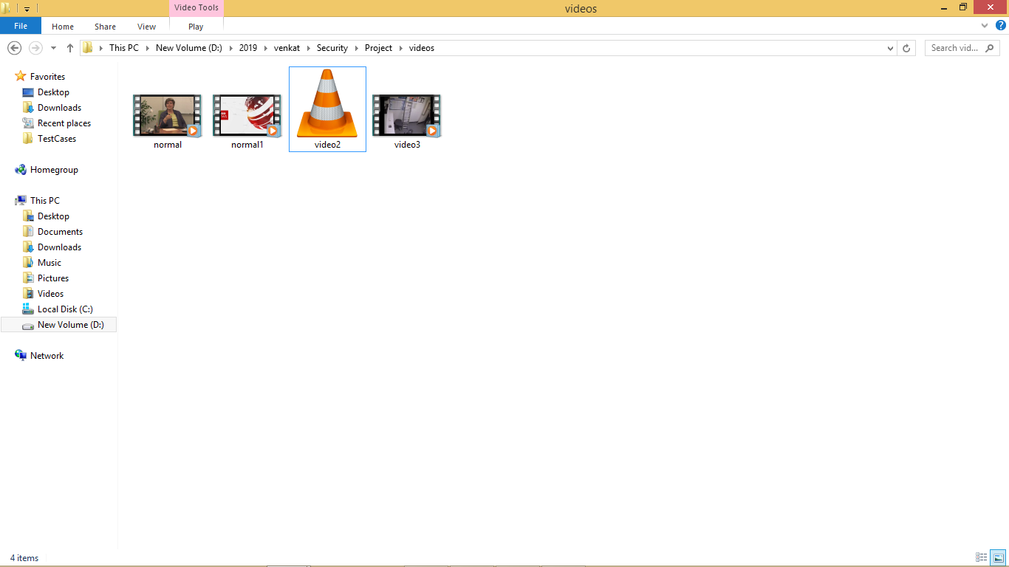

Double click on ‘run.bat’ file from project folder to start project execution. We will get below screen

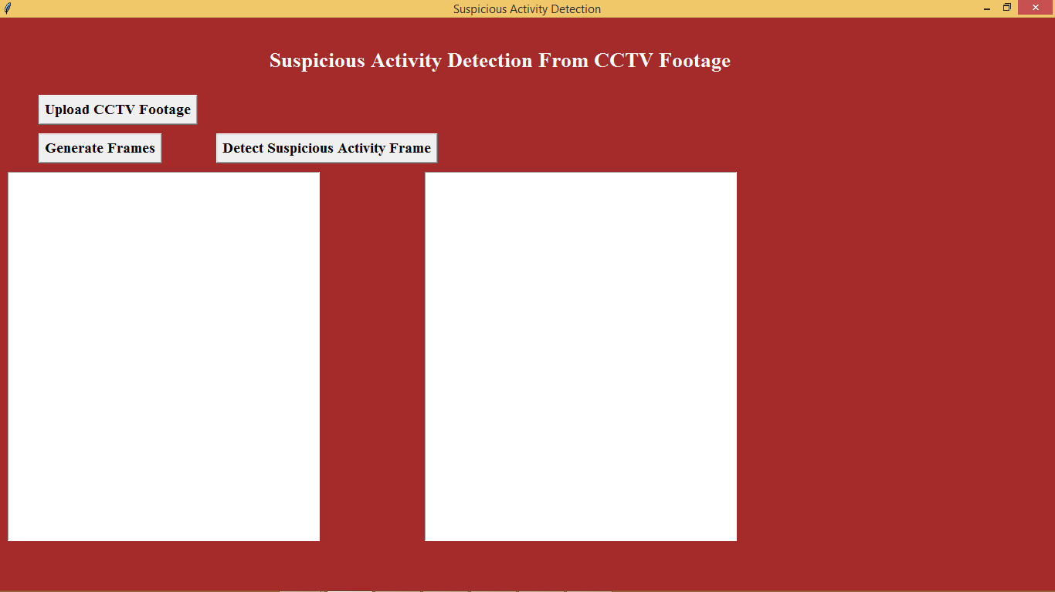

Click on ‘Upload CCTV Footage’ button to upload video

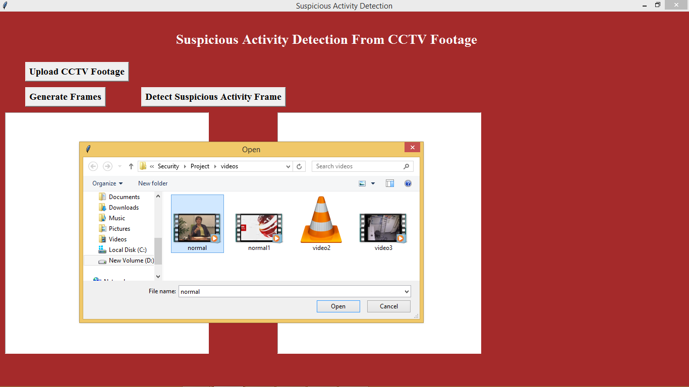

In above screen i am uploading one normal video. After uploading video click on ‘Generate Frames’ button to generate frame

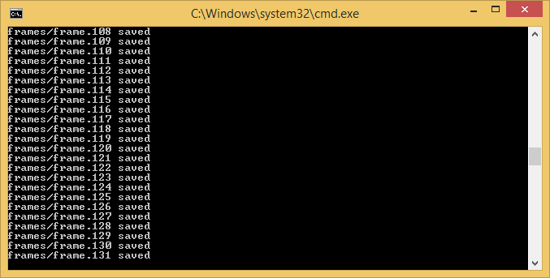

In above black screen we can see extracted frames are saving inside ‘frames’ folder frame no. Now we see frames folder below which has images from video

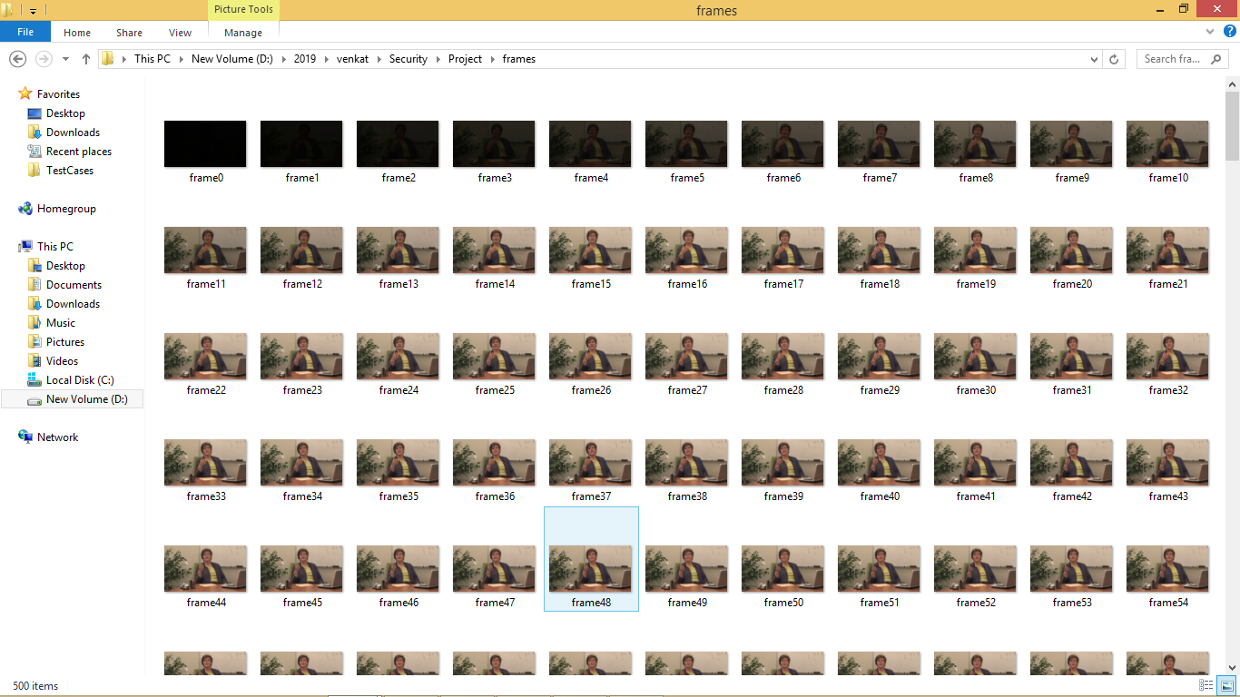

In above folder screen we can see all images from video extracted. After frame extraction will get below screen

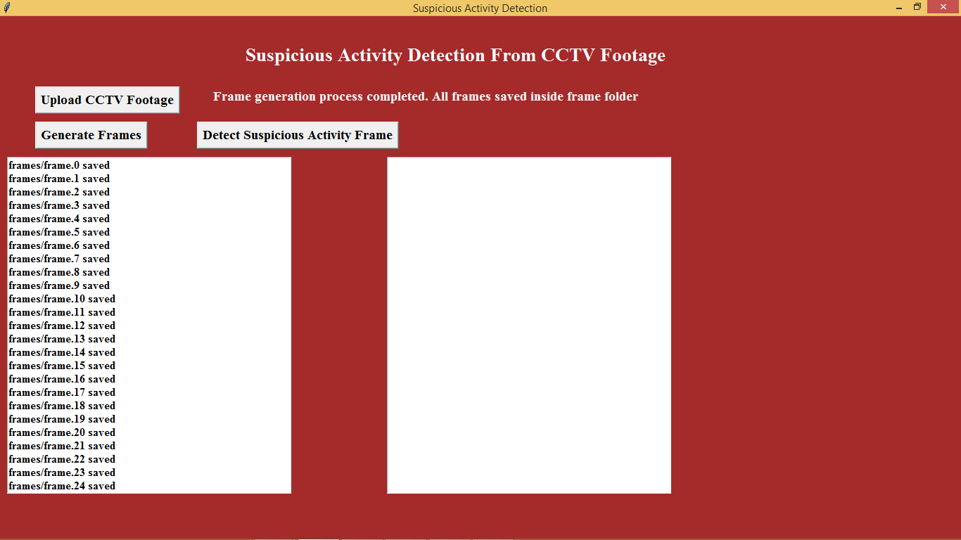

Now click on ‘Detect Suspicious Activity Frame’ button to start monitoring frames for suspicious activity

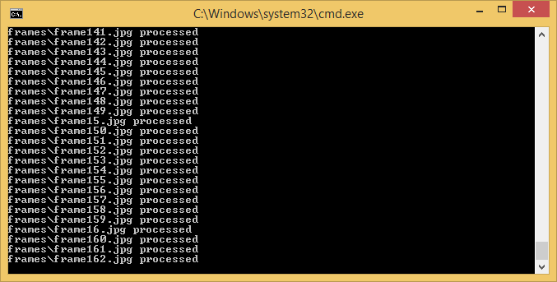

In above black console window we can see processing of each frame to detect suspicious activity.

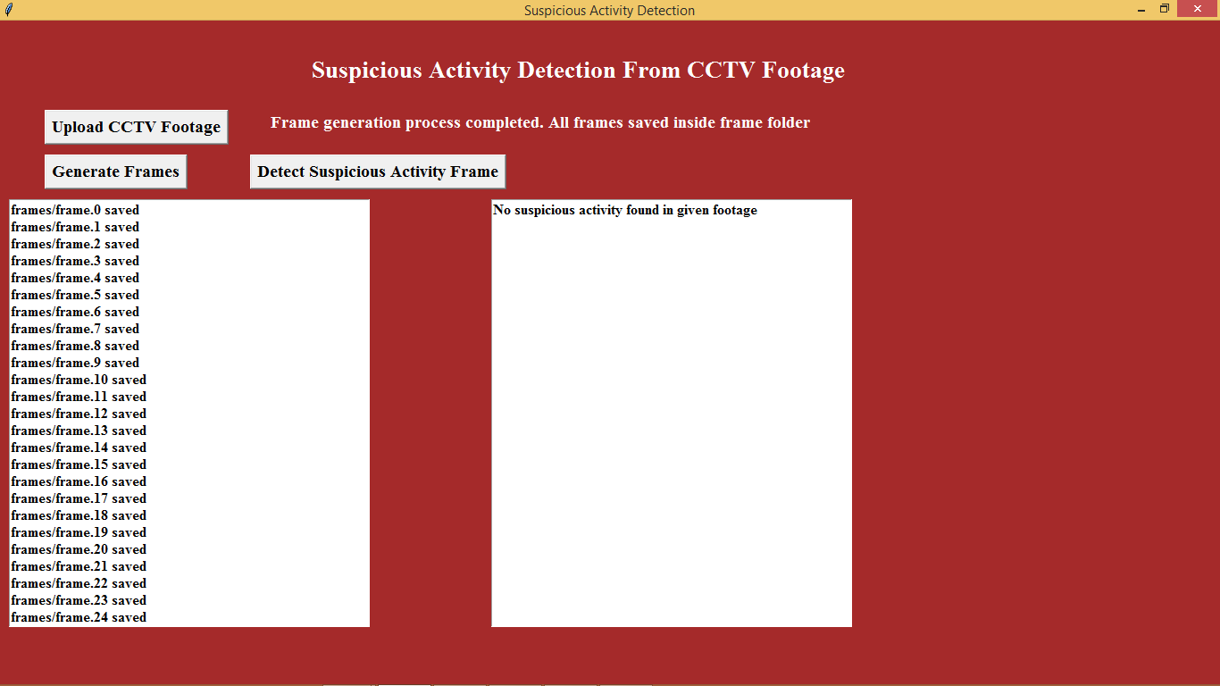

In above screen we can see frames scanned and no suspicious activity found. Now we will upload another video and check status

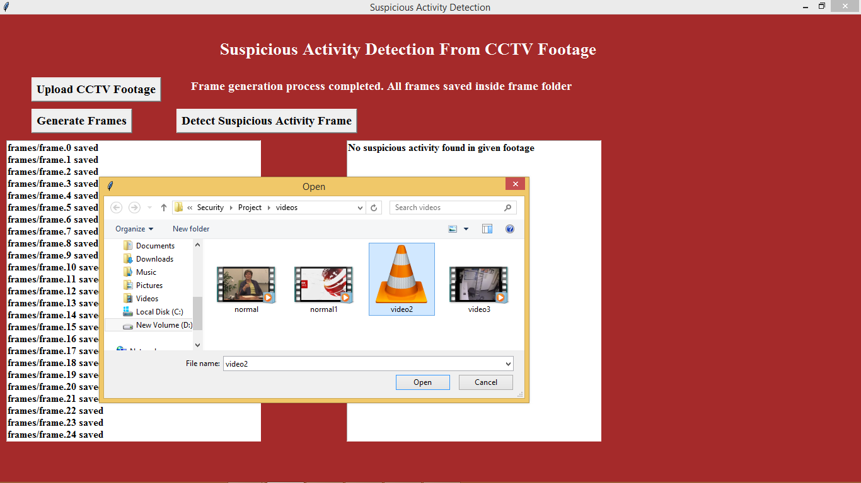

In above screen i am uploading ‘Video2’ and then extract frames

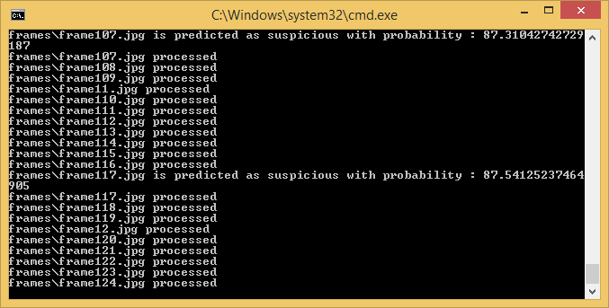

In above screen for uploaded video we can see suspicious activity found at farme117.jpg. After scanning all images we will get below details screen. Now in below screen we can see frame117.jpg image from frames folder

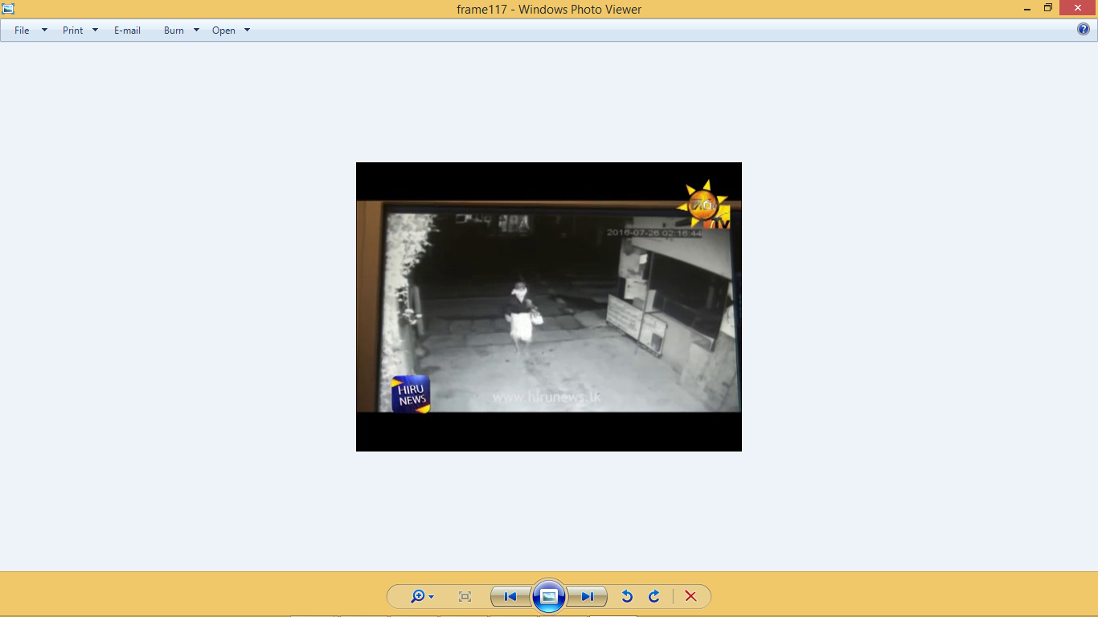

In above screen frame117 showing one image of a person with face covering. Similarly we can see all frames details in below screen which has such activities

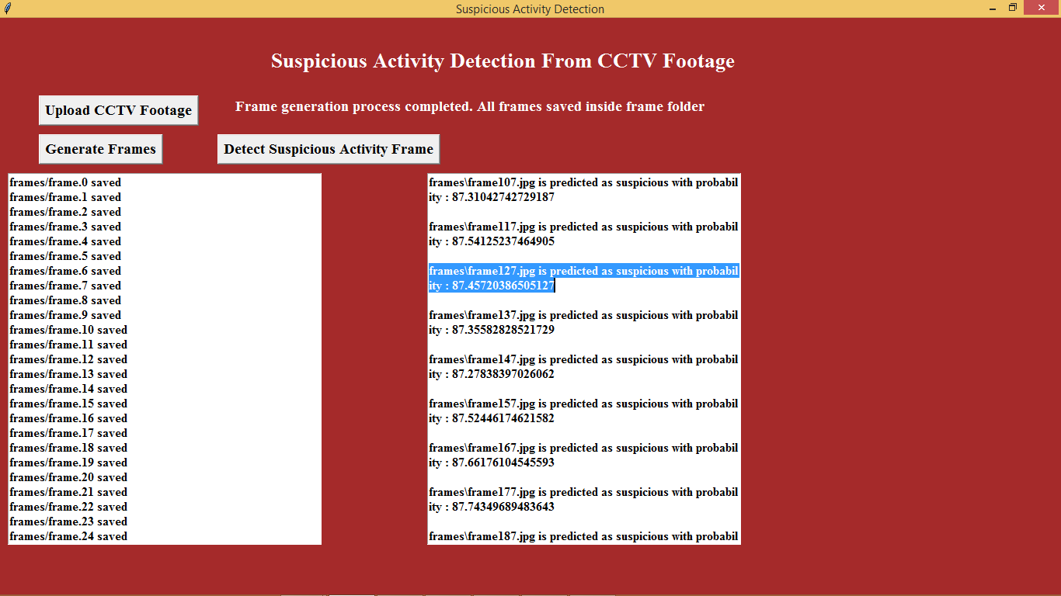

In above screen in right text area we can see details of all frames which has such activities.

Note: you to can upload your own videos and check but your videos must have person covering their faces or doing shop lifting robbers videos. Your videos must be like similar one which i used in this project