GrapiX

Local V1 System Design

STATUS  Approved target |  | OWNER  GrapiX Architecture |  | LAST UPDATED  July 29, 2026

Authors | Codex architecture review
Reviewers | Product, rendering, playout and broadcast operations
Related docs | docs/architecture.md; docs/local-v1-system-design.md
Scope | Local V1 Editor, Playout, Render Engine, Render Views and recovery.

1. Abstract
GrapiX should retain the three-product split: Editor, Playout and a persistent native Render Engine. The engine is the only production scene rasterizer; Editor and Playout consume specialised Render View extensions over authenticated local protocol v3.
Render Views share the native material, font, lighting, 3D, animation and asset pipeline. They provide view-level recovery and cached last-good frames. Only a separately isolated, synchronised and output-fenced Playout standby worker may take Program after a primary worker failure. Remote and multi-machine workflows are V2.

2. Goals and Non-Goals
Goals | Non-goals
One native source of scene pixels | Literal unbreakable network connections
Program survives UI disconnect/close | Application-owned Program renderers
Automatic reconnect and verified restore | Remote or distributed V1 deployment
Certified extension point for standby | Silent Pixi/Three or protocol-v2 fallback

3. Background and Problem Statement
The repository already contains a standalone Rust/wgpu engine, shared protocol-v3 client, Program clock, preview streaming and output adapters. The target is not yet end-to-end: Editor still rasterizes through PixiJS/Three.js, its engine connection is panel-scoped, both applications retain protocol-v2 paths, and Program state is not durably restored after worker restart.
Independent mini renderers inside the UI applications would duplicate GPU state, consume additional VRAM, couple rendering to window lifecycles and recreate pixel-parity drift. The safe boundary is a persistent Engine Host with native Render View sessions and an optional separate Playout standby protected by an output lease.

4. Proposed Architecture

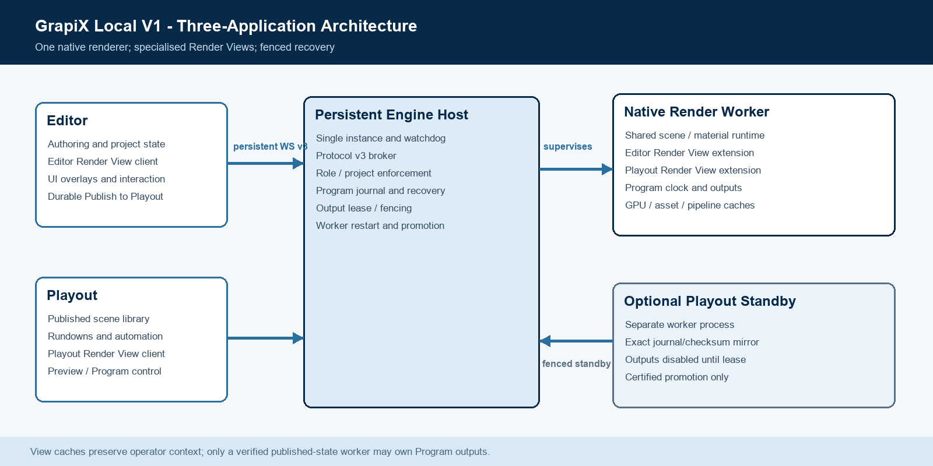
Figure 1. GrapiX Local V1 product, rendering and recovery boundaries.

Core components

Component | Responsibility | Primary storage | Failure behavior
Editor | Authoring, validation, package build and Editor View client | Project/source asset store | UI failure does not affect Program
Playout | Published library, rundown, Preview/Program commands | Published packages and rundown store | Reconnects and reconciles before control
Engine Host | Singleton lifecycle, protocol broker, watchdog and leases | Identity, journal and recovery snapshots | Restarts worker; never owned by a UI
Render Worker | Native GPU runtime, Render Views, Program clock and outputs | Content-addressed asset/pipeline caches | Verified restore; safe hold if ambiguous
Standby | Optional shadow Playout worker eligible for fenced promotion | Mirrored journal/checksums | No outputs without current lease

5. Request Lifecycle
- Editor or Playout ensures the persistent single-instance Engine Host is running.
- Protocol Hello authenticates the installation token and binds client ID, instance, role and project.
- The engine returns capabilities, engine epoch and monotonic state revision.
- The client reconciles scene/package revisions before enabling mutation or Program controls.
- Render Views are created or resumed and stream binary alpha-preserving frames.
- Program mutations are journalled before output side effects; retries retain message identity.
- Disconnects trigger indefinite reconnect/resync; worker crashes trigger verified restore or fenced standby promotion.

6. API and Data Contracts

Primary data contract

Field | Type | Required | Description
ClientSessionIdentity | object | Yes | Client, instance, role and project bound after authentication.
SceneRef | object | Yes | Project/domain/scene/revision; Program accepts published only.
RenderViewDescriptor | object | Yes | View owner, role, viewport, cadence, format and priority.
ViewFrameHeader | binary header | Yes | View, SceneRef, frame, state revision, size, stride and format.
EngineStateVersion | string/u64 | Yes | Engine epoch plus state revision for reconciliation.
OutputLease | object | Program | Generation-fenced single output owner.
RecoverySnapshot | object | Program | Verified package, data, frame, output and compatibility state.

Contract guarantees

- Commands apply only after authentication, authorization, revision validation and durable Program journalling.
- messageId prevents duplicate effects; sequence and stateRevision order commands and reconciliation.
- Audit records capture engine epoch, client identity, SceneRef, package checksum, frame and output lease.
- The engine is authoritative for active Program. Playout remains authoritative for operator intent and rundowns.
The versioned interfaces are published in Shared/render-protocol and the related Shared contract packages.
TypeScript and Rust protocol/schema changes must land together and remain backward-explicit.

7. Consistency, Idempotency, and Replay

Every mutable command is idempotent by message ID and ordered per connection. Revision or sequence gaps require reconciliation rather than best-effort application. Program recovery restores the last verified committed state without replaying a Take. Output fencing permits exactly one worker generation to drive outputs.
Scenario | Expected behavior | Reasoning
Duplicate command | Acknowledge without reapplying | Stable messageId and dedupe window
Connection loss | Reconnect, compare revisions, resubscribe | No manual recovery or blind replay
Worker crash | Restart and restore verified snapshot | Program state outlives the connection
Stale standby lease | Reject output writes and alert | Fencing prevents split-brain output

8. Security and Privacy Considerations

- Authenticate every V1 client with a per-installation token and bind role/project to the connection.
- Keep V1 on 127.0.0.1; do not expose remote bind, discovery or network publishing before V2.
- Store tokens and recovery state with native filesystem permissions; inject credentials into web clients only in memory.
- Restrict assets to configured roots, validate package checksums and shaders, and audit every Program/output mutation.
- Fail closed for authorization, recovery ambiguity and output lease conflicts; diagnostics must remain actionable.

9. Operational Readiness
Signal | SLO or alert | Owner | Launch gate
Program frame deadlines | No sustained misses; page on output drops | Render Engine | Required
Client recovery | Reconnect and reconcile without operator action | Editor / Playout | Required
Render View latency | Track p95 and stale/dropped frames | Render Engine | Required
Worker/device recovery | Verified restore or safe hold | Render Engine | Required
State integrity | Zero checksum, journal or lease ambiguity | Render Engine | Required
Rollout: M1 lifecycle and contracts; M2 native views and authority; M3 verified recovery; M4 optional standby after 8-hour nightly and 24-hour hardware certification.

10. Alternatives Considered

Alternative | Why it was considered | Why it was not selected
App mini renderers | Low-latency local preview | Duplicates GPU/runtime and is unsafe for Program
Browser + native confidence | Keeps current Editor path | Preserves pixel-parity risk
Views in one worker | Shares GPU and caches efficiently | Cannot survive worker-process crash
Separate Playout standby | Can cover primary worker failure | Extra VRAM/GPU cost; needs fencing/certification

11. Known Constraints
- A same-machine standby does not survive shared GPU, driver, operating-system or machine failure.
- Warm standby remains disabled until VRAM, scheduling, soak and output-device certification pass.
- Cached Render View frames maintain operator context only; they are never emitted as fresh Program.
- Remote and multi-machine failover require the V2 deployment and fencing architecture.

12. Decision and Next Steps
Approve the three-product architecture with native Render View extensions. Ship V1 with a persistent Engine Host, application-lifetime connections, strict scene/role isolation and verified restart recovery. Add a separate fenced Playout standby only after certification.
Milestone | Deliverable | Exit criteria
M1 | Contracts, persistent host and app-lifetime connections | Both apps auto-connect; closing either leaves engine alive
M2 | Role/scene isolation and native Render Views | Editor/Preview/Program pixel parity
M3 | Remove v2 runtime; journal and verified restore | Worker kill safely restores Program
M4 | Optional fenced Playout standby | Deterministic single-owner promotion passes certification

Use footnotes for definitions, assumptions, or terms that need precision without interrupting the main narrative.

