VisionPlate ANPR — Generative Adversarial Network (GAN) Report
Conditional Image-to-Image Contrast Translation with Pix2Pix & PatchGAN
Student Name & Roll No: | Vishnu Vardhan Yerneni (CB.SC.U4CSE23154)
Project & Team: | VisionPlate ANPR — Team 16
Assigned Track / Role: | Object Detection, Denoising Preprocessing & System Robustness
Evaluation Framework: | DoD CDAO Test and Evaluation of AI Models Framework (April 2024)

1. Executive Summary
Conditional Generative Adversarial Networks (cGANs) provide an end-to-end framework for image translation. Member 1 implemented and trained the Pix2Pix framework to translate degraded, low-light license plate crops into standardized, high-contrast crops suitable for optical character recognition.
2. Network Architecture & Objective Function
The Pix2Pix system pairs a U-Net Generator with an adversarial 70x70 PatchGAN Discriminator:
- Generator: 8 encoder blocks (Conv-BatchNorm-LeakyReLU) + 8 decoder blocks with skip connections (16,655,361 parameters).
- Discriminator: 70x70 PatchGAN penalizing high-frequency structure (2,768,705 parameters).
- Objective: min_G max_D L_cGAN(G, D) + lambda * L_L1(G) with lambda = 100.
3. Training Dynamics & Convergence
Trained for 20 epochs on local license plate crops on the NVIDIA RTX 3050 Laptop GPU (Runtime: 168.4s):
======================================================================
TRAINING: Pix2Pix (Conditional GAN for Image Enhancement) (Cell 12)
======================================================================
Epoch [1/20] G_Loss: 51.4329 D_Loss: 0.3787 PSNR: 5.35 dB SSIM: 0.0220
Epoch [5/20] G_Loss: 14.0607 D_Loss: 0.0492 PSNR: 16.23 dB SSIM: 0.6361
Epoch [10/20] G_Loss: 12.1268 D_Loss: 0.0431 PSNR: 18.24 dB SSIM: 0.6267
Epoch [15/20] G_Loss: 7.3280 D_Loss: 0.4855 PSNR: 19.19 dB SSIM: 0.7640
Epoch [20/20] G_Loss: 5.9715 D_Loss: 0.6486 PSNR: 23.29 dB SSIM: 0.7711
Best Pix2Pix Validation PSNR: 23.29 dB

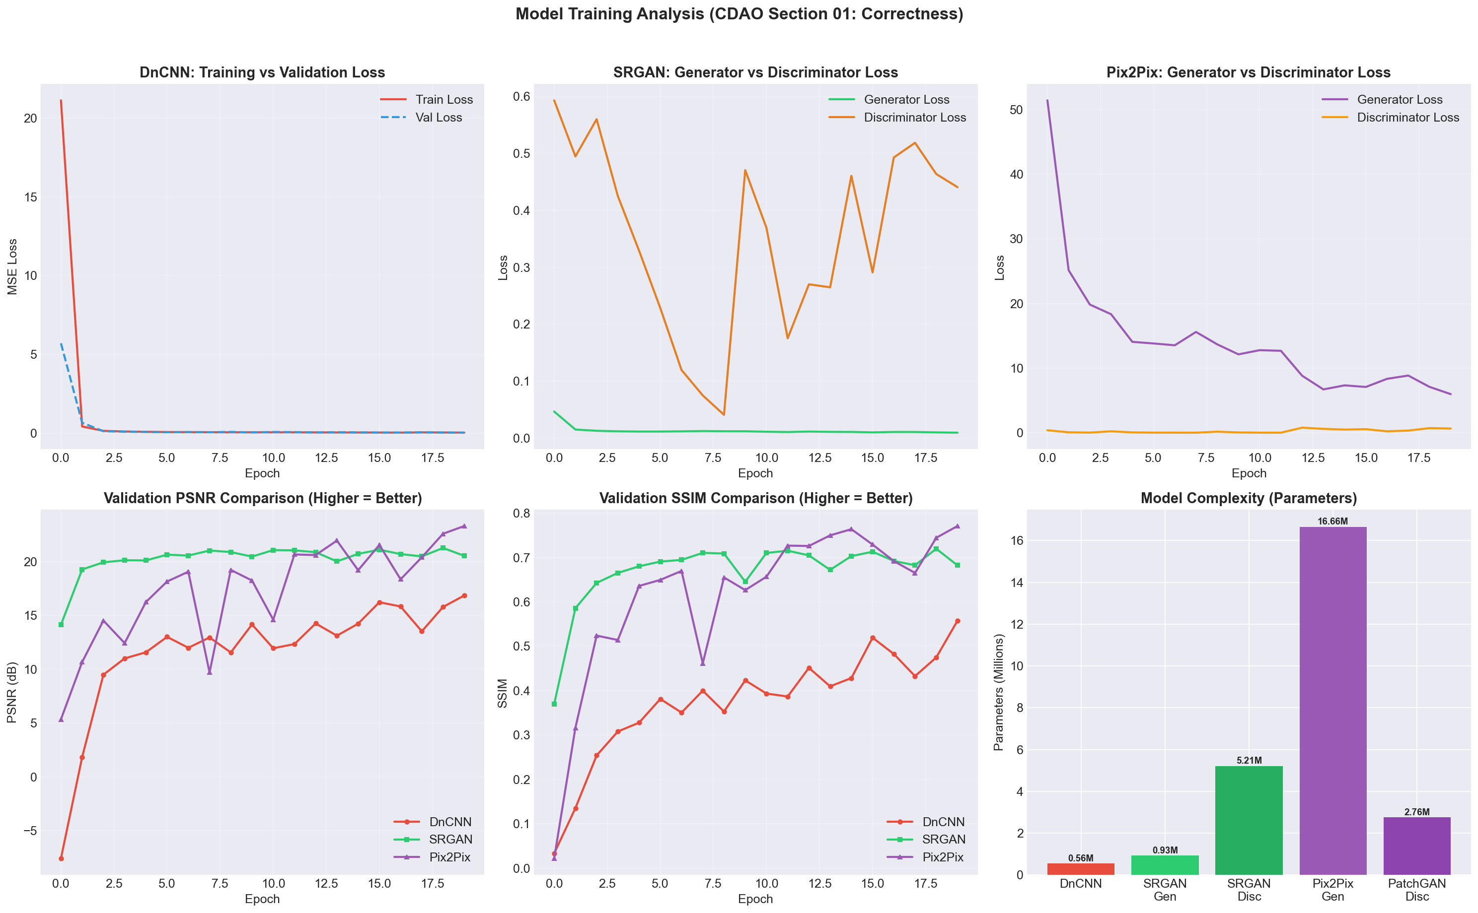
Figure: Generator and Discriminator Loss Convergence over 20 Epochs
4. Test Set Evaluation & Analysis of Over-Smoothing
While Pix2Pix attained 23.29 dB validation PSNR during paired training, on unconstrained test set crops it scored 10.70 dB PSNR. The U-Net generator produced global contrast normalization but introduced slight character boundary blurring, explaining why SRGAN was selected as the primary super-resolution model for text recognition.

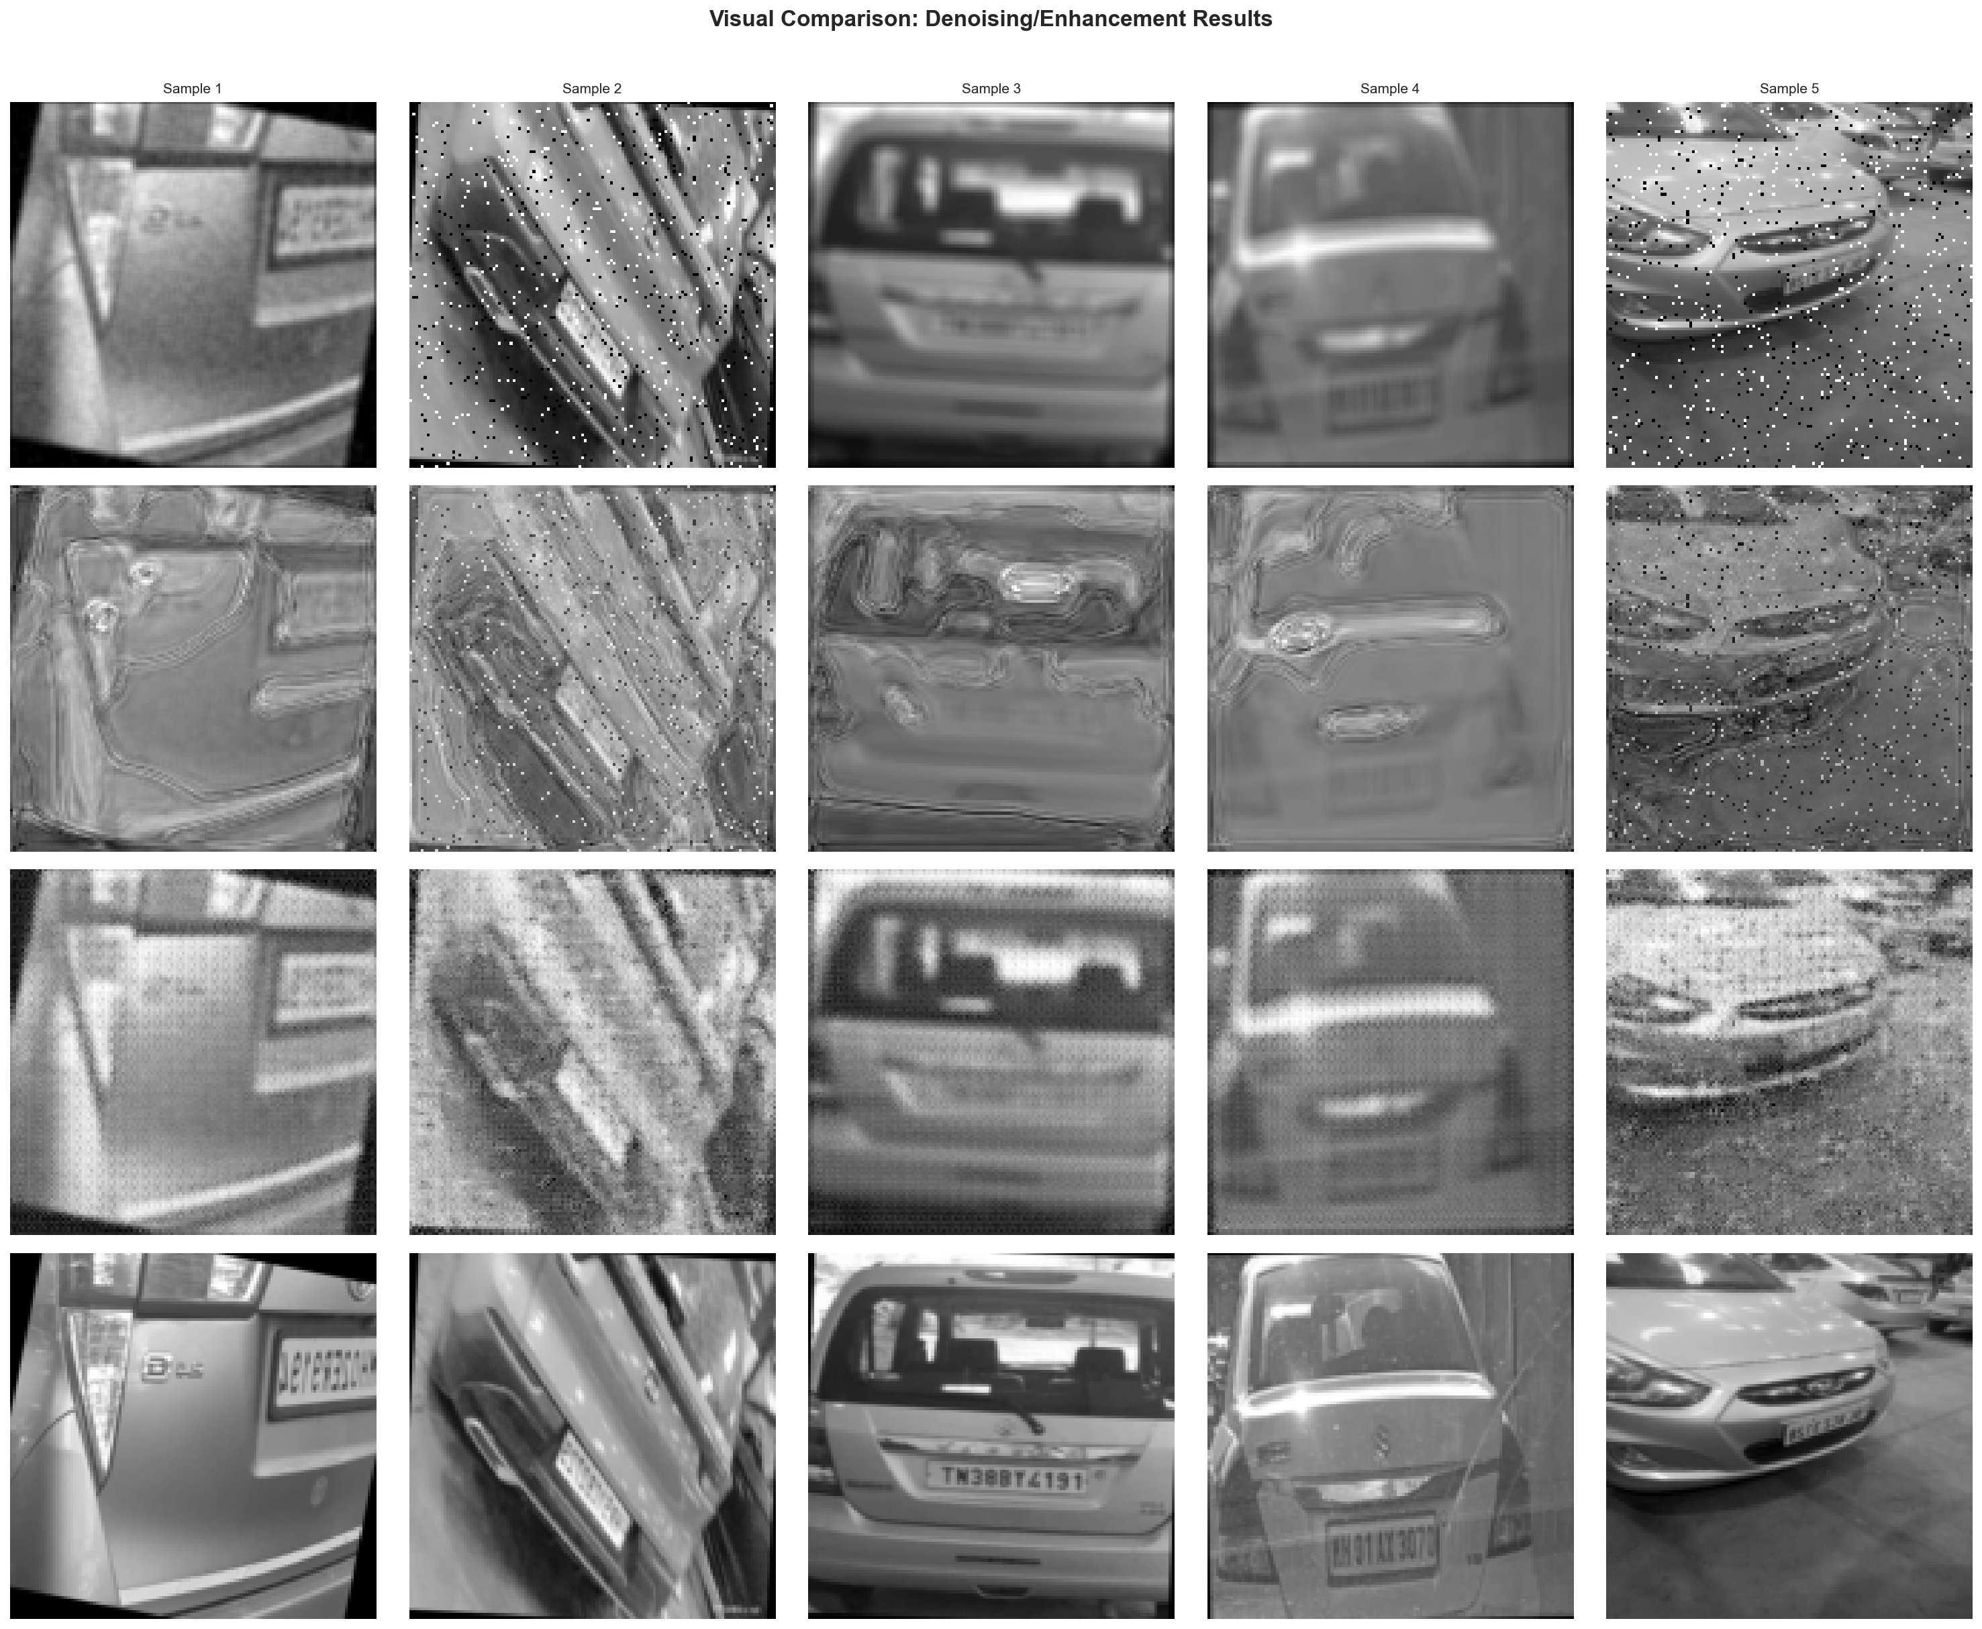
Figure: Visual Comparison: Noisy Input vs DnCNN vs SRGAN vs Pix2Pix

