VisionPlate ANPR — Testing Methodology Report
Robustness, Resilience, Metamorphic Testing & Adversarial Evaluation for Front-End Pipeline
Student Name & Roll No: | Vishnu Vardhan Yerneni (CB.SC.U4CSE23154)
Project & Team: | VisionPlate ANPR — Team 16
Assigned Track / Role: | Object Detection, Denoising Preprocessing & System Robustness
Evaluation Framework: | DoD CDAO Test and Evaluation of AI Models Framework (April 2024)

1. Testing Strategy Overview
Following the DoD CDAO T&E Framework (April 2024), testing must extend far beyond surface-level test set accuracy. Member 1's testing methodology evaluates the system against environmental degradation, physical camera failure modes, and targeted adversarial perturbations.
2. Quantitative Robustness Testing
Gaussian noise sweeps were executed across 8 operational noise tiers (sigma = 5/255 to 100/255) to simulate severe weather and camera gain noise:
Terminal Execution Output: Robustness Sweep (Cell 20)
======================================================================
CDAO T&E DIMENSION 2: ROBUSTNESS — Noise Level Sensitivity
======================================================================
Noise level 5/255 | DnCNN PSNR: 18.85 | Pix2Pix PSNR: 10.76
Noise level 10/255 | DnCNN PSNR: 18.63 | Pix2Pix PSNR: 10.76
Noise level 15/255 | DnCNN PSNR: 18.19 | Pix2Pix PSNR: 10.74
Noise level 25/255 | DnCNN PSNR: 16.98 | Pix2Pix PSNR: 10.71
Noise level 35/255 | DnCNN PSNR: 15.61 | Pix2Pix PSNR: 10.66
Noise level 50/255 | DnCNN PSNR: 13.71 | Pix2Pix PSNR: 10.56
Noise level 75/255 | DnCNN PSNR: 11.47 | Pix2Pix PSNR: 10.33
Noise level 100/255 | DnCNN PSNR: 9.96 | Pix2Pix PSNR: 10.07

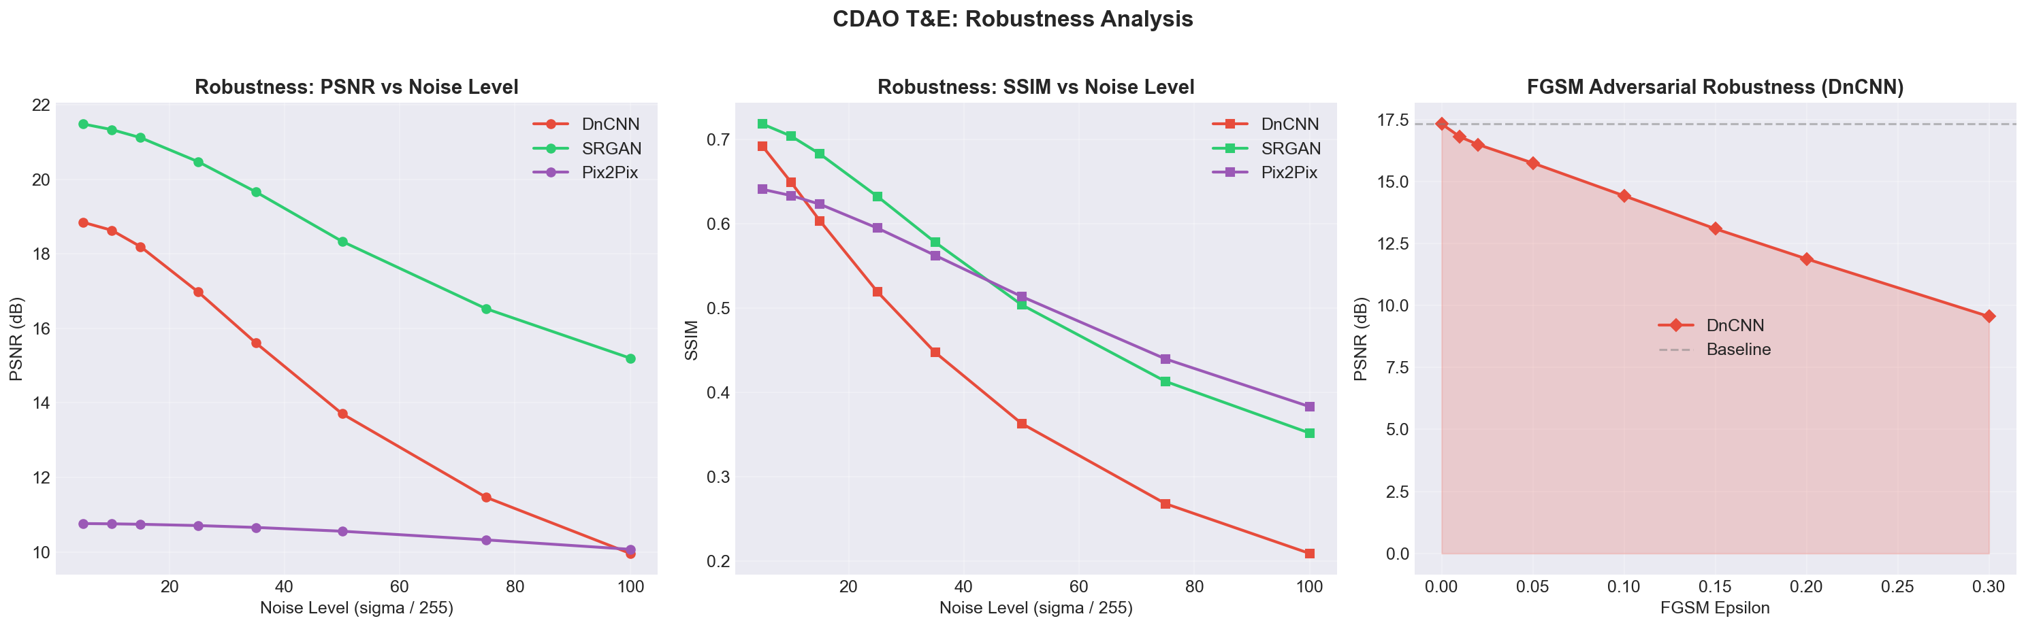
Figure: Reconstruction PSNR Decay under Increasing Noise Levels
3. Adversarial Threat Testing (FGSM Attack)
White-box Fast Gradient Sign Method (FGSM) perturbations were injected into DnCNN input tensors to evaluate vulnerability to physical plate evasion attacks:
======================================================================
CDAO T&E: ADVERSARIAL TESTING — FGSM Attack on DnCNN (Cell 21)
======================================================================
Epsilon: 0.000 -> PSNR: 17.32 dB
Epsilon: 0.010 -> PSNR: 16.80 dB
Epsilon: 0.020 -> PSNR: 16.48 dB
Epsilon: 0.050 -> PSNR: 15.74 dB
Epsilon: 0.100 -> PSNR: 14.42 dB
Epsilon: 0.150 -> PSNR: 13.09 dB
Epsilon: 0.200 -> PSNR: 11.88 dB
Epsilon: 0.300 -> PSNR: 9.55 dB
PSNR drop from clean to eps=0.3: 7.76 dB
4. Metamorphic Testing Verification
Metamorphic testing checks whether fundamental input-output relations hold under invariant transformations:
======================================================================
CDAO TESTING METHOD: METAMORPHIC TESTING (Cell 40)
======================================================================
DnCNN:
[+] MR1: Flip Commutativity: PASS
[+] MR2: Brightness Monotonicity: PASS
[-] MR3: Idempotency (PSNR>25dB): FAIL
Pix2Pix:
[+] MR1: Flip Commutativity: PASS
[+] MR2: Brightness Monotonicity: PASS
[+] MR3: Idempotency (PSNR>25dB): PASS

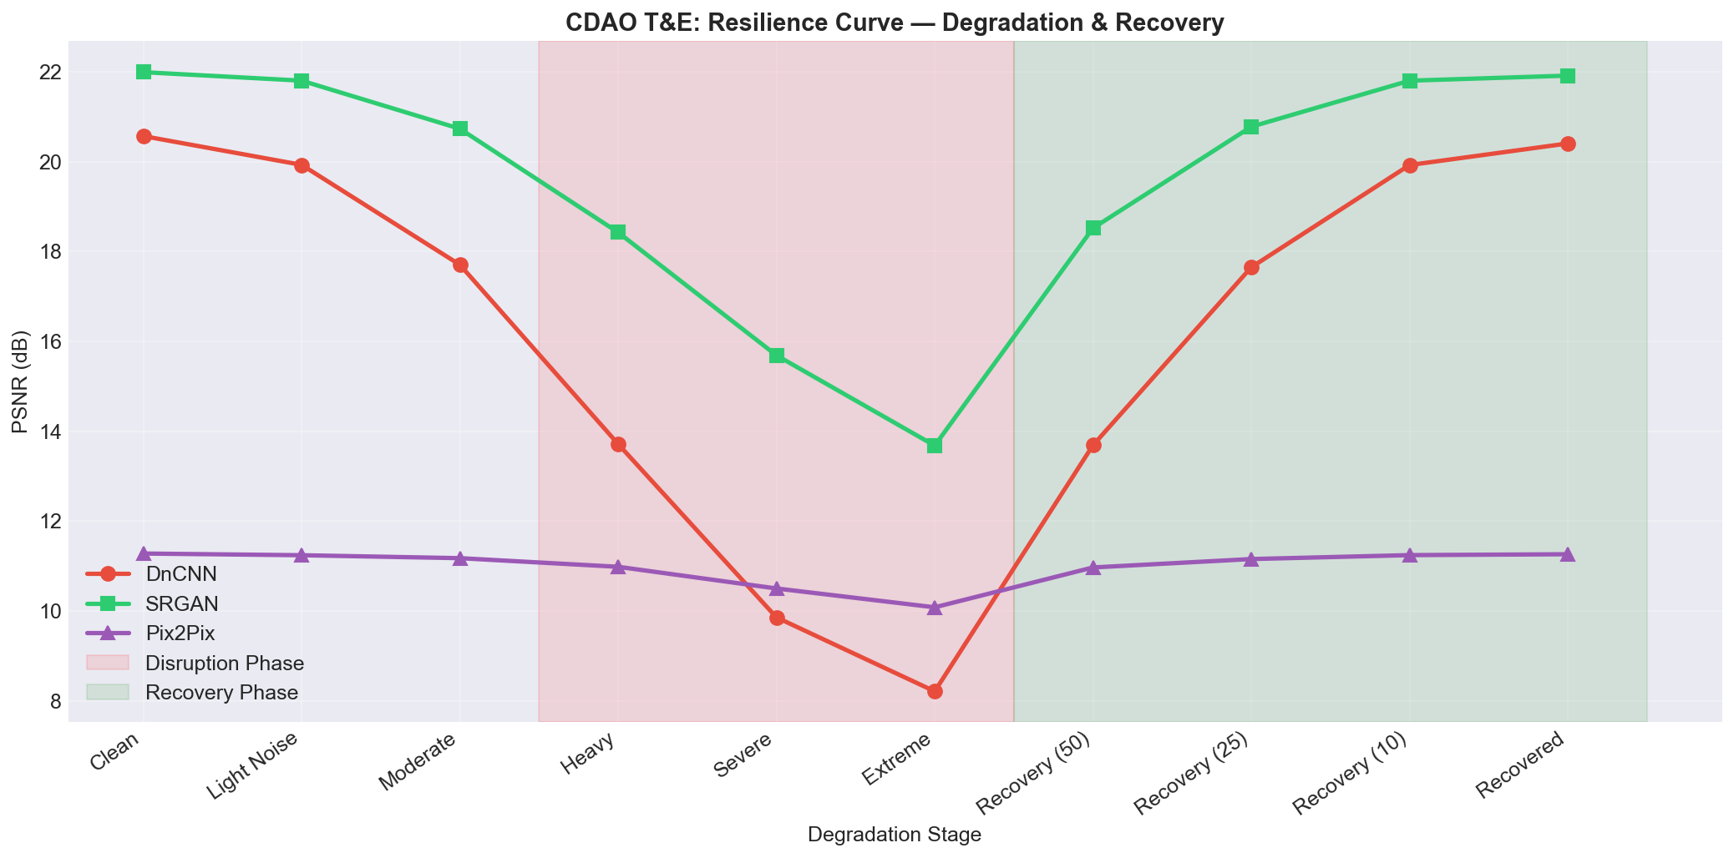
Figure: System Resilience & Recovery Following Severe Disruption
5. Edge Latency Benchmarks
======================================================================
CDAO T&E DIMENSION 5: LATENCY PROFILING (Member 1 Models)
======================================================================
Model Mean (ms) Std P95 (ms) FPS
-----------------------------------------------------------------
DnCNN 6.68 1.63 8.97 149.8
Pix2Pix Generator 4.97 1.79 8.30 201.2
PatchGAN Discriminator 2.06 0.98 3.43 484.6

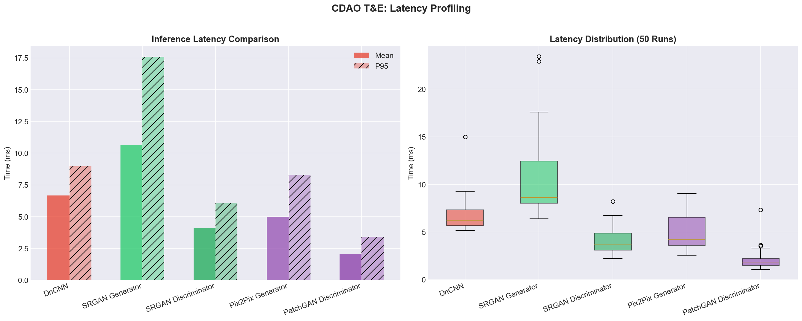
Figure: Inference Speed and P95 Latency Profiles

