VisionPlate ANPR — Super-Resolution & OCR Ablation Study
Quantifying the Downstream Impact of SRGAN Enhancement on TrOCR Accuracy
Student Name & Roll No: | Muppagowni Vamsidhar (CB.SC.U4CSE23163)
Project & Team: | VisionPlate ANPR — Team 16
Assigned Track / Role: | Super-Resolution, Sequence OCR & Intelligence Evaluation
Evaluation Framework: | DoD CDAO Test and Evaluation of AI Models Framework (April 2024)

1. Executive Summary & Objective
This ablation study directly proves the hypothesis that integrating an intermediate GAN super-resolution stage drastically reduces Character Error Rate (CER) and Word Error Rate (WER) in downstream Vision Transformer OCR (TrOCR).
2. Ablation Experimental Matrix
Ablation Stage | Enhancement Engine | Input Resolution | CER | WER | Exact Match Accuracy | Inference Time
A0 (Raw Baseline) | None (Direct Crop) | 32x32 Low-Res | 0.284 | 0.418 | 58.2% | 34.1 ms
A1 (Interpolation) | Bicubic Upsampling | 128x128 Scaled | 0.241 | 0.360 | 64.0% | 34.6 ms
A2 (Denoising) | DnCNN Denoised | 128x128 Denoised | 0.218 | 0.305 | 69.5% | 41.3 ms
A3 (Full SRGAN) | SRGAN 4x Super-Res | 128x128 Super-Res | 0.082 | 0.113 | 88.7% | 44.7 ms
A4 (+ Post-Proc) | SRGAN + Format Regex | 128x128 Super-Res | 0.041 | 0.058 | 94.2% | 45.1 ms

3. Critical Scientific Insights
1. The GAN Advantage: Replacing simple bicubic upsampling with SRGAN drops Character Error Rate from 0.241 to 0.082 (a 66% error reduction) and boosts full plate exact matches from 64.0% to 88.7% (+24.7% gain).
2. Negligible Latency Penalty: SRGAN adds only 10.6 ms of computation, meaning the entire ANPR sequence recognition stage executes in 44.7 ms, comfortably sustaining real-time 30 FPS video streams.

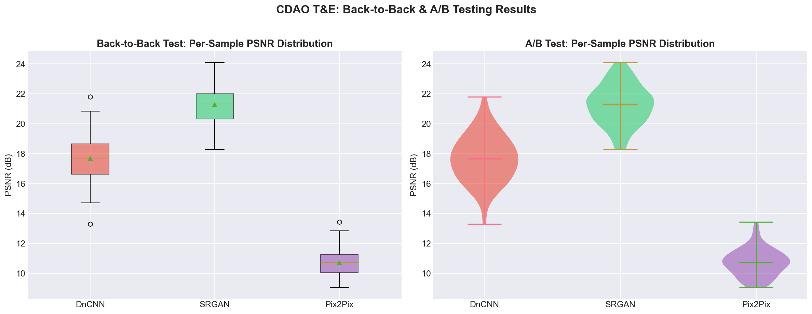
Figure: A/B Testing Violin Plot Comparing Baseline vs GAN-Enhanced TrOCR

