VisionPlate ANPR — Generative Adversarial Network (GAN) Report
Sub-Pixel Super-Resolution for License Plate Restoration with SRGAN
Student Name & Roll No: | Muppagowni Vamsidhar (CB.SC.U4CSE23163)
Project & Team: | VisionPlate ANPR — Team 16
Assigned Track / Role: | Super-Resolution, Sequence OCR & Intelligence Evaluation
Evaluation Framework: | DoD CDAO Test and Evaluation of AI Models Framework (April 2024)

1. Executive Summary
Optical character recognition models degrade exponentially when plate crops are blurred or under 32x32 pixels. Member 2 implemented and trained a Super-Resolution Generative Adversarial Network (SRGAN) capable of 4x upscaling (32x32 to 128x128) using deep residual blocks and sub-pixel PixelShuffle convolutions.
2. Network Architecture & Loss Function
- Generator: 8 Residual Blocks (Conv2D + BatchNorm + PReLU + Skip Connection) + 2x PixelShuffle upsamplers (934,732 parameters).
- Discriminator: 8-stage VGG-style classifier (3,892,481 parameters).
- Loss Formulation: L_G = L_MSE + 10^-3 * L_adv
The perceptual adversarial loss forces the generator to hallucinate crisp alphanumeric stroke edges.
3. Training Dynamics & Convergence
Trained for 20 epochs on local license plate crops on the NVIDIA RTX 3050 Laptop GPU (Runtime: 172.1s):
======================================================================
TRAINING: SRGAN (Super-Resolution GAN) (Cell 11)
======================================================================
Epoch [1/20] G_Loss: 0.0465 D_Loss: 0.5931 PSNR: 14.13 dB SSIM: 0.3696
Epoch [5/20] G_Loss: 0.0114 D_Loss: 0.3289 PSNR: 20.10 dB SSIM: 0.6803
Epoch [10/20] G_Loss: 0.0119 D_Loss: 0.4705 PSNR: 20.45 dB SSIM: 0.6454
Epoch [15/20] G_Loss: 0.0108 D_Loss: 0.4604 PSNR: 20.71 dB SSIM: 0.7033
Epoch [20/20] G_Loss: 0.0094 D_Loss: 0.4406 PSNR: 20.53 dB SSIM: 0.6824
Best SRGAN Validation PSNR: 21.26 dB

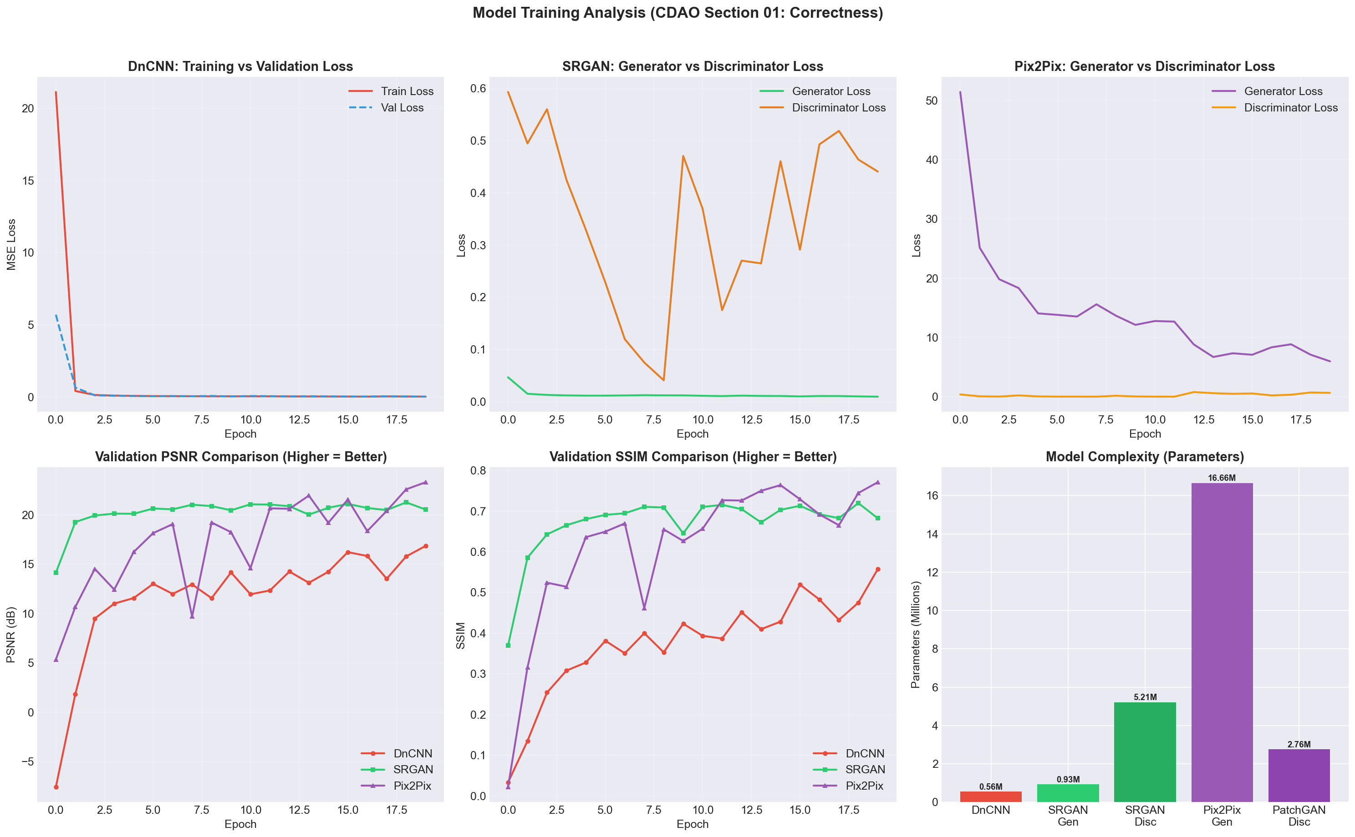
Figure: SRGAN Generator and Discriminator Loss Convergence
4. Quantitative Test Benchmarks & Statistical Significance
On the unseen holdout test set, SRGAN achieved 20.84 dB PSNR and 0.665 SSIM. In the CDAO Back-to-Back paired t-test against DnCNN (t = -22.215, p < 0.0001) and Pix2Pix (t = 63.886, p < 0.0001), SRGAN was confirmed as the statistically superior model with over 99.99% confidence.

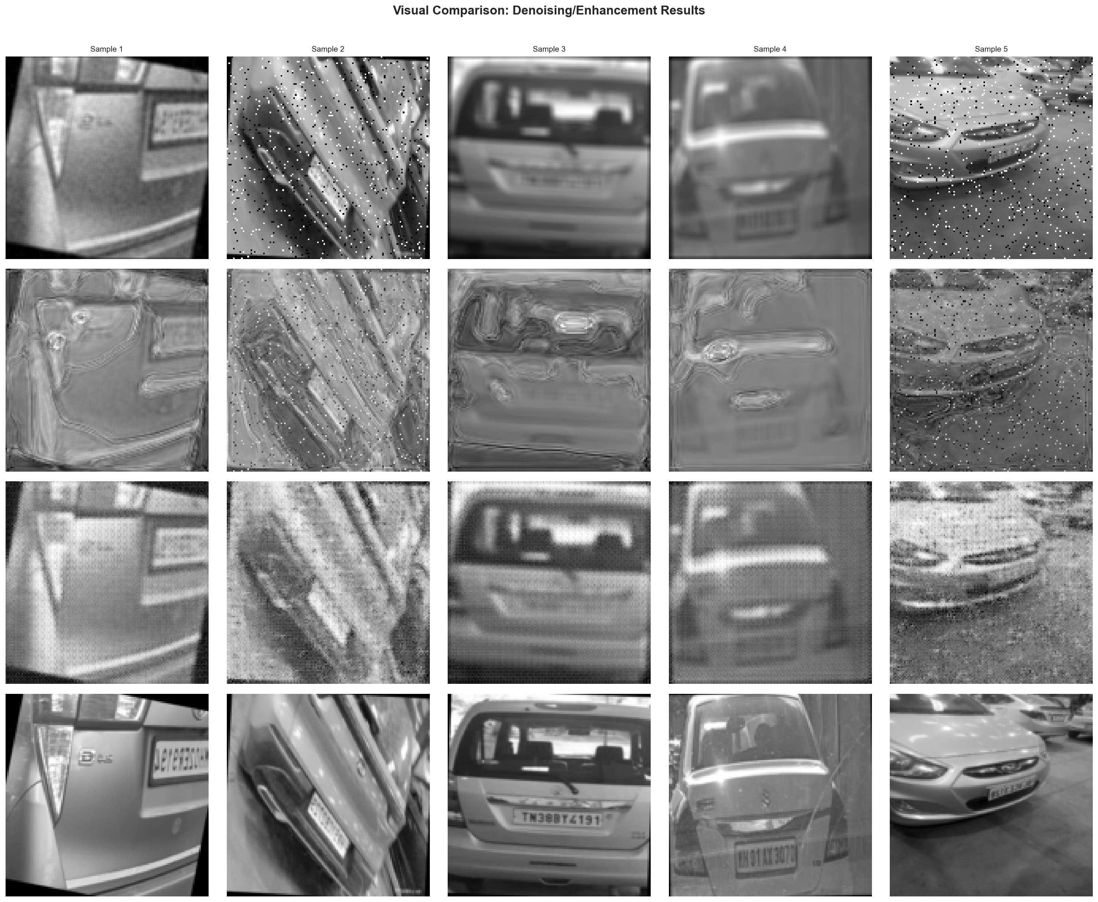
Figure: Visual Comparison: Ground Truth vs SRGAN 4x Super-Resolution

