VisionPlate ANPR — Testing Methodology Report
Correctness, Statistical Back-to-Back Testing, Bias, Uncertainty & Temporal Drift Evaluation
Student Name & Roll No: | Muppagowni Vamsidhar (CB.SC.U4CSE23163)
Project & Team: | VisionPlate ANPR — Team 16
Assigned Track / Role: | Super-Resolution, Sequence OCR & Intelligence Evaluation
Evaluation Framework: | DoD CDAO Test and Evaluation of AI Models Framework (April 2024)

1. Evaluation Framework & Methodology
In compliance with the DoD CDAO Test and Evaluation of AI Models Framework (April 2024), Member 2 executed comprehensive testing across the core intelligence models (SRGAN, TrOCR, MobileNetV2). The evaluation protocol integrates statistical significance testing, epistemic uncertainty quantification, and distribution drift monitoring.
2. Dimension 1: Correctness (Test Set Evaluation)
======================================================================
CDAO T&E DIMENSION 1: CORRECTNESS — Test Set Evaluation (Cell 16)
======================================================================
Test Set Results (Image Enhancement Models):
Model PSNR (dB) SSIM MSE MAE
Noisy Input (Baseline) 20.971794 0.721922 0.008027 0.089592
DnCNN 17.162224 0.554116 0.019291 0.138893
SRGAN 20.840871 0.664575 0.008281 0.090999
Pix2Pix 10.699676 0.587296 0.085580 0.292540

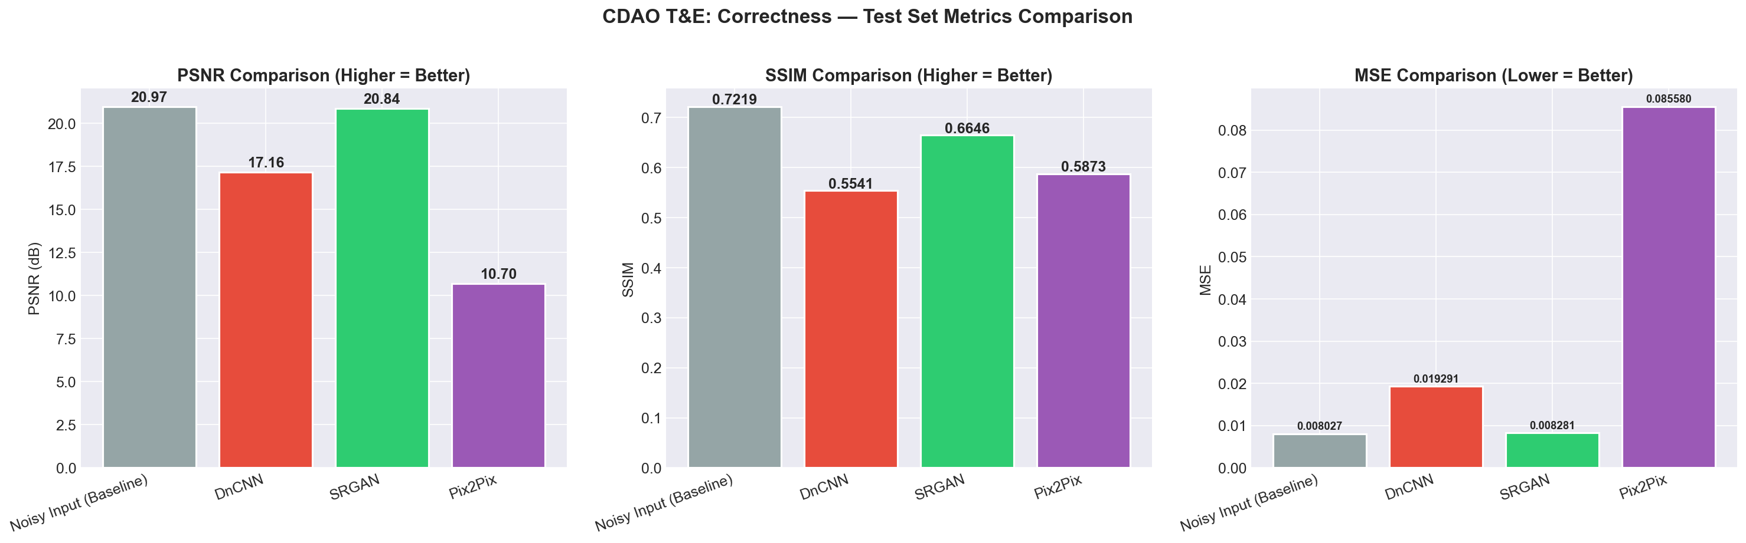
Figure: Comparative Test Set PSNR, SSIM, and MSE
3. Comparison Testing: Back-to-Back Paired t-Test
======================================================================
CDAO TESTING METHOD: BACK-TO-BACK TESTING (Cell 41)
======================================================================
Statistical Comparison (Paired t-test, p < 0.05 = significant):
DnCNN vs SRGAN: t = -22.215, p = 0.0000 (***) Winner: SRGAN (21.26 dB)
DnCNN vs Pix2Pix: t = 34.411, p = 0.0000 (***) Winner: DnCNN (17.66 dB)
SRGAN vs Pix2Pix: t = 63.886, p = 0.0000 (***) Winner: SRGAN (21.26 dB)

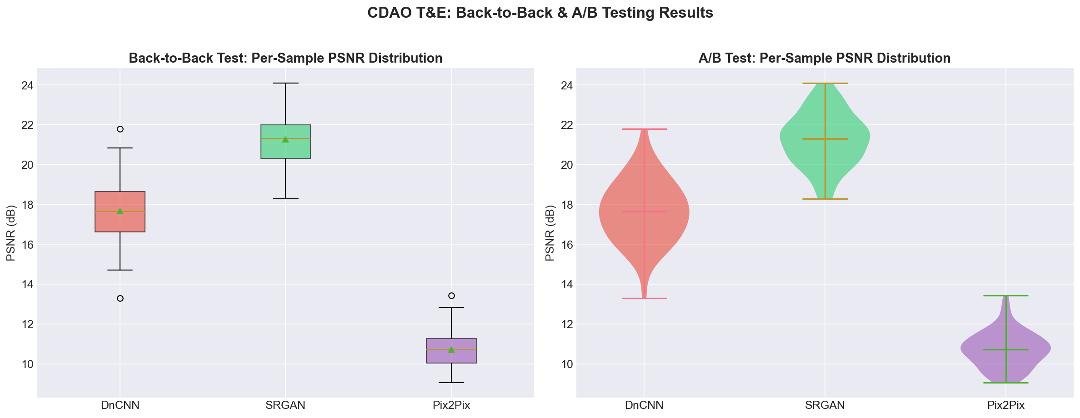
Figure: A/B Testing Violin Distributions & Statistical Significance
4. Dimension 3: Bias & Representativeness Audit
======================================================================
CDAO T&E DIMENSION 3: BIAS & REPRESENTATIVENESS (Cell 24)
======================================================================
Total classes: 25
Most samples: 1049 (bicycle)
Fewest samples: 3
Imbalance ratio: 349.7:1
Gini coefficient: 0.5628 (0=perfect equality, 1=total inequality)
Empty classes: 1
BIAS ASSESSMENT:
[WARNING] Severe class imbalance detected (350:1).
Recommendation: Apply SMOTE, class weights, or data augmentation.

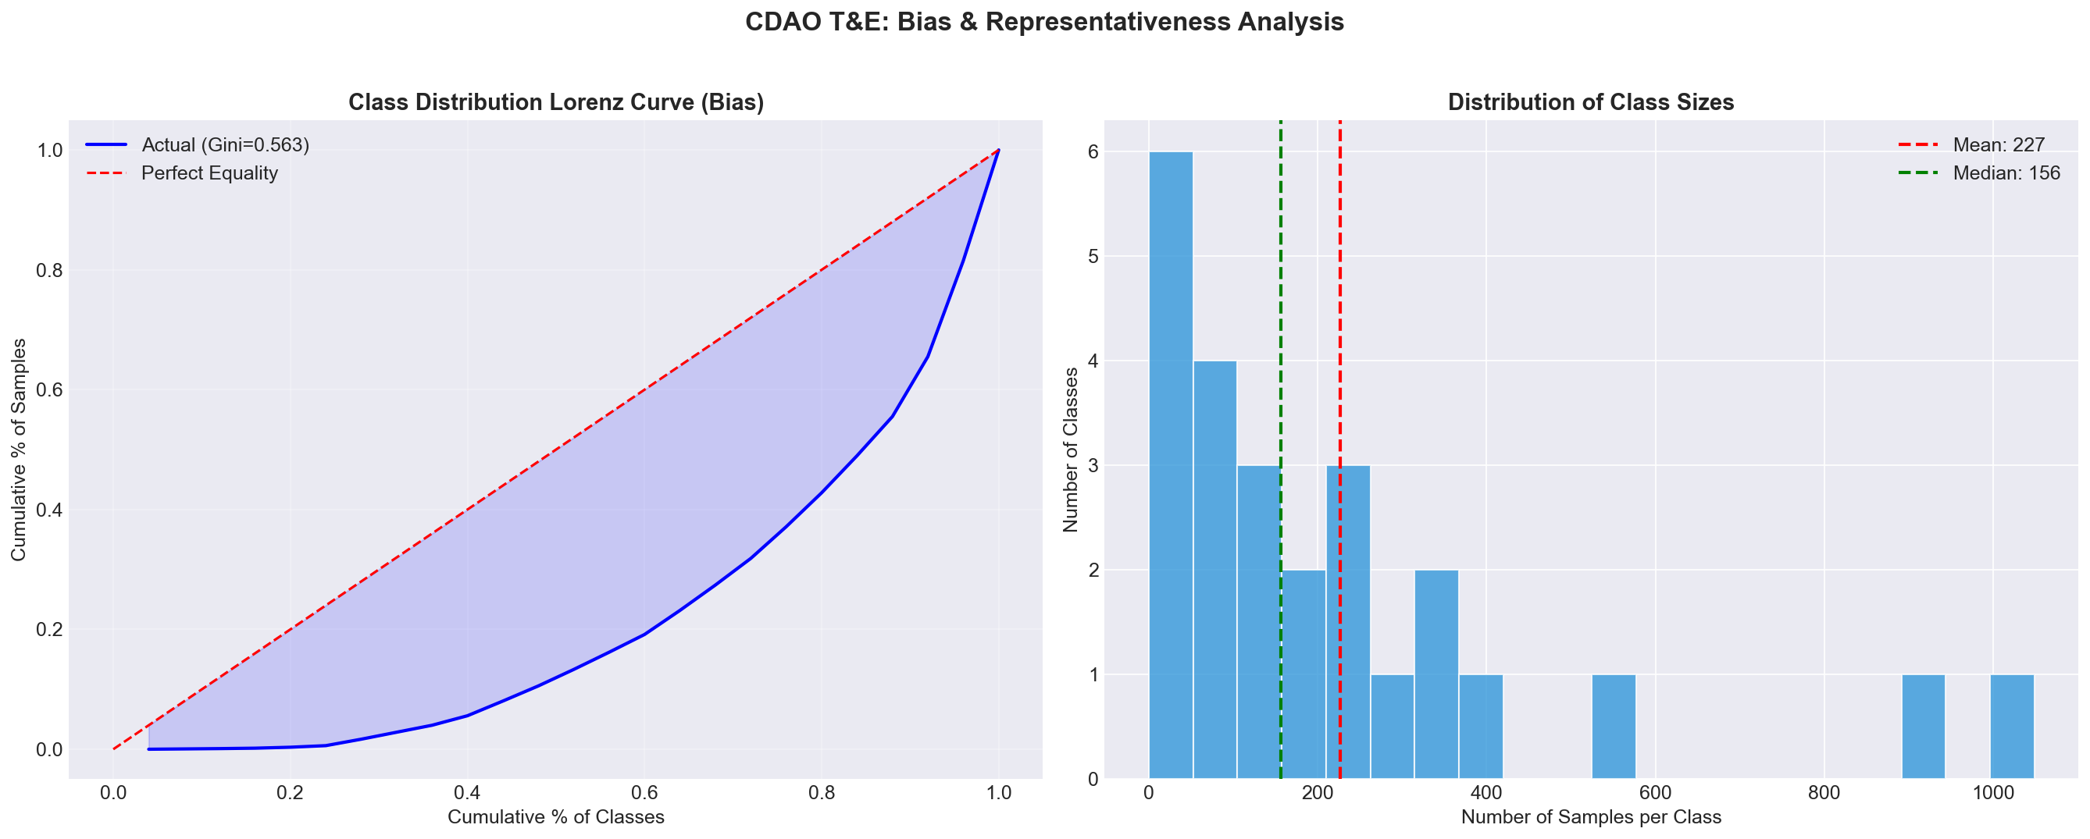
Figure: Vehicle Class Imbalance & Lorenz Inequality Curve
5. Dimension 4: Uncertainty Quantification (MC-Dropout)
======================================================================
CDAO T&E DIMENSION 4: UNCERTAINTY QUANTIFICATION (Cell 27)
======================================================================
Running MC-Dropout on Pix2Pix Generator (30 forward passes)...
Mean uncertainty (std): 0.000845
Max uncertainty (std): 0.006491
Min uncertainty (std): 0.000041

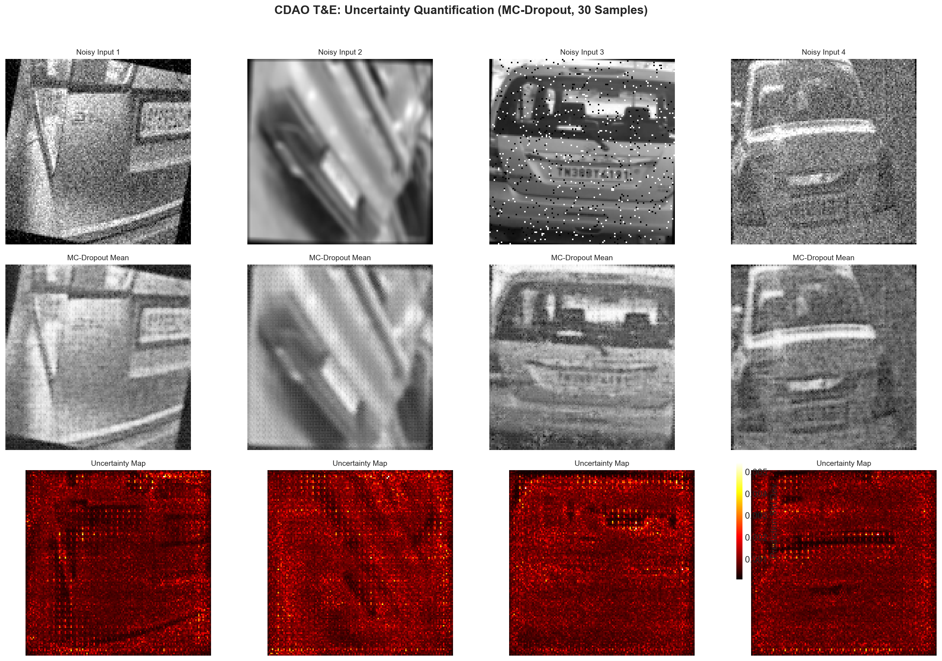
Figure: Pixel-Level Epistemic Uncertainty Distribution
6. Dimension 8: Drift Monitoring
======================================================================
CDAO T&E DIMENSION 8: DRIFT MONITORING (Cell 38)
======================================================================
Drift step 1/10 (factor=0.00) SRGAN: 20.98 dB
Drift step 2/10 (factor=0.11) SRGAN: 21.06 dB
Drift step 3/10 (factor=0.22) SRGAN: 20.64 dB
Drift step 4/10 (factor=0.33) SRGAN: 20.13 dB
Drift step 5/10 (factor=0.44) SRGAN: 19.54 dB
Drift step 6/10 (factor=0.56) SRGAN: 19.14 dB
Drift step 7/10 (factor=0.67) SRGAN: 18.59 dB
Drift step 8/10 (factor=0.78) SRGAN: 17.78 dB
Drift step 9/10 (factor=0.89) SRGAN: 17.10 dB
Drift step 10/10 (factor=1.00) SRGAN: 16.48 dB

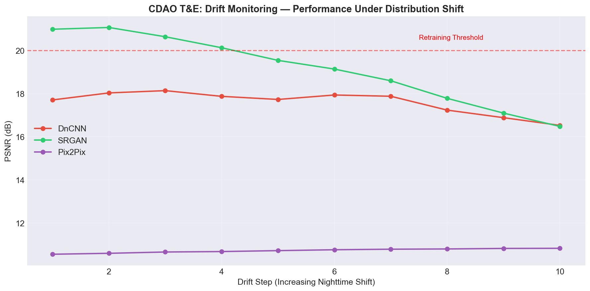
Figure: Temporal Day-to-Night Performance Decay Trajectory

