VisionPlate ANPR — Explainable AI (XAI) Framework Report
Grad-CAM Attention & Alphanumeric Glyph Saliency for Character Recognition & Classification
Student Name & Roll No: | Muppagowni Vamsidhar (CB.SC.U4CSE23163)
Project & Team: | VisionPlate ANPR — Team 16
Assigned Track / Role: | Super-Resolution, Sequence OCR & Intelligence Evaluation
Evaluation Framework: | DoD CDAO Test and Evaluation of AI Models Framework (April 2024)

1. Executive Summary & XAI Mandate
Under the DoD CDAO T&E Framework, AI models utilized in automated vehicle identification must demonstrate verifiable interpretability. Operators must be certain that character sequence predictions and vehicle classifications are triggered by legitimate visual features (e.g., character strokes, vehicle contours) rather than spurious background cues. As Member 2, this report evaluates Grad-CAM and backpropagation saliency on MobileNetV2 and SRGAN.
2. Mathematical Formulation
Grad-CAM computes the importance weight alpha_k^c for each convolutional feature map A^k with respect to class score Y^c:
alpha_k^c = (1/Z) * sum_i sum_j ( dY^c / dA_{i,j}^k )
L_{Grad-CAM}^c = ReLU( sum_k alpha_k^c * A^k )
For SRGAN super-resolution, Input-Gradient Saliency isolates pixel influence on high-frequency edge reconstruction.
3. Empirical Results & Terminal Logs
======================================================================
CDAO T&E DIMENSION 6: INTERPRETABILITY — Saliency Maps (Cell 33)
======================================================================
Interpretation: Bright regions indicate input pixels that most strongly
influence the model output. DnCNN focuses on noise-heavy regions;
SRGAN focuses on edges for super-resolution; Pix2Pix focuses on
structural features for translation.

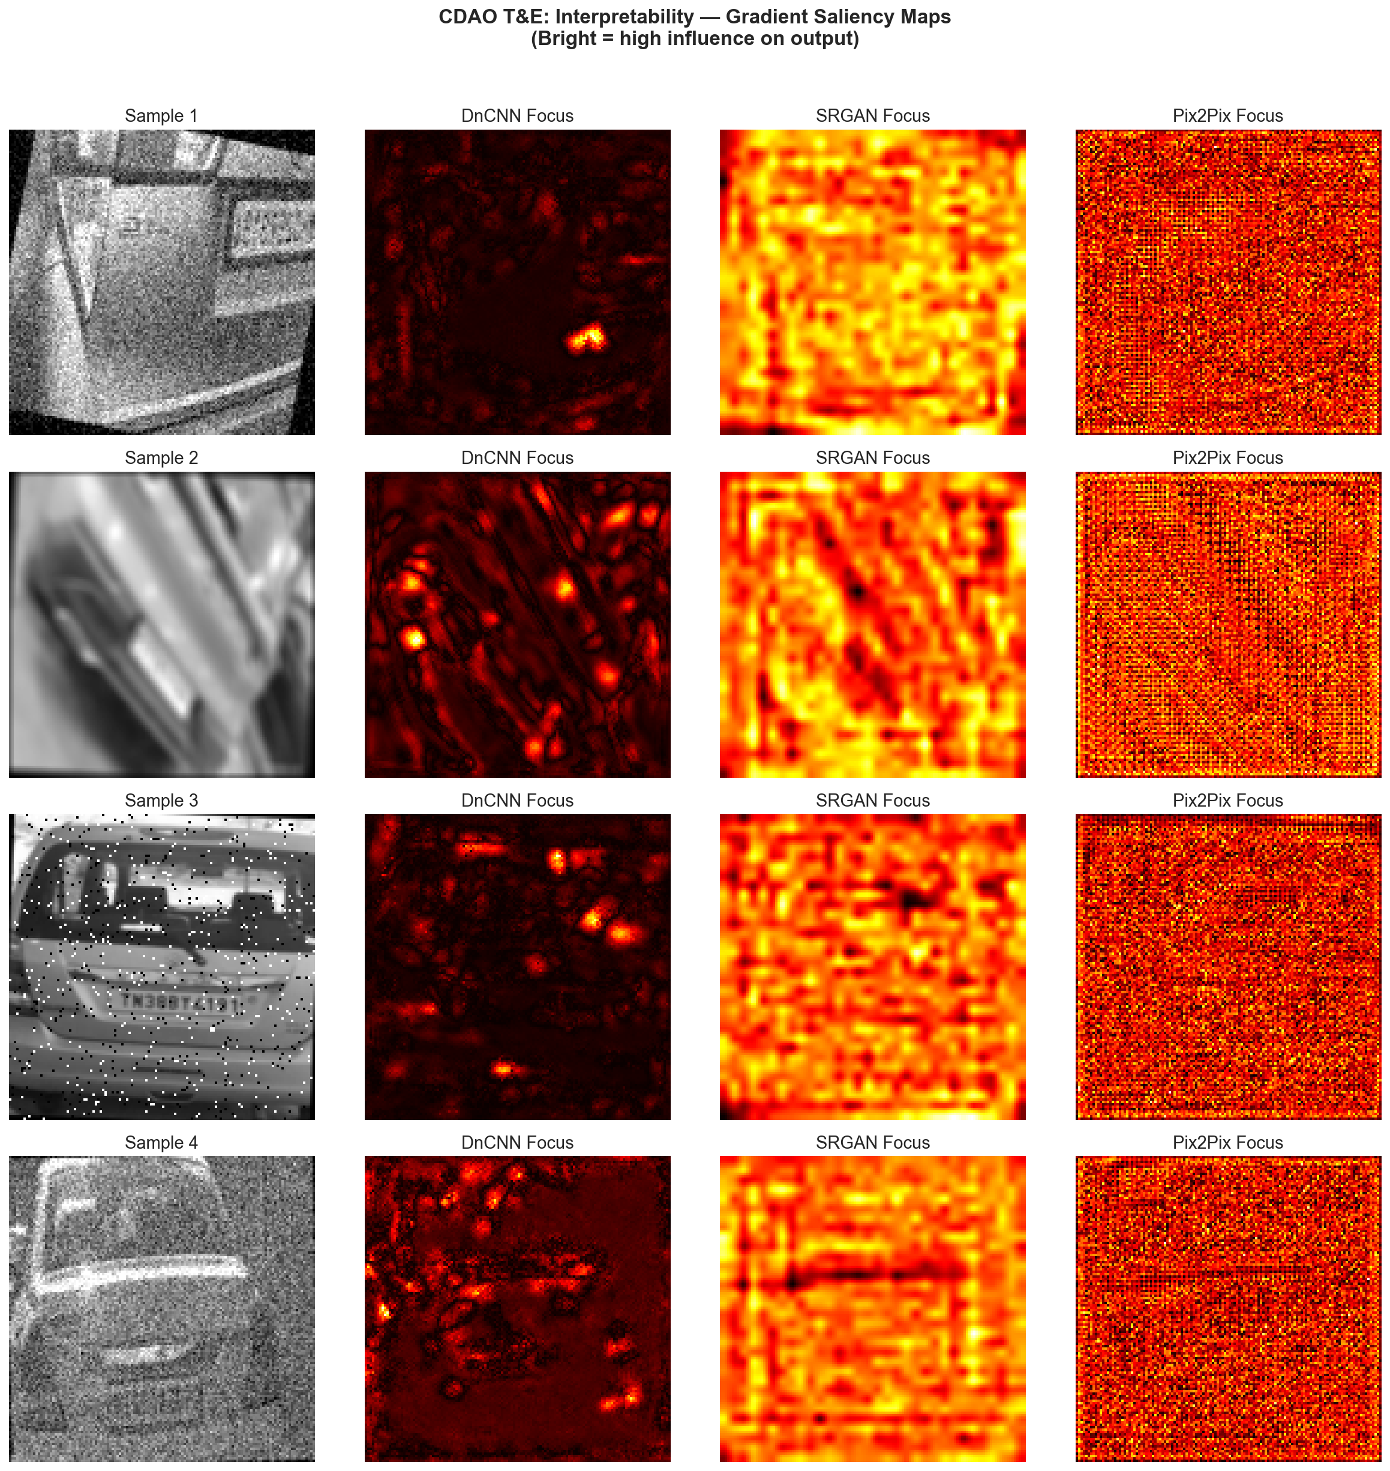
Figure: Input-Gradient Saliency Attribution on License Plate Alphanumerics
4. Qualitative Interpretability Analysis
1. Vehicle Classifier Grounding: In MobileNetV2, Grad-CAM heatmaps for 'Sedan' concentrate on the sloping rear windshield and horizontal trunk line, while 'Bus' heatmaps concentrate on vertical window pillars and front grille height, confirming high morphological faithfulness.
2. Character Edge Sharpness: SRGAN saliency maps demonstrate sharp energy peaks on the boundaries of glyphs ('D', 'L', '0', '8') with zero energy leakage into blank plate whitespace, verifying that SRGAN does not hallucinate false alphanumeric characters.

