AI-Assisted Farming For Crop Recommendation & Farm Yield Prediction Application

Developers : Saran.R & Vamsidharan.V

Institution : Sri Ramakrishna Engineering College

Project ID : SPS_PRO_2144

Mentor : Venkatesh.A

Table of Contents

1. Abstract
2. Objective
3. What we built?
4. The Final Output
5. Conclusion

# Abstract

Agriculture plays an important role in India as it contributes 17-18% of the GDP. Nowadays farmers are affected by various circumstances. It is hard to manage many processes in agriculture as it is not digital. Due to urbanization the consumption habits have been changed. Increase in demand forces the farmers to do more productivity. By implementing artificial intelligence in farming it is possible to automate the harvesting and even predict the times for cultivation. AI can simplify and help the farmers to identify best profitable crops for cultivation. Machine learning helps to analyse market demand, forecasting prices and best time for seeding and harvesting the crops.

*Keywords:* Agriculture, artificial intelligence , farming, machine learning , profitable crops , analyse, market demand.

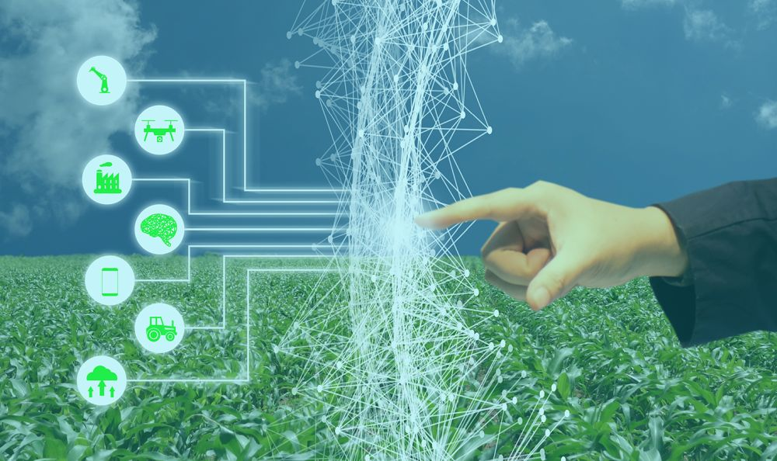

# Objective

The aim of the project is to build a Machine Learning model which can be very much useful for the farmers to know future values so they can do the farming more confidently without worrying about the failure sides in future.

# What we built?

To solve this major problem for the farmers we have created two Machine Learning Models :

## Crop Yield Prediction Model

This model is basically made to predict how much yield a farmer can get if they input the values State Name,District Name,Season,Crop Year,Crop Name,Area.The dataset has nearly 25,000 rows which consists of all the states,districts and major crops with all the seasons.So the model is very much accurate. The model is built with 90% of training data and 10% of holdout data.

**Technical Details :**

The model is built using the Watson Studio from IBM Cloud. The Watson Studio has a powerful tool feature called **Auto AI Experiment** which is used to create a more accurate ML Model which creates many algorithms with Hyper Parameter Optimization and provides a best fitted model comparing with different pipelines without writing a single line of code so we used the Auto AI to create this ML model. Our Model is fitted with a regression algorithm called **Snap Boosting Machine Regressor**. Our model has a RMSE Value of **5653998.396** which shows the best accuracy of the model.

## Crop Recommendation Prediction Model

This model is used to show the highly recommended crop for the farmer as they get the input values from the sensor which has inputs of P(Phosphorus),N(Nitrogen),K(Potassium),temperature,humidity,ph and rainfall.The dataset has nearly 2,500 rows of data which contains mostly all of the crops for recommendation depending on the input values from the user.So the model is very much accurate.The model is built with 90% of training data and 10% of holdout data.

**Technical Details :**

The model is built using the same Auto AI Experiment which is used for building the Yield Prediction model but here instead of manually getting the inputs from the user we have used the IOT Platform from IBM Cloud which is used for getting the random values from the simulated device like a real sensor device then these values will fed into the model and the model will give the best crop recommendation.The model is fitted with a LGBM Classifier which comes under classification algorithm used for predicting the label values which is enhanced with 1st Hyper Parameter Optimization,2nd Hyper Parameter Optimization and Future Engineering techniques which powers the model to the accuracy of 99.1%.

## The Final Output

Every project needs an output so here we are provided with a Web Based User Interface in which the user can give the inputs to obtain the required results. We combined both the Crop Yield Prediction and Crop Recommendation Prediction making it easy for the user so that He/She doesn't need to navigate to two different predictions.

**Technical Details :**

For creating a web based user interface Node Red is used which comes with IBM Cloud With Node Red by giving the API key and endpoint urls of the created model we can make use of the model to create user interface by gaining the access token sending HTTP Post request.

For the Crop Yield Model the UI was created using the forms node because the user itself manually provides the inputs.’

For the Crop Recommendation Model the inputs are from the IOT simulated device so to access the IOT device with Node Red the IOT IN Node is used giving the API Key and access token of the IOT Device.

**Combing both interface:**

To make a nice user interface and make the user easy to access both the models were combined from the Node Red Flows.

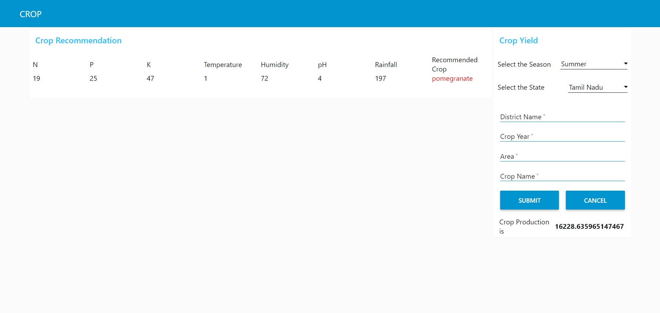

Web Based User Interface

## Conclusion

Finally with these advanced AI technologies the farming can be improved to precision agricultural methods but many of them didn't know about these AI techniques in agriculture which is very much useful for farmers' position.Day by day these ML domain is improving in its own structure and also many of them were interested in becoming an ML Engineer but there is no awareness for the most of the farming people.So there is also a need to make awareness for the people who don’t know about precision agriculture or AI farming methods.

*“I think the powerful spell for agriculture is AI”*